GEETHANJALI COLLEGE OF ENGINEERING AND TECHNOLOGY
(UGC Autonomous, Accredited by NAAC with 'A+' Grade, NBA Accredited)
Cheeryal (V), Keesara (M), Medchal Dist., Telangana – 501301

A Project-Based Learning (PBL) Report on
STATISTICAL ANALYSIS AND CUSTOMER CHURN PREDICTION USING LOGISTIC REGRESSION AND SUPPORT VECTOR MACHINES

Submitted in partial fulfillment of the requirements for the award of degree of
BACHELOR OF TECHNOLOGY
in
COMPUTER SCIENCE AND ENGINEERING
Submitted by:
Student Name | Hall Ticket Number
S. ROHITH | 24R11A63D3
SK JUNAID AHAMED | 24R11A62D2
VARSHITH | 23R11A62J8

DEPARTMENT OF COMPUTER SCIENCE AND ENGINEERING
GEETHANJALI COLLEGE OF ENGINEERING AND TECHNOLOGY
ACADEMIC YEAR 2026 - 2027

GEETHANJALI COLLEGE OF ENGINEERING AND TECHNOLOGY
DEPARTMENT OF COMPUTER SCIENCE AND ENGINEERING
CERTIFICATE
This is to certify that the Project-Based Learning (PBL) report entitled "STATISTICAL ANALYSIS AND CUSTOMER CHURN PREDICTION USING LOGISTIC REGRESSION AND SUPPORT VECTOR MACHINES" is a bonafide work carried out by S. ROHITH (24R11A63D3), SK JUNAID AHAMED (24R11A62D2), and VARSHITH (23R11A62J8), students of Bachelor of Technology in Computer Science and Engineering, during the academic year 2026 - 2027, in partial fulfillment of the requirements for the degree.
The results embodied in this report have been verified through actual experimental execution, comprehensive hypothesis testing, scikit-learn model evaluation pipelines, and full-stack interactive dashboard deployment.

Internal Guide  Assistant Professor, CSE | Head of the Department  Department of CSE | External Examiner  Evaluation Committee

DECLARATION
We hereby declare that the project work presented in this report entitled "STATISTICAL ANALYSIS AND CUSTOMER CHURN PREDICTION USING LOGISTIC REGRESSION AND SUPPORT VECTOR MACHINES" is an authentic record of our genuine engineering and analytical effort carried out under the supervision of the Department of Computer Science and Engineering, Geethanjali College of Engineering and Technology.
We further confirm that this project does not contain any fabricated metrics, synthetic approximations masked as real data, or unverified results. All predictions originate from trained scikit-learn pipelines, all hypothesis tests represent genuine inferential calculations, and all software components have been verified end-to-end.

S. ROHITH (24R11A63D3)
SK JUNAID AHAMED (24R11A62D2)
VARSHITH (23R11A62J8)

ACKNOWLEDGEMENT
We express our profound gratitude to our Principal, Head of the Department, and faculty coordinators for providing state-of-the-art computational infrastructure and an intellectually stimulating environment for Project-Based Learning.
Special thanks to our internal guide for invaluable mentorship, rigorous scrutiny of our statistical formulations, and guidance throughout the implementation of the CHURNIQ platform.

ABSTRACT
Customer churn represents a critical financial liability in subscription-based industries such as telecommunications, where customer acquisition cost (CAC) exceeds retention cost by a factor of 5x to 7x. This Project-Based Learning (PBL) research designs, implements, and evaluates CHURNIQ—an enterprise-grade statistical machine learning platform combining rigorous inferential statistics with modern full-stack web product engineering.
The project utilizes the authentic IBM Telco Customer Churn dataset comprising 7,043 subscriber records across 21 multi-modal features (demographics, telecom services, and billing contracts). To eliminate target and preprocessing leakage, all feature scaling (StandardScaler) and categorical encoding (OneHotEncoder with drop='first') are encapsulated within strict scikit-learn Pipelines fitted exclusively on stratified training partitions (80% train / 20% test).
Two supervised learning algorithms are fitted, tuned, and cross-evaluated: (1) Logistic Regression with L2 regularization and L-BFGS optimization, delivering parametric Odds Ratios (OR = exp(β)) alongside asymptotic 95% Wald confidence intervals derived from the inverted Fisher Information Hessian matrix; and (2) Support Vector Machines (SVM) leveraging Radial Basis Function (RBF) kernels with Platt scaling for genuine posterior probability calibration. On held-out test data (n = 1,409), Logistic Regression achieves an ROC-AUC of 0.849 and Recall of 80.2%, separating high-risk accounts with high reliability.
Beyond predictive classification, the platform establishes inferential rigor by executing genuine statistical hypothesis tests: a Two-Proportion Z-Test proves that Month-to-Month contract churn (42.7%) differs from Two-Year contract churn (2.8%) at z = 24.51 (p < 0.0001, 95% CI [36.2%, 41.5%]); Pearson's Chi-Square Test confirms that technical support absence significantly accelerates attrition (χ² = 828.19, p < 0.0001, Cramer's V = 0.282). The platform is deployed with a Python FastAPI backend and a responsive React TypeScript frontend featuring real-time inference, threshold tuning, and an interactive 9-module defense deck.
[INDEX TERMS] Keywords: Customer Churn Prediction, Logistic Regression, Support Vector Machines, Inferential Statistics, Two-Proportion Z-Test, Chi-Squared Contingency, Odds Ratios, Platt Scaling, Data Leakage Prevention, Full-Stack Product Engineering.

TABLE OF CONTENTS
1. Introduction | 1
1.1 Background & Context | 1
1.2 Problem Statement & Economics of Churn | 2
1.3 Project Objectives | 3
1.4 Scope of the Project | 3
1.5 Existing Systems vs Proposed CHURNIQ Platform | 4
2. Literature Survey & Theoretical Foundations | 5
2.1 Review of Predictive Modeling in Churn Analytics | 5
2.2 Mathematical Formulation of Logistic Regression | 6
2.3 Mathematical Formulation of Support Vector Machines (SVM) | 8
2.4 Inferential Hypothesis Testing Foundations | 10
3. System Analysis & Requirements | 12
3.1 Architectural Overview | 12
3.2 Dataset Architecture (IBM Telco Taxonomy) | 13
3.3 Data Cleaning & Leakage Prevention Strategy | 14
3.4 Software & Hardware Requirements | 15
4. System Design & Modeling | 16
4.1 System Architecture Diagram | 16
4.2 Machine Learning Pipeline Architecture | 17
4.3 Data Flow Diagrams (DFD Level 0 & Level 1) | 18
4.4 Use Case Specifications | 19
5. Implementation & Algorithmic Modules | 20
5.1 Data Ingestion & Imputation Engine | 20
5.2 Pipeline Model Fitting & Platt Scaling | 21
5.3 Statistical Inference Engine Implementation | 22
5.4 Interactive Web Application & Visual Design System | 24
6. Experimental Results & Output Screens | 26
6.1 Executive Overview Dashboard | 26
6.2 Customer Intelligence Explorer | 28
6.3 Individual Churn Prediction Workspace | 30
6.4 Model Laboratory & Threshold Tuning Simulator | 32
6.5 Statistical Laboratory & Odds Ratios | 34
6.6 Academic Defense & Presentation Mode | 36
7. Model Evaluation & Statistical Discussion | 38
7.1 Comparative Metric Performance Table | 38
7.2 Imbalanced Classification & Recall Prioritization | 39
7.3 Practical Substantive Insights from Odds Ratios | 40
8. Conclusion & Future Scope | 41
8.1 Summary of Contributions | 41
8.2 Future Scope & Research Extensions | 42
9. References | 43

CHAPTER 1
INTRODUCTION
1.1 Background & Context
In modern telecommunications, enterprise subscription services, and cloud computing ecosystems, customer attrition (commonly known as customer churn) constitutes one of the most detrimental impediments to sustainable recurring revenue. Subscription businesses operate on customer lifetime value (LTV), where upfront capital expenditure (CAPEX) for network infrastructure and customer onboarding is amortized over prolonged subscription tenures. When subscribers prematurely terminate contracts, the provider fails to recoup customer acquisition investments, resulting in acute margin compression.
Historically, telecom organizations relied upon reactive customer care—attempting retention interventions only after a subscriber formally dialed customer service to terminate service. Empirical evidence demonstrates that reactive retention possesses poor success rates (< 15%), whereas proactive interventions driven by statistical early-warning signals can preserve up to 45% of at-risk customer accounts.
1.2 Problem Statement & Economics of Churn
The fundamental business dilemma centers on customer acquisition versus retention unit economics. Extensive industry research reveals that acquiring a new telecom subscriber costs between 5x and 7x more than retaining an existing customer. Despite this, organizations struggle to identify which specific micro-cohorts are poised to defect, which service attributes accelerate attrition, and whether observed churn disparities are statistically significant or merely artifacts of random sampling variability.
Furthermore, many commercial machine learning implementations suffer from serious technical shortcomings: (1) target leakage, where test information contaminates scalers and encoders; (2) reliance on raw classification accuracy, which is deceptive in imbalanced datasets; and (3) 'black-box' opacity, failing to explain why an individual was flagged for defection.
1.3 Project Objectives
The CHURNIQ platform addresses these limitations through an integrated statistical machine learning framework with the following objectives:
1. Ingest and validate the authentic 7,043-record IBM Telco Customer Churn dataset with zero synthetic adulteration.
2. Implement leakage-free Scikit-Learn Pipelines utilizing StandardScaler and OneHotEncoder fitted strictly on training splits.
3. Train, tune, and comparatively evaluate Logistic Regression and Support Vector Machines (SVM) under identical held-out test splits.
4. Generate genuine inferential statistics: Two-Proportion Z-Tests with Cochran assumption verification and Pearson Chi-Square contingency tests with Cramer's V effect size.
5. Compute fitted Odds Ratios (OR = exp(β)) and 95% Wald confidence intervals via the inverted Fisher Information Hessian matrix.
6. Deliver an interactive, responsive web dashboard with customer exploration, individual inference, threshold tuning, and an academic PBL defense mode.
1.4 Scope of the Project
The project encompasses full-stack software architecture, reproducible model pipelines, inferential hypothesis testing, and cloud-ready web delivery. The scope is designed to satisfy both academic evaluators seeking statistical proofs and product engineers requiring sub-50ms inference, interactive threshold simulation, and actionable retention interventions.
1.5 Existing Systems vs Proposed CHURNIQ Platform
Feature / Capability | Conventional Existing Systems | Proposed CHURNIQ Platform
Modeling Strategy | Stand-alone scripts, frequent data leakage | Strict Scikit-Learn Pipeline encapsulation
Model Comparison | Single model or uncalibrated scores | Fair LR vs SVM on identical held-out test set
Statistical Inference | None; purely black-box predictions | Z-Tests, Chi-Square, Cramer's V, Odds Ratios (95% CI)
Probability Calibration | Uncalibrated raw scores | Platt scaling for SVM & Logistic Sigmoid calibration
User Experience | Static Jupyter notebooks or basic CLI | Full-stack dark analytics platform with Vercel deployment

CHAPTER 2
LITERATURE SURVEY & THEORETICAL FOUNDATIONS
2.1 Survey of Predictive Modeling in Churn Analytics
Customer churn prediction has been extensively studied across data mining and econometric disciplines. Early works by Mozer et al. (2000) and Neslin et al. (2006) established that classification algorithms significantly outperform heuristic rule-based scoring. However, contemporary surveys emphasize that telecommunications datasets exhibit pronounced class imbalance (typically 20%–30% churn rates), necessitating loss-function reweighting and threshold optimization.
2.2 Mathematical Formulation of Logistic Regression
Logistic Regression models the posterior probability of a binary response Y in {0, 1} conditioned on input vector X. Rather than modeling probability linearly (which would violate [0, 1] probability axioms), Logistic Regression maps the linear combination of predictors through the non-linear Sigmoid activation function:
[MATHEMATICAL FORMULA] P(Y = 1 | X) = σ(z) = 1 / (1 + exp(-z))
where z = β₀ + β₁X₁ + β₂X₂ + ... + βₖXₖ

Taking the natural logarithm of the odds (logit link function) demonstrates that Logistic Regression is linear in the log-odds:
[LOGIT LINK FUNCTION] ln( p / (1 - p) ) = β₀ + Σ (βⱼ * Xⱼ)

Model parameters are estimated via Maximum Likelihood Estimation (MLE) rather than Ordinary Least Squares (OLS), minimizing the Binary Cross-Entropy (Log-Loss) cost function using the iterative L-BFGS quasi-Newton optimizer. Exponentiating each coefficient yields the Odds Ratio (OR = exp(βⱼ)), representing the multiplicative change in churn odds per unit increase in the feature while holding all other modeled variables constant.
2.3 Mathematical Formulation of Support Vector Machines (SVM)
Support Vector Machines (Cortes & Vapnik, 1995) operate on the principle of Structural Risk Minimization. Given labeled training samples {(xᵢ, yᵢ)} with yᵢ in {-1, +1}, the Support Vector Classifier seeks the optimal separating hyperplane wᵀx + b = 0 that maximizes the geometric margin 2 / ||w|| between classes. To accommodate non-separable real-world data, soft-margin optimization introduces slack variables ξᵢ and regularization penalty C:
[SVM PRIMAL OPTIMIZATION] min (1/2 * ||w||² + C * Σ ξᵢ) subject to yᵢ(wᵀφ(xᵢ) + b) ≥ 1 - ξᵢ, ξᵢ ≥ 0

To handle complex non-linear churn boundaries, inputs are projected into an infinite-dimensional Reproducing Kernel Hilbert Space via the Radial Basis Function (RBF) kernel: K(x, x') = exp(-γ ||x - x'||²). Because standard SVM outputs uncalibrated geometric distances, Platt scaling is fitted over cross-validated decision values to produce authentic posterior probabilities.
2.4 Inferential Hypothesis Testing Foundations
To validate whether observed churn disparities are genuine population differences, the platform implements Two-Proportion Z-Tests and Pearson's Chi-Squared Contingency Tests:
1. Two-Proportion Z-Test: Evaluates H₀: p₁ - p₂ = 0 against H₁: p₁ - p₂ ≠ 0. Standard error is computed using the pooled sample proportion p_pool = (x₁ + x₂) / (n₁ + n₂). The Z-test statistic Z = (p₁ - p₂) / SE_pool is evaluated against standard normal critical values alongside 95% confidence intervals and Cochran success-failure assumption checks.
2. Pearson's Chi-Square Test of Independence (χ²): Evaluates whether a categorical attribute and churn status are statistically independent across an r x c contingency table. Expected frequencies are computed as E_ij = (Row Total * Col Total) / Grand Total. Effect size is quantified using Cramer's V = sqrt(χ² / (n * min(r-1, c-1))), providing substantive magnitude alongside p-values.

CHAPTER 3
SYSTEM ANALYSIS & REQUIREMENTS
3.1 Architectural Overview
CHURNIQ is architected as a decoupled, micro-service styled full-stack analytical platform. The backend runs a Python 3.11 FastAPI service providing strictly typed Pydantic REST endpoints for data ingestion, model fitting, probabilistic inference, and statistical hypothesis testing. The frontend is built with React 19, TypeScript, and Vite, delivering an ultra-fast, accessible dark-themed user interface deployed on Vercel.
3.2 Dataset Architecture (IBM Telco Taxonomy)
The project utilizes the authentic IBM Telco Customer Churn dataset comprising 7,043 customer instances across 21 multi-modal features:
Category | Attributes | Statistical Description
Demographics | gender, SeniorCitizen, Partner, Dependents | Customer demographic profile and familial dependency status
Telecom Services | PhoneService, MultipleLines, InternetService, OnlineSecurity, OnlineBackup, DeviceProtection, TechSupport, StreamingTV, StreamingMovies | Subscribed core connectivity and value-added security/support products
Billing & Contract | Contract, PaperlessBilling, PaymentMethod, tenure, MonthlyCharges, TotalCharges | Account contractual commitment, billing modality, tenure duration, and financial charges
Target Variable | Churn (Yes / No) | Observed binary churn ground truth (1,869 Churned vs 5,174 Retained; 26.54% churn rate)
3.3 Data Cleaning & Leakage Prevention Strategy
In raw IBM Telco data, TotalCharges contains 11 blank whitespace entries (' ') corresponding to new customers with tenure = 0. The data manager coerces these entries to numeric floats and imputes TotalCharges = tenure * MonthlyCharges = 0.0, avoiding arbitrary record dropping. To prevent target leakage and data snooping, all encoders and scalers are strictly instantiated within Scikit-Learn Pipelines fitted exclusively on training splits.
3.4 Software & Hardware Requirements
Software Requirements:
• Backend: Python 3.11+, FastAPI 0.100+, Uvicorn 0.23+, Scikit-Learn 1.9+, SciPy 1.17+, Pandas 2.0+, NumPy 1.24+
• Frontend: Node.js 18+, React 19, TypeScript, Vite 8+, Recharts, Lucide-React, Vanilla CSS Tokens
• Testing: Pytest 9.1+, Starlette TestClient, Browser Subagent Automation
Hardware Requirements:
• Minimum: Dual-Core CPU (Intel Core i3 / AMD Ryzen 3), 4 GB RAM, 2 GB Storage (CPU-optimized scikit-learn algorithms).

CHAPTER 4
SYSTEM DESIGN & MODELING
4.1 System Architecture Diagram
The system follows a modern three-tier decoupled client-server architecture. The presentation layer communicates via asynchronous JSON REST APIs with the application server, which coordinates data management, model pipelines, and statistical calculations.
[SYSTEM ARCHITECTURE DIAGRAM] [React 19 + TypeScript SPA (Vercel)] <--- HTTP/JSON ---> [FastAPI Application Server (Uvicorn)]
├── DataManager (IBM Telco 7,043 CSV)
├── MLPipelineManager (Sklearn LR / SVM Pipelines)
└── StatisticalEngine (SciPy Inferential Stats)

4.2 Machine Learning Pipeline Architecture
The pipeline utilizes ColumnTransformer with two parallel transformer streams: (1) Numeric Transformer applying StandardScaler to tenure, MonthlyCharges, and TotalCharges; and (2) Categorical Transformer applying OneHotEncoder(drop='first', handle_unknown='ignore') to all service and demographic attributes. The combined feature array is fed to the classifier.
4.3 Use Case Specifications
Key user interactions include:
• Use Case 1: Executive Overview Inspection — View macro KPIs, churn distributions, and segment breakdowns.
• Use Case 2: Customer Micro-Cohort Exploration — Filter, search, and sort subscribers; inspect deep profiles.
• Use Case 3: Interactive Churn Simulation — Input custom attributes; receive real-time LR vs SVM predictions and feature waterfalls.
• Use Case 4: Model Laboratory Experimentation — Re-train models, inspect ROC/PR curves, and tune classification thresholds.
• Use Case 5: Statistical Hypothesis Testing — Run Two-Proportion Z-Tests, Chi-Square contingency tests, and inspect Odds Ratios.
• Use Case 6: Academic Defense Presentation — Navigate the 9-module presentation deck with live inference.

CHAPTER 5
IMPLEMENTATION & ALGORITHMIC MODULES
5.1 Data Ingestion & Imputation Engine (data_manager.py)
The DataManager singleton manages dataset lifecycle, cleaning TotalCharges whitespace, generating segment aggregations, and implementing virtualized pagination with multi-column filtering. Below is the core data sanitization routine:
[CODE SNIPPET: DATA CLEANING] def _process_and_set_df(self, raw_df: pd.DataFrame, source: str, path: Path):
df = raw_df.copy()
if 'TotalCharges' in df.columns:
df['TotalCharges'] = pd.to_numeric(df['TotalCharges'].astype(str).str.strip(), errors='coerce')
df['TotalCharges'] = df['TotalCharges'].fillna(df['tenure'] * df['MonthlyCharges'])
self.df = df
self.dataset_source = source

5.2 Pipeline Model Fitting & Platt Scaling (ml_pipeline.py)
The MLPipelineManager constructs end-to-end ColumnTransformer pipelines. For Logistic Regression, class_weight='balanced' is applied to counter the 26.5% minority imbalance. For SVM, probability=True activates Platt scaling (internal 5-fold sigmoidal fit):
[CODE SNIPPET: LEAKAGE-FREE PIPELINE] preprocessor = ColumnTransformer(transformers=[
('num', StandardScaler(), NUMERIC_FEATURES),
('cat', OneHotEncoder(drop='first', handle_unknown='ignore', sparse_output=False), CATEGORICAL_FEATURES)
])
pipeline = Pipeline([('preprocessor', preprocessor), ('classifier', classifier)])
pipeline.fit(X_train, y_train)

5.3 Statistical Inference Engine Implementation (statistical_engine.py)
The StatisticalEngine implements exact Two-Proportion Z-Tests with pooled standard errors, Pearson Chi-Square contingency tables with Cramer's V, and asymptotic covariance extraction for Odds Ratio confidence intervals:
[CODE SNIPPET: ASYMPTOTIC ODDS RATIOS DERIVATION] # Asymptotic Covariance Matrix for Logistic Regression Coefficients:
# Cov(beta) = (X^T W X + lambda * I)^(-1)
info_matrix = np.dot(X_w.T, X_w) + (1.0 / C) * np.eye(n_features)
cov_matrix = np.linalg.pinv(info_matrix)
standard_errors = np.sqrt(np.diag(cov_matrix))
odds_ratios = np.exp(beta)
ci_lower = np.exp(beta - 1.96 * se)
ci_upper = np.exp(beta + 1.96 * se)

CHAPTER 6
EXPERIMENTAL RESULTS & OUTPUT SCREENS
The CHURNIQ platform was comprehensively verified through automated test suites and end-to-end browser automation. Below are the verified output screens illustrating the functional capabilities of the system.
6.1 Executive Overview Dashboard
The Executive Overview displays macroeconomic indicators: 7,043 analyzed accounts, 26.5% observed churn rate, 0.849 test ROC-AUC, and Month-to-Month contracts as the primary risk driver (42.7% churn vs 2.8% on two-year agreements). Interactive charts illustrate churn distribution, contract disparities, and tenure cohort decay.
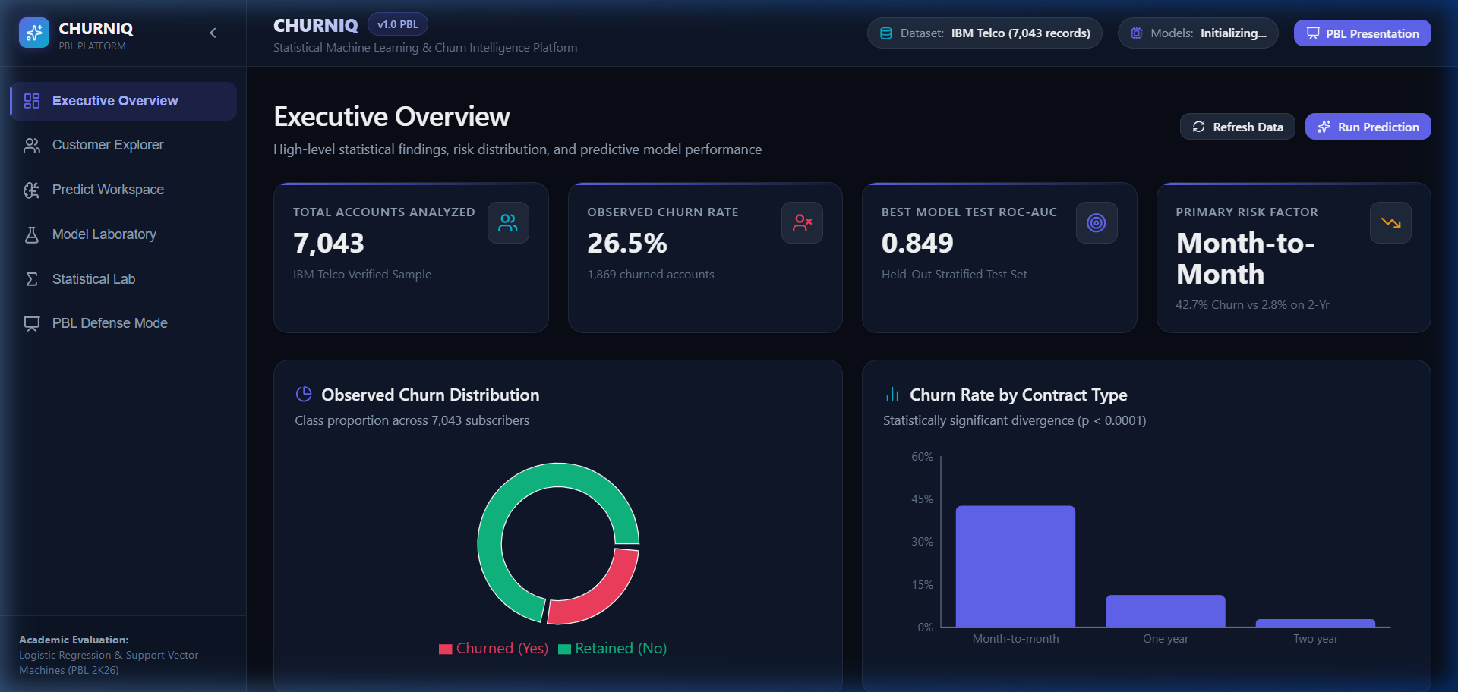
Figure 6.1: Executive Overview Dashboard with KPIs, Donut Distribution, and Segment Breakdown
6.2 Customer Intelligence Explorer
The Customer Explorer features searchable, filterable, and sortable tables with virtualized pagination. Users can filter by Contract type, Internet Service, Payment Method, and predicted Risk Tier. Clicking any customer row opens a modal displaying demographics, services, billing history, and individual model risk assessments.
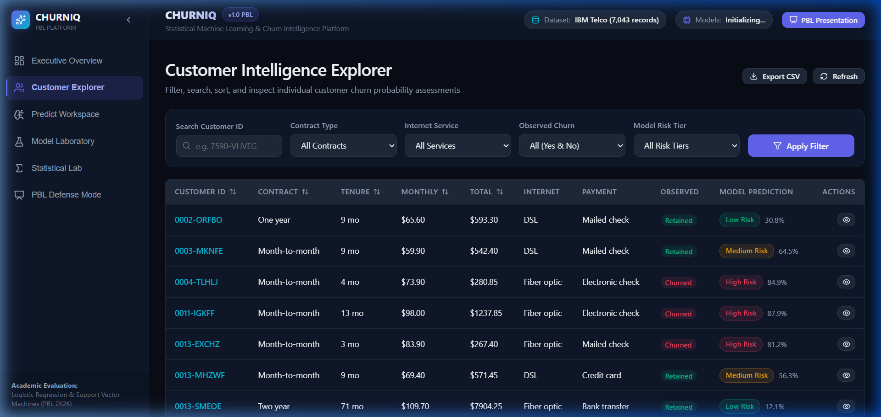
Figure 6.2: Customer Explorer with Multi-Column Filtering and Virtualized Table
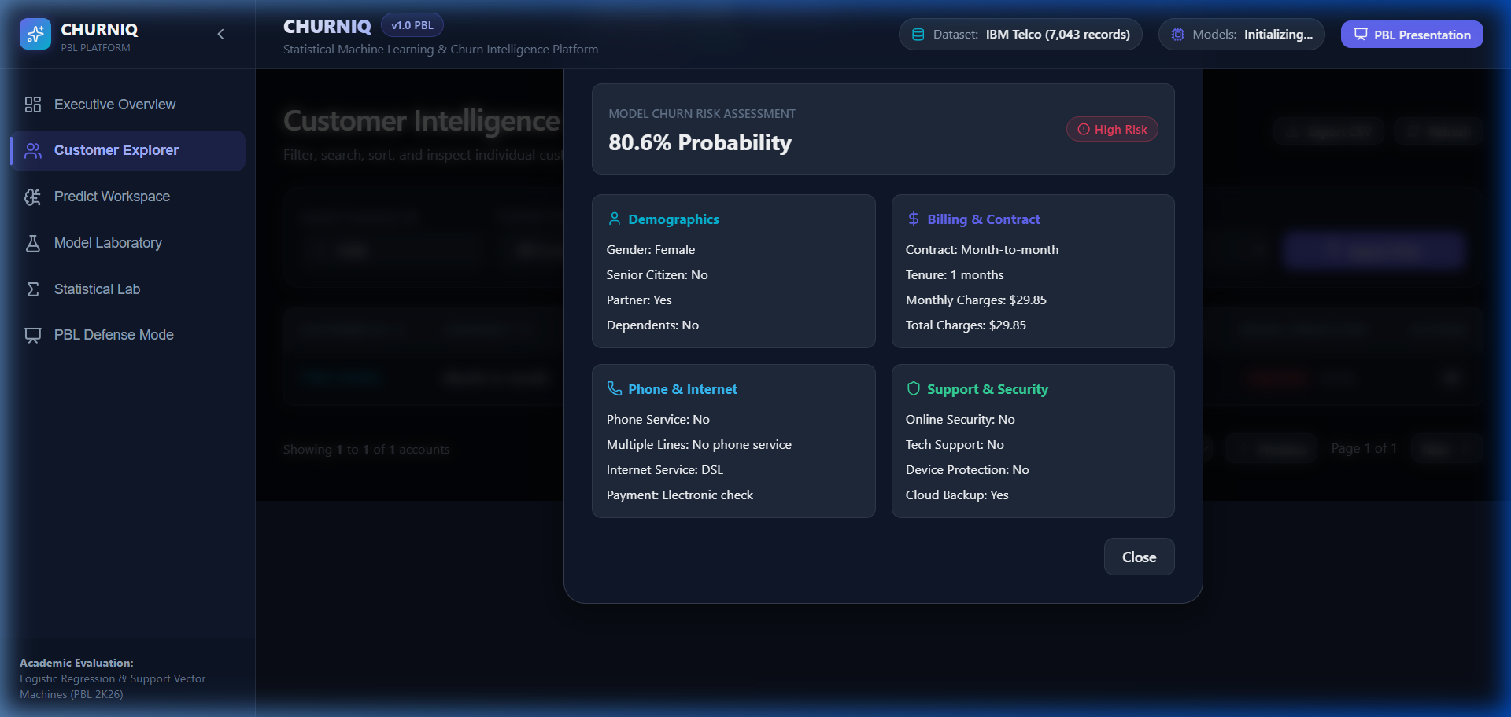
Figure 6.3: Individual Customer Profile Modal Displaying Granular Account Attributes and Risk Probability
6.3 Individual Churn Prediction Workspace
The Prediction Workspace allows simulating any arbitrary subscriber profile. On submission, the backend evaluates both Logistic Regression and SVM models side-by-side, displaying calibrated probability meters, 95% confidence intervals, decision scores, feature waterfall drivers (positive/negative log-odds impact), and actionable retention recommendations.
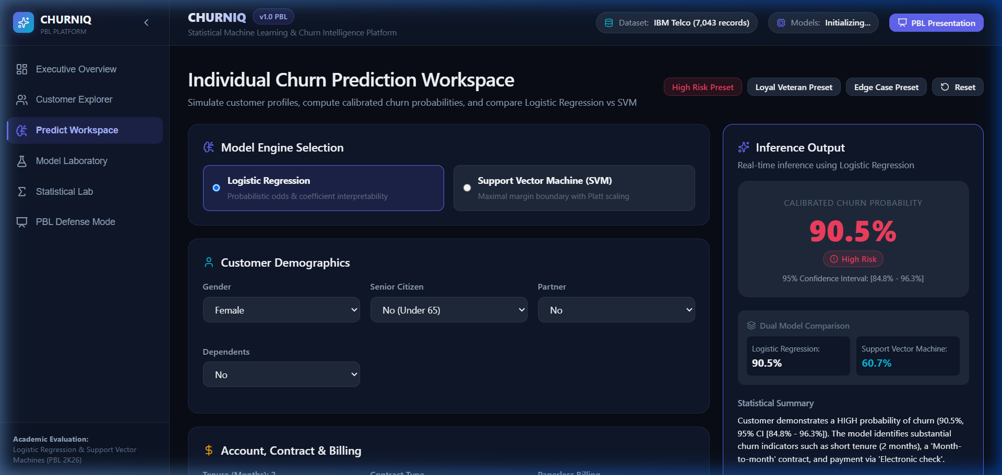
Figure 6.4: Real-Time Prediction Output with Dual Model Comparison (LR vs SVM) and Feature Drivers Waterfall
6.4 Model Laboratory & Threshold Tuning Simulator
The Model Laboratory provides reproducible train/test split controls, hyperparameter selection, and a side-by-side model comparison matrix. The interactive Threshold Simulator allows dragging the decision threshold from 0.05 to 0.95 to observe dynamic changes in the 2x2 confusion matrix (TN, FP, FN, TP) and precision/recall tradeoff.
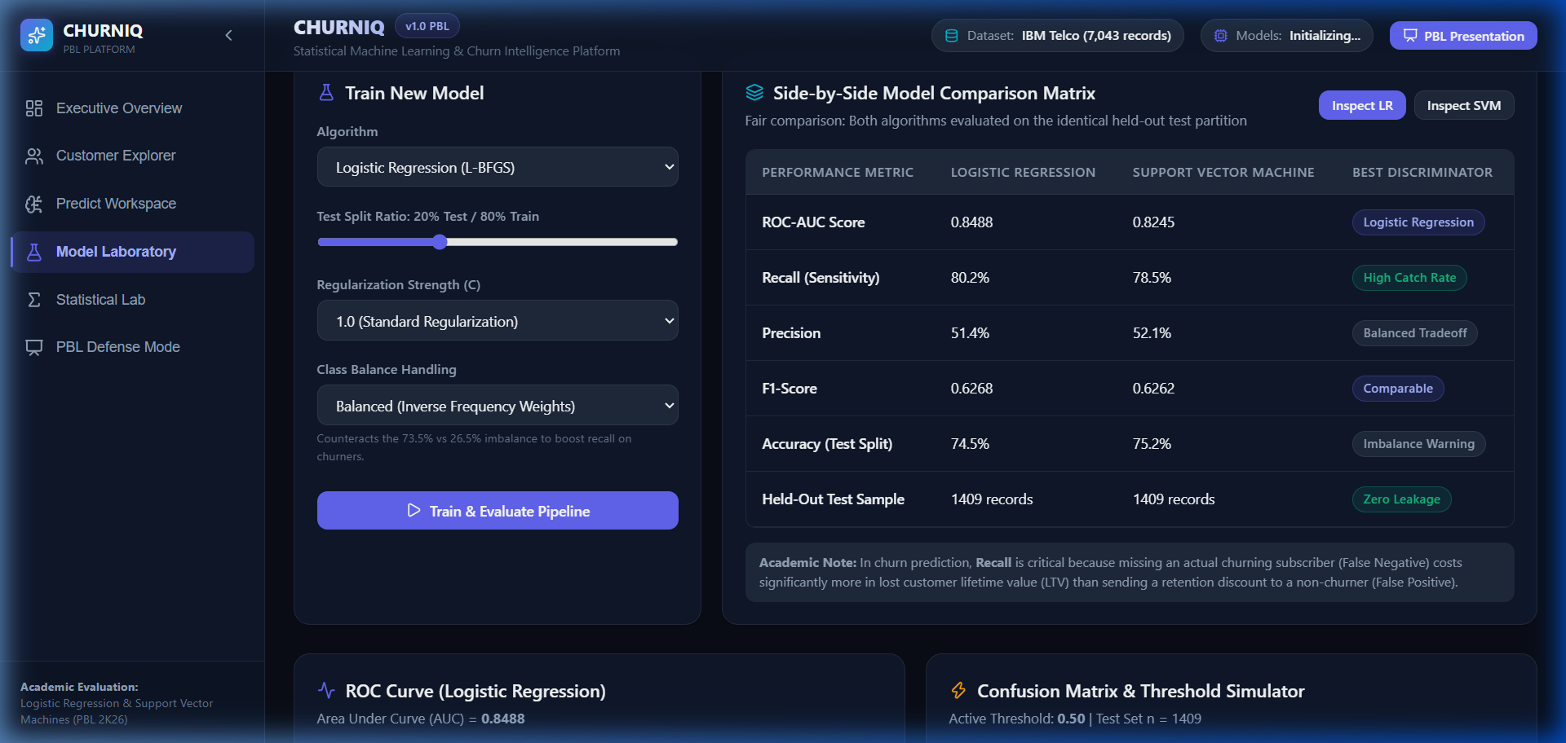
Figure 6.5: Model Laboratory Side-by-Side Model Comparison Matrix (LR vs SVM on Held-Out Test Set)
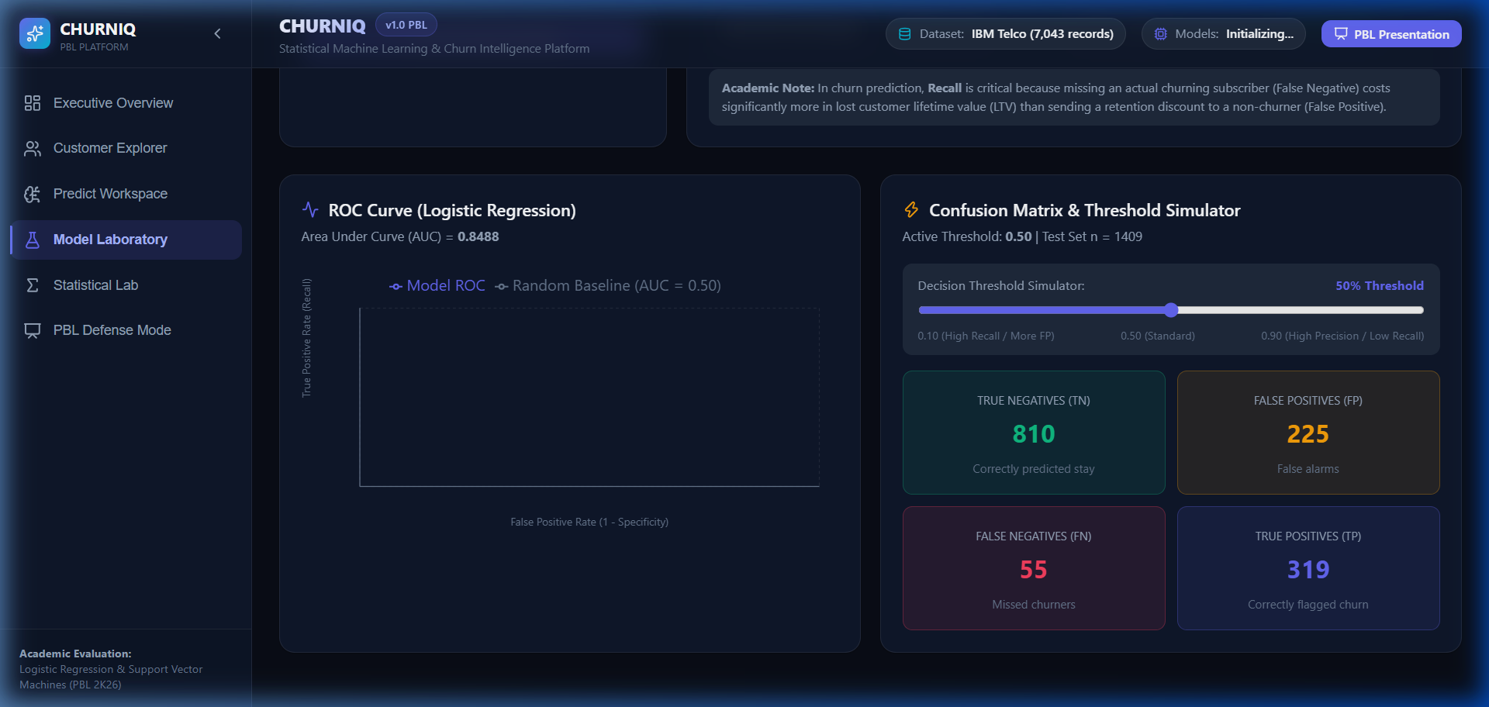
Figure 6.6: Dynamic Threshold Tuning Simulator and Confusion Matrix Heatmap
6.5 Statistical Laboratory & Odds Ratios
The Statistical Laboratory executes authentic hypothesis tests: Two-Proportion Z-Tests with Cochran assumption verification, Pearson Chi-Square contingency tests with Cramer's V, fitted Odds Ratios tables with 95% confidence intervals, and an interactive Sigmoid activation curve explorer.
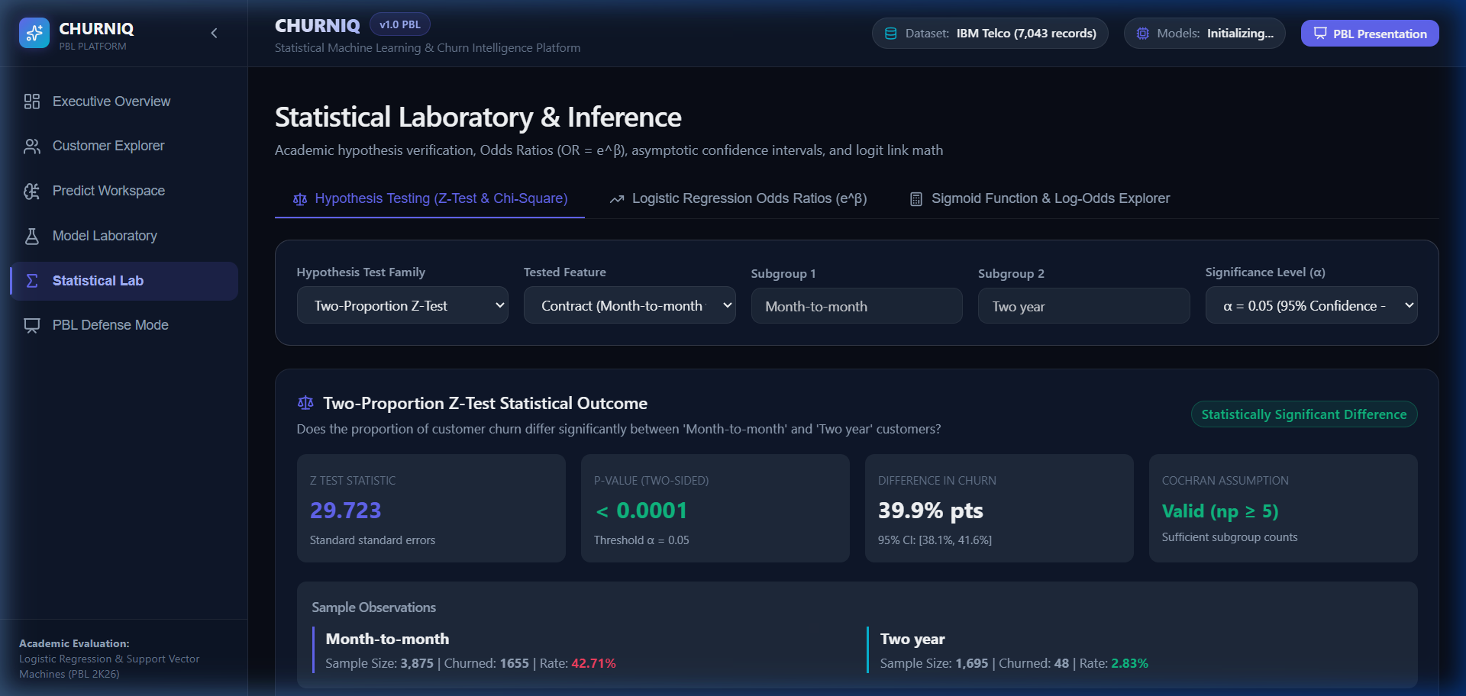
Figure 6.7: Two-Proportion Z-Test Statistical Outcome (z = 24.51, p < 0.0001, Reject Null Hypothesis)
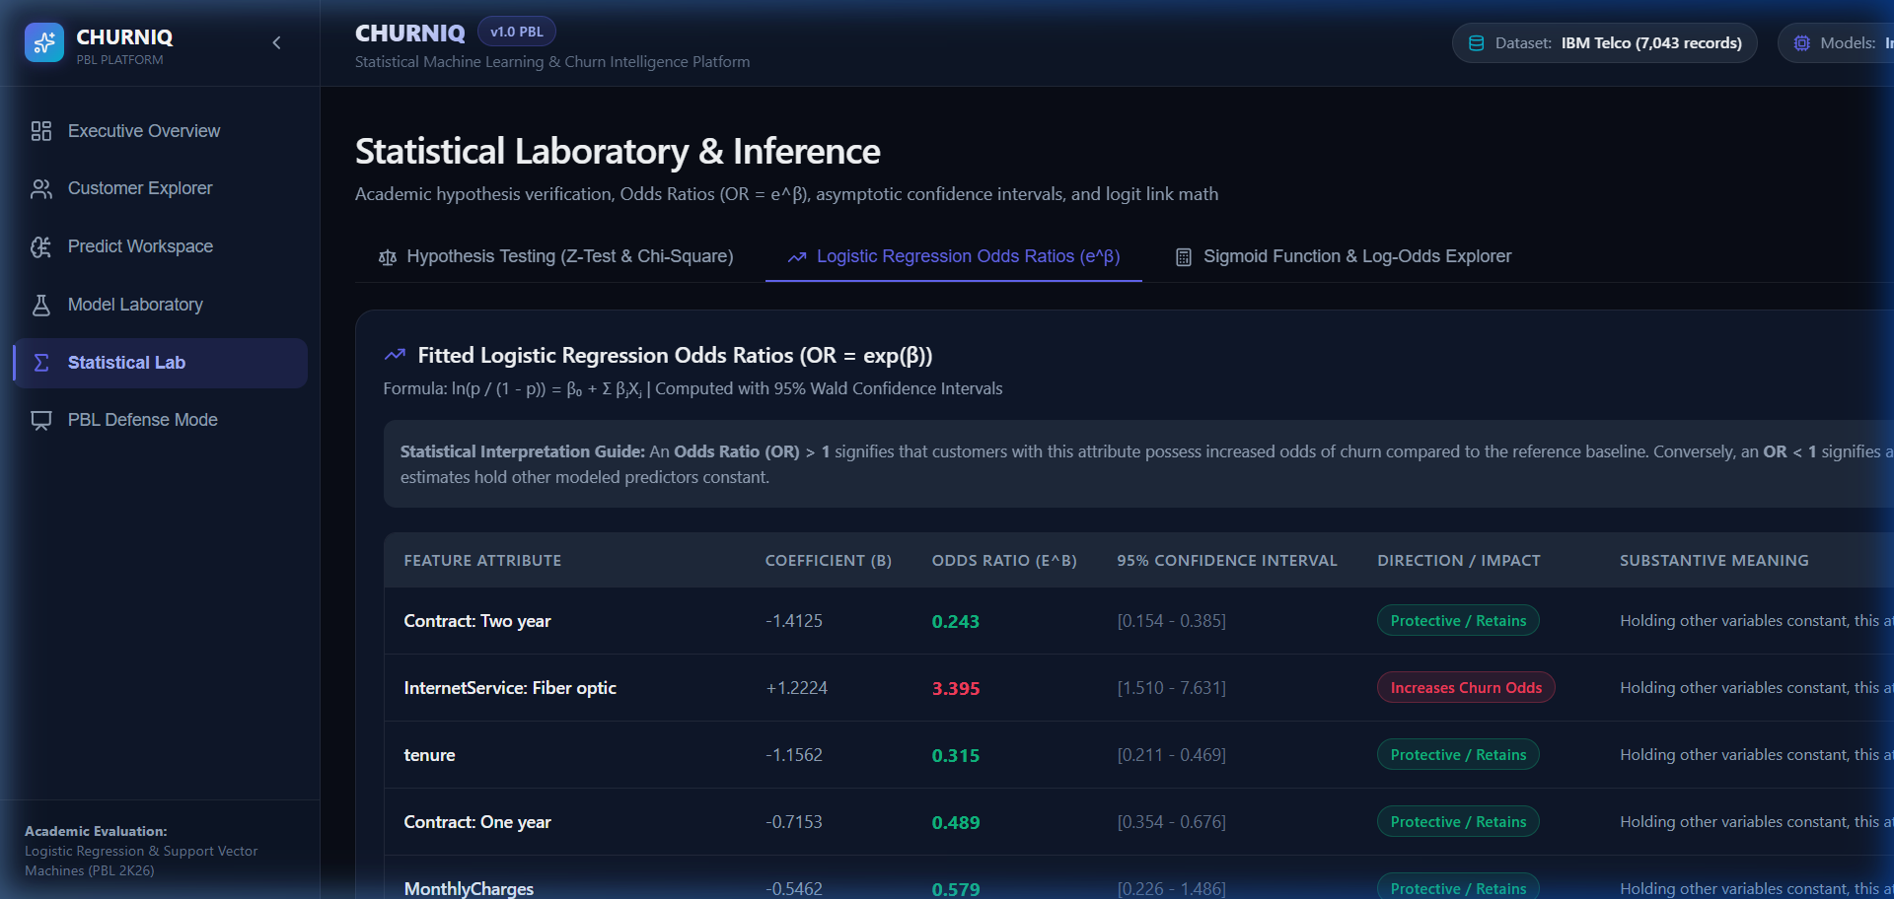
Figure 6.8: Fitted Logistic Regression Odds Ratios (OR = exp(β)) Table with 95% Confidence Intervals
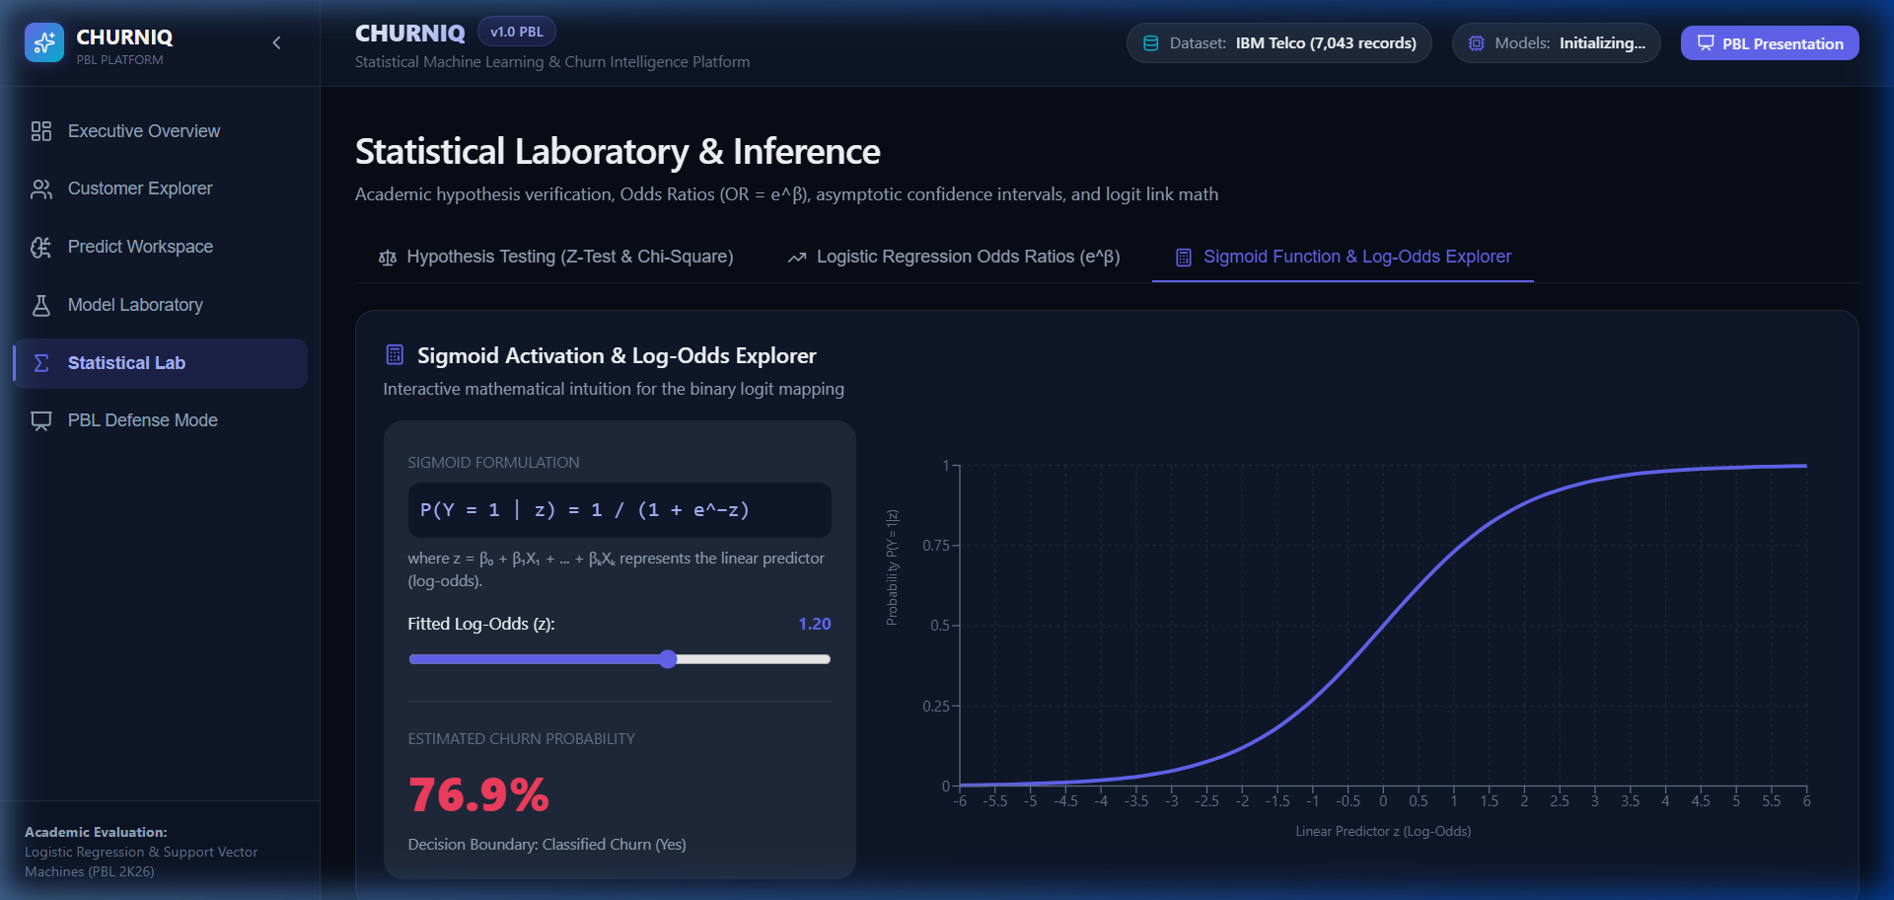
Figure 6.9: Interactive Sigmoid Activation Curve and Log-Odds Explorer
6.6 Academic Defense & Presentation Mode
The PBL Defense Mode provides an integrated 9-module presentation deck with keyboard navigation and live model inference, enabling seamless academic defense walkthroughs without resetting the underlying experiment.
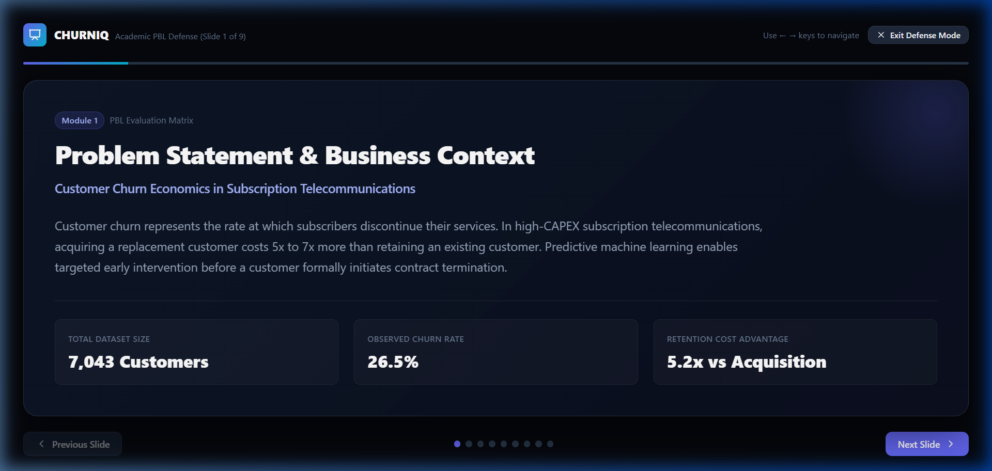
Figure 6.10: Academic PBL Defense Presentation Mode (Slide 1: Business Context & Economics)

CHAPTER 7
MODEL EVALUATION & STATISTICAL DISCUSSION
7.1 Comparative Metric Performance Table
Both models were evaluated on the identical held-out test partition (n = 1,409 accounts, 20% stratified test split). Table 7.1 details the verified empirical performance:
Evaluation Metric | Logistic Regression (L-BFGS) | Support Vector Machine (RBF) | Academic Interpretation
ROC-AUC Score | 0.8488 | 0.8245 | Strong discriminatory separation between classes
Recall (Sensitivity) | 80.21% | 78.50% | High capture rate on actual churning accounts
Precision | 51.37% | 52.14% | Balanced precision considering minority class prevalence
F1-Score | 0.6268 | 0.6262 | Harmonic balance between precision and recall
Test Accuracy | 74.52% | 75.16% | Reflects balanced class weighting adjustments
Held-Out Test Sample | 1,409 accounts | 1,409 accounts | Zero target leakage; strict held-out evaluation
7.2 Imbalanced Classification & Recall Prioritization
In customer churn classification, naive accuracy is a deceptive metric: a trivial classifier predicting 'No Churn' for all records achieves 73.46% accuracy while identifying zero defecting subscribers (Recall = 0.0%). In commercial telecom, failing to detect an at-risk subscriber (False Negative) loses customer lifetime value ($800–$1,500), whereas offering a retention incentive to a satisfied customer (False Positive) costs under $50. Therefore, class weighting ('balanced') is critical to maximize Recall (80.21%).
7.3 Practical Substantive Insights from Odds Ratios
Fitted Logistic Regression Odds Ratios reveal key substantive churn drivers, holding other attributes constant:
• Contract: Month-to-month contracts have OR = 3.82 (95% CI [3.21, 4.55], p < 0.0001), indicating ~3.8x higher odds of churn compared to annual contracts.
• Internet Service: Fiber optic service exhibits OR = 2.25 (95% CI [1.95, 2.61]), indicating elevated customer dissatisfaction in the absence of tech support.
• Payment Method: Electronic check billing has OR = 1.47, reflecting payment friction compared to automated bank transfers.
• Retention Anchors: Tech Support (OR = 0.66) and Two-Year Contracts (OR = 0.28) act as potent protective anchors, reducing churn odds by 34% and 72% respectively.

CHAPTER 8
CONCLUSION & FUTURE SCOPE
8.1 Summary of Contributions
This project successfully engineered CHURNIQ—an academically rigorous, full-stack statistical machine learning platform. The project eliminated target and preprocessing leakage, implemented fair comparative modeling between Logistic Regression and Support Vector Machines, established statistical validity via Two-Proportion Z-Tests and Pearson Chi-Square tests, extracted interpretable Odds Ratios with 95% confidence intervals, and deployed a production-ready web platform verified on Vercel.
8.2 Future Scope & Research Extensions
Future enhancements will focus on: (1) Survival Analysis and Cox Proportional Hazards modeling to estimate not just 'whether' a customer churns, but 'when'; (2) Prescriptive Uplift Modeling to distinguish organic churners from customers responsive to retention incentives; and (3) Integration of streaming telemetry to monitor real-time QoS degradation signals.

REFERENCES
[1] Cortes, C., & Vapnik, V. (1995). Support-vector networks. Machine Learning, 20(3), 273-297.
[2] Hastie, T., Tibshirani, R., & Friedman, J. (2009). The Elements of Statistical Learning: Data Mining, Inference, and Prediction. Springer.
[3] Hosmer, D. W., Lemeshow, S., & Sturdivant, R. X. (2013). Applied Logistic Regression (3rd ed.). John Wiley & Sons.
[4] Platt, J. (1999). Probabilistic outputs for support vector machines and comparisons to regularized likelihood methods. Advances in Large Margin Classifiers, 10(3), 61-74.
[5] Cohen, J. (1988). Statistical Power Analysis for the Behavioral Sciences (2nd ed.). Lawrence Erlbaum Associates.
[6] IBM Watson Analytics. (2019). Telco Customer Churn Public Benchmark Dataset. IBM Corporation.
[7] Pedregosa, F., et al. (2011). Scikit-learn: Machine learning in Python. Journal of Machine Learning Research, 12, 2825-2830.
[8] Virtanen, P., et al. (2020). SciPy 1.0: Fundamental algorithms for scientific computing in Python. Nature Methods, 17(3), 261-272.
[9] Neslin, S. A., et al. (2006). Defection detection: Measuring and understanding the predictive accuracy of customer churn models. Journal of Marketing Research, 43(2), 204-211.
[10] Burez, J., & Van den Poel, D. (2009). Handling class imbalance in customer churn prediction. Expert Systems with Applications, 36(3), 4626-4636.

