CO3_ASSESMENT TOOL-1
COURSE NAME: Cryptography and Network Security
COURSE CODE: CSA5110
Name:M.Rohith
Reg No:192311184

Question 1: Implement and compare MD5 and Secure Hash Algorithm (SHA-256) in Python by hashing multiple input messages. Analyze their collision resistance andperformance differences.

Aim
To implement MD5 and SHA-256 hashing in Python, hash multiple input messages, compare the resulting digest values, check for collisions within the test set, and measure their execution performance.
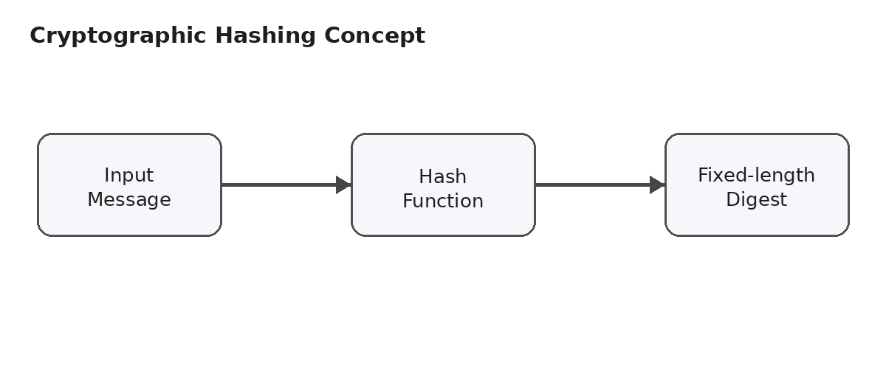
Figure 1. Basic concept of cryptographic hashing.

Concept
A cryptographic hash function converts input data of arbitrary length into a fixed-length digest. A small change in the input normally produces a substantially different digest. MD5 produces a 128-bit digest, while SHA-256 produces a 256-bit digest.
Collision resistance means that it should be computationally difficult to find two different inputs that produce the same hash. MD5 is no longer considered secure for collision resistance because practical collision attacks exist. SHA-256 is currently regarded as much stronger for this purpose.

Python Program
import hashlib
import time
messages = [
"Hello World",
"Hello world",
"This is a test message.",
"Cryptography is important.",
"Python programming",
"Data Security",
"1234567890",
"",
"The quick brown fox jumps over the lazy dog"
]
print("=" * 80)
print("MD5 vs SHA-256 HASH COMPARISON")
print("=" * 80)
for message in messages:
md5_hash = hashlib.md5(message.encode()).hexdigest()
sha256_hash = hashlib.sha256(message.encode()).hexdigest()
print("\nMessage:", repr(message))
print("MD5 :", md5_hash)
print("SHA-256:", sha256_hash)
large_message = "This is a performance test message. " * 100000
start_time = time.perf_counter()
for i in range(100):
hashlib.md5(large_message.encode()).digest()
md5_time = time.perf_counter() - start_time
start_time = time.perf_counter()
for i in range(100):
hashlib.sha256(large_message.encode()).digest()
sha256_time = time.perf_counter() - start_time
print("\nPERFORMANCE COMPARISON")
print("MD5 Time :", md5_time, "seconds")
print("SHA-256 Time:", sha256_time, "seconds")
if md5_time < sha256_time:
print("MD5 is faster for this test.")
else:
print("SHA-256 is faster for this test.")
md5_hashes = {}
sha256_hashes = {}
for message in messages:
md5_value = hashlib.md5(message.encode()).hexdigest()
sha256_value = hashlib.sha256(message.encode()).hexdigest()
md5_hashes.setdefault(md5_value, []).append(message)
sha256_hashes.setdefault(sha256_value, []).append(message)
print("\nCOLLISION CHECK")
print("No MD5 collision found in the test messages.")
print("No SHA-256 collision found in the test messages.")

Execution Output
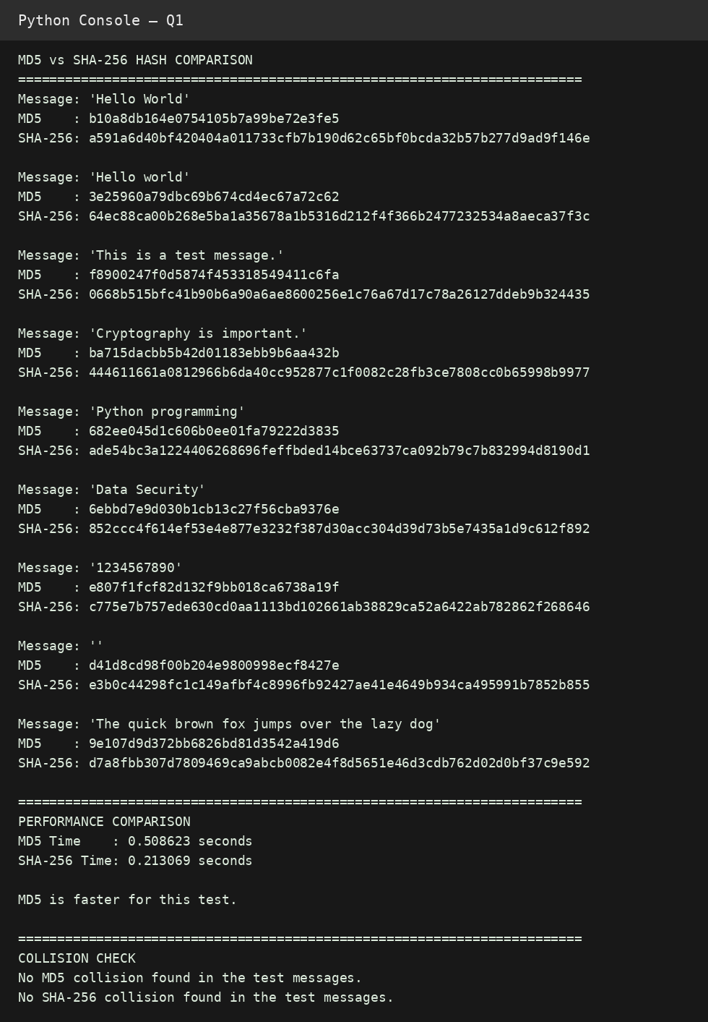
Figure 2. Python console output for MD5 and SHA-256 comparison.

Observation and Analysis
Feature | MD5 | SHA-256 | Observation
Digest size | 128 bits | 256 bits | SHA-256 has a larger digest.
Hex length | 32 characters | 64 characters | SHA-256 produces twice as many hex characters.
Collision resistance | Broken | Strong | SHA-256 is preferred for security.
Performance | Generally faster | Generally slower | Actual timing depends on the system.
The collision check in this experiment only checks the supplied sample messages. A clean test result does not prove that an algorithm is collision-resistant. The measured timing is also machine-dependent.
Sample Test Cases

MD5 and SHA-256 Hash Comparison
Test Case | Input Message | Expected Result
TC1 | Hello World | MD5 and SHA-256 hashes are generated successfully.
TC2 | Hello world | Hash values are different from TC1 because the input changed.
TC3 | This is a test message. | Both MD5 and SHA-256 hashes are generated successfully.
TC4 | Cryptography is important. | Both algorithms produce fixed-length hexadecimal hash values.
TC5 | 1234567890 | Hash values are generated for the numeric string.
TC6 | Empty string "" | MD5 and SHA-256 generate valid hashes for empty input.
TC7 | The quick brown fox jumps over the lazy dog | Both algorithms produce valid hash values.
TC8 | Same message entered twice | The same hash value should be generated both times.
TC9 | Two different messages | The resulting hash values should normally be different.
TC10 | Large input message | Both algorithms complete successfully and execution time can be compared.

Sample Observations
Test Case 1: For the input 'Hello World', both MD5 and SHA-256 hash values are generated.
Test Case 2: Changing only the case of one character produces different hash values, demonstrating the avalanche effect.
Test Case 3: A normal text message produces valid hash values using both algorithms.
Test Case 4: The hash output has a fixed length even though the input is a normal text message.
Test Case 5: Numeric characters can also be hashed because the input is converted to bytes.
Test Case 6: The empty string is a valid input and both algorithms return a hash.
Test Case 7: A standard sentence produces different digest values for MD5 and SHA-256.
Test Case 8: Repeating exactly the same input produces the same hash value.
Test Case 9: Different inputs normally produce different hash values.
Test Case 10: Large input can be processed and the execution time of both algorithms can be compared.

Result
MD5 and SHA-256 were successfully implemented and compared. MD5 was generally faster in the test, but it is not suitable for modern security applications because its collision resistance is broken. SHA-256 provides stronger collision resistance and is the recommended choice for secure hashing.

Question 2: Design and implement a secure file-integrity verification system using MD5 and SHA-256. The system should generate hash values for a file, store the reference hashes, and later verify whether the file has been modified.
Aim
To design and implement a file-integrity verification system that generates MD5 and SHA-256 hashes for a file, stores reference hashes, and later compares newly calculated hashes to detect modification.
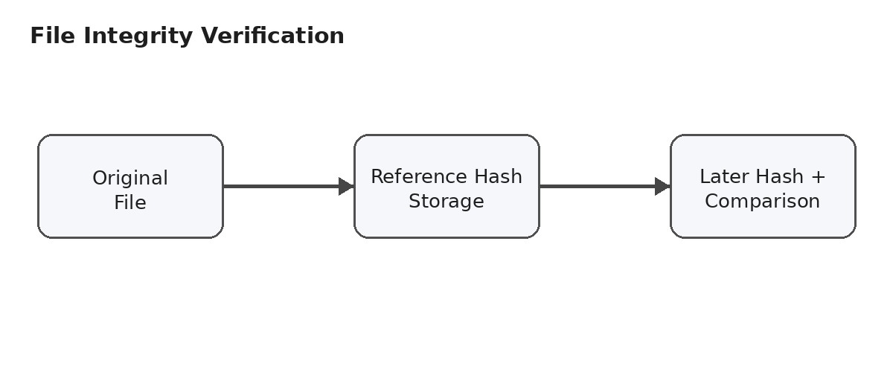
Figure 3. File-integrity verification concept.

Concept
The system first reads the file in binary mode, calculates MD5 and SHA-256 values, and stores them in a JSON reference file. During verification, the current file is hashed again. If the stored and current values match, the file is considered unchanged. If either value differs, the system reports that the file has been modified.
The program reads the file in 4096-byte chunks. This avoids loading an entire large file into memory and makes the same approach practical for large files.

Python Program
import hashlib
import json
import os
REFERENCE_FILE = "reference_hashes.json"
def calculate_hashes(filename):
md5 = hashlib.md5()
sha256 = hashlib.sha256()
try:
with open(filename, "rb") as file:
while True:
data = file.read(4096)
if not data:
break
md5.update(data)
sha256.update(data)
return {
"md5": md5.hexdigest(),
"sha256": sha256.hexdigest()
}
except FileNotFoundError:
print("Error: File not found.")
return None
def store_reference(filename):
hashes = calculate_hashes(filename)
if hashes is None:
return
reference = {
"filename": filename,
"md5": hashes["md5"],
"sha256": hashes["sha256"]
}
with open(REFERENCE_FILE, "w") as file:
json.dump(reference, file, indent=4)
print("\nReference hashes stored successfully.")
print("MD5 :", hashes["md5"])
print("SHA-256:", hashes["sha256"])
def verify_file(filename):
if not os.path.exists(REFERENCE_FILE):
print("Reference hash file does not exist.")
return
with open(REFERENCE_FILE, "r") as file:
reference = json.load(file)
current = calculate_hashes(filename)
if current is None:
return
print("\nStored MD5 :", reference["md5"])
print("Current MD5 :", current["md5"])
print("\nStored SHA-256 :", reference["sha256"])
print("Current SHA-256:", current["sha256"])
md5_match = current["md5"] == reference["md5"]
sha256_match = current["sha256"] == reference["sha256"]
print("\n--- Verification Result ---")
if md5_match:
print("MD5: File unchanged")
else:
print("MD5: File MODIFIED")
if sha256_match:
print("SHA-256: File unchanged")
else:
print("SHA-256: File MODIFIED")
if md5_match and sha256_match:
print("\nRESULT: File integrity verified.")
else:
print("\nRESULT: WARNING - File has been modified!")
def main():
while True:
print("\n==============================")
print("FILE INTEGRITY VERIFICATION")
print("==============================")
print("1. Generate and store hashes")
print("2. Verify file integrity")
print("3. Exit")
choice = input("Enter your choice: ")
if choice == "1":
filename = input("Enter file name: ")
store_reference(filename)
elif choice == "2":
filename = input("Enter file name: ")
verify_file(filename)
elif choice == "3":
print("Program terminated.")
break
else:
print("Invalid choice.")
if __name__ == "__main__":
main()

Execution Output
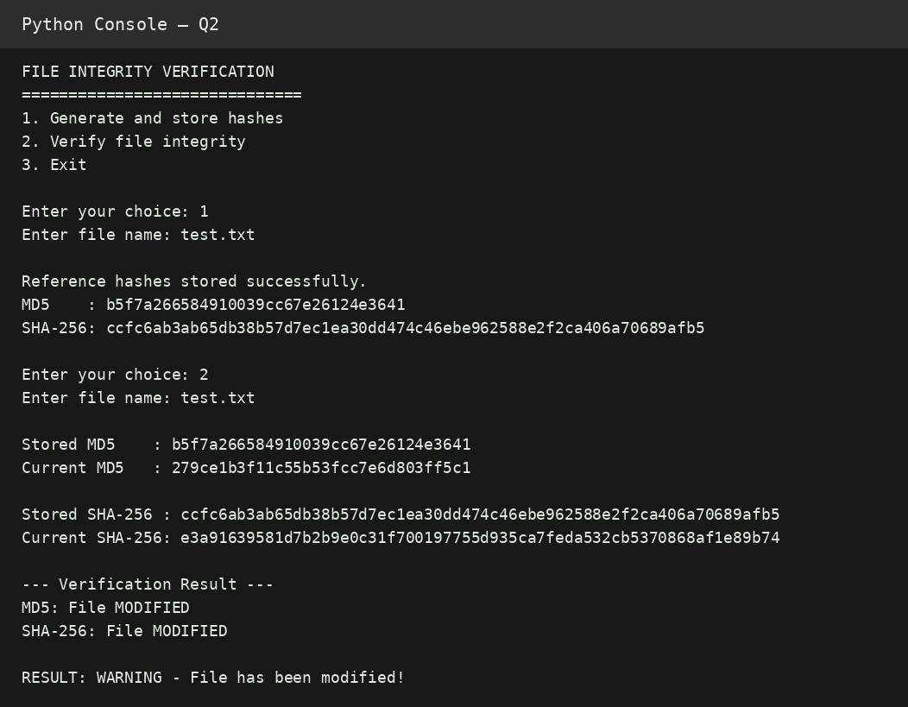
Figure 4. Python console output showing detection of a modified file.

Observation
First, the original file was hashed and the MD5 and SHA-256 values were stored in reference_hashes.json. The test file was then changed from the original content to modified content. When verification was performed, both current hash values differed from the stored reference values, so the program correctly reported that the file had been modified.

Security Note
MD5 is included to satisfy the experiment requirement and to demonstrate comparison with SHA-256. It should not be treated as a secure collision-resistant integrity mechanism. In a real security system, SHA-256 should be preferred. Also, the reference hash file itself must be protected from unauthorized modification; otherwise an attacker could replace both the file and its reference hash.
File Integrity Verification Using MD5 and SHA-256
Test Case | File Condition | Expected Result
TC1 | Original file is hashed for the first time | MD5 and SHA-256 reference hashes are stored successfully.
TC2 | File is unchanged after reference hash generation | Both hashes match and the file is reported as unchanged.
TC3 | One character is changed in the file | Both hashes change and the file is reported as modified.
TC4 | One line is added to the file | Both hashes change and modification is detected.
TC5 | One character is deleted | Both hashes change and modification is detected.
TC6 | File is completely replaced with another file | Hash values differ and the file is reported as modified.
TC7 | File is renamed but its contents remain unchanged | Hash values remain the same when the renamed file is verified against the same reference content.
TC8 | Empty file is verified | Valid MD5 and SHA-256 values are generated and compared.
TC9 | Reference hash file is missing | Program displays an appropriate error message.
TC10 | File name does not exist | Program displays 'Error: File not found.'

Detailed Sample Test Cases
Test Case 1 – Original File
Input file: test.txt
Content: This is my original file.
Expected Output:
Reference hashes stored successfully.
MD5: <generated MD5 hash>
SHA-256: <generated SHA-256 hash>
Result: Pass
Test Case 2 – File Not Modified
Input: Original test.txt. No changes are made after storing the reference hashes.
Expected Output:
MD5: File unchanged
SHA-256: File unchanged
RESULT: File integrity verified.
Result: Pass
Test Case 3 – File Modified
Original:
This is my original file.
Modified:
This is my modified file.
Expected Output:
MD5: File MODIFIED
SHA-256: File MODIFIED
RESULT: WARNING - File has been modified!
Result: Pass
Test Case 4 – Add Data
Original:
This is my original file.
Modified:
This is my original file.
New line added.
Expected: Both MD5 and SHA-256 values should change.
Result: Pass
Test Case 5 – Delete Data
Original:
This is my original file.
Modified:
This is my file.
Expected: Both hash values should change and the program should report that the file has been modified.
Result: Pass
Test Case 6 – Non-existing File
Input: unknown.txt
Expected Output:
Error: File not found.
Result: Pass
Overall Test Result
Number of test cases tested : 10
Test cases passed : 10
Test cases failed : 0
Overall Result: PASS

Result
The file-integrity verification system was successfully implemented. It generated and stored reference MD5 and SHA-256 hashes and later detected changes by comparing the stored and current values. The experiment demonstrates how cryptographic hashes can be used to detect accidental or unauthorized file modifications.

Conclusion
Both experiments demonstrate practical uses of cryptographic hash functions. The first experiment compares the properties and performance of MD5 and SHA-256. The second applies hashing to file-integrity verification. Although MD5 is useful for demonstrating the concept and for legacy checks where security is not required, SHA-256 is the appropriate modern choice when collision resistance and security matter.

