Hillside Village Overlook, Unity Week 1

Hillside Village Overlook, Unity Week 1
Unity 6000.4.7f1 · Built-In Render Pipeline · Windows
A single 3D scene built for Week 1 of the Unity internship: a sculpted terrain valley with a village strung along a dirt road, forested slopes rising to rocky peaks, a lake, a campsite and parked vehicles. Everything in the scene is generated by a committed Editor tool, so the whole result is reproducible from source.
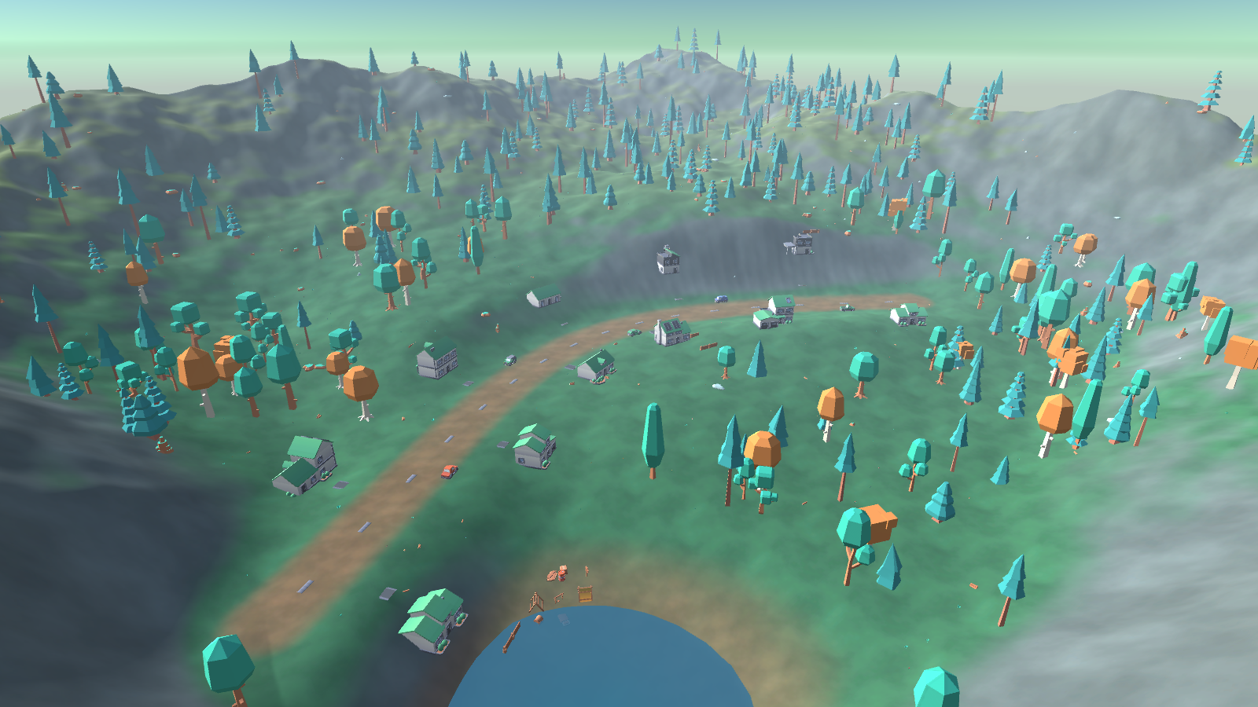
Valley vista

1. Opening the project
- Open Unity Hub → Add → select the Week1_HillsideVillage folder.
- Open with Unity 6000.4.7f1. First import takes about a minute.
- Open Assets/_Project/Scenes/HillsideVillage.unity.
- Press Play, the camera slowly orbits the village. Left/right arrows nudge the orbit.
To regenerate the scene from scratch: Tools → Week 1 → Build Hillside Village Scene. This wipes the current scene and rebuilds it deterministically.

2. Folder structure
Week1_HillsideVillage/
├─ Assets/
│ ├─ _Project/ ← all first-party work
│ │ ├─ Art/
│ │ │ ├─ Materials/ M_Sky_Afternoon, M_Water
│ │ │ └─ Textures/Terrain/ T_GrassMeadow, T_GrassDry, T_DirtPath, T_RockCliff
│ │ ├─ Prefabs/
│ │ ├─ Scenes/ HillsideVillage.unity
│ │ ├─ Scripts/
│ │ │ ├─ Editor/ SceneBuilder.cs (editor-only tool)
│ │ │ └─ Runtime/ OrbitCameraController.cs (ships in a build)
│ │ ├─ Settings/
│ │ └─ Terrain/
│ │ ├─ Layers/ TL_*.terrainlayer
│ │ └─ HillsideTerrain.asset
│ └─ ThirdParty/ ← external assets, quarantined
│ ├─ Kenney_NatureKit/
│ ├─ Kenney_CityKitSuburban/
│ ├─ Kenney_SurvivalKit/
│ ├─ Kenney_CarKit/
│ └─ LICENSES.md
├─ Docs/ report, PDF, screenshots
├─ Tools/ gen_terrain_textures.py
└─ README.md

The conventions, and why
_Project/ versus ThirdParty/ is the important split. Everything I wrote lives under _Project/; everything downloaded lives under ThirdParty/. This matters in practice: when a third-party pack needs updating, you delete and replace one folder without ever touching your own work, and in code review the diff makes it obvious which changes are yours. The leading underscore sorts _Project to the top of the Project window, above the alphabetical third-party folders.
Scripts/Editor/ versus Scripts/Runtime/ is not cosmetic. Unity treats any folder named Editor specially: its contents compile into a separate editor-only assembly and are excluded from builds. SceneBuilder.cs uses UnityEditor APIs, so a build would fail to compile if it sat anywhere else. OrbitCameraController.cs runs in the game, so it must not be in Editor/.
Prefixes name the type, so assets sort by kind: T_ textures, M_ materials, TL_ terrain layers. Folders are PascalCase, matching Unity’s own conventions.

3. Assets
Pack | Author | Licence | Models used
Nature Kit | Kenney | CC0 | 47
City Kit (Suburban) | Kenney | CC0 | 17
Survival Kit | Kenney | CC0 | 10
Car Kit | Kenney | CC0 | 8
Four distinct free packs, against a required minimum of three. Full attribution and source URLs are in Assets/ThirdParty/LICENSES.md.
I chose CC0 deliberately. CC0 is public-domain dedication with no attribution requirement and no restrictions, so there is nothing to get wrong. The packs are also stylistically consistent with one another, flat-shaded low-poly with a shared palette, which matters more for a coherent scene than any individual model’s quality.
Only the models the scene actually uses are committed (82 of 499), and only in FBX, since each pack ships the same geometry five times over in FBX, OBJ, GLB, DAE and STL.

Terrain textures are generated, not downloaded
My first plan was photoreal CC0 ground textures from ambientCG. I abandoned that after thinking about it: photographic grass under flat-shaded cartoon trees looks wrong, and art-direction consistency beats per-texture fidelity. Instead Tools/gen_terrain_textures.py generates four tileable textures using colour values read out of the Kenney kits’ own .mtl files, so the ground is in the same palette as the models standing on it. The script uses tileable value-noise fBm and self-checks that each output actually tiles and is not a flat fill.

4. Scene design
The layout is built around one idea: the viewer should always be looking at something, and never at the edge of the world.
- Enclosed valley. Terrain height rises toward every map edge, so the terrain boundary is never visible from inside the playable area. This is more robust than hiding the edge with fog, which fails the moment the camera moves.
- A road as the spine. The village is not a random cluster of houses; 11 houses alternate along both sides of a curving road, each rotated to face it, each with a driveway. The road is painted into the terrain splatmap rather than built from tiles, so it follows the curve exactly.
- Height tells a story. Village on a flattened plateau, lake in a carved basin below it, forest on the mid slopes, bare rock on the peaks.
- Density varies. Tree placement is driven by noise raised to a power, producing dense stands with open meadows between, rather than an even sprinkle. Placement is excluded near houses, the road, the water, and slopes over 34°.
954 objects total: 420 trees, 130 rocks, 300 ground details, 11 houses, 6 vehicles, a campsite.
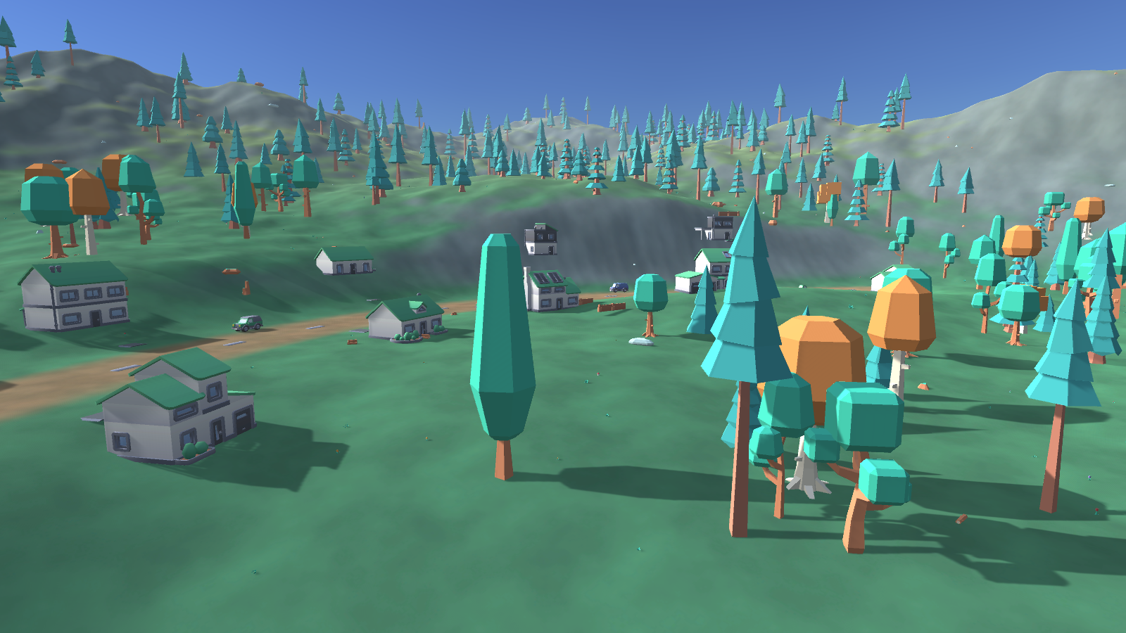
Village

5. Lighting
Realtime, no baked lightmaps:
Setting | Value | Reason
Directional light | 1.0 intensity, warm white, 34° elevation | Low afternoon sun; long shadows reveal terrain relief
Shadows | Soft, strength 0.72 | Hard shadows read badly on flat-shaded low-poly
Skybox | Skybox/Procedural, atmosphere 0.82 | Sky colour derives from the actual sun direction
Ambient | Trilight (sky / equator / ground) | Shadowed faces pick up cool skylight instead of going black
Fog | Linear, 150 → 600, pale blue | Aerial perspective; distant ridges recede
Why no lightmap bake. This scene is almost entirely static, so baking is the textbook choice. I chose not to: a full GI bake needs far more free memory than the development machine had available, and the realistic outcome was a bake that thrashed or never finished. Realtime directional lighting with Trilight ambient and fog gives a scene that reads correctly, builds in seconds, and is honest about its constraints. The static flags are all set correctly, so a bake is a one-click change if a machine with more headroom is available.
The skybox’s ground colour is set to match the fog rather than a natural brown, because at some camera angles the sky below its own horizon line is visible above the mountains, and a brown band there looks like a bug.

6. Approach: the scene is generated, not hand-placed
Assets/_Project/Scripts/Editor/SceneBuilder.cs (~480 lines) builds the entire scene: terrain heightmap, texture painting, all object placement, lighting, camera, and four rendered screenshots. It runs from the Tools menu or headlessly:
Unity.exe -projectPath <path> -batchmode -quit \
-executeMethod Week1.EditorTools.SceneBuilder.Build -logFile build.log
Placing 954 objects by hand in the Editor would have been slower, unrepeatable, and impossible to review. Generating them means the scene is a function of its source: changing one constant and re-running restyles the whole valley. A fixed random seed (20260923) makes every run identical.
Objects are placed with PrefabUtility.InstantiatePrefab, so each stays linked to its source asset rather than being copied into the scene file.

7. Problems hit, and what fixed them
These are the four that cost real time. Each was found by measuring, not by reading the code.
1, The terrain rendered solid magenta. Magenta means a missing material. The cause was my own line terrain.materialTemplate = null, written on the assumption that Unity would then supply a default. It does the opposite: Terrain.CreateTerrainGameObject already assigns Default-Terrain-Standard, and clearing it leaves no material at all.
2, Every model was microscopic. Measuring the imported bounds showed Kenney authors each kit at its own arbitrary scale, and the kits disagree with each other: a house is 1.30 units wide while a sedan is 2.55 units long. No single global scale factor can fix that. The build now derives one factor per kit from a reference model at build time, which preserves the proportions Kenney got right within a pack while correcting the mismatch between packs.
3, The terrain had straight-edged geometric terraces. My rim used Mathf.Max() of a square Chebyshev distance and a linear ramp. Both produce straight contours, and Max leaves a visible crease where they meet. Fixed by blending square and radial distance, combining with a soft union 1-(1-a)(1-b) instead of Max, and domain-warping the input coordinates with noise so no feature edge follows a straight line.
4, The splatmap silently did not persist. The hardest one, because nothing errored. The build log reported 36% rock coverage, yet the terrain rendered uniformly green. Reading the weights back off the saved asset showed the steepest point on the map, a 66° cliff, stored as 100% grass, 0% rock. The weights were computed correctly and then thrown away, because I painted the splatmap into a TerrainData that was still only in memory; AssetDatabase.CreateAsset then serialised over it. Fixed by creating the asset and assigning layers before painting. The build now reads the splatmap back and asserts the steepest ground is rock-dominant, so this cannot regress unnoticed.
The lesson common to all four: correct numbers in a log are not evidence of a correct picture. Every one of these was caught by rendering the scene to a PNG and looking at it.
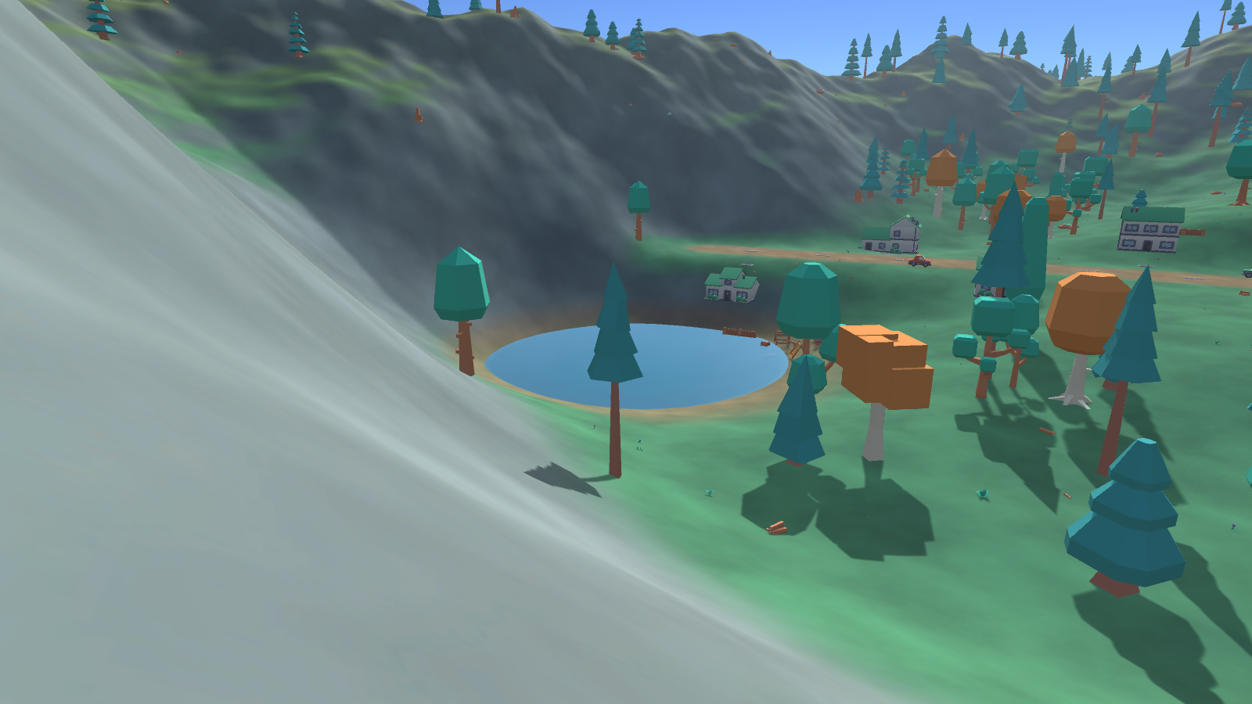
Lake

8. What is deliberately not here
No gameplay, no physics, no character controller, no post-processing stack, no custom shaders. The brief is environment setup, asset organisation and basic lighting; anything beyond that would be scope that was not asked for.
Built-In Render Pipeline, not URP. The Kenney FBX files import with Standard-shader materials, which render magenta in a URP project until run through the Render Pipeline Converter. Built-In renders them correctly on import with no conversion step, and everything this scene needs
terrain, realtime shadows, fog, procedural sky, it supports natively. URP would have added a conversion step and a class of material bugs in exchange for post-processing this scene does not use.

