Player Controller and Basic Physics, Unity Week 2

Player Controller and Basic Physics, Unity Week 2
Unity 6000.4.7f1 · Built-In Render Pipeline · Windows
A playable third person character driven by a dynamic Rigidbody, and a purpose built obstacle course that isolates one physics behaviour per obstacle. Every movement rule in the controller is covered by an automated test that measures the simulation rather than eyeballing it.
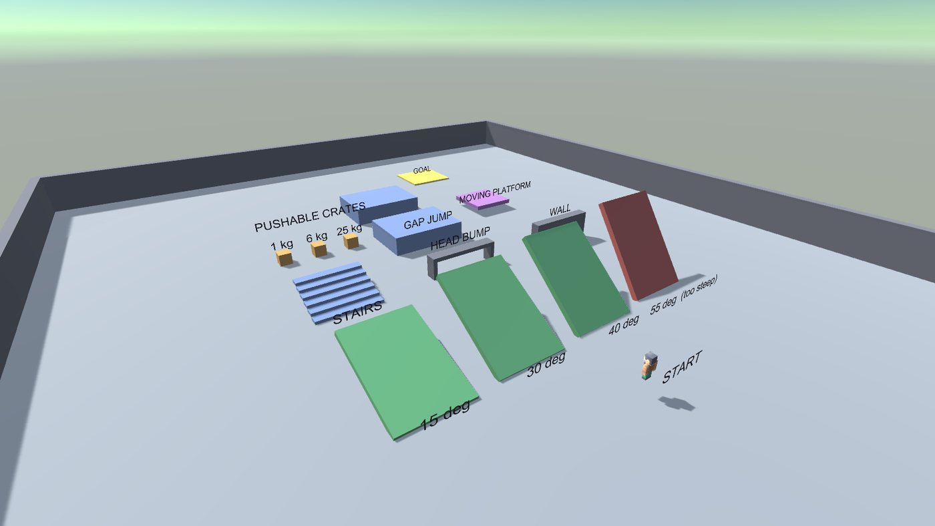
Course overview

1. Running it
- Unity Hub, Add, select the Week2_PlayerController folder, open with 6000.4.7f1.
- Open Assets/_Project/Scenes/PlayerCourse.unity.
- Press Play.
A project created from the command line does not appear in Unity Hub until you add it, and Unity opens a blank Untitled scene the first time, so step 2 matters.
Control | Action
W A S D or arrows | Move, relative to the camera
Space | Jump. Hold for a higher jump, release early to cut it short
Shift | Sprint
Mouse | Orbit the camera
F1 | Toggle the on screen readout
The readout shows live speed, vertical velocity, grounded state and the angle of the ground underfoot, so the physics is inspectable while playing.

2. Script design
Five runtime scripts and three editor scripts. Every runtime script is a single responsibility and none of them know about the editor.
Assets/_Project/Scripts/
├─ Runtime/
│ ├─ PlayerController.cs movement, ground detection, jumping, slopes
│ ├─ InputSources.cs MoveInput, IInputSource, keyboard and scripted sources
│ ├─ CharacterAnimator.cs procedural walk cycle driven by velocity
│ ├─ FollowCamera.cs damped third person orbit camera
│ ├─ MovingPlatform.cs kinematic platform that carries its rider
│ └─ ControlsHud.cs OnGUI overlay, controls plus live physics readout
└─ Editor/
├─ CourseBuilder.cs builds the whole scene deterministically
├─ PhysicsTests.cs headless behavioural test suite
└─ Screenshots.cs renders the figures in this document

The two decisions that shaped everything else
A dynamic Rigidbody, not Unity’s CharacterController component. CharacterController is the faster route to a walking character, but it deliberately bypasses the physics engine: it cannot push a rigidbody, cannot be pushed by one, and resolves its own collisions outside the solver. The brief asks for a physics simulation with gravity and collision interactions, so the player is a real Rigidbody with a CapsuleCollider and takes part in the same simulation as the crates. The cost is that every behaviour a CharacterController gives away free, ground detection, slope limits, step handling, has to be written. Sections 3 and 4 are that work.
Movement lives in a public Tick(MoveInput, float dt), not directly in FixedUpdate. This looks like an odd indirection until you try to test it. Physics.Simulate() steps the solver but does not call FixedUpdate, so a test cannot drive the controller through Unity’s normal loop at all. Exposing Tick lets the test call it and then step physics by hand:
for (int i = 0; i < steps; i++)
{
player.Tick(input.Read(), DT);
Physics.Simulate(DT);
}
FixedUpdate is then a one line caller. The same seam is why IInputSource exists: the tests substitute a ScriptedInputSource so the controller can be driven with no keyboard present.

Input edges versus physics steps
Input.GetButtonDown is true for exactly one render frame. The controller runs in FixedUpdate, which may not run on that frame, or may run twice. Reading the jump edge directly in FixedUpdate therefore drops jumps on high frame rates and double fires them on low ones.
KeyboardInputSource solves this by splitting the read: Poll() runs in Update and latches the edge, Read() runs in FixedUpdate and consumes it. That is the only reason IInputSource has two methods.

3. Physics settings, and why

On the player
Setting | Value | Reason
Rigidbody mass | 70 kg | Realistic, and it sets how hard the crates are to shove
Freeze rotation | on | The controller aims the model; physics torque would tip the capsule over
Interpolation | Interpolate | Physics runs at 50 Hz, rendering does not. Without this the player visibly stutters even though the motion is correct
Collision detection | ContinuousDynamic | At the measured terminal fall speed of 43.8 m/s the player moves 0.88 m per step against a 1 m thick floor. Discrete detection tunnels
Capsule | height 1.8, radius 0.38 | A 1.8 m person
Physics material | friction 0.02, Minimum combine | The controller writes velocity directly, so collider friction only fights it and makes the player cling to walls it brushes

In the controller
Setting | Value | Reason
Walk / sprint | 5.0 / 8.5 m/s | Brisk jog and a run
Ground accel / decel | 55 / 65 m/s squared | Reaches full speed in about 0.1 s. Lower felt sluggish, higher removed any sense of weight
Air acceleration | 16 m/s squared | Roughly a third of ground control, so a jump commits you without feeling locked
Jump height | 1.7 m | Set in metres, not as an impulse. The code solves v = sqrt(2gh), so the number means something and the test can assert against it
Coyote time | 0.12 s | Jump still fires just after walking off a ledge
Jump buffer | 0.12 s | Jump pressed just before landing is not swallowed
Fall gravity multiplier | 2.2 | Real gravity alone gives a floaty, slow descent
Low jump multiplier | 2.6 | Releasing jump early cuts the rise, giving variable height
Slope limit | 45 degrees | Below it you walk, above it you slide
Ground stick | 12 | Pushes into the ground so walking downhill does not launch you into the air every bump
Gravity is left at Unity’s default -9.81. The fall and low jump multipliers add extra acceleration on top of it rather than changing the global, so falling crates still behave normally.

Ground detection
A SphereCast straight down from the bottom of the capsule, not collision callbacks. Contact normals are noisy at edges and give a grounded flag that flickers when standing on a corner. The cast uses SphereCastNonAlloc rather than SphereCast because the cast begins inside the player’s own capsule, so the nearest hit is frequently the player, and a single result cast simply returns that. The loop skips any hit belonging to the player and keeps the closest of the rest.
Ground angle decides everything downstream: at or under 45 degrees it is walkable, above it the player is treated as airborne and gets an acceleration down the slope so they slide off.
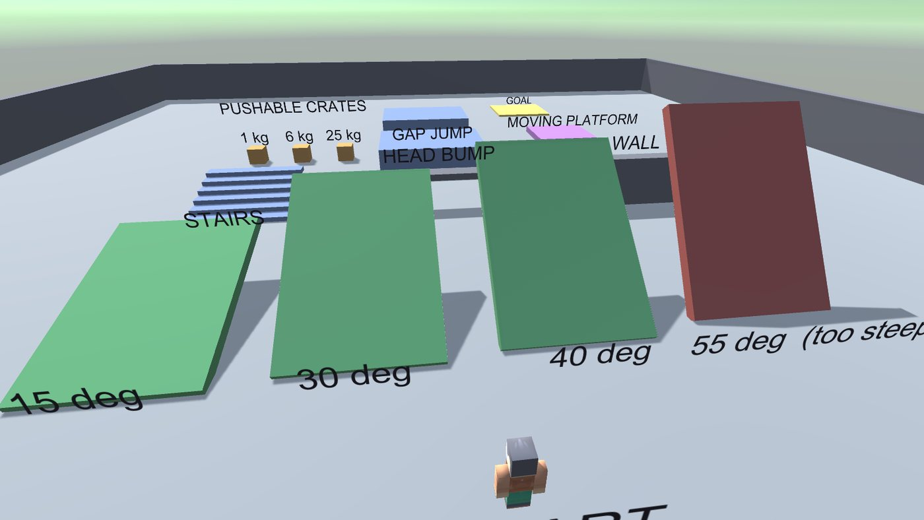
Ramps

4. Challenges

The jump only moved the player 11 cm
The first test run reported a peak jump height of 0.112 m against a 1.7 m target. That number is exactly one physics step of the correct jump velocity, 5.77 m/s x 0.02 s, which said the velocity was being set correctly and then destroyed on the very next step.
The cause was ordering. After jumping, the player is only 11 cm off the floor, well inside the 0.30 m ground check, so the next step re-grounded them. The grounded branch re-projects velocity onto the ground plane to keep speed constant on slopes:
v = alongSlope - GroundNormal * (groundStick * dt);
alongSlope is horizontal, so this assignment discarded the upward velocity entirely. Two fixes: the branch now only runs when v.y <= 0, and a 0.12 s lockout stops the ground check re-grounding immediately after a jump. Coyote time had been failing for the same reason and started passing once this was fixed.

A test that was wrong, not the code
The 30 degree slope test failed reporting a height gain of -0.400 m, which looks like the player could not climb. It could. The test ran 220 steps at 5 m/s, which is 22 m of travel, and the ramp is only 9 m long: the player climbed it, walked off the top and landed back on flat ground, and the test measured the final height. Tracking the peak instead reports 4.411 m, matching the ramp’s real 4.5 m rise.
Worth recording because the failure looked exactly like a controller bug. The measured numbers in the test output are what made the difference; a bare pass or fail would have sent me into the controller.

Verifying something interactive
Week 1 was a static scene, so rendering an image and looking at it was proof. Nothing about a still image proves that jumping works. The whole testing approach in this project exists because of that, and it caught both bugs above before the scene was ever played by hand.

The character had a rig but no animations
The Kenney pack is rigged as six separate parts with pivots at the joints, but ships no clips. Instead of sourcing animations, CharacterAnimator rotates the limbs directly, advancing the stride by distance travelled rather than by time, so the feet keep pace with the body at any speed and can never desync from the actual motion. Arms counter-swing against the legs, the torso bobs twice per stride and leans into acceleration, and the legs tuck while airborne.

5. Test results
Tools > Week 2 > Run Physics Tests, or headless:
Unity.exe -projectPath . -batchmode -quit \
-executeMethod Week2.EditorTools.PhysicsTests.RunAll -logFile tests.log
All eleven pass. These are the real measured values from the run:
Test | Measured
Gravity settles on ground | y=0.000, vy=0.000, grounded
Walk speed matches config | 4.99 m/s against a configured 5.00
Sprint is faster than walk | 8.45 m/s against 5.00
Wall blocks movement | stopped at z=-4.880, wall face at -4.5
Jump reaches configured height | peak 1.643 m against a target of 1.700
Coyote time allows late jump | jumped 0.06 s after leaving the ledge, 0.040 s of grace left, reached 5.58 m/s upward
Walks up 30 degree slope | gained 4.411 m, ramp rises 4.5
Does NOT climb 55 degree slope | gained 0.000 m, limit is 45 degrees
Pushes crate | 1 kg crate displaced 13.332 m
Long fall does not tunnel | fell at 43.8 m/s, landed at y=0.000, grounded
Rides moving platform | player moved 3.144 m, platform moved 2.994 m
The jump peak reads 1.643 m rather than exactly 1.700 because the apex falls between two 20 ms physics steps, so the sampled maximum is slightly below the true one. The suite allows 25 percent either way for that reason.

The jump arc is measured, not drawn
Tools > Week 2 > Visualise Jump Arc runs a real sprinting jump, records the player’s position every physics step, and drops a marker at each sample. The figure below is that data. The markers bunch together during acceleration and spread as the player reaches full speed, then trace the parabola.
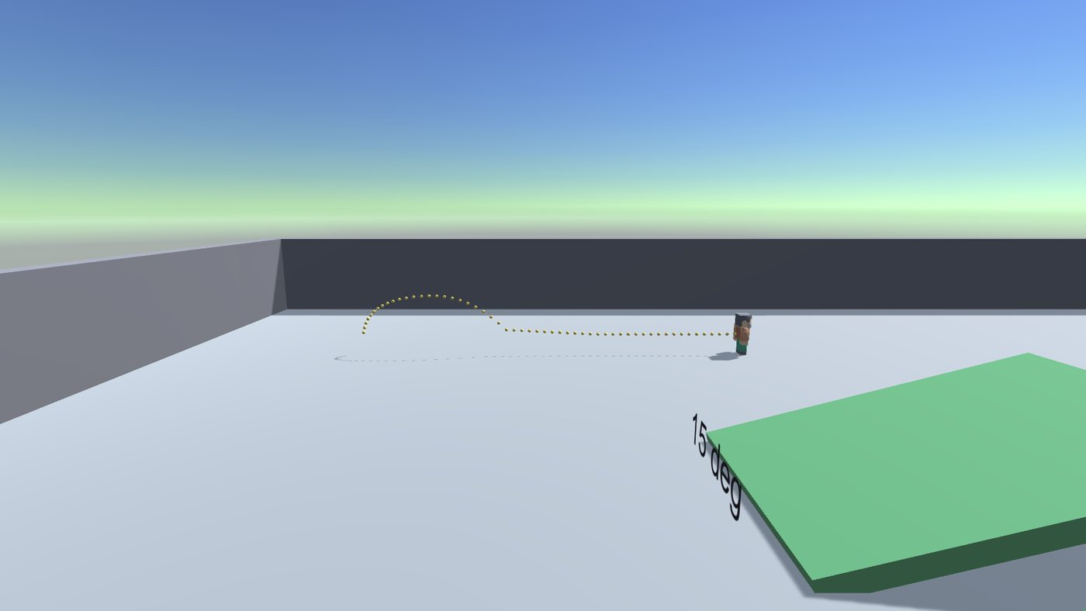
Jump arc

6. The course
Each obstacle isolates one behaviour, and colour codes its purpose: green ramps are walkable, the red one is deliberately past the slope limit.
Obstacle | Tests
Ramps at 15, 30, 40, 55 degrees | Slope projection and the 45 degree limit
Staircase, six 28 cm steps | Step climbing without a dedicated step offset
Low bar | Head collision
Wall | Flat collision response
Gap between two platforms | Jump distance, and coyote time at the edges
Crates at 1, 6 and 25 kg | Two way physics, mass actually mattering
Moving platform | Riding a kinematic body
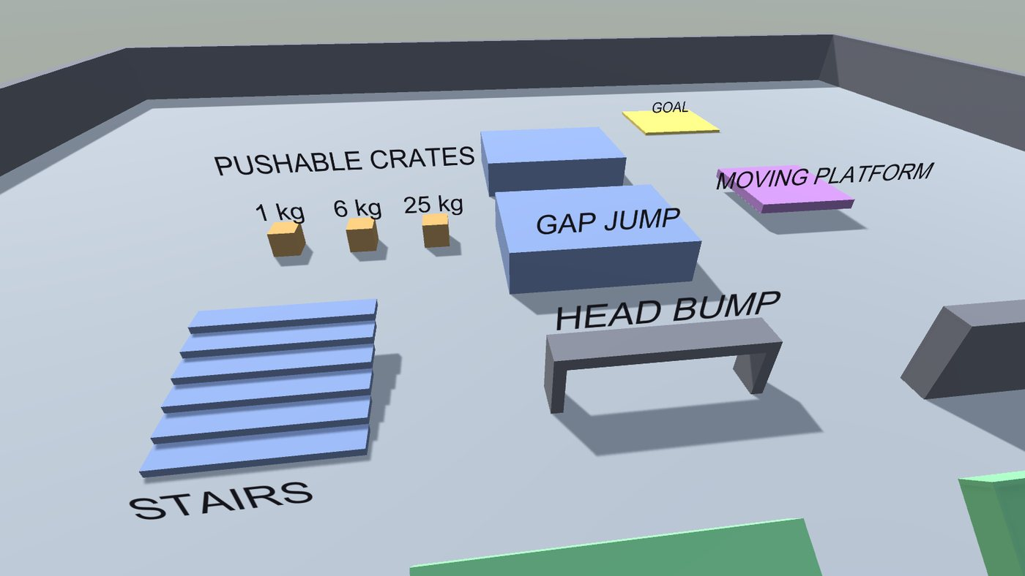
Obstacles
The scene is generated by CourseBuilder.cs rather than placed by hand, so it is reproducible from source and reviewable as a diff. Tools > Week 2 > Build Player Course rebuilds it.

7. Assets
One free pack: Kenney Blocky Characters, CC0 public domain. 4 of 18 models committed, FBX only. Full attribution in Assets/ThirdParty/LICENSES.md. Everything else, all scripts, the course geometry, the materials and the scene, is original work. The project needs no packages beyond the modules in a default Unity 3D project.

8. What is deliberately not here
No enemies, pickups, health, menus or sound. No animation clips, no Animator state machine, no post processing, no URP. The brief is a player controller and its physics, and anything past that is scope that was not asked for.

