LLM-Based Financial Analysis of Nicaragua

Introduction
This research examines the utilization of Large Language Models (LLMs) for the extraction and analysis of macroeconomic and financial stability data from the International Monetary Fund's Nicaragua: 2025 Article IV Consultation (IMF, 2026). The examination includes automated document processing, structured data extraction, Retrieval-Augmented Generation (RAG), and financial visualization.
The major purpose is to examine if a pipeline applying LLM can turn large-scale financial records into precise, organized, and comprehensible evidence, while minimizing unfounded statements provided by the model.

Methodology

Data Source and Preparation
The collection features the 105-page IMF Country Report No. 26/014, which contains economic assessments, financial indicators, policy recommendations, statistical information, and a debt sustainability analysis.
The pypdf module of Python extracted approximately 39,338 words. Eliminating redundant headers, footers, and formatting artifacts during preprocessing, while preserving numerical data and source-page citations.

Token-Aware Chunking
The purified text was divided into 188 overlapping segments, with a target size of 450 tokens with a 50-token overlap. The tiktoken library provided token-aware segmentation, employing sentence-boundary adjustments to improve contextual consistency.
Additionally, 32 report parts were identified to enhance specific summaries and uphold the document's analytical structure.

LLM Architecture and Prompt Design
Gemini 3.5 Flash was chosen as the exclusive generative LLM for summarization, extraction of financial indicators, and evidence-based answers.
Structured prompts featured source constraints, numerical precision standards, and JSON compliance checks. An independent LLM-as-a-Judge promptly reviewed factual accuracy, completeness, and coherence.

Retrieval and Evaluation Strategy
A localized RAG process employed MiniLM language embeddings and FAISS vector indexing to retrieve relevant IMF extracts. The obtained context was supplied to Gemini to provide responses grounded in evidence.
The method additionally includes response caching, monitoring of API rate restrictions, and a four-panel financial dashboard. These solutions provide effective implementation and consistency, while automated judge scores still necessitate significant human validation.

Summarisation and Prompt Engineering

Executive and Section Summarisation
Gemini 3.5 Flash generated seven executive summary bullet points and 32 unique section summaries from the IMF report on Nicaragua. Each section summary adhered to the stipulation of being below 100 words.
The executive summary highlighted economic growth, inflationary patterns, banking stability, fiscal sustainability, foreign threats, and IMF policy recommendations. It projected a GDP expansion of 3.4% for 2026, while emphasizing apprehensions related to US trade restrictions, dependence on remittances, and natural disasters.

Prompt Design and Optimisation
Prompt engineering prioritizes verifiable correctness, numerical precision, and consistent output formatting. The summary instructions required the model to:
- Utilize solely data corroborated by the IMF source.
- Preserve numerical data, chronological references, and fiscal terminology.
- Distinguish between historical observations and forecasts.
- Produce approximately 60 to 80 words for each section, making certain that the overall count remains under 100 words.
- Avoid baseless claims and invented recommendations.
Pydantic schemas were employed to generate organized JSON responses. The report sections were organized into nine categories, while local caching and sequential API requests reduced redundant queries and helped manage API rate limits.

Summarisation Quality and Limitations
The generated summaries retained crucial macroeconomic insights while distilling lengthy financial discussions into concise accounts. Segmented processing improved comprehensiveness and preserved the report's structure.
Nonetheless, summary carries the potential for information loss. Statistical analyzes, policy regulations, and debt stress-test assumptions may lose essential subtleties when summarized. Quantitative claims require comparison with the authentic IMF data, particularly when there are variations in observation periods and predictions.

LLM-as-a-Judge Evaluation

Evaluation Framework
An autonomous evaluation standard appraised every generated summary against its original IMF source document, focusing on three aspects: factual precision, thoroughness, and logical consistency.
The evaluator utilized a five-point scale and was instructed to identify unsupported numerical claims, omitted outcomes, and contradictory statements.

Evaluation Results
Evaluation criterion | Average score
Factual alignment | 5.00/5
Completeness | 5.00/5
Consistency | 5.00/5

The executive summary received an impeccable rating of 5/5 across all three categories, with no major concerns identified by the automated reviewer.

Critical Interpretation
While these findings show robust performance based on the automated evaluation, uniformly faultless scores should be treated with caution.
The same category of generative models performed both summarization and evaluation. This creates potential shared-model bias and limits the independence of the assessment. Moreover, heightened judicial evaluations cannot solely determine factual accuracy or guaranty the retention of all relevant source information.
Consequently, the evaluation indicates inherent regularity and significant source connection rather than conclusive evidence of impeccable summarization. Human validation of quantitative data and policy determinations is essential.

Thematic and Structured Financial Analysis

Financial Theme Distribution
Seven subjects related to financial stability were identified through a keyword-focused analysis of the IMF report. Sovereign Debt exhibited the greatest occurrence with 115 references (34.12%), succeeded by Banking Capital and Liquidity with 62 references (18.40%) and Labor Market Dynamics with 47 references (13.95%). The Housing and Real Estate sector was mentioned only two times (0.59%).
These frequencies indicate the report's linguistic emphasis rather than the economic importance or severity of each threat. Keyword matching may overlook relevant discussions that utilize alternative terminology.

Macroeconomic Strengths and Vulnerabilities
Six advantages and six disadvantages were recognized. Notable benefits included substantial GDP growth, declining inflation rates, well-capitalized banks, significant foreign reserves, and improved debt sustainability.
Nevertheless, dependence on US remittances and trade, international sanctions, natural disasters, and pressures on the pension system persist as significant vulnerabilities. These findings suggest that Nicaragua's current fiscal strength does not eliminate its medium-term structural weaknesses (IMF, 2026).

Structured Indicator Extraction
Schema-constrained prompting yielded seven fundamental JSON fields, including the following quantitative metrics:
Financial indicator | Extracted value
GDP growth forecast (2026) | 3.4%
Headline inflation (Nov. 2025) | 2.9%
Monetary reference rate (Oct. 2025) | 6.0%
Non-performing loans (Oct. 2025) | 1.1%
Unemployment (2024) | 3.4%
Tier 1 capital ratio | null

The country's name was recorded as Nicaragua. The Tier 1 ratio was unavailable and correctly marked as null, rather than substituting the reported overall capital adequacy ratio of 19.1%.

All seven categories received an impeccable rating of 5 out of 5 from the evaluators. However, the data relates to different reporting periods, highlighting the importance of maintaining temporal metadata and confirming the original source.

RAG Retrieval and Evaluation

Retrieval Implementation
A regional RAG pipeline using MiniLM embeddings and FAISS, cataloging 421 passages into 384-dimensional vectors. Five pertinent excerpts were obtained for each inquiry to furnish corroborative evidence for responses supplied by Gemini.

Retrieval Results and Critical Assessment
Three financial queries were evaluated, with two resulting in affirmative replies. The system successfully acquired data concerning banks capital, non-performing loans, and the viability of public debt.
Nevertheless, the investigation of the countercyclical capital buffer produced insufficient evidence, despite the relevant IMF proposal being incorporated in the preliminary report.
The RAG assessor awarded average ratings of 5.00/5 for fidelity and thoroughness, emphasizing the limitation of evaluating responses solely on recovered documents. These evaluations failed to recognize the excluded source details.
This result highlights the importance of evaluating retrieval thoroughness separately from the precision of answers. Improving retrieval coverage would strengthen the basis of evidence and reduce misleading evaluation outcomes.

Financial Dashboard and Analytical Findings

Dashboard Overview

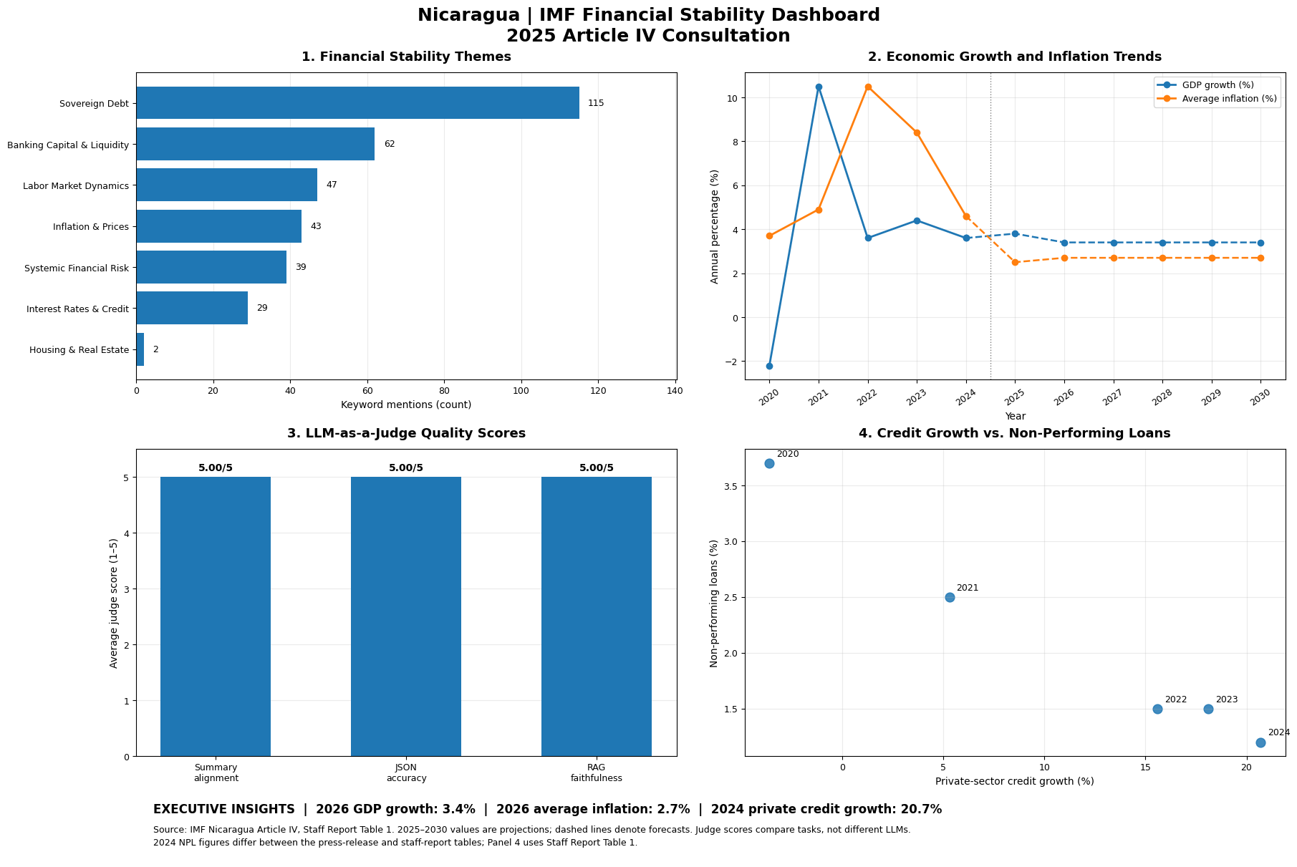
Figure 1. Nicaragua Financial Stability Dashboard

Macroeconomic and Financial Interpretation
The thematic analysis reveals that Sovereign Debt accounted for 34.12% of acknowledged financial-theme references, underscoring the report's considerable emphasis on fiscal resilience and debt sustainability.
Historical documentation reveals that Nicaragua's GDP growth surged from −2.2% in 2020 to 10.5% in 2021, ultimately attaining a condition of stability. The International Monetary Fund projects a growth rate of 3.4% for the year 2026. Projected inflation is expected to decline from 10.5% in 2022 to 2.7% by 2026.
Banking indicators suggest an improvement in asset quality and an increase in lending volume. However, the relationship between credit and non-performing loans is only demonstrative and does not indicate causality.
The evaluation committee consistently receives high evaluations from adjudicators, all at 5/5. These require meticulous analysis because the RAG evaluation fails to identify a substantial retrieval error.

Extra-Credit: Prompt Benchmarking

Experimental Comparison
Two prompting techniques were evaluated using Gemini 3.5 Flash: a general user prompt and strict system instructions. Each configuration performed two extraction trials utilizing the same IMF data.

Performance measure | Generic | Strict
JSON schema compliance | 100% | 100%
Mean latency (seconds) | 1.49 | 1.40
Mean judge score (/5) | 5.00 | 4.33

Critical Evaluation
The unflexible system protocols led to a little decrease in extraction delay, however both approaches produced structurally robust JSON.
However, the reduced strict-prompt judge score suggested discrepancies in the choice of the reporting time. The general approach predominantly produced signals for 2024, but particular instructions aimed at the 2026 GDP forecast and the latest information for supplementary measures.
Consequently, our results do not corroborate that generic cues demonstrate superior accuracy. Equivalent temporal standards and further experiments would be crucial for a reliable evaluation of performance.

Critical Limitations and Improvements
The IMF report encompasses historical analyzes, forecasts, and financial metrics from various reporting intervals, leading to possible discrepancies during extraction. The absent Tier 1 capital ratio was accurately depicted as `null` instead of employing an unsupported figure. Moreover, keyword-centric thematic analysis quantifies the prevalence of financial subjects but does not inherently indicate their economic importance or risk intensity.
Despite the LLM-as-a-Judge paradigm yielding consistently elevated results, employing the identical model for both creation and evaluation could lead to evaluative bias. The RAG system did not succeed in obtaining the IMF's suggestion for a countercyclical capital buffer, even though it was included in the report. This underscores the significance of assessing retrieval completeness separately from the precision of answers. Enhanced retrieval methodologies and direct source authentication may bolster dependability.
The Gemini API imposes rate constraints that need sequential processing, response caching, and automated retry systems. These actions enhanced execution dependability but prolonged processing duration. The supplementary credit benchmarking consisted of merely two trials for each prompting configuration, whilst variations in the selection of reporting periods constrained the validity of the comparisons. Subsequent enhancements would entail more regulated trials, uniform definitions of indicators, and impartial assessment of the derived financial data.

Conclusion
This research demonstrates the relevance of Large Language Models in evaluating Nicaragua's 2025 IMF Article IV Consultation. The cohesive workflow effectively merges PDF handling, automatic summarization, organized financial extraction, Retrieval-Augmented Generation (RAG), and a four-panel financial dashboard. The results highlighted Nicaragua's economic robustness, enhanced debt sustainability, and stability within the banking system, however persistent external and structural vulnerabilities remain.
Despite the automated assessments yielding elevated scores, the identified RAG retrieval limitation suggested that the outcomes produced by the model necessitate external validation. The study substantiates the feasibility of utilizing LLMs for financial analysis, while emphasizing the necessity for factual accuracy, transparent scrutiny, and human oversight for dependable economic assessment.

References
- Fabbri, A.R. et al. (2021) ‘SummEval: Re-evaluating Summarization Evaluation’, Transactions of the Association for Computational Linguistics, 9, pp. 391–409. Available at: https://doi.org/10.1162/tacl_a_00373
- Karpukhin, V. et al. (2020) ‘Dense Passage Retrieval for Open-Domain Question Answering’, Proceedings of the 2020 Conference on Empirical Methods in Natural Language Processing, pp. 6769–6781. Available at: https://doi.org/10.18653/v1/2020.emnlp-main.550
- McKinney, W. (2010) ‘Data Structures for Statistical Computing in Python’, Proceedings of the 9th Python in Science Conference, pp. 56–61. Available at: https://doi.org/10.25080/Majora-92bf1922-00a

