A Project Report
On
DIGI_SLAM
Submitted in partial fulfillment of the
Requirements for the award of degree of

Bachelor of Technology
In
Computer Science and Engineering

By
Munnuru Rohitha
[10H61A0534]
K Swathi Reddy
[10H61A0516]

Under the guidance of

Mr. V. Rama Krishna

Assistant Professor, CSE Dept.


Department of Computer Science and Engineering,
Anurag Group of Institutions
(Formerly CVSR College of Engineering)
(Affiliated to JNTU-HYD, Approved by AICTE and NBA Accredited)
Venkatapur (V), Ghatkesar (M), R.R. District, A.P. 500 088
(2009-13)



CERTIFICATE

This is to certify that the Thesis entitled “DIGI_SLAM” being submitted by Ms.Munnuru Rohitha and Ms.K Swathi Reddy in partial fulfillment of the requirements for the award of the degree of B.Tech in Computer Science and Engineering from Anurag Group of Institutions (formerly CVSR College of Engineering), Affiliated to JNTU Hyderabad is a record of bonafide work carried out by them under my guidance and supervision from December, 2012 to April, 2013.

The results presented in this Thesis have been verified and found to be satisfactory. The results embodied in this thesis report have not been submitted to any other University for the award of any other degree or diploma.

Internal Guide External Examiner
Mr. V. Rama Krishna

G. Vishnu Murthy
HOD, CSE Dept

ACKNOWLEDGEMENTS

It is my privilege and pleasure to express my profound sense of respect, gratitude and indebtedness to my guide Mr. V. Rama Krishna, Assistant Professor, of Department of Computer Science and Engineering, for his indefatigable inspiration, guidance, cogent discussion, constructive criticisms and encouragement throughout the dissertation work.

I express my sincere gratitude to Mr. G. Vishnu Murthy, Head of Department & Associate Professor of Department of Computer Science and Engineering, for his precious suggestions, motivation and co-operation for the successful completion of the project work.

I extend my sincere thanks to Prof. P. Subba Reddy, and Prof. V. Vijaya Kumar, Department of Computer Science and Engineering, for their motivation and co-operation for the successful completion of the project work.

I extend my sincere thanks to Prof. M Mutha Reddy, Principal, Dr. K.S. Rao, Director, M.Bhagavanth Rao, Director and Prof. K. RamaReddy, senior Director, for their encouragement and constant help.

Last but not least, I wish to acknowledge my friends, family members and colleagues for giving moral strength and helping me to complete this dissertation.

Munnuru Rohitha
(10H61A0534)

K Swathi Reddy
(10H61A0516)

DECLARATION
I hereby declare that the project entitled “DIGI_SLAM” submitted to the JNTUH in partial fulfillment of the requirements for the award of the degree of B.Tech in CSE is a record of an original work done by me under the guidance of Mr. V. Rama Krishna, Assistant Professor of department of Computer Science and Engineering and this project work has not been submitted to any other university for the award of any other degree or diploma.

Munnuru Rohitha
(10H61A0534)
K Swathi Reddy
(10H61A0516)
Date:

ABSTRACT
In olden days, people used to maintain a slam book to record all the details of their friends. But as the technology is developing day-by-day and all are interested in using mobiles, some digital applications have been developed. DIGI-SLAM is one of this kind . It is a home of memories which enables the user to create a collection of memories of friends, loved ones, college/classmates, colleagues likes/dislikes, birthday and other stuff which otherwise becomes cumbersome to remember. Using this application user can also store the pictures of his/her friends. The user can edit the slam and also update it. He/she can also delete the unwanted slam. This application can be deployed in android devices.

INDEX

contents page no

- Introduction 1
1.1 Motivation 2
1.2 Problem Definition 2
1.3 Objective of the Project 3
1.4 Limitations of the Project 3

- Literature Survey 4

3. Analysis
3.1 Introduction 10
3.2 Existing System 10
3.3 Proposed System 11
3.4 Software Requirement Specification 11
3.4.1 Purpose
3.4.2 Scope
3.4.3 Overall Description
3.4.4 External Interface Requirements

- Design
4.1 Introduction 13
4.2 UML diagrams 17

- Implementation
5.1 Modules 23
  - Module description 23
5.3 Technologies used 24
5.4 Sample code 24

6. Testing
6.1 Introduction 28
  - Test cases 29
6.3 Screen Shots 30

7. Conclusions and Limitations 34

8. Future Enhancement 35

9. Bibliography 36

1. Introduction

Now-a-days with the advancement of technology particularly in the field of mobiles, all the activities in our day-to-day living have become part of information technology and we find everything possible with mobiles. Today’s mobile phone models also serve to combine the functions of portable media players, low-end compact digital cameras, pocket video cameras, and GPS navigation units. The most common mobile operating system (OS) used by modern smart phones includes Apple’s iOS, Google’s android and Microsoft’s Windows Phone etc. which can be installed on many different phone models, and typically each device can receive multiple OS software updates over its lifetime. This project is a mobile application done in Android.

1
1.1 Motivation

As the existing application of slam book does not has an option to store the picture of their friends and there is no edit option also. So we are motivated to do this project by keeping both the options - edit and storing picture, available. Edit option is included because the entered slam may require some changes to be made like change of mobile number etc.

1.2 Problem Definition

DIGI-SLAM is a home of memories which enables user to create a collection of memories of friends, loved one’s, their college/classmates/colleagues likes and dislikes, their opinions, their birthday and other stuff which otherwise becomes cumbersome to remember.

2
1.3 Objectives of the Project

User can
- Store the information of their friends
- Insert the picture of their friends
- Make a calll
- Send a message
- Edit the entered details
- Delete the details

1.4 Limitations of the Project

- Image size can’t be adjusted.
- If image is removed from SD card, that image will not be displayed in application.
- The entries are not listed in alphabetical order.

3

2. Literature Survey

2.1 ANDROID
Android is a software stack for mobile devices that includes an operating system, middleware and key applications. The android SDK provides the tools and APIs necessary to begin developing applications on the Android platform using the Java programming language.
The Android SDK includes a comprehensive set of development tools. These include a debugger, libraries, a handset emulator (based on QEMU), documentation, sample code, and tutorials. Currently supported development platforms include x86-architecture computers running Linux (any modern desktop Linux distribution), Mac OS X 10.4.8 or later, Windows XP or Vista. The officially supported integrated development environment (IDE) is Eclipse (3.2 or later) using the Android Development Tools (ADT) Plug in, though developers may use any text editor to edit Java and XML files then use command line tools to create, build and debug Android applications.

3. Analysis

3.1 Introduction

Digi-Slam is used to store the details of your friends, loved ones’ college/classmates and colleagues. As it is impossible to remember the Mobile No, Address, Date of birth of all of them it helps to store the entire information at one place.

3.2 Existing System

In the existing system, there are some applications of slam-book which stores the details of your friends but none of those applications help you to store the picture of them and cannot edit the details which are once entered. For example if any of your friend’s mobile no. is changed it cannot be updated.

10
3.3 Proposed System

We are going to create a mash up type of application which maintains the details of your friends like name, pet name, phone number, email id, address, date of birth, favorite actor, favorite singer, favorite movie, favorite dish, favorite place, what they are thinking about you and even their picture. In this the user can view his/her friend’s slam, edit, search using search bar and even delete if any unwanted slam is there.

3.4 Software Requirement Specification

3.4.1 Purpose:

This application can be downloaded to the mobile device from marketplace. After installing, people can add the slam (details of your friends) and save them. They can view them whenever they want. They can even edit the entered slam if there are any changes to be done.

3.4.2 Scope:

This application helps the user to maintain some important information about his/her friends and their likes/dislikes, their pictures.

3.4.3 Overall Description:

The user can take the slam of his/her friends including their picture and save them. They can view the entries whenever they want and at the same time he/she can call or send a message to the person of whom the slam is. If there are many entries in the application, the user can search the required person’s slam using search bar. The user can even delete the unwanted entries made into the slam book.

3.4.4 External Interface Requirements:

I. SOFTWARE REQUIREMENTS
- Java
- Android SDK 1.5 or later
- Eclipse Ganymede IDE
- Operating System can be Windows XP, LINUX and Mac etc.

II. HARDWARE REQUIREMENTS
1. PROCESSOR : (min) P2 Processor
2. RAM : (min) 128
3. HARD DISK : 100 MB

4. Design

4.1 Introduction
4.1.1 ARCHITECTURE DIAGRAM

Architecture diagram is a diagram of a system, in which the principal parts or functions are represented by blocks connected by lines that show the relationships of the blocks. The block diagram is typically used for a higher level, less detailed description aimed more at understanding the overall concepts and less at understanding the details of implementation.
Slam entry

User
Android SDK
SQLite
Java program
Get all
details
Fig 4.1 Architecture of Call History

A Call History user for who the application looks like a user interface actually consists of a database called as SQLite that comes along with Android SDK and need no other installation. This is the database that is used to store and retrieve information. This is an application that is developed in java and hence all its features apply here as well such as platform independence, data hiding, portable etc.

4.1.2 DATA FLOW DIAGRAMS

A data-flow diagram (DFD) is a graphical representation of the "flow" of data through an information system. DFDs can also be used for the visualization of data processing (structured design).
On a DFD, data items flow from an external data source or an internal data store to an internal data store or an external data sink, via an internal process. The idea behind the explosion of a process into more process is that understanding at one level of detail is exploded into greater detail at the next level. This is done further explosion is necessary and an adequate amount of detail is described for analyst to understand the process.

`A DFD is also known as a “bubble chart” has the purpose of clarifying system requirements and identifying major transformations that will become programs in system design.
So it is the starting point of the design to the lowest level of detail. A DFD consists of a series of bubbles joined by data flows in the system.
DFD Symbols:
In the DFD, there are four symbols
- A Square defines a source or destination of system data.
- An arrow identifies data flow. It is the pipeline through which the information flows.
- A circle or a bubble represents a process that transforms incoming data flow into outgoing data flows.
- An open rectangle is a data store ,data at rest or a temporary repository of data

Process that transforms data flow

13

Source or destination of data

Data flow

Data store

4.1.3 UNIFIED MODELING LANGUAGE (UML)

The unified modeling is a standard language for specifying, visualizing, constructing and documenting the system and its components is a graphical language which provides a vocabulary and set of semantics and rules. The UML focuses on the conceptual and physical representation of the system. It captures the decisions and understandings about systems that must be constructed. It is used to understand, design, configure and control information about the systems.
Depending on the development culture, some of these artifacts are treated more or less formally than others. Such artifacts are not only the deliverables of a project; they are also critical in controlling, measuring, and communicating about a system during its development and after its deployment.
The UML addresses the documentation of a system's architecture and all of its details. The UML also provides a language for expressing requirements and for tests. Finally, the UML provides a language for modeling the activities of project planning and release management.

Building Blocks of the UML:

The vocabulary of the UML encompasses three kinds of building blocks:
- Things
- Relationships
- Diagrams
Things are the abstractions that are first-class citizens in a model; relationships tie these things together; diagrams group interesting collections of things.

Things in the UML:
There are four kinds of things in the UML:
- Structural things
- Behavioral things
- Grouping things
- Annotational things

4.2 UML Diagrams
- Use-case Diagram
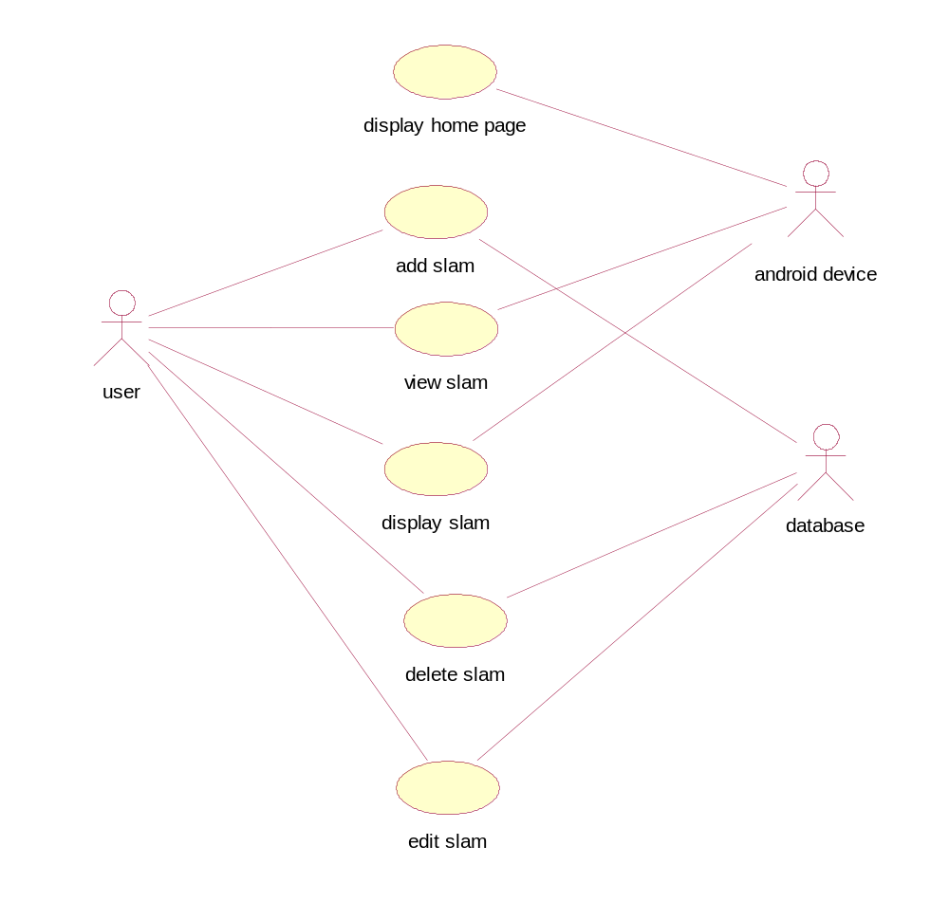

- Class Diagram
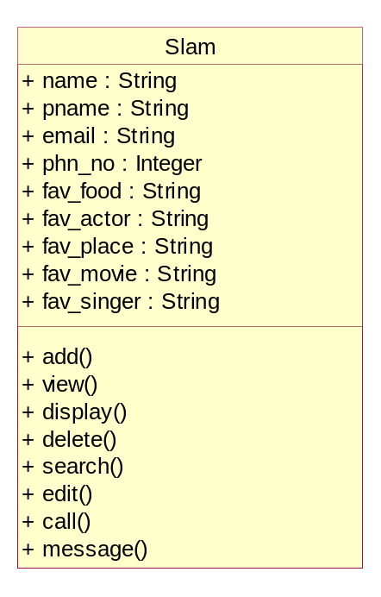
- Sequence Diagram
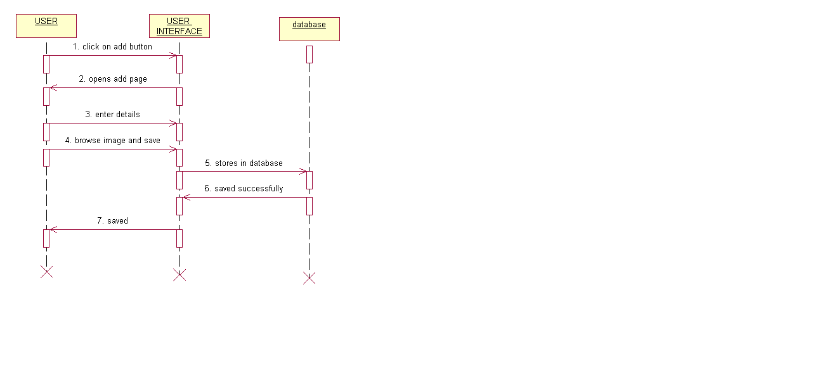

- Collaboration Diagram
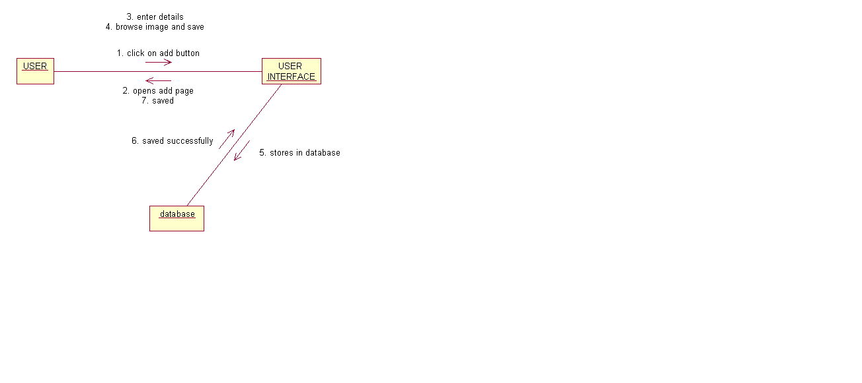

- Activity Diagram
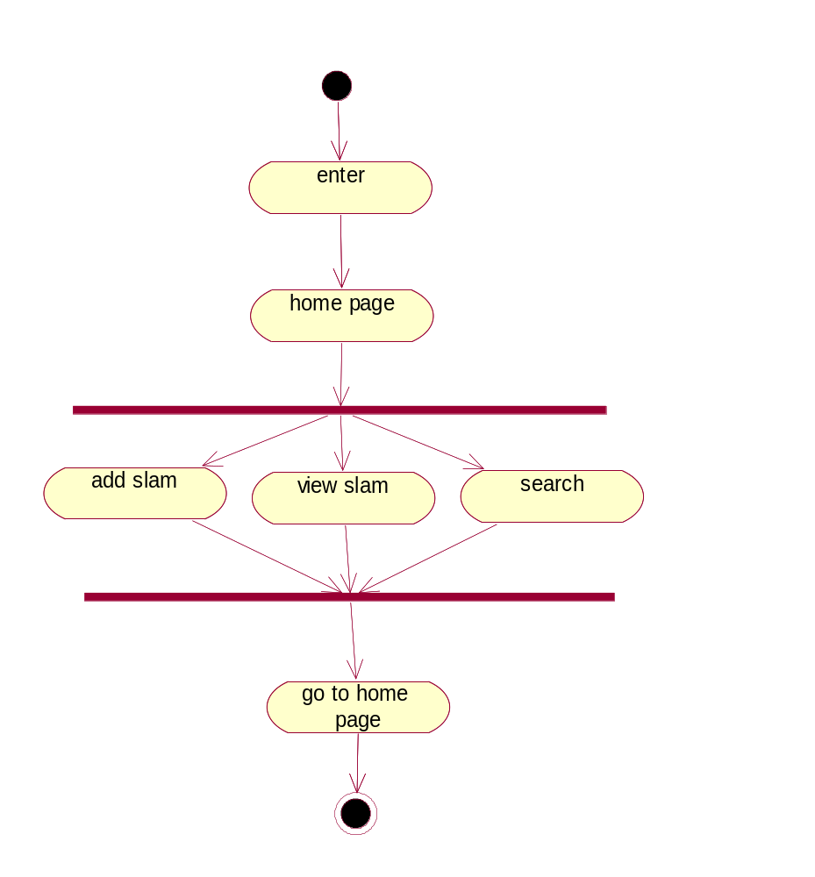

- State chart Diagram
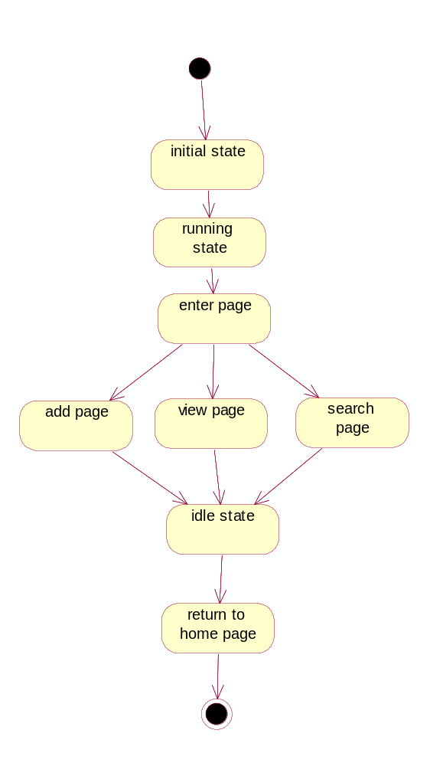

- Component Diagram
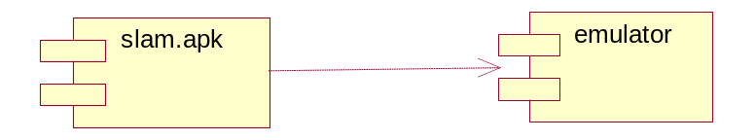
- Deployment Diagram
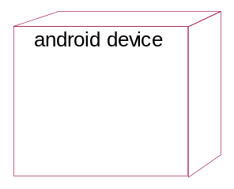

5. Implementation

5.1 Modules
1. Add
2. View
3. Display
4. Search
5. Edit
6. Delete
7. Call/Message

5.2 Module Description

1. Add:
In this module the user is allowed to add new details in a slam book. It contains fields like Name, Pet Name, Mobile No, E-mail Id, favorites etc. After filling the details click on the save button. The new details of a person will be successfully saved in database.

2. View:
In this module the user can view the names of all the persons who have already entered the slam. All the names which are previously stored in the database using “add” function are likely to be displayed using this function.

3. Display:
In this module all the details of any particular person, which we select, are likely to be displayed. We have three menu options included in this module. They are call, message & edit options.

4. Search:
In this module the user can perform search operation by entering the person’s name in the search bar. After clicking the search button , the respective person’s details or any relevant details are retrieved from the database and a list is displayed.

5. Edit:
In this module the user can update any kind of details in any field of slam book like Pet Name, Address, Mobile No, E-mail Id, Image etc. and then click on the Update Button .The details are successfully updated in Database records.

6. Delete:
In this module the user can delete the slam of unwanted person. This can be done by clicking the Delete button after viewing the entire details of that person.

7. Call/Message:
In this module we can call/message any particular person while viewing their details.

5.3 Technologies used
- Java
- Android SDK 1.5 or later
5.4 Sample Code
Home page:
import android.app.Activity;
import android.content.Intent;
import android.database.sqlite.SQLiteDatabase;
import android.os.Bundle;
import android.view.View;
import android.view.View.OnClickListener;
import android.widget.Button;
import android.widget.RelativeLayout;

public class Home extends Activity {
SQLiteDatabase db;

@Override
protected void onCreate(Bundle savedInstanceState) {
// TODO Auto-generated method stub
super.onCreate(savedInstanceState);
setContentView(R.layout.home);
RelativeLayout rl=(RelativeLayout)findViewById(R.id.rel1);
rl.setBackgroundResource(R.drawable.new8);
Button bt=(Button)findViewById(R.id.button1);
Button bt1=(Button)findViewById(R.id.button2);
Button bt2=(Button)findViewById(R.id.button3);

bt.setOnClickListener(new OnClickListener() {
@Override
public void onClick(View v) {
// TODO Auto-generated method stub
Intent it = new Intent(Home.this, Add.class);
startActivity(it);
}
});
bt1.setOnClickListener(new OnClickListener() {
@Override
public void onClick(View v) {
// TODO Auto-generated method stub
Intent it = new Intent(Home.this, Viewslam.class);
startActivity(it);
}
});
bt2.setOnClickListener(new OnClickListener() {
@Override

public void onClick(View v) {
// TODO Auto-generated method stub
Intent it = new Intent(Home.this, Search.class);
startActivity(it);
}
});
}
}

Add page:

import android.app.Activity;
import android.content.Intent;
import android.database.Cursor;
import android.database.sqlite.SQLiteDatabase;
import android.graphics.Bitmap;
import android.graphics.BitmapFactory;
import android.net.Uri;
import android.os.Bundle;
import android.provider.MediaStore;
import android.view.View;
import android.view.View.OnClickListener;
import android.widget.Button;
import android.widget.EditText;
import android.widget.ImageView;
import android.widget.RelativeLayout;
import android.widget.Toast;

public class Add extends Activity{
SQLiteDatabase db;
String s1,s2,s3,s4,s5,s6,s7,s8,s9,s10,s11,s12,type1,selectdimg;
ImageView imv;
private static final int Pick_img = 0;
EditText et1,et2,et3,et4,et5,et6,et7,et8,et9,et10,et11,et12;
@Override
protected void onCreate(Bundle savedInstanceState) {
// TODO Auto-generated method stub
super.onCreate(savedInstanceState);
setContentView(R.layout.adds);
RelativeLayout rl=(RelativeLayout)findViewById(R.id.rel);
rl.setBackgroundResource(R.drawable.new9);
et1=(EditText)findViewById(R.id.editText1);
et2=(EditText)findViewById(R.id.editText2);
et3=(EditText)findViewById(R.id.editText3);
et4=(EditText)findViewById(R.id.editText4);
et5=(EditText)findViewById(R.id.editText5);
et6=(EditText)findViewById(R.id.editText6);
et7=(EditText)findViewById(R.id.editText7);
et8=(EditText)findViewById(R.id.editText8);
et9=(EditText)findViewById(R.id.editText9);
et10=(EditText)findViewById(R.id.editText10);
et11=(EditText)findViewById(R.id.editText11);
et12=(EditText)findViewById(R.id.editText12);
imv=(ImageView)findViewById(R.id.imageView1);

Button bt1=(Button)findViewById(R.id.button2);
bt1.setOnClickListener(new View.OnClickListener() {
@Override
public void onClick(View arg0) {
// TODO Auto-generated method stub
Intent i = new Intent(
MediaStore.INTENT_ACTION_MEDIA_SEARCH);
type1 = "image/*";
i.setType(type1);
i.setAction(Intent.ACTION_GET_CONTENT);
startActivityForResult(i, Pick_img);
}
});
}

protected void onActivityResult(int requestCode, int resultCode, Intent data) {
// TODO Auto-generated method stub
super.onActivityResult(requestCode, resultCode, data);
switch (requestCode) {

case Pick_img:
if (resultCode == RESULT_OK) {
Uri uri = data.getData();
selectdimg = getRealPathFromURI(uri);
}
break;
}

try {

Uri selected = data.getData();
String filename = getRealPathFromURI(selected);

Bitmap b = BitmapFactory.decodeFile(filename);
imv.setImageBitmap(b);
} catch (Exception e) {
// TODO: handle exception
}
Button bt=(Button)findViewById(R.id.button1);
bt.setOnClickListener(new OnClickListener() {
@Override
public void onClick(View v) {
// TODO Auto-generated method stub
s1=et1.getText().toString();
s2=et2.getText().toString();
s3=et3.getText().toString();
s4=et4.getText().toString();
s5=et5.getText().toString();
s6=et6.getText().toString();
s7=et7.getText().toString();
s8=et8.getText().toString();
s9=et9.getText().toString();
s10=et10.getText().toString();
s11=et11.getText().toString();

s12=et12.getText().toString();
db=openOrCreateDatabase("new", MODE_PRIVATE, null);
db.execSQL("create table if not exists swa(name varchar,pname varchar,number varchar,email varchar,address varchar,dob varchar,fava varchar,favs varchar,favm varchar,favd varchar,favp varchar,abtme varchar,img varchar)");
db.execSQL("insert into swa values('"+s1+"','"+s2+"','"+s3+"','"+s4+"','"+s5+"','"+s6+"','"+s7+"','"+s8+"','"+s9+"','"+s10+"','"+s11+"','"+s12+"','"+selectdimg+"')");
Toast.makeText(getApplicationContext(), "SAVED", Toast.LENGTH_LONG).show();
Intent it=new Intent(Add.this,Home.class);
startActivity(it);
finish();

}
});
}

private String getRealPathFromURI(Uri contentUri) {
// TODO Auto-generated method stub
String[] proj = { MediaStore.Images.Media.DATA };
@SuppressWarnings("deprecation")
Cursor cursor = managedQuery(contentUri, proj, null, null, null);
int column_index = cursor
.getColumnIndexOrThrow(MediaStore.Images.Media.DATA);
cursor.moveToFirst();
return cursor.getString(column_index);
}
}

6. Testing

6.1 Introduction
The development of software systems involves of a series of production activities where opportunities for injection of human fallibilities are enormous. Errors may begin to occur at the very inception of the process where the objectives may be erroneously or imperfectly specified, as well as in later design and development stages. Because of human inability to perform and communicate with perfection, software development is accompanied by a quality assurance activity.

TESTING TECHNIQUES
Testing is the process of executing a program with the intention of finding errors. The various test strategies used for testing the software are as follows.

1 Unit Testing
Unit testing focuses on verification effort on the smallest unit of the software design module. The main goal is to make sure that every source statement and logic path has been executed correctly at least once. The output of this stage is the source code.

2 Integration Testing
In Integration testing, we find errors that have occurred during the integration. After testing each module, which is then integrated into subsystems and then to form the entire system on which integration testing is performed. The goal of testing is to detect the design errors, while focusing on the testing the interconnection between modules.

3 Validation Testing
This testing concentrates on confirming that the software is error-free in all respects. All the specified validations are verified and the software is subjected to hard-core testing. It also aims at determining the degree of deviation that exists in the software designed from the specification; they are listed out and are corrected.

6.2 Test Cases

S.no | Test case name | Test case description | Expected result | Actual result | status
1 | Click on Add | For adding members into the slam | Opens add page | Opens add page | success
2 | Add page | Enter all the fields in it and browse an picture | Saved | Saved | success
3 | Click on View Slam | Displays entries in the slam book | Displays all the entries | Displays all the entries | success
4 | Click on Search | Searches for the required names entered in search bar | Displays the list of entries | Displays the list of entries if any | success
5 | Click on Edit | Rewrites the entered fields and updates the picture | Slam is updated | Slam is updated | success
6 | Click on call/message | Retrieves number from the slam and call is made/message is sent | Call activated/message is sent to the required destination | Call activated/message is sent to the required destination | success
7 | Click on delete | To delete the slam | Removes from the entries made | Removes from the entries made | success

6.3 Screenshots

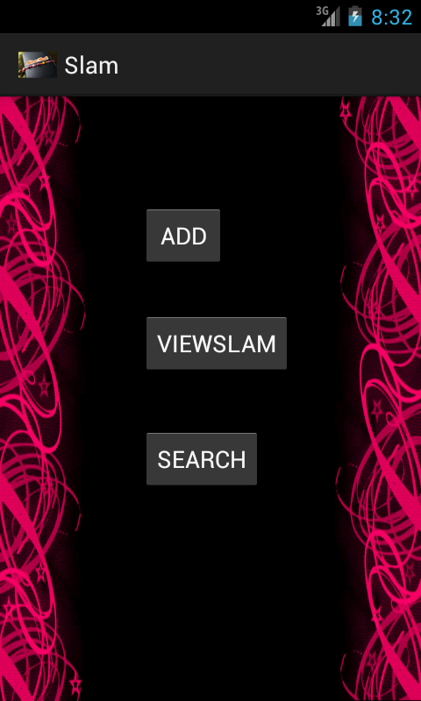
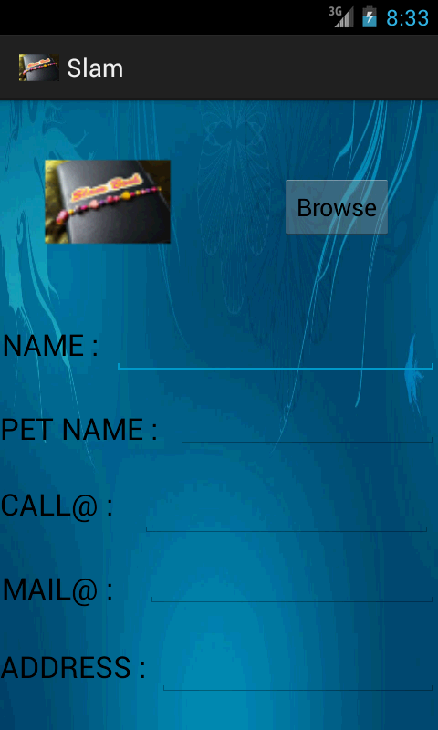

1. Home page 2. Add page

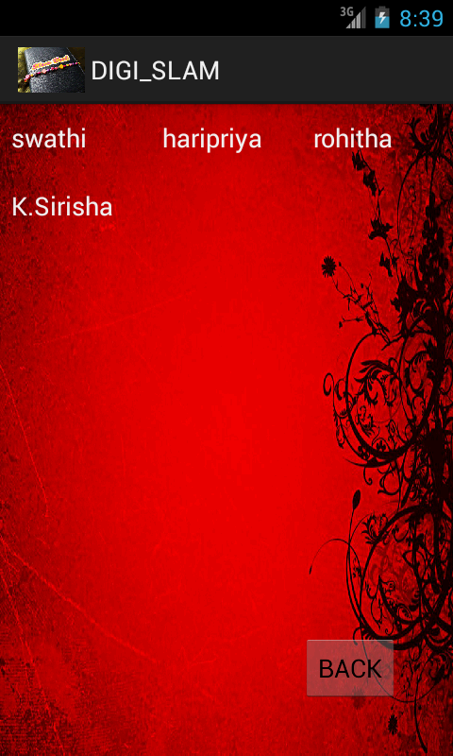

3. View page

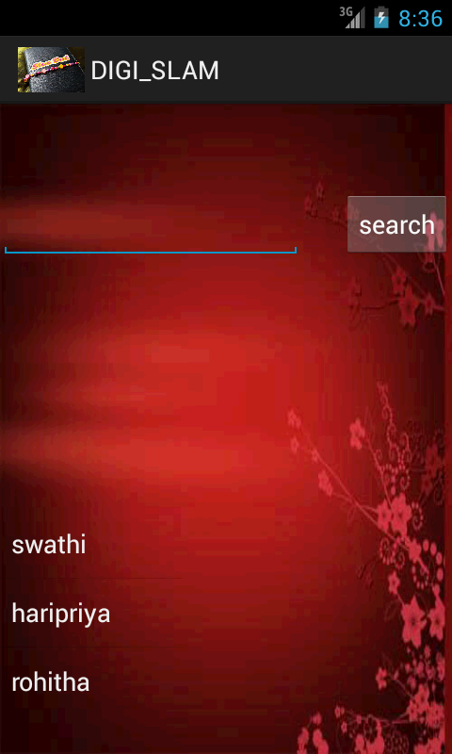

4. Search page

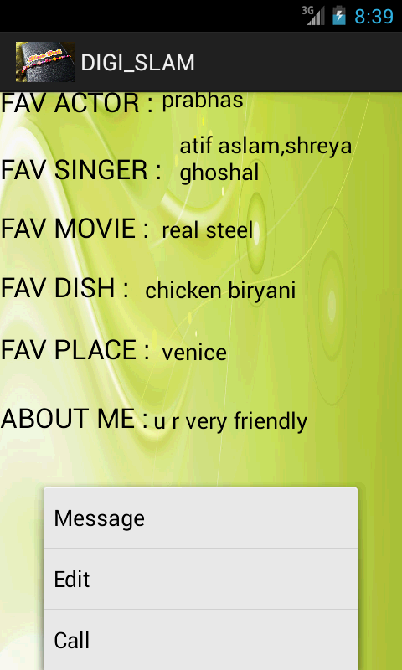

5. Display page

7. Conclusions and Limitations
This application is used for storing information of friends. This application is build using Android SDK. It is a tool developed for android platform, which is used to maintain the slam of friends and their pictures, likes/dislikes within the mobile. This is an advantage when compared to existing system because a single mobile piece is enough for deploying the application .As this is a mobile application one can easily be in touch with all the friends. This makes this application efficient, convenient and easy to use along with providing maximum user satisfaction which is the key aspect for any developer.

8. Future Enhancement
Any project that has been already developed can always be improved further for better efficiency, better performance, easy understanding and important of all, satisfy customer/user to a higher extent.
The future enhancements that can be done to this project are
- Giving link to the email id so that user can send mails to his/her friends.
- Appearance of pages/themes can be changed by the user.
- Storing pictures directly into database rather than storing uri so that even if the picture is deleted from SD card it can be viewed in the slam book.

9. Bibliography
- Herbert Schildt.2008,”Java Complete Reference”, Tata McGraw-Hill, 7th Edition, pp.177-180.

2. Grady Booch, James Rambaugh.1998, “Unified Modeling Language User Guide”, Addison Wesley Publishing, chapter 8-31.
www.android.com http://developer.android.com/index.html
www.google.com http://en.wikipedia.org/wiki/SQLite

