UNIVERSITY SCHOLARSHIP ALLOCATION SYSTEM
Problem Analysis, Algorithm, Flowchart, Pseudocode and Python Implementation
This document presents a structured design for a university scholarship allocation system. The system checks applicants against academic, attendance and family-income requirements, ranks eligible applicants, and applies transparent tie-breaking rules.

1. Problem Statement
A university receives scholarship applications from students. Each application contains the student's name or ID, aggregate marks, marks in individual subjects, attendance percentage, and annual family income. The system must identify applicants who satisfy every eligibility condition, rank those applicants according to academic performance, and select recipients according to the available number of scholarships.

2. Assumptions and Eligibility Rules
The following sample rules are used. A university can change the thresholds to match its official policy.
Criterion | Sample requirement
Aggregate marks | At least 75%
Subject-wise minimum | At least 60% in every required subject
Attendance | At least 75%
Annual family income | Not more than ₹3,00,000
Scholarship limit | A fixed number of awards, entered by the user
An applicant is eligible only when all four conditions are satisfied. Meeting the aggregate threshold does not compensate for failing a subject-wise minimum.

3. Inputs, Processing and Outputs

Inputs
- Number of applicants and number of scholarships available.
- For each applicant: student ID/name, aggregate percentage, list of subject percentages, attendance percentage, and annual family income.

Processing
- Validate that percentages are between 0 and 100 and income is non-negative.
- Check every eligibility condition using conditional statements and logical operators.
- Store eligible applicants and their details in a list of records.
- Sort eligible applicants using the ranking and tie-breaking rules.
- Select the first K applicants, where K is the number of available scholarships.

Outputs
- List of eligible applicants in rank order.
- Selected scholarship recipients.
- Ineligible applicants with the reason or reasons for rejection.
- A message if fewer eligible applicants exist than the number of scholarships.

4. Tie-Breaking and Ranking Rules
Use the following rules in order, comparing one criterion at a time:
- Higher aggregate percentage receives the higher rank.
- If aggregate marks are equal, higher attendance percentage receives the higher rank.
- If still tied, higher annual family income is NOT preferred; the applicant with the lower family income receives the higher rank.
- If still tied, compare the average of the subject percentages; the higher average receives the higher rank.
- If all the above values are equal, sort by student ID in ascending alphabetical/numeric order to ensure a deterministic result.
Policy note: The income tie-breaker above prioritizes greater financial need among applicants who are already within the income limit. The university should publish these rules before applications open.

5. Computational Thinking Concepts Used
Concept | Application in this system
Decomposition | Break the task into input, validation, eligibility checking, ranking, selection and reporting.
Pattern recognition | Every applicant is checked against the same set of criteria.
Abstraction | Only information relevant to eligibility and ranking is used.
Algorithm design | A finite sequence of steps produces the same result for the same input.
Logical reasoning | AND is used because every eligibility condition must be true; comparison operators implement thresholds.
Testing | Boundary values and tie cases are tested to verify the rules.

6. Data Structures, Variables and Data Types
Variable | Data type | Purpose
student_id | String | Unique student identifier
name | String | Applicant's name
aggregate | Float | Aggregate percentage
subject_marks | List of floats | Marks for each subject
attendance | Float | Attendance percentage
income | Integer/Float | Annual family income in rupees
eligible | Boolean | True if all eligibility conditions pass
eligible_applicants | List of dictionaries/records | Stores applicants who pass
ranked_applicants | List | Eligible applicants after sorting
scholarship_count | Integer | Number of awards available

7. Operators and Conditional Statements
- Relational operators: >=, <=, == and > compare marks, attendance, income and tie-break values.
- Logical AND: aggregate >= 75 AND attendance >= 75 AND income <= 300000 AND every subject mark >= 60.
- Logical NOT: used when checking whether an applicant fails a requirement.
- Conditional statements: if/else determine eligibility and record rejection reasons.
- Loops: for loops process applicants and subject marks; a while loop may be used for repeated menu-based input.

8. Algorithm
- Start.
- Read the number of applicants, N, and the number of scholarships, K.
- Create empty lists for eligible and ineligible applicants.
- Repeat for each applicant from 1 to N:
- a. Read applicant details and subject marks.
- b. Validate the input values.
- c. Set eligible = True and reasons = an empty list.
- d. If aggregate is below 75, set eligible = False and record the reason.
- e. Check each subject using a loop. If any subject mark is below 60, set eligible = False and record the subject.
- f. If attendance is below 75, set eligible = False and record the reason.
- g. If annual income is above ₹3,00,000, set eligible = False and record the reason.
- h. Add the applicant to the eligible list if eligible; otherwise add the applicant and reasons to the ineligible list.
- Sort eligible applicants by aggregate descending, attendance descending, income ascending, subject average descending, and student ID ascending.
- Select the first K applicants from the sorted list.
- Display the ranked eligible list, selected recipients and rejection reasons.
- Stop.

9. Flowchart
The following text flowchart shows the main control flow. Each applicant is processed before the next one is read.
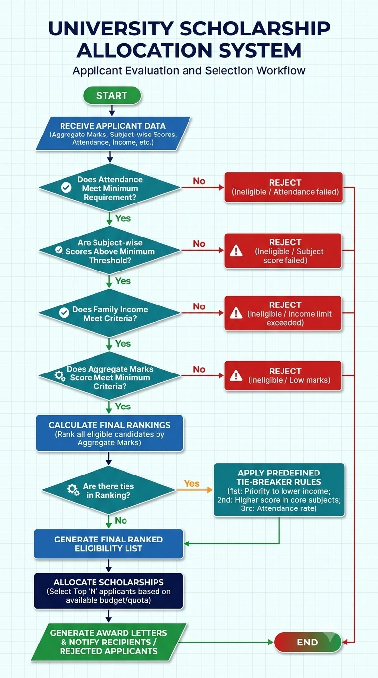

10. Pseudocode
BEGIN
INPUT N, K
eligible_applicants ← empty list
rejected_applicants ← empty list
FOR each applicant from 1 to N
INPUT student_id, name, aggregate
INPUT subject_marks, attendance, income
eligible ← TRUE
reasons ← empty list
IF aggregate < 75 THEN
eligible ← FALSE
ADD "Aggregate below 75%" TO reasons
END IF
FOR each mark IN subject_marks
IF mark < 60 THEN
eligible ← FALSE
ADD "A subject mark is below 60%" TO reasons
END IF
END FOR
IF attendance < 75 THEN
eligible ← FALSE
ADD "Attendance below 75%" TO reasons
END IF
IF income > 300000 THEN
eligible ← FALSE
ADD "Income exceeds ₹3,00,000" TO reasons
END IF
IF eligible = TRUE THEN
ADD applicant TO eligible_applicants
ELSE
ADD (applicant, reasons) TO rejected_applicants
END IF
END FOR
SORT eligible_applicants BY
aggregate DESCENDING,
attendance DESCENDING,
income ASCENDING,
subject_average DESCENDING,
student_id ASCENDING
recipients ← first K records from eligible_applicants
DISPLAY eligible_applicants
DISPLAY recipients
DISPLAY rejected_applicants
END

11. Python Program
def evaluate_applicant(applicant):
reasons = []
if not 0 <= applicant["aggregate"] <= 100:
reasons.append("Invalid aggregate percentage")
elif applicant["aggregate"] < 75:
reasons.append("Aggregate below 75%")
if not 0 <= applicant["attendance"] <= 100:
reasons.append("Invalid attendance percentage")
elif applicant["attendance"] < 75:
reasons.append("Attendance below 75%")
if applicant["income"] < 0:
reasons.append("Invalid family income")
elif applicant["income"] > 300000:
reasons.append("Income exceeds Rs. 3,00,000")
if not applicant["subject_marks"]:
reasons.append("Subject marks were not provided")
else:
for mark in applicant["subject_marks"]:
if not 0 <= mark <= 100:
reasons.append("Invalid subject mark")
break
if mark < 60:
reasons.append("At least one subject mark is below 60%")
break
return reasons
def scholarship_allocation(applicants, scholarship_count):
eligible = []
rejected = []
for applicant in applicants:
reasons = evaluate_applicant(applicant)
if not reasons:
applicant["subject_average"] = (
sum(applicant["subject_marks"]) /
len(applicant["subject_marks"])
)
eligible.append(applicant)
else:
rejected.append((applicant["student_id"], reasons))
# Higher aggregate and attendance rank first.
# Lower income is preferred when the first two values are tied.
# Higher subject average is next; student ID makes the order deterministic.
eligible.sort(key=lambda a: (
-a["aggregate"],
-a["attendance"],
a["income"],
-a["subject_average"],
a["student_id"]
))
recipients = eligible[:scholarship_count]
return eligible, recipients, rejected
# Example data
applicants = [
{
"student_id": "S103", "name": "Asha",
"aggregate": 88.5, "subject_marks": [85, 91, 89],
"attendance": 92, "income": 250000
},
{
"student_id": "S101", "name": "Bharat",
"aggregate": 88.5, "subject_marks": [90, 86, 90],
"attendance": 92, "income": 180000
},
{
"student_id": "S102", "name": "Charan",
"aggregate": 72, "subject_marks": [80, 75, 78],
"attendance": 90, "income": 150000
}
]
eligible, recipients, rejected = scholarship_allocation(applicants, 2)
print("Ranked eligible applicants:")
for rank, student in enumerate(eligible, start=1):
print(rank, student["student_id"], student["name"],
student["aggregate"], student["attendance"])
print("\nScholarship recipients:")
for student in recipients:
print(student["student_id"], student["name"])
print("\nIneligible applicants and reasons:")
for student_id, reasons in rejected:
print(student_id, "-", "; ".join(reasons))

12. Sample Output and Explanation
For the sample data, Asha and Bharat both have an aggregate of 88.5% and attendance of 92%. The tie is resolved by annual family income, so Bharat (₹1,80,000) ranks above Asha (₹2,50,000). Charan is rejected because the aggregate is below 75%, even though the other sample values meet their respective thresholds.
Ranked eligible applicants:
1 S101 Bharat 88.5 92
2 S103 Asha 88.5 92
Scholarship recipients:
S101 Bharat
S103 Asha
Ineligible applicants and reasons:
S102 - Aggregate below 75%

13. Lists, Nested Lists, Tuples and Unpacking
The program uses a list to store applicants and another list to store subject marks. A nested list can represent marks for multiple applicants. A tuple is useful for storing fixed ranking information or returning a student ID with rejection reasons.
# List of subject marks for one applicant
subject_marks = [85, 91, 89]
# Nested list: each inner list contains one student's subject marks
all_subject_marks = [
[85, 91, 89],
[90, 86, 90],
[80, 75, 78]
]
# Common list operations
subject_marks.append(95) # add a mark
highest_mark = max(subject_marks)
subject_marks.sort() # sort marks in ascending order
# Tuple: an immutable record-like grouping
student_record = ("S101", "Bharat", 88.5)
# Tuple operations and unpacking
student_id, student_name, aggregate = student_record
first_subject, second_subject, third_subject = (85, 91, 89)
# Tuple indexing and slicing
record_id = student_record[0]
basic_details = student_record[0:2]
# A tuple can be used to store rejection details
rejection = ("S102", ("Aggregate below 75%",))

14. Strings and Pattern Generation
Strings store names and student IDs. String operations can format reports, standardize IDs, and generate simple output patterns. Pattern generation is not essential to the allocation decision, but it demonstrates loop and string concepts.
student_name = " asha reddy "
clean_name = student_name.strip().title()
student_id = "s103".upper()
# Simple rank pattern
for rank in range(1, 5):
print("*" * rank)
# Example output:
*
**
***
****

15. Testing and Edge Cases
Test case | Expected result
Aggregate exactly 75% | Passes the aggregate condition.
A subject mark exactly 60% | Passes the subject minimum.
Attendance exactly 75% | Passes the attendance condition.
Income exactly ₹3,00,000 | Passes the income condition.
One subject mark is 59.99% | Fails subject-wise eligibility.
Two applicants tie on aggregate | Compare attendance, then income, then subject average, then ID.
No eligible applicants | Display an empty eligible list and no recipients.
Fewer eligible applicants than K | Award scholarships to all eligible applicants only.
Invalid percentage or negative income | Reject the record as invalid; do not rank it.

16. Time Complexity
Let N be the number of applicants and S be the number of subjects per applicant. Eligibility checking takes O(N × S), because each subject is checked once for each applicant. Sorting E eligible applicants takes O(E log E), where E is at most N. Therefore, the overall time complexity is O(N × S + E log E). The lists used to store applicant information require O(N × S) space in the general case.

17. Conclusion
The proposed scholarship allocation system applies clear eligibility conditions and a published ranking policy to produce consistent results. It demonstrates computational thinking, algorithm development, flowcharts, pseudocode, variables, data types, operators, conditional statements, loops, strings, pattern generation, lists, nested lists, tuples, tuple operations and unpacking. For real deployment, the university should verify the policy thresholds, protect applicant data, provide an appeal process, and test the program with official sample cases.

