UNIVERSITY SCHOLARSHIP ALLOCATION SYSTEM
Python Programming Project

1. Problem Statement
Universities receive scholarship applications from many students. Manually checking each application and preparing a merit list can be time-consuming and may lead to inconsistent decisions. The aim is to develop a Python-based system that evaluates applicants using aggregate marks, subject-wise minimum marks, attendance, and annual family income. The system identifies eligible students, ranks them according to fixed rules, resolves ties fairly, and selects students according to the number of scholarships available.

2. Objectives
- Accept applicant details, subject marks, attendance percentage, and annual family income.
- Calculate aggregate percentage from the entered subject marks.
- Check every eligibility condition consistently.
- Reject applicants who fail at least one required condition.
- Rank eligible applicants using predefined merit and tie-break rules.
- Select the highest-ranked applicants up to the available scholarship slots.
- Display applicant-wise eligibility and the final merit list.

3. Eligibility Rules and Assumptions
For this demonstration, the following sample rules are used. A university can change these limits according to its official scholarship policy.
- Aggregate percentage must be at least 75%.
- Each subject mark must be at least 60%.
- Attendance must be at least 75%.
- Annual family income must not exceed Rs. 3,00,000.
- The top 3 eligible applicants receive scholarships in the sample run.
Tie-break order: (1) higher aggregate percentage, (2) higher attendance, (3) lower annual family income, and (4) applicant ID in ascending alphabetical order. This order is applied only when the previous criterion is tied.

4. Algorithm
1. Start the program and define the eligibility limits and number of scholarships.
2. Read the details of each applicant: ID, name, subject marks, attendance, and annual family income.
3. Calculate aggregate percentage as the average of the subject marks.
4. Check whether aggregate, every subject mark, attendance, and income satisfy the eligibility rules.
5. If any condition fails, mark the applicant as NOT ELIGIBLE; otherwise, add the applicant to the eligible list.
6. After processing all applicants, sort the eligible list by aggregate (descending), attendance (descending), income (ascending), and ID (ascending).
7. Assign ranks and select the first N applicants, where N is the number of available scholarships.
8. Display the eligibility status, ranked list, selected applicants, and end.

5. Flowchart
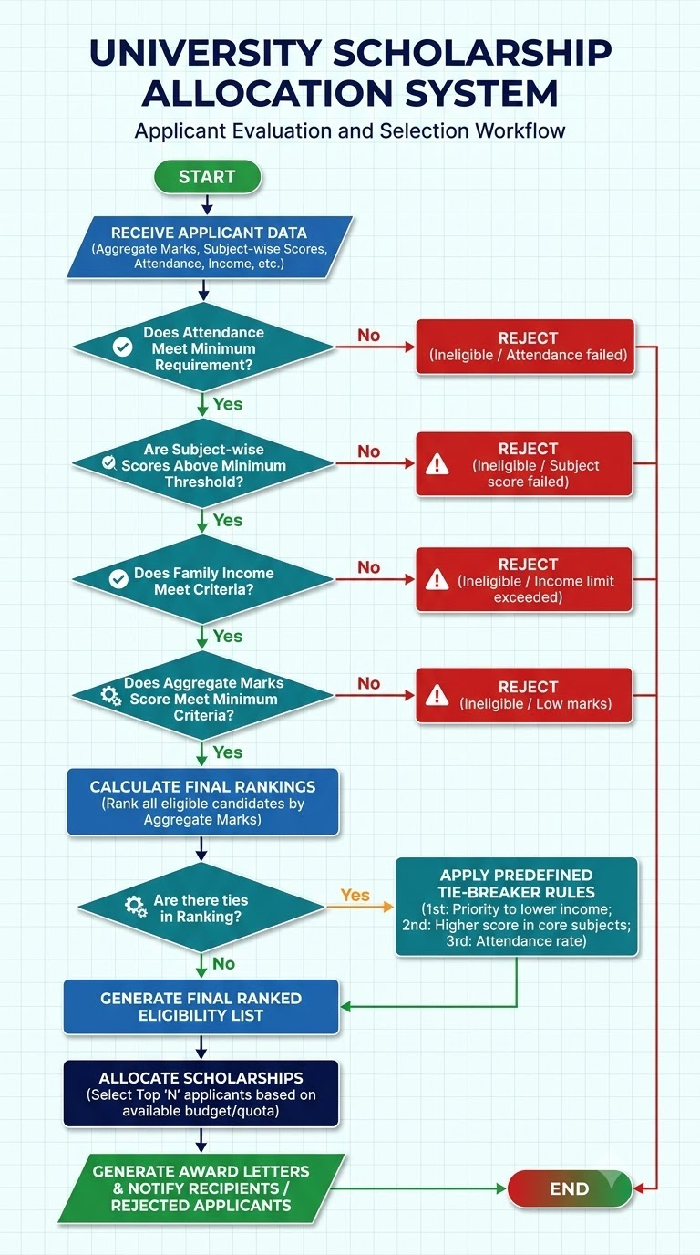

6. Pseudocode
BEGIN
SET MIN_AGGREGATE = 75
SET MIN_SUBJECT = 60
SET MIN_ATTENDANCE = 75
SET MAX_INCOME = 300000
SET SCHOLARSHIP_SLOTS = 3
CREATE empty ELIGIBLE_LIST
FOR each APPLICANT
CALCULATE aggregate = average(subject_marks)
IF aggregate >= MIN_AGGREGATE AND
every subject mark >= MIN_SUBJECT AND
attendance >= MIN_ATTENDANCE AND
income <= MAX_INCOME THEN
ADD applicant to ELIGIBLE_LIST
SET status = "ELIGIBLE"
ELSE
SET status = "NOT ELIGIBLE"
END IF
END FOR
SORT ELIGIBLE_LIST BY
aggregate descending,
attendance descending,
income ascending,
applicant_id ascending
DISPLAY ranked ELIGIBLE_LIST
DISPLAY first SCHOLARSHIP_SLOTS applicants as SELECTED
END

7. Python Actual Code
# University Scholarship Allocation System
MIN_AGGREGATE = 75
MIN_SUBJECT = 60
MIN_ATTENDANCE = 75
MAX_INCOME = 300000
SCHOLARSHIP_SLOTS = 3
applicants = [
{"id": "S101", "name": "Asha", "marks": [88, 90, 86], "attendance": 92, "income": 180000},
{"id": "S102", "name": "Bharat", "marks": [82, 80, 84], "attendance": 85, "income": 220000},
{"id": "S103", "name": "Charan", "marks": [78, 80, 76], "attendance": 90, "income": 250000},
{"id": "S104", "name": "Divya", "marks": [91, 93, 89], "attendance": 70, "income": 150000},
{"id": "S105", "name": "Esha", "marks": [84, 86, 82], "attendance": 88, "income": 350000},
{"id": "S106", "name": "Farhan", "marks": [80, 82, 78], "attendance": 80, "income": 200000},
]
eligible = []
print("UNIVERSITY SCHOLARSHIP ALLOCATION SYSTEM")
print("=" * 60)
print("Applicant-wise evaluation")
for applicant in applicants:
aggregate = sum(applicant["marks"]) / len(applicant["marks"])
applicant["aggregate"] = aggregate
subject_ok = all(mark >= MIN_SUBJECT for mark in applicant["marks"])
attendance_ok = applicant["attendance"] >= MIN_ATTENDANCE
income_ok = applicant["income"] <= MAX_INCOME
aggregate_ok = aggregate >= MIN_AGGREGATE
if aggregate_ok and subject_ok and attendance_ok and income_ok:
applicant["status"] = "ELIGIBLE"
eligible.append(applicant)
else:
applicant["status"] = "NOT ELIGIBLE"
print(f'{applicant["id"]:<6} {applicant["name"]:<10} '
f'{aggregate:>6.2f}% {applicant["status"]}')
# Tie-break rules: aggregate high, attendance high,
# income low, then applicant ID alphabetical.
eligible.sort(key=lambda a: (
-a["aggregate"],
-a["attendance"],
a["income"],
a["id"]
))
print("\\nRANKED ELIGIBLE APPLICANTS")
print("=" * 60)
for rank, applicant in enumerate(eligible, start=1):
print(f'{rank}. {applicant["id"]} - {applicant["name"]} | '
f'Aggregate: {applicant["aggregate"]:.2f}% | '
f'Attendance: {applicant["attendance"]}% | '
f'Income: Rs. {applicant["income"]}')
selected = eligible[:SCHOLARSHIP_SLOTS]
print(f"\\nScholarship slots available: {SCHOLARSHIP_SLOTS}")
print("Selected:", ", ".join(a["id"] for a in selected))

8. Sample Input Data
ID | Name | Subject Marks | Attendance | Income (Rs.) | Expected Status
S101 | Asha | 88, 90, 86 | 92% | 180,000 | Eligible
S102 | Bharat | 82, 80, 84 | 85% | 220,000 | Eligible
S103 | Charan | 78, 80, 76 | 90% | 250,000 | Eligible
S104 | Divya | 91, 93, 89 | 70% | 150,000 | Not eligible: attendance
S105 | Esha | 84, 86, 82 | 88% | 350,000 | Not eligible: income
S106 | Farhan | 80, 82, 78 | 80% | 200,000 | Eligible

9. Sample Output Screenshot
The following screenshot-style image shows the expected console output when the program is run with the sample data.
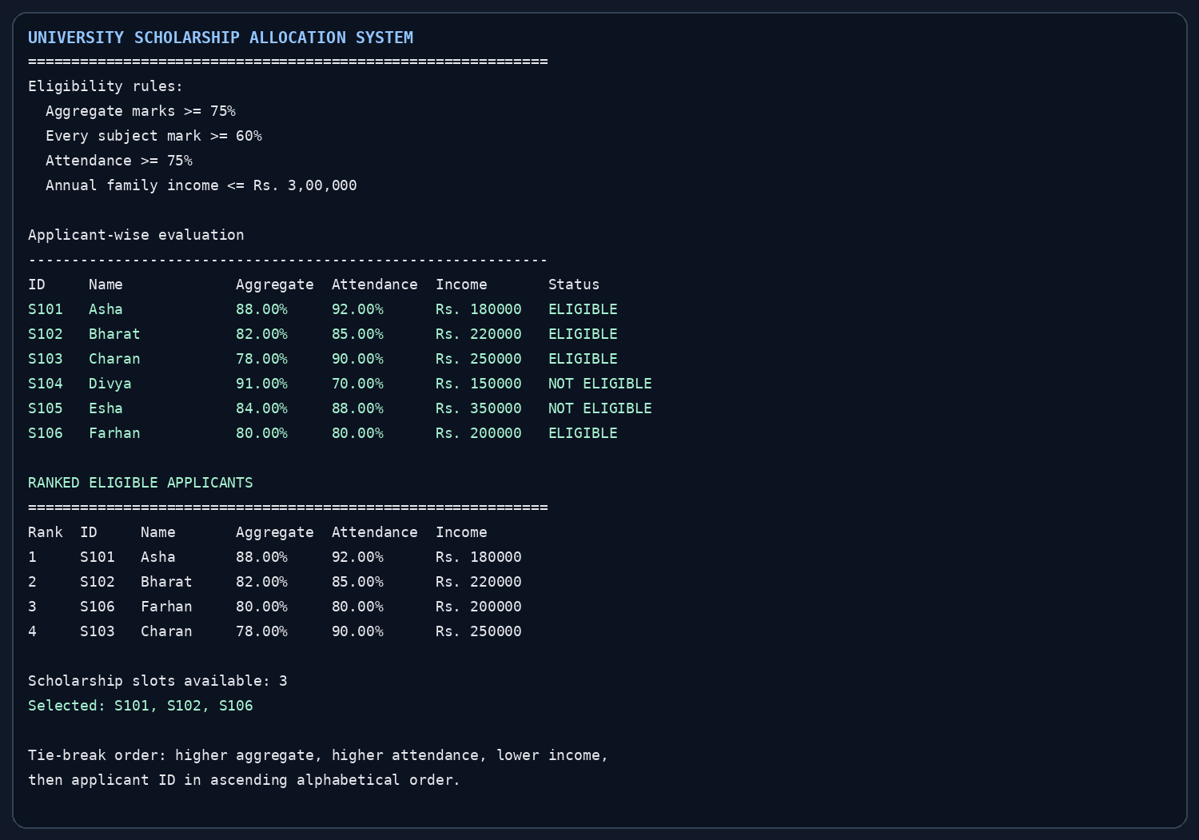

10. Explanation of the Output
Asha, Bharat, Charan, and Farhan satisfy all four eligibility conditions. Divya is rejected because her attendance is below 75%, even though her marks and income satisfy the other limits. Esha is rejected because her annual family income is above Rs. 3,00,000. The eligible applicants are ranked by the stated tie-break order. Asha ranks first, Bharat second, Farhan third, and Charan fourth. Since only three scholarships are available, Asha, Bharat, and Farhan are selected.

11. Conclusion
The University Scholarship Allocation System automates the checking and ranking of scholarship applications. It applies the same eligibility conditions to every applicant and uses transparent tie-break rules to prepare a merit list. The project demonstrates computational thinking, algorithms, conditional statements, loops, lists, dictionaries, functions such as all(), and sorting in Python. The system can be extended by accepting user input, reading applicant records from a file or database, and generating official merit-list reports. The thresholds and tie-break rules in this project are illustrative and should be replaced with the university's approved policy before real use.

— End of Project —

