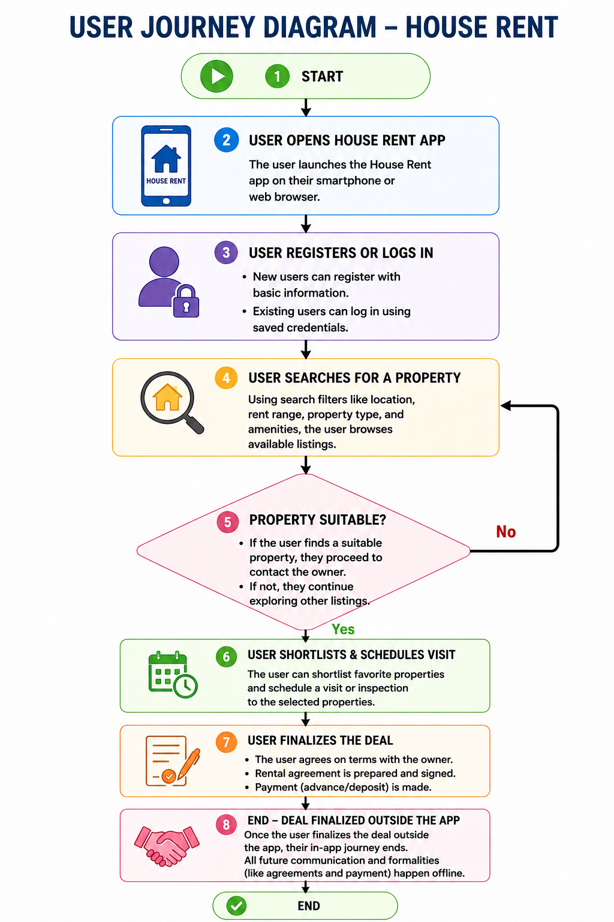
User Flow Diagram for House Rent
Title
User Journey Diagram – House Rent Application

Objective
The user journey diagram shows the complete flow of how a user interacts with the House Rent application, from opening the app to completing the rental process.

Step-by-Step Explanation
- Step 1: Start
- Step 2: User opens the House Rent app.
- Step 3: User registers or logs in.
- Step 4: User searches for properties using filters.
- Step 5: System checks whether a suitable property is found.
If No, the user continues searching.
If Yes, the user proceeds to the next step.
- Step 6: User shortlists the property and schedules a visit.
- Step 7: The rental deal is finalized outside the application.
- End: The user journey is completed.

Benefits of the User Journey
- Helps understand the user flow.
- Improves user experience.
- Identifies important features.
- Makes the application easy to use.
- Helps developers plan the system.

Conclusion
The User Journey Diagram provides a clear understanding of how users interact with the House Rent application and helps ensure a simple and efficient rental process.

