MVC Architecture – HouseRent Application

Description
The HouseRent application follows the Model-View-Controller (MVC) architecture separating the application into Model, View (Routes), and Controller layers.

MVC Architecture Diagram
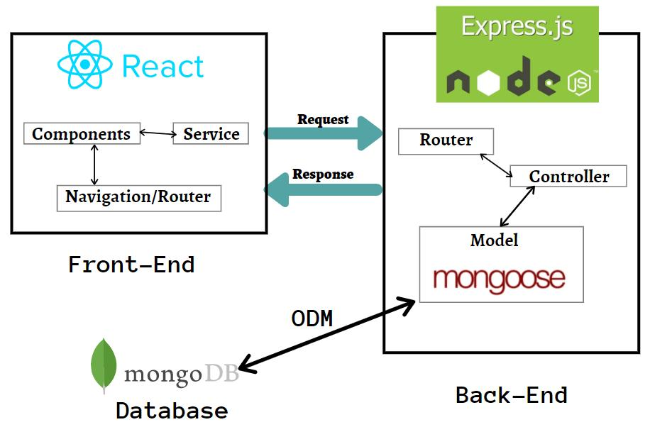

Model Layer
Handles data schemas and database operations using Mongoose with MongoDB.

Controller Layer
Receives requests, performs business logic, communicates with models, and returns responses.

View (Routing) Layer
Defines REST API endpoints and invokes controller methods.

Advantages of MVC
• Separation of Concerns
• Scalability
• Reusability
• Easier Testing
• Collaboration-Friendly

Conclusion
MVC provides a modular, scalable, and maintainable architecture for the HouseRent application.

