FEATURES FOR HOUSE RENT

Advanced Property Search
This module allows users to efficiently find rental properties using multiple search filters and save their preferred search criteria.
- Search by location
- Budget
- Property type
- Bedrooms
- Furnishing
- Parking
- Nearby schools or hospitals

Features
• Filters: Location, Price Range, Property Type, Property Size, Bedrooms, Bathrooms, Amenities (Parking, Garage, Pool, Pet-Friendly, Wi-Fi, Furnished, Security).
• Saved Searches: Users can save frequently used search criteria for quick access.

Market Insights and Trends
This module provides useful information about rental markets to support informed decisions.
• Price Trends: Average rent and price trends by location.
• Neighbourhood Insights: Schools, hospitals, transport, shopping, parks and nearby facilities.
• Investment Potential: Rental demand, appreciation, occupancy and investment opportunities.
- Rental price trends
- Popular locations
- Investment opportunities
- Nearby amenities
- Property demand analysis

Functional Requirements
- User Registration and Login
- Property Management
- Advanced Property Search
- Booking Management
- Online Payment
- Complaint Management
- Review and Rating System
- Rental Agreement Generation
- Notification Service
- Dashboard and Reports

House Rent Management System Diagrams

1. Use Case Diagram
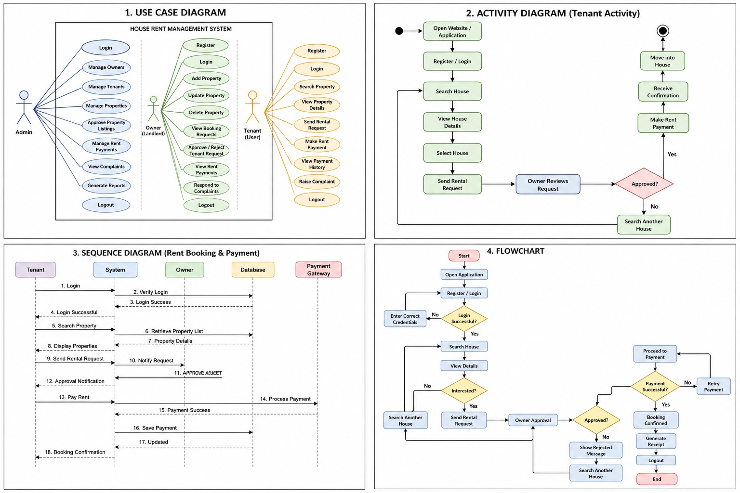
1. Admin logs into the system.
2. Owner registers and logs in.
3. Tenant registers and logs in.
4. Owner adds and manages property details.
5. Tenant searches and views available properties.
6. Tenant sends a rental request to the owner.
7. Owner approves or rejects the rental request.
8. Tenant makes rent payment and views payment history.

2. Activity Diagram

1. Start the application.
2. User registers or logs into the system.
3. Tenant searches for available houses.
4. Tenant views property details.
5. Tenant submits a rental request.
6. Owner reviews and approves/rejects the request.
7. If approved, the tenant completes the payment.
8. Booking is confirmed and the process ends.

3. Sequence Diagram

1. Tenant sends a login request to the system.
2. System verifies the login using the database.
3. Tenant searches for available properties.
4. System retrieves property details from the database.
5. Tenant sends a rental request.
6. Owner receives and responds to the request.
7. Tenant completes the rent payment through the payment gateway.
8. System stores the payment details and confirms the booking.

4. Flowchart

1. Start the application.
2. Register or log into the system.
3. Search for available houses.
4. View and select a suitable property.
5. Submit a rental request.
6. Owner approves or rejects the request.
7. If approved, proceed with the payment.
8. Booking is confirmed, receipt is generated, and the process ends.
Property Availability Status
- Shows whether a property is:
  - Available
  - Booked
  - Under Maintenance
- Prevents duplicate bookings.
Future Enhancements
- AI-based property recommendations.
- Chat feature between owner and tenant.
- GPS location and map integration.
- Virtual property tour using 360° images.
- QR code-based rent payment.
- Mobile application for Android and iOS.
- Multi-language support.
- Biometric or OTP-based login.

