TECHNICAL ARCHITECTURE

Technical Architecture For House Rent
The House Rent Management System follows a client-server architecture using the MERN stack. It consists of a Presentation Layer (Frontend), Application Layer (Backend), and Data Layer (Database).

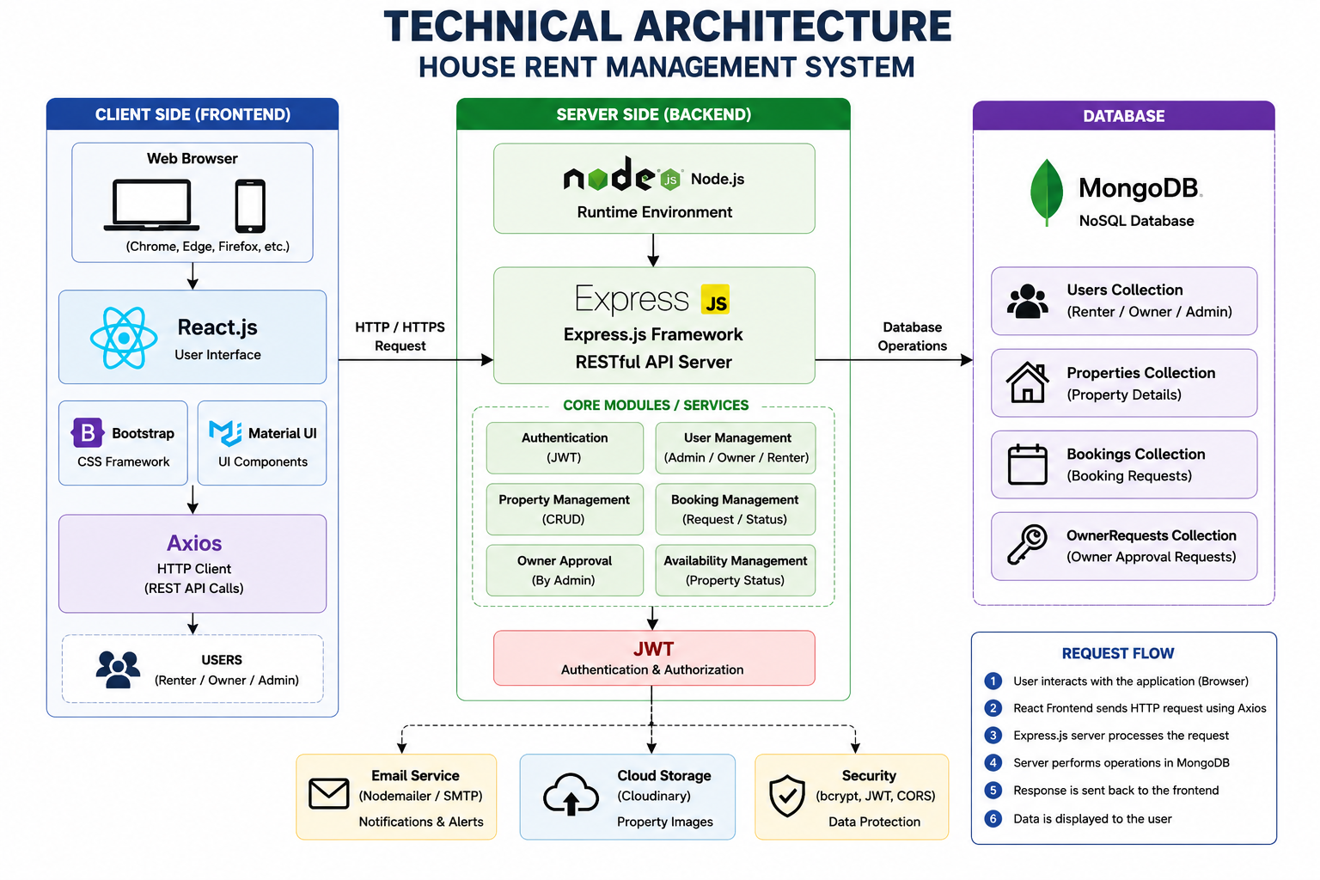

Presentation Layer (Frontend)
React.js provides the user interface. Bootstrap and Material UI create responsive pages. Axios communicates with backend REST APIs. Separate dashboards are available for Admin, Owner, and Renter.

Application Layer (Backend)
Node.js and Express.js implement business logic, authentication, property CRUD, booking management, owner approval, and REST APIs secured with JWT.

Data Layer (Database)
MongoDB stores Users, Properties, Bookings, and Owner Requests. Mongoose manages schemas and database operations.

Communication Flow
Users interact through a browser. Axios sends requests to Express APIs. Express processes the request, interacts with MongoDB, and returns responses displayed by React.

