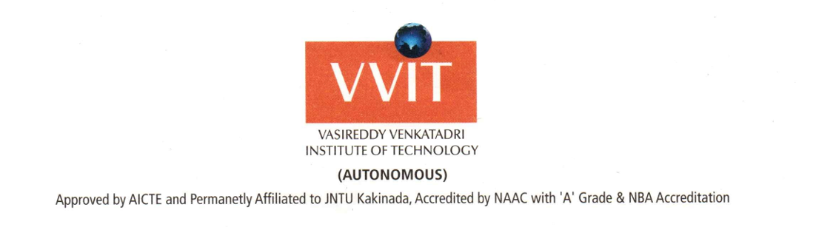

**LETTER OF RECOMMENDATION**

I take immense pleasure in recommending my student Rohitha Kalla for the master’s program at your esteemed institution. she has been under my instruction and guidance for 4 years. I have observed her performance and diligence during her tenure under my tutelage. She is an innovative thinker and has been very keen to learn concepts in Electronics and Communication. She has also assisted me in a National Level Techno Management Fest VIVA.

I have been a keen observant critic of Rohitha and guided her on her final project submission of Weather monitoring system using IoT. She has shown immense growth potential to adapt and learn multiple courses in a short time. Her performance has been consistent with an average of over 77% in academics. Rohitha has always had a voracious appetite for IoT technologies. I have witnessed her prowess and interest to learn and explore different areas of research during her final year project work.

Her earnestness along with her hardworking nature places her ahead of her peers. She has sound academic knowledge and research skills, which in my opinion would add immense value to your course and her career.

I have been part of this initiative and a guiding force for Rohitha throughout her course curriculum. She has made significant improvement in her social skills and has assiduously worked to improve her technical skills. Owing to the merit presented, she earned an internship in Java at Cognizant Technology Solutions later which turned to be a full time as Full Stack Developer.

As a student, Rohitha has shown immense growth and caliber in the years that I have groomed and mentored her. She has taught to set ambitious goals for herself and work to achieve them. With a deep sense of pride. Pursuing Masters at your esteemed institution would be a positive contributing factor to her career.

Yours Sincerely,

Dr. M.Y. Bhanu Murthy, Ph.D

Professor & Head of the Department

Department of Electronics and Communication Engineering

Email id:

Contact:

NAMBUR (V), PEDAKAKANI (M), GUNTUR (Dt.), A.P. INDIA, PIN:522 508 995102336, 0863-2234336 www.vvitguntur.com