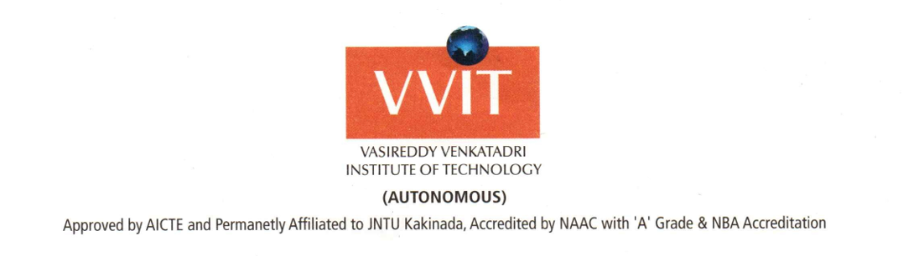

# LETTER OF RECOMMENDATION

1 take great pleasure in recommending **Rohitha Kalla** for her admission into the master’s program at your prestigious university. I have handled course of DIGITAL SIGNAL PROCESSING. As an Associate professor**,** I take this opportunity to evaluate her knowledge.

She has a good hold on the basic principles underlying the above subject, she is an extremely intelligent individual, who strives to achieves any goal that she sets her mind to. Her intuitive and methodical work has helped her in developing a broad perspective as well as mastery over fundamentals. She has shown great promise by venturing beyond the scope of the subject syllabi.

I found her very much interested in actively participating in all the department events. I have observed her works closely during the Academic events. She is one of the active participants and got appreciation for her innovative thoughts. Her presentations were always unique among all the submissions. Rohitha always tries to integrate the lectures with practical experiments.

During one of my interactions with her about future accomplishments, she told me of her interest in doing her Master's. Her zeal to apply all the learned concepts in their real life and expanding her knowledge through higher studies and research abilities is one of the strong reasons in recommending her.

I am sure that she possess all the requirements of a mere prospective student and your university will be the best place for her to fulfill all her desires and improve her existing skills. So, 1 sincerely recommend her for admission to your university and provide her with the requisite financial aid and assistantships. I wish her every success in her future endeavors.

Yours Sincerely,

Sri M. Pardha Saradhi, M.Tech(Ph.D),

Assoc. Professor

Department of Electronics and Communication Engineering

Email id:

Contact:

NAMBUR (V), PEDAKAKANI (M), GUNTUR (Dt.), A.P. INDIA, PIN:522 508 995102336, 0863-2234336 www.vvitguntur.co