SAP CPI Project Documentation
Author: Rohitha
Date:29/12/2025
________________________________________________________________
Scenario: Customer_Order_Processing_Integration
1.Scenario Overview
This project demonstrates a real-time order processing integration for an enterprise retail organization. Customer orders are received through a REST-based API in JSON format. These orders are processed in SAP Cloud Platform Integration (CPI), validated against business rules, and routed dynamically based on the order category (Online Store Orders or Express Store Orders). The integration ensures reliable processing with proper success responses and robust error-handling mechanisms.

2.Architechture Diagram
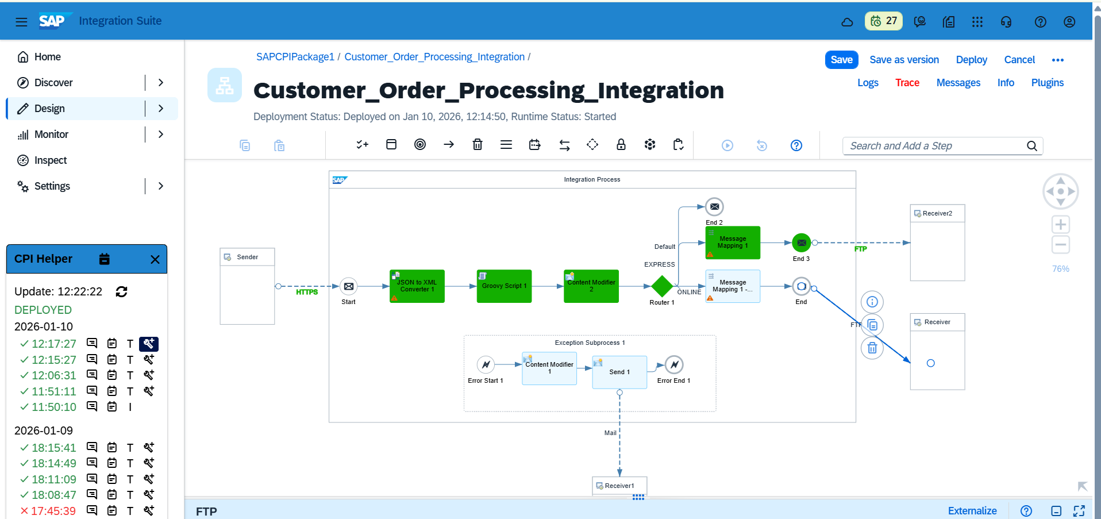3. Step-by-Step Implementation
- Input Sales orders from customer received via a REST API (JSON payload).
- Implemented Groovy scripting to validate incoming request payloads, such as mandatory fields.
- Routing logic to differentiate and process Online Store Orders and Express Store Orders based on order type.
- Implemented success and failure response flows with meaningful HTTP status codes and response messages for API consumers.
- Exception Subprocess to manage error scenarios such as invalid payloads, missing fields, and routing failures.
- Gmail Notification will send to Support team in case of exception.
- Applied Logic, Business rules and posted to receiver system.
4.Adapter Configuration:
REST Adapter (Sender): HTTP Rest API
Endpoint: https://b84a8864trial.it-cpitrial05-rt.cfapps.us10-001.hana.ondemand.com/http/SalesOrder
Method: POST
Authentication: Basic
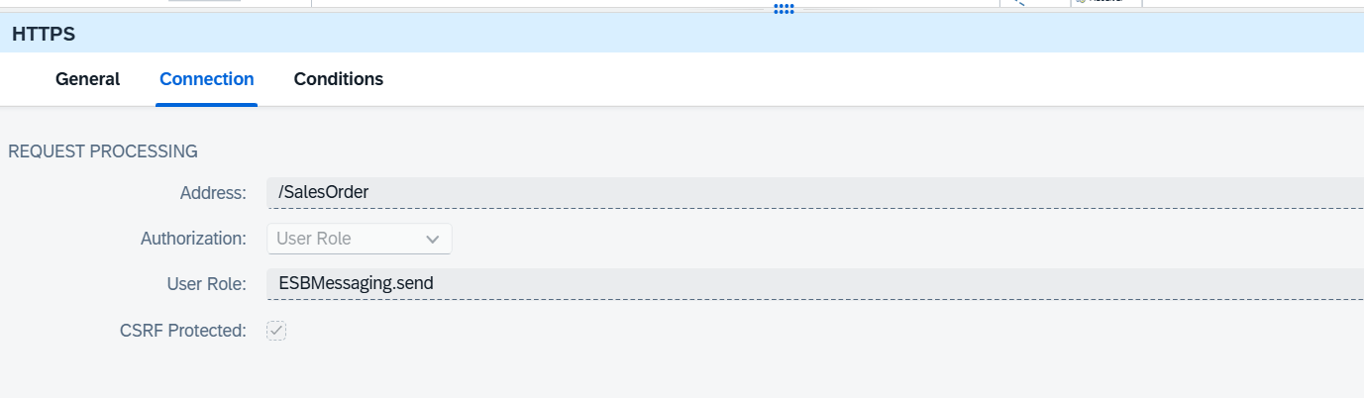
FTP Adapter (Receiver):
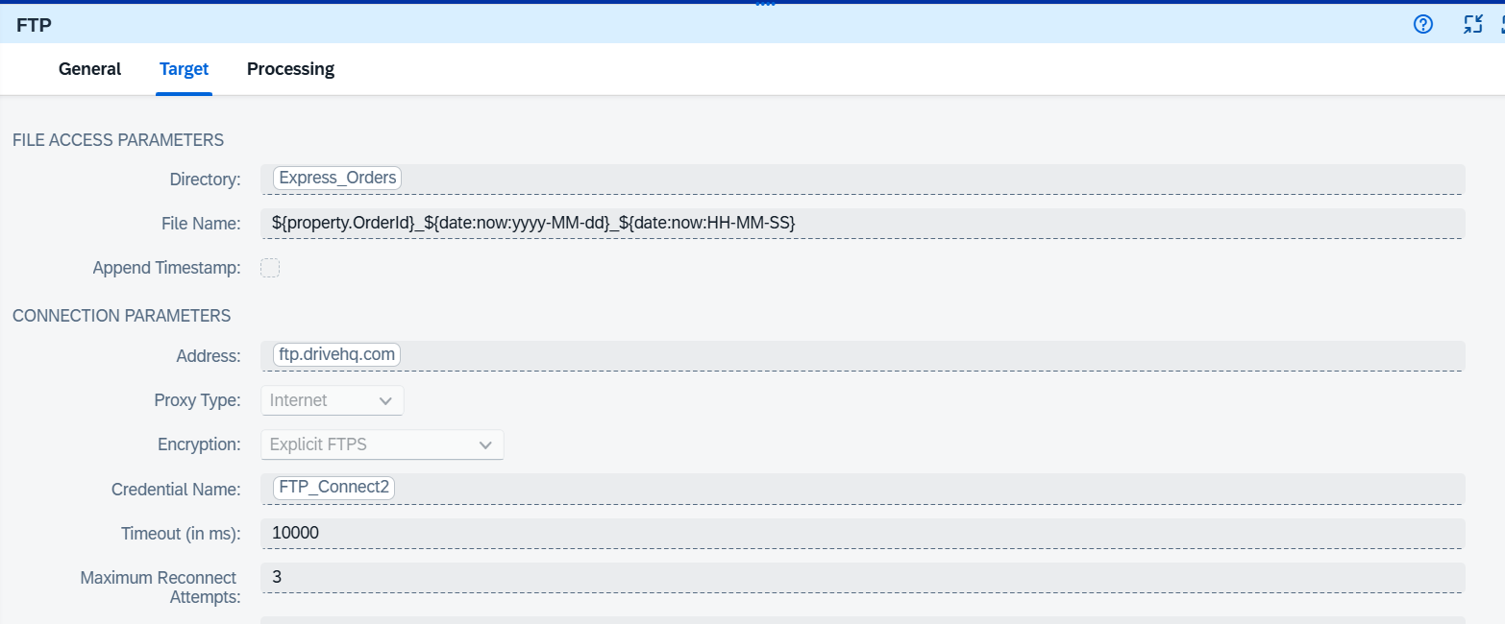

5.Integration Components:
JSON to XML Converter:
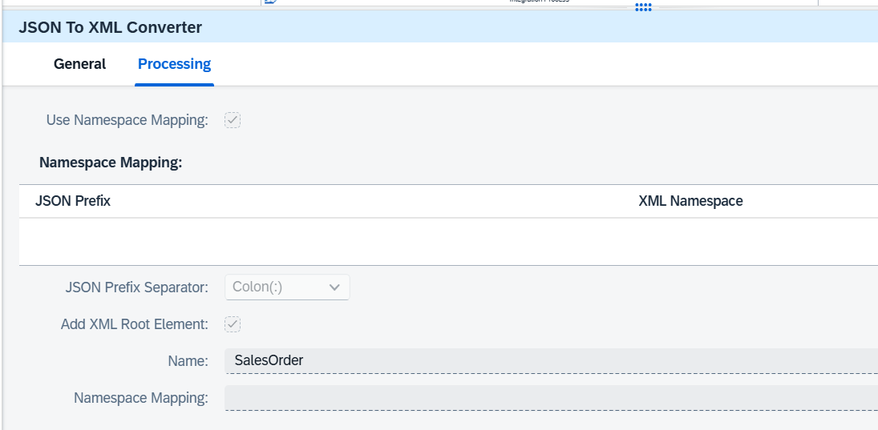
Content Modifier:
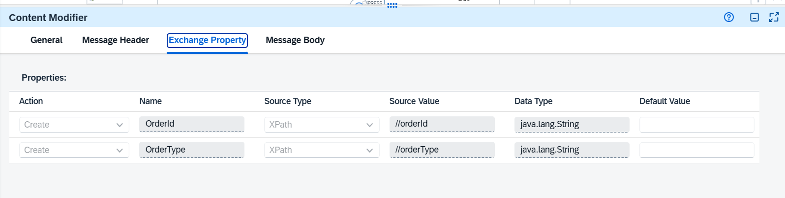
Router:
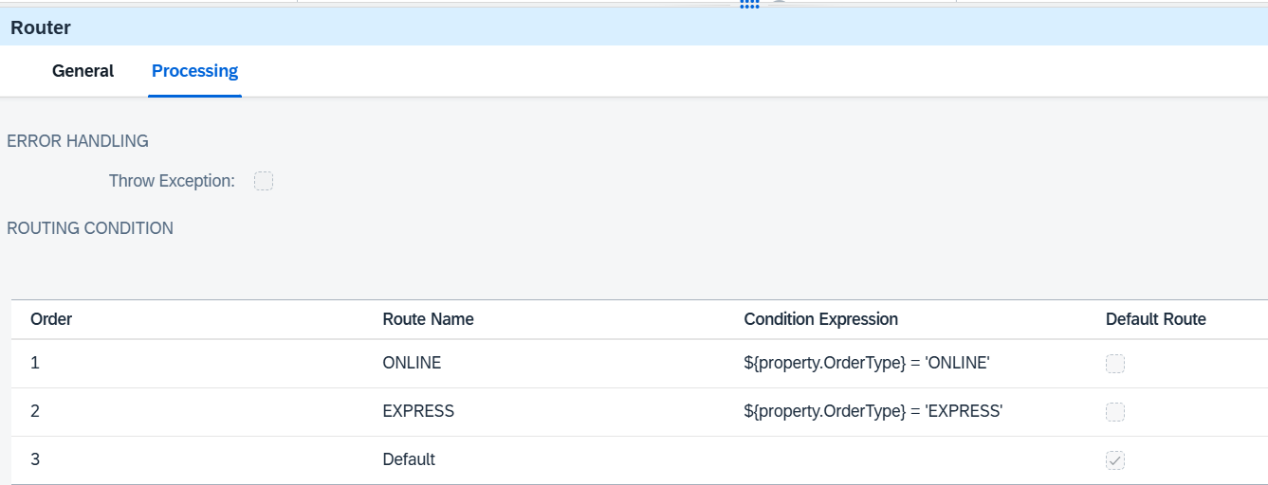

6.Exception Subprocess: Handles errors and log details.
7. Groovy Script:
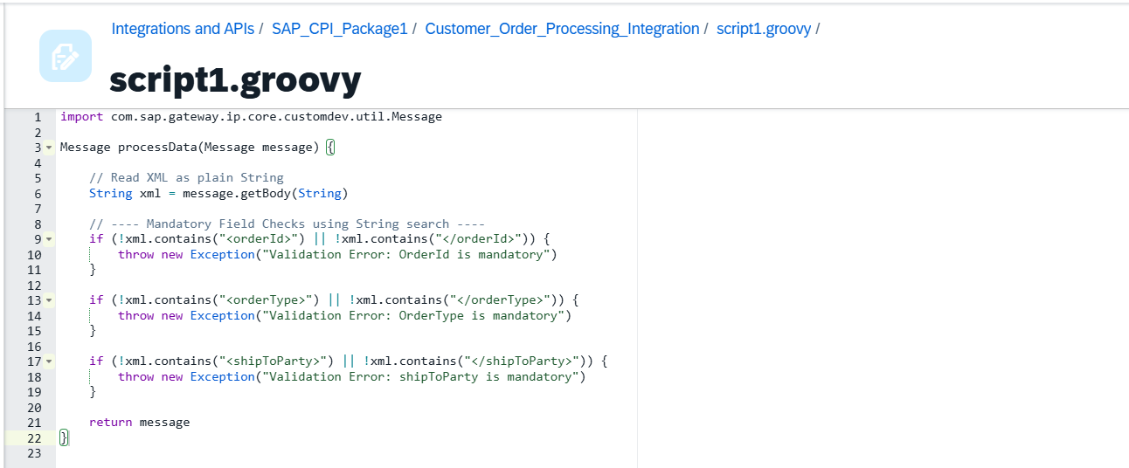

8. Input Data:
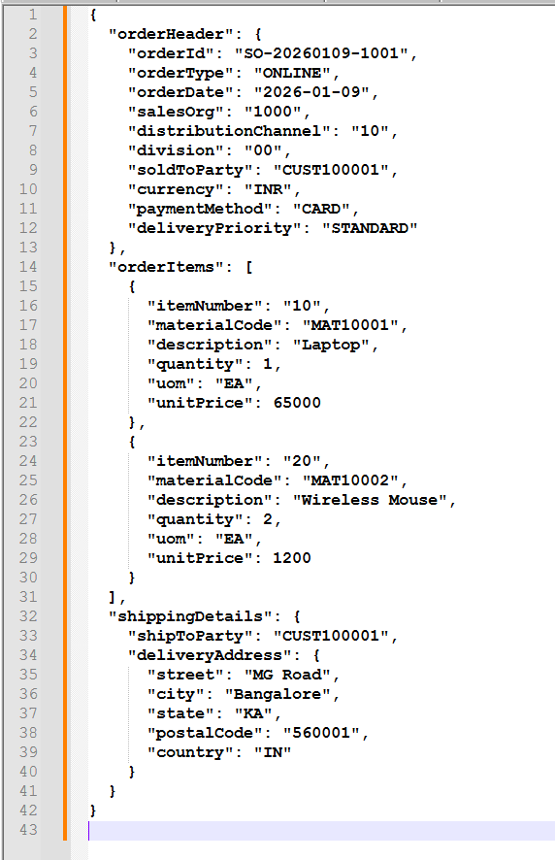

9. Output Data:
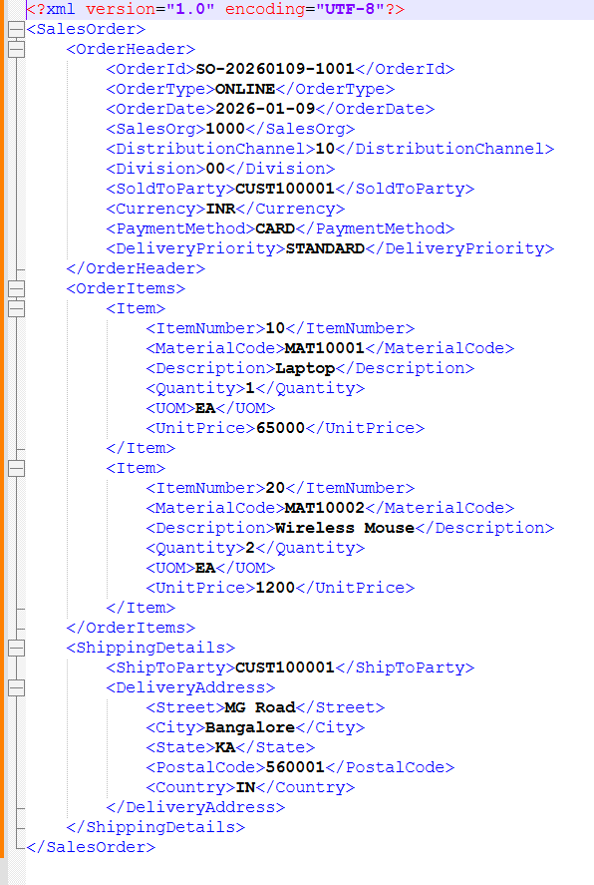

10 Notification to Gmail in failure case:
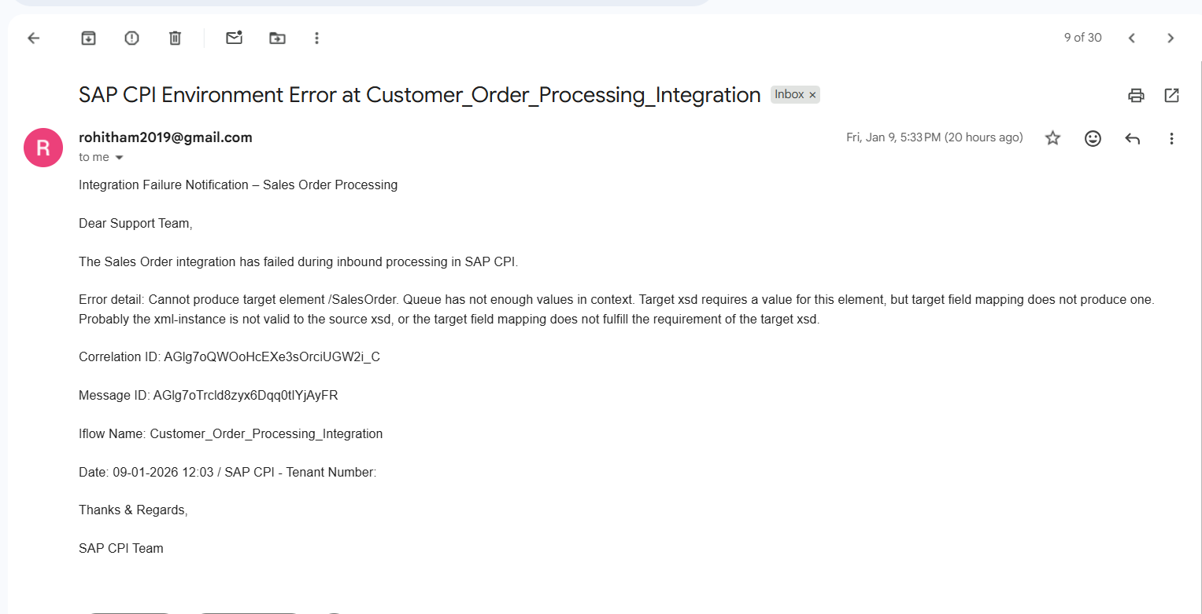
11 Iflow Package:

