SAP CPI Project Documentation
Author: Rohitha
Date:29/12/2025
________________________________________________________________
Scenario: Content-Based File Passthrough Interface
“It’s called a Content-Based File integration because the file name and target path are determined dynamically at runtime based on the payload content.”
1.Scenario Overview
This project automates the classification and routing of inbound files received from an upstream system. Files are transferred to SAP Cloud Platform Integration (CPI) via FTP. Based on the file name pattern, SAP CPI intelligently routes the files to different target folders on the FTP server. Files starting with “Order” are routed to the Orders folder, files starting with “Invoice” are routed to the Invoices folder, and all other files are moved to a default Other folder. This solution eliminates manual file segregation and ensures organized downstream processing.

2.Architechture Diagram
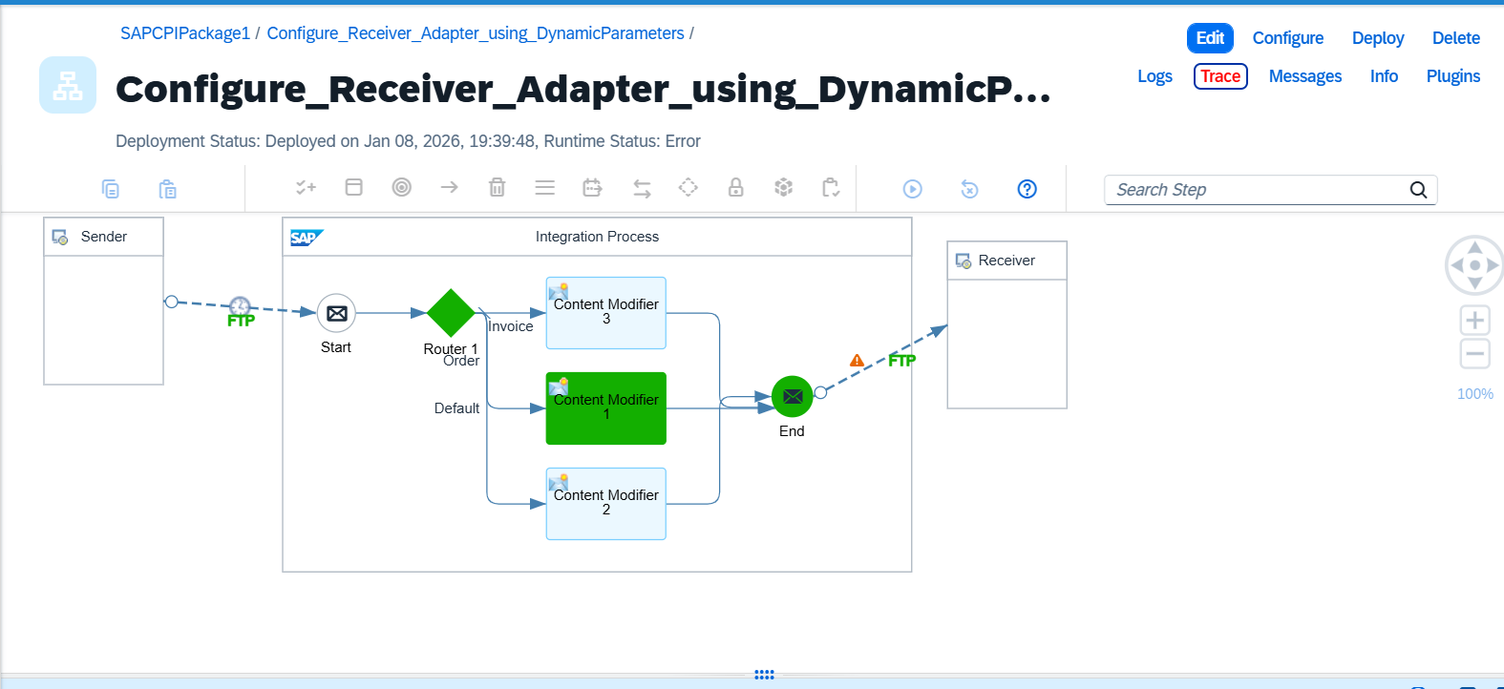

3. Step-by-Step Implementation
- Configured FTP Sender Adapter to receive files from the source system
- Implemented Content-Based Routing (CBR) using Regex Expressions
- Dynamically determined the target directory based on business rules:
  - Files starting with “Order” → Orders folder
  - Files starting with “Invoice” → Invoices folder
  - All other files → Other folder
- Configured FTP Receiver Adapter with dynamic directory assignment using message properties.
- Performed end-to-end testing for multiple file name scenarios to ensure accurate routing.

Step1 – Configure the FTP Sender Adapter:
Fetching all files in directory “ALL_FILES”
FTP Adapter (Sender):
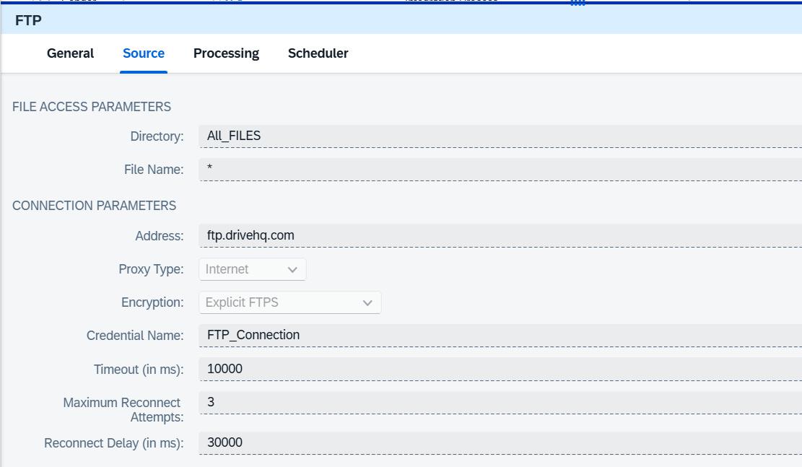

Step2 – Configure Content -Based Router
The filename of the incoming file will be available in the header parameter CamelFileNameOnly”.
We will route the files based on the prefix of the filename. Using a Regex expression,
We can find if the filename matches the pattern we are looking for
Regular expression to check if the file name starts with Order. Or Invoice.
${header.CamelFileNameOnly} regex ‘Order.*’
${header.CamelFileNameOnly} regex ‘Invoice.*’
Router:
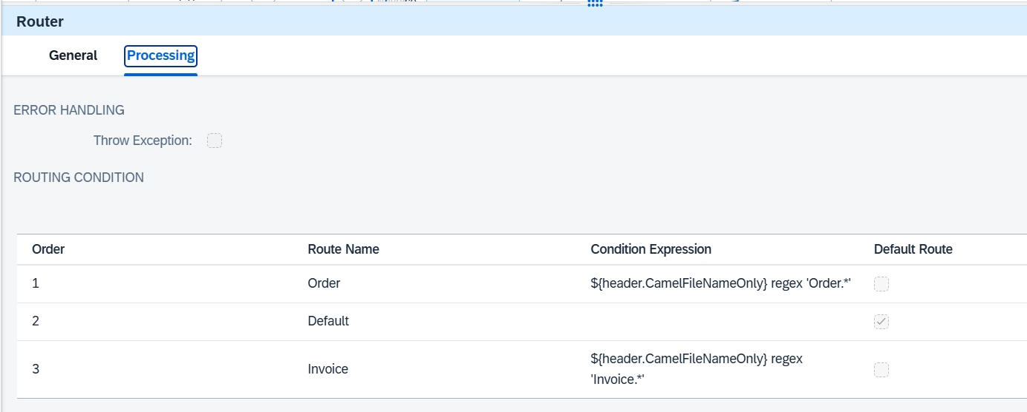

Step3 – Make Use of Exchange or Header parameters to set the Directory
Let’s make use of content modifiers to determine the directory at runtime.
We will have an exchange property parameter named “directory” to set the value of the directory.
Content Modifier:
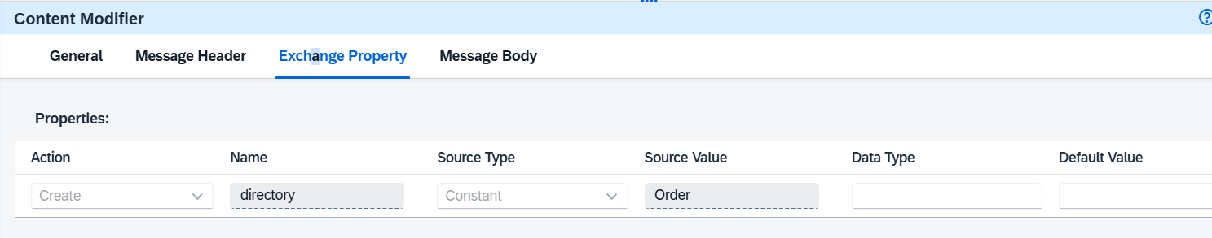
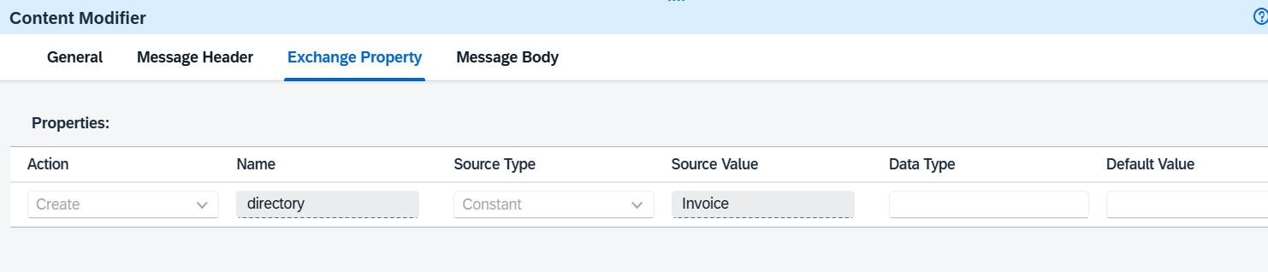
Step4 – Configure Receiver Adapter using Dynamic Parameters
We will make use of Camel Expressions to define the filename dynamically.
${file:onlyname.noext} – Camel Simple Expression to get the prefix or the filename of the incoming file without the extension
FTP Adapter (Receiver):
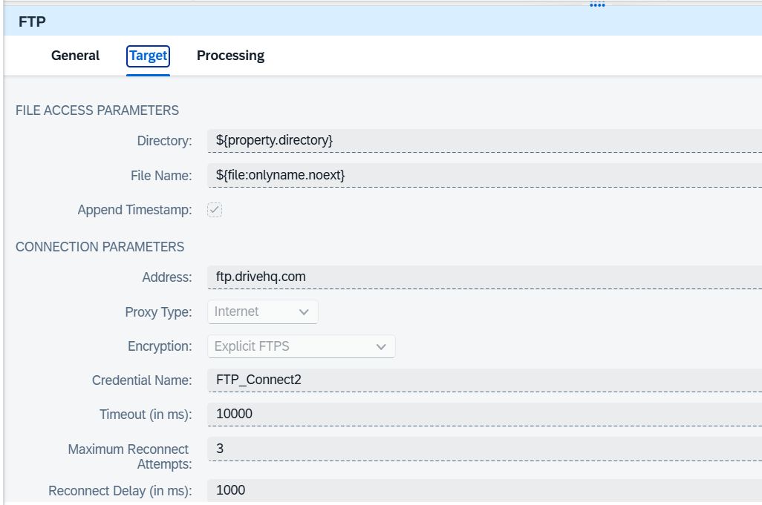

6. Input Data:

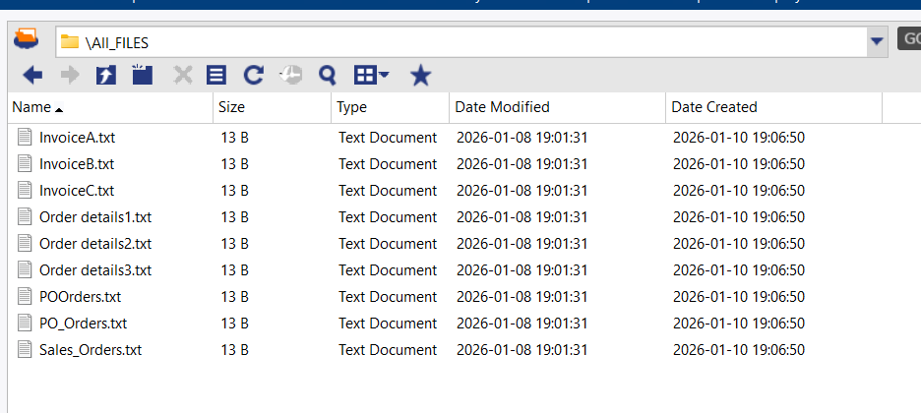
7. Output Data:

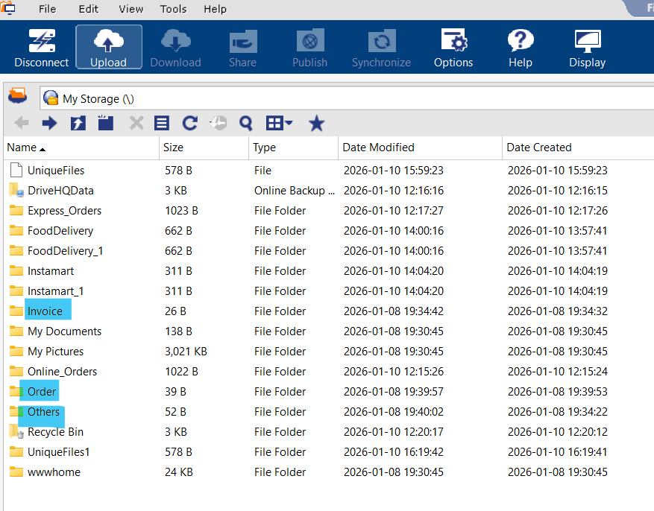
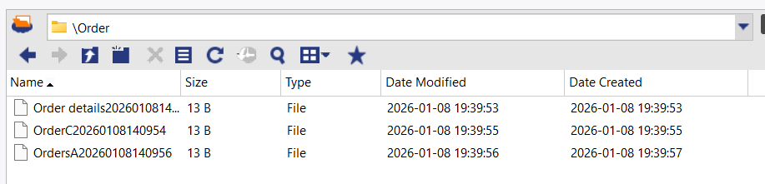
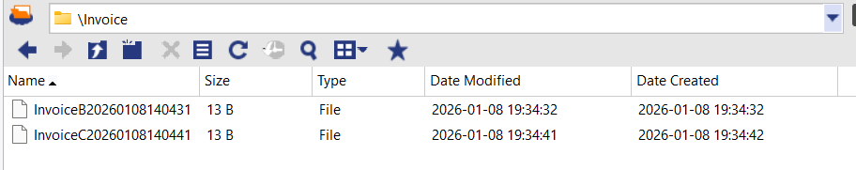
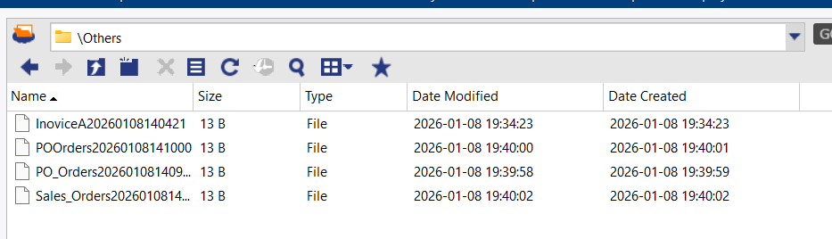
8. Iflow Package:

