Singleton Design Pattern
Output: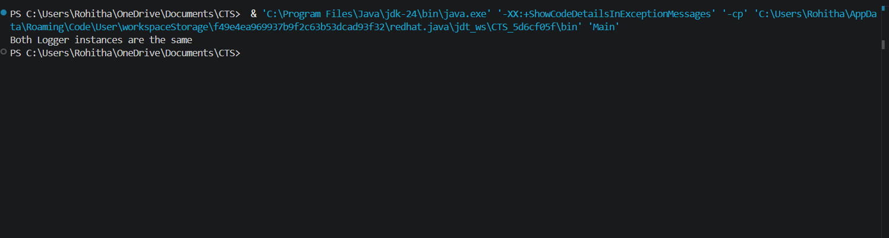
Factory Design Pattern
Output:

