1.Ecommerce Search Function
package Ecom;
import java.util.*;
public class Main {
public static void main(String[] args) {
Product[] products = {
new Product(101, "Laptop", "Electronics"),
new Product(205, "Shirt", "Clothing"),
new Product(150, "Watch", "Accessories"),
new Product(303, "Mobile", "Electronics")
};

// Sort array for binary search
Arrays.sort(products, Comparator.comparingInt(p -> p.productId));

int searchId = 150;

// Linear Search
Product result1 = SearchProduct.linearSearch(products, searchId);
System.out.println("Linear Search:");
System.out.println(result1 != null ? result1.productName : "Product not found");

// Binary Search
Product result2 = SearchProduct.binarySearch(products, searchId);
System.out.println("Binary Search:");
System.out.println(result2 != null ? result2.productName : "Product not found");
}

}

package Ecom;
public class Product {
int productId;
String productName;
String category;

public Product(int productId, String productName, String category) {
this.productId = productId;
this.productName = productName;
this.category = category;
}

}
package Ecom;

public class SearchProduct {

public static Product linearSearch(Product[] products, int targetId) {
for (Product product : products) {
if (product.productId == targetId) {
return product;
}
}
return null;
}

// Binary search - array must be sorted by productId
public static Product binarySearch(Product[] products, int targetId) {
int low = 0, high = products.length - 1;

while (low <= high) {
int mid = (low + high) / 2;
if (products[mid].productId == targetId) {
return products[mid];
} else if (products[mid].productId < targetId) {
low = mid + 1;
} else {
high = mid - 1;
}
}
return null;
}
}
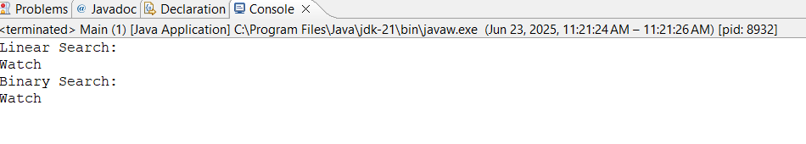

2.Financial Forecasting
Public class FinancialForecast{
public static double calculateFutureValue(double presentValue, double rate, int years) {
if (years == 0) {
return presentValue;
}
return (1 + rate) * calculateFutureValue(presentValue, rate, years - 1);
}
public static void main(String[] args) {
double presentValue = 10000.0; // Starting money
double annualGrowthRate = 0.08; // 8%
int years = 5;
double futureValue = calculateFutureValue(presentValue, annualGrowthRate, years);
System.out.printf("Future Value after %d years: ₹%.2f\n", years, futureValue);
}
}
