Hands on 1
Create a Spring Web Project using Maven
Follow steps below to create a project:
- Go to https://start.spring.io/
- Change Group as “com.cognizant”
- Change Artifact Id as “spring-learn”
- Select Spring Boot DevTools and Spring Web
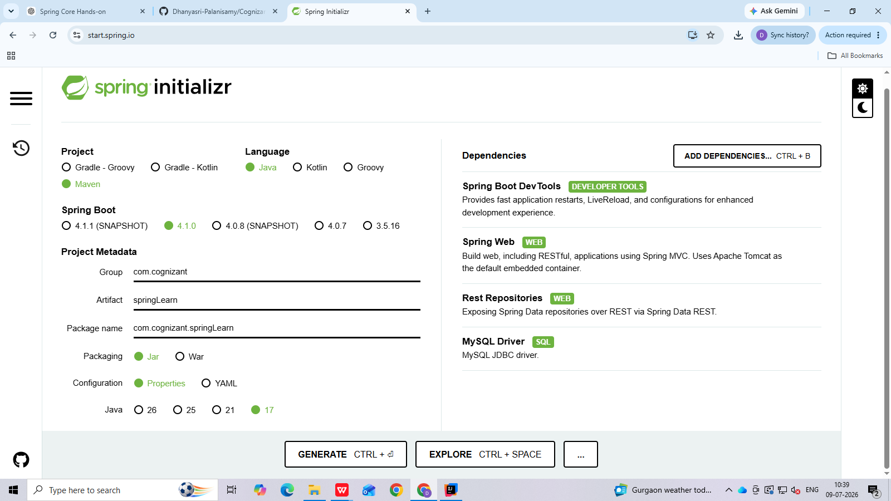
- Create and download the project as zip
- Extract the zip in root folder to Eclipse Workspace
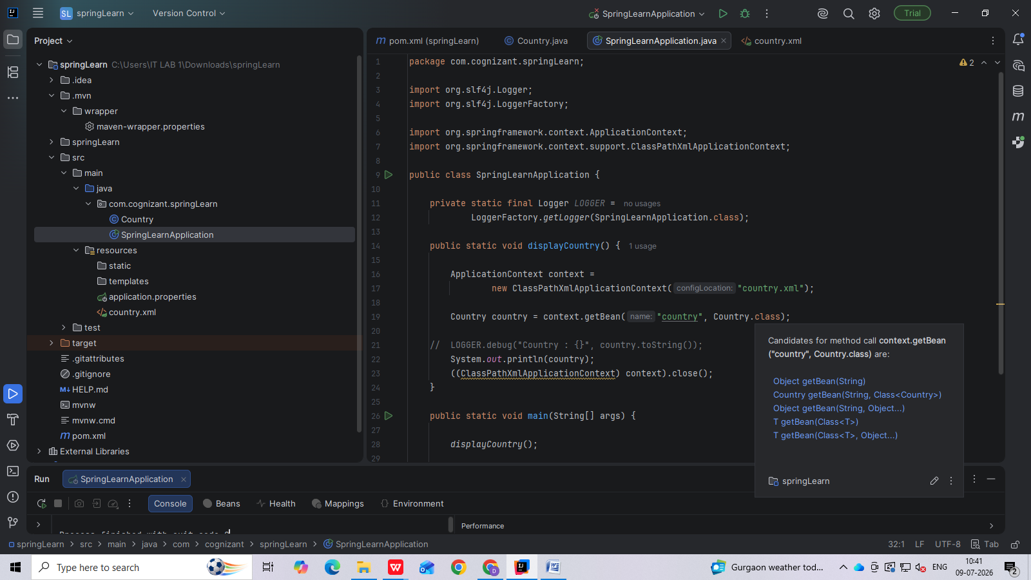
- Build the project using ‘mvn clean package -Dhttp.proxyHost=proxy.cognizant.com -Dhttp.proxyPort=6050 -Dhttps.proxyHost=proxy.cognizant.com -Dhttps.proxyPort=6050 -Dhttp.proxyUser=123456’ command in command line
- Import the project in Eclipse "File > Import > Maven > Existing Maven Projects > Click Browse and select extracted folder > Finish"
- Include logs to verify if main() method of SpringLearnApplication.
- Run the SpringLearnApplication class.
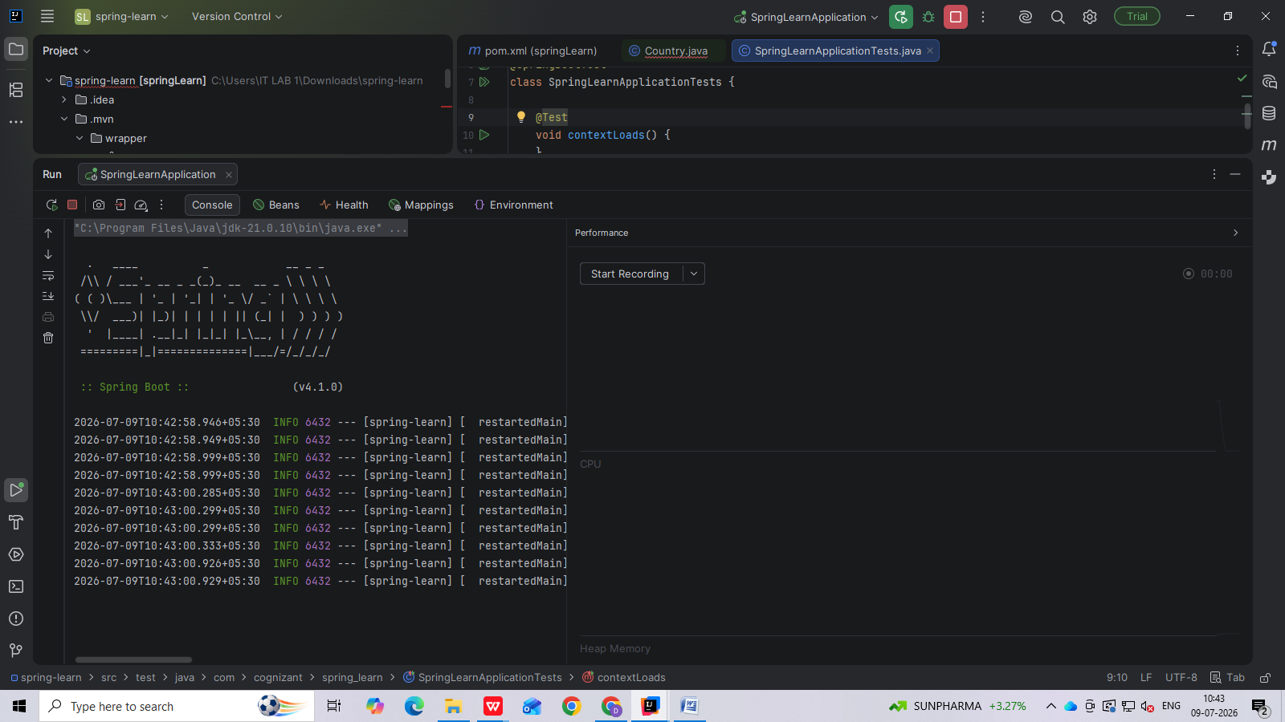
Spring Core - Incorporate Logging
Incorporate logging in the Spring Boot project created in previous hands on. Refer steps below:
- Create application.properties if not yet created in src/main/resources folder
- Add below lines in application.properties
- In SpringLearnApplication.java include the following imports:
- package com.cognizant.springLearn;
import org.slf4j.Logger;
import org.slf4j.LoggerFactory;
import org.springframework.context.ApplicationContext;
import org.springframework.context.support.ClassPathXmlApplicationContext;
public class SpringLearnApplication {
private static final Logger LOGGER =
LoggerFactory.getLogger(SpringLearnApplication.class);
public static void displayCountry() {
ApplicationContext context =
new ClassPathXmlApplicationContext("country.xml");
Country country = context.getBean("country", Country.class);
LOGGER.debug("Country : {}", country.toString());
((ClassPathXmlApplicationContext) context).close();
}
public static void main(String[] args) {
displayCountry();
}
}

- Include the below static variable in SpringLearnApplication.java:
- Include info log on start and end of method. Debug log for displaying the date (refer code below)
Country.java:
package com.cognizant.springLearn;
import org.slf4j.Logger;
import org.slf4j.LoggerFactory;
public class Country {
private static final Logger LOGGER =
LoggerFactory.getLogger(Country.class);
private String code;
private String name;
public Country() {
LOGGER.debug("Inside Country Constructor.");
}
public String getCode() {
LOGGER.debug("Inside getCode()");
return code;
}
public void setCode(String code) {
LOGGER.debug("Inside setCode()");
this.code = code;
}
public String getName() {
LOGGER.debug("Inside getName()");
return name;
}
public void setName(String name) {
LOGGER.debug("Inside setName()");
this.name = name;
}
@Override
public String toString() {
return "Country [code=" + code + ", name=" + name + "]";
}
}
country.xml:
<?xml version="1.0" encoding="UTF-8"?>
<beans xmlns="http://www.springframework.org/schema/beans"
xmlns:xsi="http://www.w3.org/2001/XMLSchema-instance"
xsi:schemaLocation="
http://www.springframework.org/schema/beans
https://www.springframework.org/schema/beans/spring-beans.xsd">
<bean id="country"
class="com.cognizant.springLearn.Country">
<property name="code" value="IN"/>
<property name="name" value="India"/>
</bean>
</beans>
Output;
