Hello World RESTful Web Service
Write a REST service in the spring learn application created earlier, that returns the text "Hello World!!" using Spring Web Framework. Refer details below:
Method: GET
URL: /hello
Controller: com.cognizant.spring-learn.controller.HelloController
Method Signature: public String sayHello()
Method Implementation: return hard coded string "Hello World!!"
Sample Request: http://localhost:8083/hello
Sample Response: Hello World!!
hellocontroller.java
package com.cognizant.springLearn.controller;
import org.slf4j.Logger;
import org.slf4j.LoggerFactory;
import org.springframework.web.bind.annotation.GetMapping;
import org.springframework.web.bind.annotation.RestController;
@RestController
public class HelloController {
private static final Logger LOGGER =
LoggerFactory.getLogger(HelloController.class);
@GetMapping("/hello")
public String sayHello() {
LOGGER.info("START");
LOGGER.info("END");
return "Hello World!!";
}
}
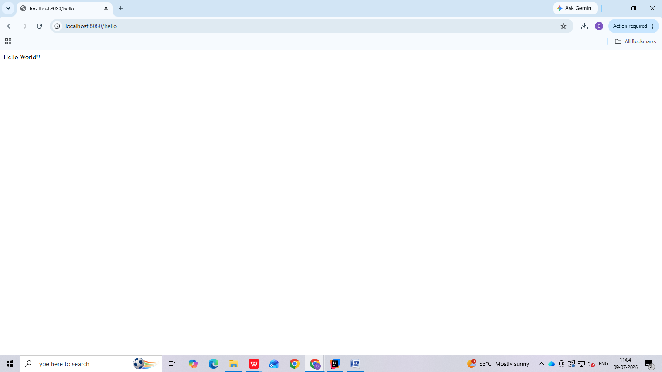
REST - Country Web Service
Write a REST service that returns India country details in the earlier created spring learn application.
CountruController.java
package com.cognizant.springLearn.controller;
import com.cognizant.springLearn.Country;
import org.slf4j.Logger;
import org.slf4j.LoggerFactory;
import org.springframework.context.ApplicationContext;
import org.springframework.context.support.ClassPathXmlApplicationContext;
import org.springframework.web.bind.annotation.RequestMapping;
import org.springframework.web.bind.annotation.RestController;
@RestController
public class CountryController {
private static final Logger LOGGER =
LoggerFactory.getLogger(CountryController.class);
@RequestMapping("/country")
public Country getCountryIndia() {
LOGGER.info("START");
ApplicationContext context =
new ClassPathXmlApplicationContext("country.xml");
Country country = context.getBean("country", Country.class);
LOGGER.info("END");
return country;
}
}
Country.java
package com.cognizant.springLearn;
public class Country {
private String code;
private String name;
public Country() {
}
public String getCode() {
return code;
}
public void setCode(String code) {
this.code = code;
}
public String getName() {
return name;
}
public void setName(String name) {
this.name = name;
}
}

output: 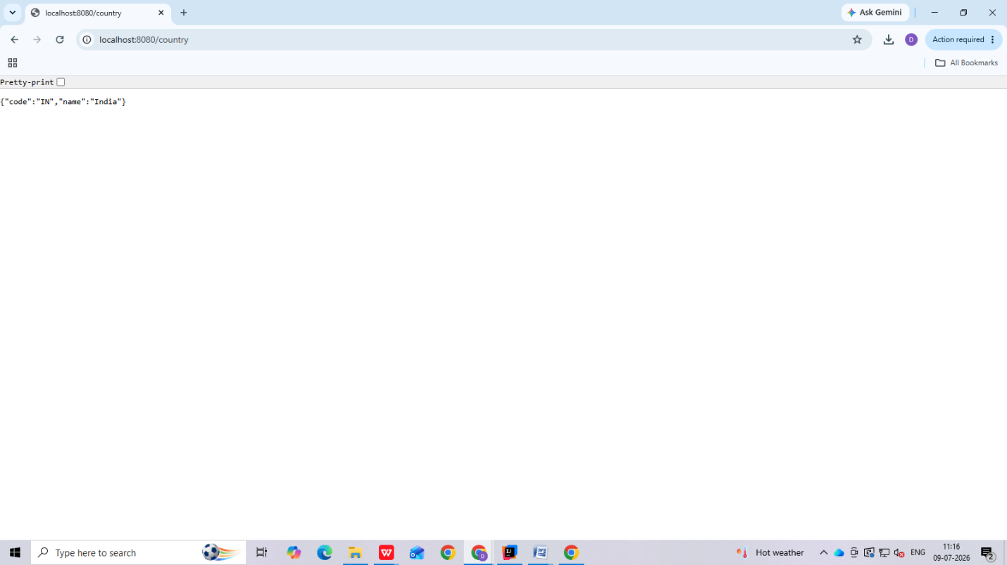

REST - Get country based on country code
Write a REST service that returns a specific country based on country code. The country code should be case insensitive.
country.xml:
<?xml version="1.0" encoding="UTF-8"?>
<beans xmlns="http://www.springframework.org/schema/beans"
xmlns:xsi="http://www.w3.org/2001/XMLSchema-instance"
xsi:schemaLocation="
http://www.springframework.org/schema/beans
https://www.springframework.org/schema/beans/spring-beans.xsd">
<bean id="countryList"
class="java.util.ArrayList">
<constructor-arg>
<list>
<bean class="com.cognizant.springLearn.Country">
<property name="code" value="IN"/>
<property name="name" value="India"/>
</bean>
<bean class="com.cognizant.springLearn.Country">
<property name="code" value="US"/>
<property name="name" value="United States"/>
</bean>
<bean class="com.cognizant.springLearn.Country">
<property name="code" value="DE"/>
<property name="name" value="Germany"/>
</bean>
<bean class="com.cognizant.springLearn.Country">
<property name="code" value="JP"/>
<property name="name" value="Japan"/>
</bean>
</list>
</constructor-arg>
</bean>
</beans>
Controller: com.cognizant.spring-learn.controller.CountryController
package com.cognizant.springLearn.controller;
import org.springframework.beans.factory.annotation.Autowired;
import org.springframework.web.bind.annotation.*;
import com.cognizant.springLearn.Country;
import com.cognizant.springLearn.service.CountryService;
@RestController
public class CountryController {
@Autowired
private CountryService countryService;
@GetMapping("/countries/{code}")
public Country getCountry(@PathVariable String code) {
return countryService.getCountry(code);
}
}
Method Annotation: @GetMapping("/countries/{code}")
Method Name: getCountry(String code)
Method Implemetation: Invoke countryService.getCountry(code)
Service Method: com.cognizant.spring-learn.service.CountryService.getCountry(String code)
Service Method Implementation:
- Get the country code using @PathVariable
- Get country list from country.xml
- Iterate through the country list
- Make a case insensitive matching of country code and return the country.
- Lambda expression can also be used instead of iterating the country list
- package com.cognizant.springLearn.service;
import java.util.List;
import org.springframework.context.ApplicationContext;
import org.springframework.context.support.ClassPathXmlApplicationContext;
import org.springframework.stereotype.Service;
import com.cognizant.springLearn.Country;
@Service
public class CountryService {
public Country getCountry(String code) {
ApplicationContext context =
new ClassPathXmlApplicationContext("country.xml");
List<Country> countries =
(List<Country>) context.getBean("countryList");
for (Country country : countries) {
if (country.getCode().equalsIgnoreCase(code)) {
return country;
}
}
return null;
}
}

Sample Request: http://localhost:8083/country/in
Sample Response:
{
"code": "IN",
"name": "India"
}
Output:
