7.
Netlist :

V1 N002 0 0.9
V2 N001 0 V
M1 N001 N002 0 N003 NMOS l=0.36u w=5u
M2 N001 N002 0 N004 PMOS l=.36u w=5u
.model NMOS NMOS
.model PMOS PMOS
.lib Z:\home\rohith\Documents\LTSpiceRunFIles\lib\cmp\standard.mos
.inc 180nm.txt
.dc V2 0 1.8 0.01
.backanno
.end

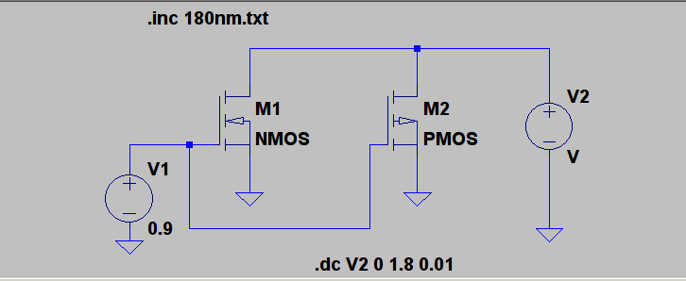
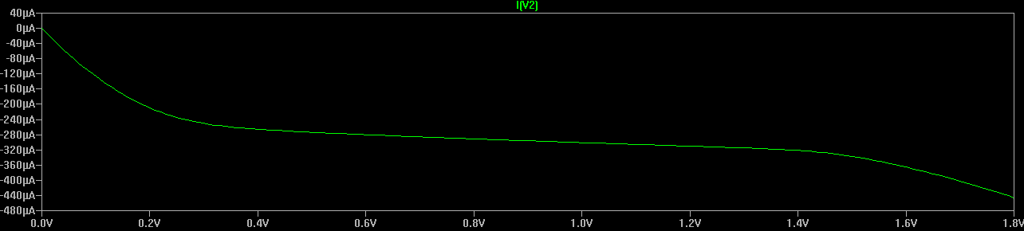
8.
Netlist :

