Differential equation solver circuit.

Made by : Rohith A.S.R.K. Submitted to : Dr. Sudeb Dasgupta

Enrollment number : 15116044 Date : 11/08/2016

Batch : O7

------------------------------------------------------------------------------------------------------------------------

Aim :

To solve the differential equation V'' + 2V' + V = 10sin(4t) using operational amplifiers where V is the output voltage and is subjected to the initial conditions V(0) = - 4 and V'(0) = 1.

Circuit :

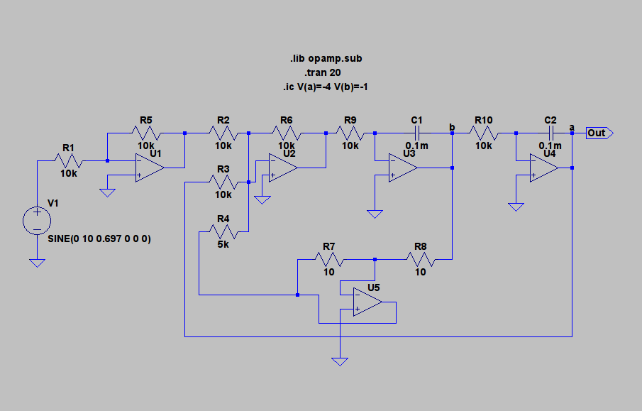

Circuit Analysis :

1. The higher order derivative was first solved and written as the sum of lower order derivatives and variables. Upon solving, we see that V'' = 10sin(4t) – V – 2V' which is realised using a summing amplifier. As we've realised V'', we can now get V' and V using integrating opamps.

2. Inverting opamps have been used because the summing and integrating opamps result in a negative output.

3. All the values have been put calculating the amplification of the opamps required for realising the given equation.

4. The frequency of the sine source has been calculated using the relation w = 2 * 3.14 * f.

5. Used two inverters, an inverting summer and two inverting integrators to realise the above circuit.

Output ( V ) :

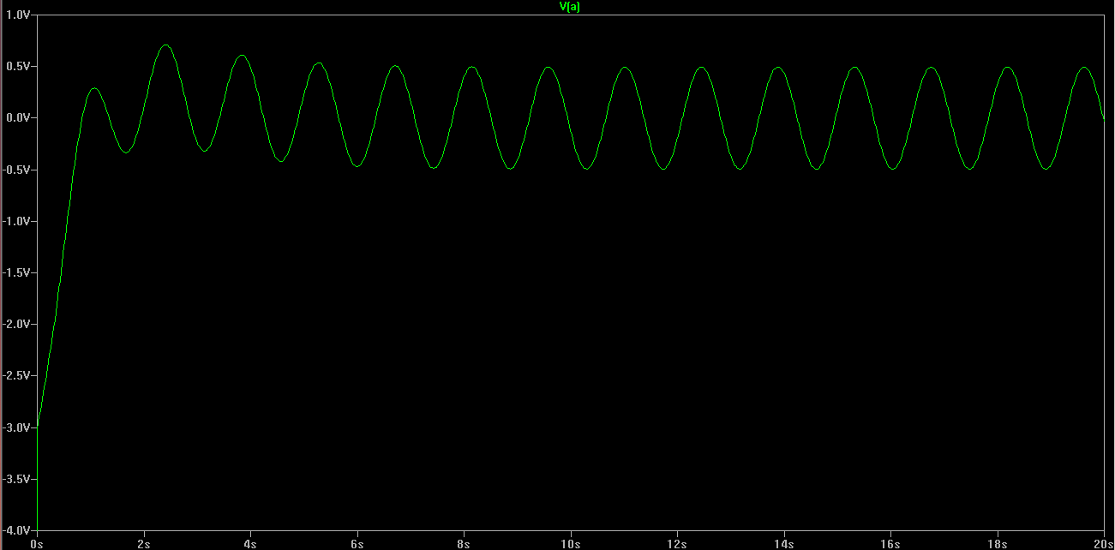
The above curve is the solution of the given differential equation subjected to the given initial conditions.

Bibliography :

1. http://www.niser.ac.in/sps/sites/default/files/basic_page/Solving%20differential%20equation%20using%20OPAMP.pdf

2. http://www.electronics-tutorials.ws/opamp/

