SIMATS ENGINEERING
CO3-ASSESSMENT TOOL 2

COURSE NAME: ANALOG CIRCUIT S COURSE CODE: ECA04

COURSE OUTCOME COVERED

CO3: Examine the frequency response characteristics of BJT and FET amplifiers at low and high frequencies to determine bandwidth, gain variation, and overall amplifier performance (BTL 2,3, 4), (WK1,WK2,WK3,WK4)

Assessment Tool number : AT2
Assessment Tool Weightage : 35%
Assessment Tool Name : Circuit Debugging
Duration of this assessment : 90 Minutes
Marks : 20
Type of Assessment conduction : Inside Class
Evaluation Type : Manual Correction

Description:

- Each student will be assigned one Circuit debugging problem 20 marks inside class. Analyze and debug one faulty analog circuit.
- Simulate the corrected circuit using LTspice and verify results.
- Document the debugging process, observations, and conclusions.
- Upload LTspice files, simulation results, and report to GitHub.
- Evaluation is based on fault identification, debugging approach, simulation accuracy, documentation, and GitHub submission.

Topics Covered In this assessment:
General shape of frequency response of amplifiers - Low frequency analysis of BJT/ FET amplifiers to obtain Lower cut off frequency - High frequency analysis of BJT amplifiers to obtain Upper cut off frequency- rise time and sag and their relation to cut off frequencies-High frequency analysis of FET amplifiers- High frequency equivalent circuit of FETs.

S.NO | REG NO | QUESTION BANK
1 | 192212335 | 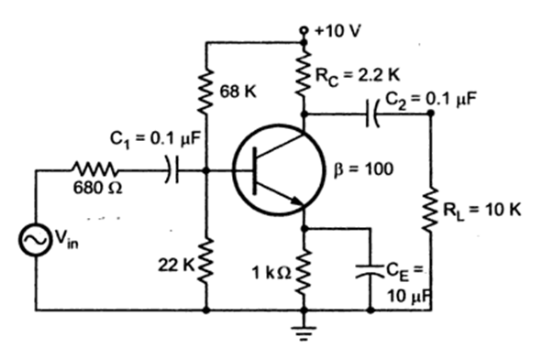  During AC Sweep analysis of the given Common Emitter amplifier, the lower cut-off frequency is measured as 320 Hz, whereas the expected value is 150 Hz. Analyze the circuit and identify which capacitor is most likely responsible for the increase in lower cut-off frequency. Justify your answer using low-frequency response analysis and verify it using LTspice.
2 | 192512494 |   The amplifier produces the expected mid-band gain but the output amplitude decreases significantly below 250 Hz. Debug the circuit and determine whether C1 (Input Coupling Capacitor), C2 (Output Coupling Capacitor), or CE (Emitter Bypass Capacitor) is responsible for the fault. Support your answer using frequency response analysis.
3 | 192512442 |   During transient analysis using a 100 Hz square-wave input, the output waveform exhibits noticeable percentage sag. Analyze the amplifier circuit and identify the component responsible for the distortion. Explain how replacing the faulty component restores the original waveform.
4 | 192212114 |   The designed amplifier should provide a mid-band voltage gain of approximately −90, but LTspice simulation shows only −42 while the DC bias voltages remain correct. Debug the circuit and determine the most probable faulty component affecting the AC gain. Justify your answer using the role of the emitter bypass capacitor.
5 | 192312461 |   During frequency response testing, the output voltage decreases rapidly above the designed operating frequency, resulting in a much smaller bandwidth than expected. Analyze the circuit and identify whether the reduction is caused by component variation, improper coupling, or transistor parasitic effects. Recommend suitable corrective measures to restore the desired bandwidth.
6 | 192412229 | 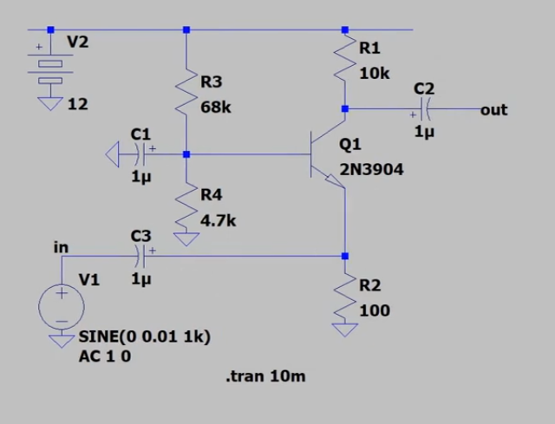  The Common Base amplifier shown in the laboratory circuit is expected to provide a voltage gain of approximately 18 dB at 1 kHz. During LTspice simulation, the measured gain is only 7 dB. Analyze the circuit, identify the faulty component responsible for the reduced gain, modify the circuit, and verify the corrected gain using AC Analysis.
7 | 192512216 |   During AC Sweep analysis, the amplifier exhibits a lower cut-off frequency of 850 Hz instead of the expected 120 Hz. Using LTspice, analyze the circuit and determine whether C1, C2, or C3 is responsible for the fault. Correct the circuit and compare the frequency responses before and after debugging.
8 | 192512379 |   During Transient Analysis with a 10 mV, 1 kHz sinusoidal input, the output waveform is highly attenuated although the transistor remains in the active region. Debug the circuit using LTspice, identify the faulty passive component, implement the correction, and verify the restored output waveform.
9 | 192512277 |   The Common Base amplifier is designed to operate over a wide bandwidth. However, LTspice AC analysis shows a significant reduction in the upper cut-off frequency. Analyze the circuit, identify the component or parasitic effect responsible for the reduced bandwidth, modify the circuit, and verify the improved frequency response.
10 | 192412608 |   During simulation, the DC operating point of the transistor is correct, but the output signal is almost zero. Using LTspice, analyze the signal path of the Common Base amplifier, identify the faulty component causing the signal loss, correct the fault, and verify proper amplifier operation through Transient and AC analyses.
11 | 192412043 | 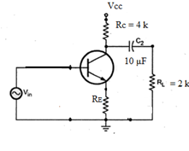  A student has implemented the Common Collector (Emitter Follower) amplifier in LTspice using the component values shown in the figure. During transient analysis, the output voltage across the load resistor (RL = 2 kΩ) is found to be zero, even though the input sinusoidal signal is present. Simulate the circuit and identify the possible causes of the fault. Explain how incorrect transistor pin connections, an open coupling capacitor (C2), missing supply voltage, or improper grounding can prevent the output signal from appearing. Suggest the necessary corrections and verify the output waveform after debugging.
12 | 192512136 | While constructing the circuit in LTspice, the collector resistor (RC = 4 kΩ) is mistakenly replaced with 400 Ω. Perform a transient simulation and observe the collector voltage, emitter voltage, and output waveform across the load resistor. Explain how the incorrect collector resistor affects the transistor operating point, voltage gain, and output signal quality. Compare the simulated results with those of the original circuit and recommend the appropriate resistor value.
13 | 192512157 | The output coupling capacitor (C2 = 10 µF) is accidentally replaced with 0.01 µF during simulation. Perform a transient analysis in LTspice and observe the output waveform across the load resistor. Explain how the reduced capacitor value affects the low-frequency response and the amplitude of the output signal. Discuss the role of the coupling capacitor in blocking DC while allowing AC signals to pass and justify the correct capacitor selection.
14 | 192512459 |   During simulation, the load resistor (RL = 2 kΩ) is mistakenly changed to 200 Ω. Simulate the circuit and observe the output voltage, emitter current, and waveform distortion. Analyze how the reduced load resistance affects the current drawn from the transistor, voltage gain, and output voltage. Explain why proper load matching is important for the satisfactory operation of an emitter follower and recommend the correct load resistance.
15 | 192512499 |   The Common Collector amplifier is designed to operate with the specified DC supply voltage. During LTspice simulation, the supply voltage is accidentally reduced to 2 V instead of the intended value. Perform a transient analysis and observe the collector voltage, emitter voltage, and output waveform. Explain how the reduced supply voltage affects transistor biasing, the available output voltage swing, and the overall amplifier performance. Identify the fault from the simulation results and suggest suitable corrective measures to restore proper operation.
16 | 192513085 | 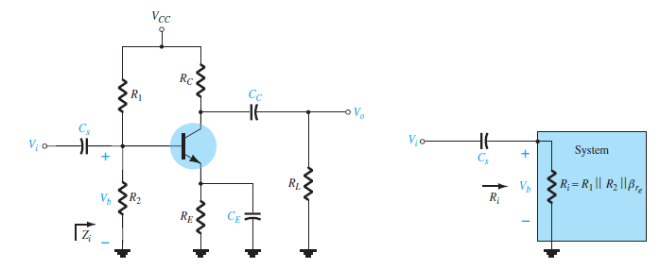  A student has implemented the voltage-divider biased Common Emitter amplifier in LTspice using the component values shown in the figure. During transient analysis, the input signal is present, but no amplified output is observed across the load resistor (RL). Simulate the circuit and identify the possible causes of the fault. Explain how incorrect transistor terminal connections, missing DC supply, open coupling capacitors (Ci or Cc), or improper biasing through R1 and R2 can prevent amplification. Suggest the necessary corrections and verify the output waveform after debugging.
17 | 192512210 |   During simulation, the emitter bypass capacitor (CE) is accidentally removed from the circuit. Perform a transient analysis in LTspice and compare the output waveform with that of the original circuit. Explain how the absence of the bypass capacitor affects the AC gain, emitter degeneration, and voltage amplification. Discuss why the emitter bypass capacitor is essential for obtaining higher voltage gain while maintaining DC bias stability.
18 | 192412062 |   While constructing the circuit in LTspice, the resistor R2 in the voltage divider network is mistakenly replaced with a much smaller value than specified. Simulate the modified circuit and observe the base voltage, collector voltage, emitter voltage, and output waveform. Analyze how the incorrect bias resistor changes the transistor operating point and affects amplification. Explain how improper biasing may force the transistor into saturation or cutoff and recommend suitable resistor values to restore normal operation.
19 | 192512093 |   The output coupling capacitor (Cc) is mistakenly replaced with a capacitor of much smaller value than the original design. Perform a transient simulation and observe the output waveform across the load resistor. Explain how the reduced coupling capacitance affects the low-frequency response, output amplitude, and signal distortion. Compare the simulated waveform with the expected output and justify the selection of an appropriate coupling capacitor value.
20 | 192512178 |   During simulation, the collector resistor (RC) is accidentally changed from its designed value to a much lower resistance. Perform transient and DC operating point analyses in LTspice to observe the collector current, collector voltage, and output waveform. Explain how the incorrect collector resistor influences the transistor's Q-point, voltage gain, and output signal swing. Identify the fault based on the simulation results and recommend corrective measures to restore proper amplifier operation.
21 | 192512464 | 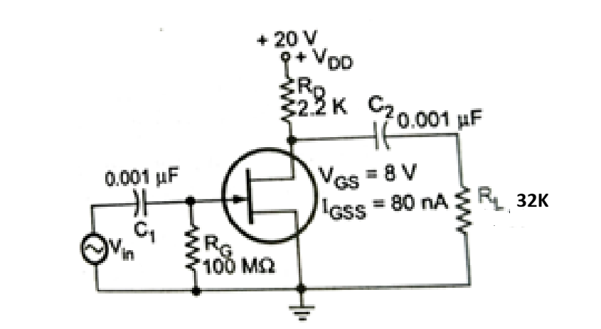  During LTspice simulation of the JFET common-source amplifier, it is observed that the output voltage across the load resistor RLR_LRL​ remains at 0 V even though a sinusoidal input signal is applied at VinV_{in}Vin​. Explain the possible reasons for this fault by examining the DC supply, coupling capacitors (C1 and C2), gate bias resistor (RG), drain resistor (RD), and JFET connections. Describe the debugging procedure and identify the measurements required to restore normal amplifier operation.
22 | 192519026 |   After simulating the amplifier, the output waveform appears clipped at one side of the signal, indicating nonlinear operation. Analyze the circuit to determine whether the distortion is caused by improper gate-source bias voltage, incorrect drain resistor value, excessive input signal amplitude, or an incorrect JFET model. Explain how each parameter affects the operating point and describe the necessary modifications to obtain an undistorted amplified output.
23 | 192412473 |   The measured DC drain voltage is found to be nearly equal to the supply voltage (+20 V), whereas the expected operating point should allow maximum symmetrical signal swing. Investigate the circuit to identify possible faults such as an open drain resistor, disconnected source terminal, incorrect gate bias, or a damaged JFET model. Explain how you would verify the Q-point using LTspice and recommend suitable corrections.
24 | 192512026 |   The simulated amplifier produces an output signal with almost the same amplitude as the input, resulting in negligible voltage gain. Examine the circuit to determine whether the problem is caused by an incorrect drain resistor value, improper load resistance, coupling capacitor issues, or insufficient transconductance of the selected JFET. Describe the debugging steps required to improve the amplifier gain while maintaining proper biasing.
25 | 192512094 |   When the input signal frequency is reduced from 1 kHz to 50 Hz, the output amplitude decreases significantly. Analyze the effect of the input and output coupling capacitors (C1 and C2) on the frequency response of the amplifier. Explain how capacitor values influence the lower cutoff frequency and describe the changes required in LTspice to achieve proper low-frequency amplification.
26 | 192313067 |   During transient simulation, the gate terminal of the JFET is observed to develop an unexpected DC voltage instead of remaining close to 0 V through the gate resistor (RG = 100 MΩ). Investigate possible causes such as leakage currents, incorrect capacitor polarity or connection, floating nodes, or an improper JFET model. Explain how these faults affect the drain current, output voltage, and overall amplifier performance, and describe the corrective actions required.
27 | 192512198 |   During AC Sweep analysis of the given Common Emitter amplifier, the lower cut-off frequency is measured as 350 Hz, whereas the expected value is 160 Hz. Analyze the circuit and identify which capacitor is most likely responsible for the increase in lower cut-off frequency. Justify your answer using low-frequency response analysis and verify it using LTspice.
28 | 192512254 |   During AC Sweep analysis of the given Common Emitter amplifier, the lower cut-off frequency is measured as 420 Hz, whereas the expected value is 250 Hz. Analyze the circuit and identify which capacitor is most likely responsible for the increase in lower cut-off frequency. Justify your answer using low-frequency response analysis and verify it using LTspice.
29 | 192519025 |   The Common Base amplifier shown in the laboratory circuit is expected to provide a voltage gain of approximately 28 dB at 2 kHz. During LTspice simulation, the measured gain is only 9 dB. Analyze the circuit, identify the faulty component responsible for the reduced gain, modify the circuit, and verify the corrected gain using AC Analysis.
30 | 192412569 |   During AC Sweep analysis, the amplifier exhibits a lower cut-off frequency of 950 Hz instead of the expected 220 Hz. Using LTspice, analyze the circuit and determine whether C1, C2, or C3 is responsible for the fault. Correct the circuit and compare the frequency responses before and after debugging
31 | 192419031 |   The Common Collector amplifier is designed to operate with the specified DC supply voltage. During LTspice simulation, the supply voltage is accidentally reduced to 5 V instead of the intended value. Perform a transient analysis and observe the collector voltage, emitter voltage, and output waveform. Explain how the reduced supply voltage affects transistor biasing, the available output voltage swing, and the overall amplifier performance. Identify the fault from the simulation results and suggest suitable corrective measures to restore proper operation.
32 | 192412042 |   The Common Collector amplifier is designed to operate with the specified DC supply voltage. During LTspice simulation, the supply voltage is accidentally reduced to 3 V instead of the intended value. Perform a transient analysis and observe the collector voltage, emitter voltage, and output waveform. Explain how the reduced supply voltage affects transistor biasing, the available output voltage swing, and the overall amplifier performance. Identify the fault from the simulation results and suggest suitable corrective measures to restore proper operation.
33 | 192519022 |   During transient simulation, the gate terminal of the JFET is observed to develop an unexpected DC voltage instead of remaining close to 0 V through the gate resistor (RG = 300 MΩ). Investigate possible causes such as leakage currents, incorrect capacitor polarity or connection, floating nodes, or an improper JFET model. Explain how these faults affect the drain current, output voltage, and overall amplifier performance, and describe the corrective actions required.
34 | 192519093 |   During transient simulation, the gate terminal of the JFET is observed to develop an unexpected DC voltage instead of remaining close to 0 V through the gate resistor (RG = 200 MΩ). Investigate possible causes such as leakage currents, incorrect capacitor polarity or connection, floating nodes, or an improper JFET model. Explain how these faults affect the drain current, output voltage, and overall amplifier performance, and describe the corrective actions required.
35 | 192512290 |   While constructing the circuit in LTspice, the resistor R2 in the voltage divider network is mistakenly replaced with a much smaller value than specified. Simulate the modified circuit and observe the base voltage, collector voltage, emitter voltage, and output waveform. Analyze how the incorrect bias resistor changes the transistor operating point and affects amplification. Explain how improper biasing may force the transistor into saturation or cutoff and recommend suitable resistor values to restore normal
36 | 192412663 |   While constructing the circuit in LTspice, the resistors R1 and R2 in the voltage divider network is mistakenly replaced with a much smaller value than specified. Simulate the modified circuit and observe the base voltage, collector voltage, emitter voltage, and output waveform. Analyze how the incorrect bias resistor changes the transistor operating point and affects amplification. Explain how improper biasing may force the transistor into saturation or cutoff and recommend suitable resistor values to restore normal
37 | 192312238 |   While constructing the circuit in LTspice, the resistor R1 in the voltage divider network is mistakenly replaced with a much smaller value than specified. Simulate the modified circuit and observe the base voltage, collector voltage, emitter voltage, and output waveform. Analyze how the incorrect bias resistor changes the transistor operating point and affects amplification. Explain how improper biasing may force the transistor into saturation or cutoff and recommend suitable resistor values to restore normal
38 | 192512255 |   During AC Sweep analysis of the given Common Emitter amplifier, the lower cut-off frequency is measured as 720 Hz, whereas the expected value is 350 Hz. Analyze the circuit and identify which capacitor is most likely responsible for the increase in lower cut-off frequency. Justify your answer using low-frequency response analysis and verify it using LTspice.
39 | 192512164 |   During AC Sweep analysis of the given Common Emitter amplifier, the lower cut-off frequency is measured as 620 Hz, whereas the expected value is 450 Hz. Analyze the circuit and identify which capacitor is most likely responsible for the increase in lower cut-off frequency. Justify your answer using low-frequency response analysis and verify it using LTspice.
40 | 192512340 |   During AC Sweep analysis of the given Common Emitter amplifier, the lower cut-off frequency is measured as 520 Hz, whereas the expected value is 350 Hz. Analyze the circuit and identify which capacitor is most likely responsible for the increase in lower cut-off frequency. Justify your answer using low-frequency response analysis and verify it using LTspice.

Code of Conduct:

I ____________________ (Name / Reg No) certify that this submission is my original work and that I have adhered to the guidelines specified for this assessment.
I understand that any violation of academic integrity rules will result in disciplinary action.

Signature of the student:

RUBRICS FOR CALCULATION:

Criteria | Weightage | Level 3 (Exemplary) | Level 2 (Proficient) | Level 1 (Beginning)
Fault Identification | 30% | Correctly identifies the faulty component/connection and recognizes all affected circuit elements accurately. (6 Marks) | Identifies the fault with minor errors or incomplete understanding.. (4-5 Marks) | Unable to identify the fault or identifies an incorrect component. (1-3 Marks)
Technical Analysis and Explanatio | 45% | Provides a logical explanation of how the fault affects biasing, current flow, operating region, gain, or circuit performance using appropriate engineering concepts. (9 Marks) | Explains the effect of the fault with minor conceptual errors or incomplete reasoning (5–8 Marks) | Shows little understanding of circuit operation and provides incorrect or unclear explanation (1–4 Marks)
Corrective Action and Prediction using Simulation | 25% | Suggests the correct remedy and accurately predicts the expected circuit behavior after correction with proper engineering justification. (5 Marks) | Suggests a partially correct correction and provides limited prediction of circuit behavior. (3–4 Marks) | Unable to suggest a suitable correction or predict the circuit response. (1-2 Marks)

Student:
Criteria | Student 1
 | H | M | L
Fault Identification
Technical Analysis and Explanation
Corrective Action and Prediction using Simulation
TOTAL

