SIMATS ENGINEERING
ASSESSMENT TOOL 2 | Annexure A: Constraint-Based Problem Solving
Name | MULI ROHITH BABA REDDY | Reg. No. | 192512026
Branch | ECE | Course Code | CSA1708
Course Name | Artificial Intelligence | CO Covered | CO1 (BL3): intelligent agents and uninformed search

Code of Conduct: I, Muli Rohith Baba Reddy (192512026), certify that this submission is my original work and that I have adhered to the guidelines specified for this assessment. I understand that any violation of academic integrity rules will result in disciplinary action. Signature of the student: ______________________
Question 1: Doctor Shift Scheduling (Backtracking Search)
1.1 Problem formulation as a Constraint Satisfaction Problem
Variables: D1, D2, D3 (the shift of each doctor). Domain: {Morning (M), Afternoon (A), Night (N)}, ordered M < A < N. Search order: variables D1, D2, D3; values tried in the order M, A, N.
Id | Constraint | Type / use during search
C1 | D1 cannot work Night: D1 ≠ N | Unary: prunes the domain of D1
C2 | D2 works before D3: shift(D2) < shift(D3) | Binary: checked once both D2 and D3 are assigned
C3 | One doctor per shift: D1, D2, D3 all different | All-different: checked on every assignment
C4 | D3 cannot work Morning: D3 ≠ M | Unary: prunes the domain of D3
C5 | Every doctor gets exactly one shift | Goal test: a complete assignment (all 3 variables set)
1.2 Backtracking trace with constraint checks
Step | Assignment tried | Constraint checks | Outcome
1 | D1 = M | C1: M ≠ N ✓; C3: no other doctor assigned ✓ | Consistent, go deeper
2 | D1 = M, D2 = M | C3: Morning already taken by D1 ✗ | Reject, try next value
3 | D1 = M, D2 = A | C3: A is free ✓; C2 pending (D3 not yet assigned) | Consistent, go deeper
4 | D1 = M, D2 = A, D3 = M | C4: D3 cannot be Morning ✗; C3: Morning taken ✗ | Reject, try next value
5 | D1 = M, D2 = A, D3 = A | C3: Afternoon already taken by D2 ✗ | Reject, try next value
6 | D1 = M, D2 = A, D3 = N | C4: N ≠ M ✓; C3: all different ✓; C2: A < N ✓; C1 ✓; C5: complete ✓ | All constraints satisfied: SOLUTION

Search-tree summary: Root → D1=M → {D2=M ✗ | D2=A → {D3=M ✗ | D3=A ✗ | D3=N ✓ goal}}. Only 6 assignments were examined (against 27 in blind enumeration) because every violated constraint cut a branch immediately, and the search stopped at the first complete consistent assignment.
1.3 Final valid schedule
Shift | Morning | Afternoon | Night
Doctor assigned | D1 | D2 | D3

Verification: D1 is not on Night (C1 ✓); D2 (Afternoon) is before D3 (Night) (C2 ✓); one doctor per shift (C3 ✓); D3 is not on Morning (C4 ✓); each doctor has exactly one shift (C5 ✓). Note: continuing the search for all solutions would also give D1 = A, D2 = M, D3 = N; the answer above is the first valid schedule found with the stated ordering.
Question 2: Grid Robot Path Finding (BFS, with A* and Manhattan heuristic)
2.1 Problem set-up  The question does not include the grid picture, so the following 5×5 grid is assumed (cells written as (row, column), counted from 0 at the top-left): Start S = (0,0), Goal G = (4,4), obstacles = (1,1), (2,1), (1,3), (3,3) (dark cells in Fig. 1). The same method works for any other obstacle layout.  - Actions: Up, Down, Left, Right (expansion order U, D, L, R). Step cost: 1. Obstacles cannot be entered.  - Heuristic: Manhattan distance h(n) = |r − 4| + |c − 4|, so h(S) = 8. It is admissible and consistent because each move changes the distance by at most 1 and costs 1.  - Note on the algorithms: plain BFS uses a FIFO queue and needs no heuristic. The question also asks for priority-queue updates with the Manhattan heuristic, so BFS is traced first (2.2) and the priority-queue trace follows with A*, f(n) = g(n) + h(n) (2.3). Both are shown so that every requirement is covered. | 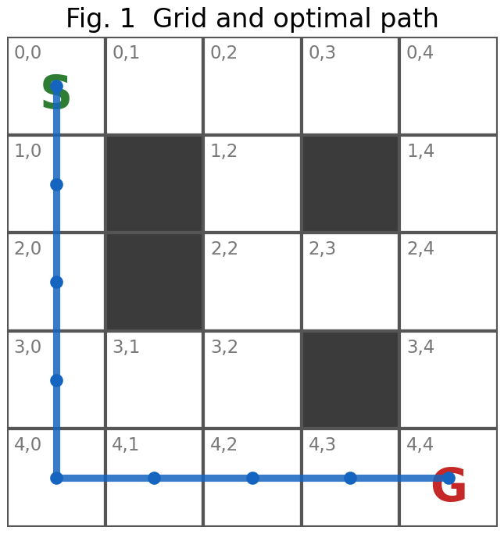
2.2 BFS node expansion (FIFO queue, front → back)
# | Expand | Queue after expansion | # | Expand | Queue after expansion
1 | (0,0) | (1,0), (0,1) | 12 | (0,4) | (4,1), (3,2), (2,3), (1,4)
2 | (1,0) | (0,1), (2,0) | 13 | (4,1) | (3,2), (2,3), (1,4), (4,2)
3 | (0,1) | (2,0), (0,2) | 14 | (3,2) | (2,3), (1,4), (4,2)
4 | (2,0) | (0,2), (3,0) | 15 | (2,3) | (1,4), (4,2), (2,4)
5 | (0,2) | (3,0), (1,2), (0,3) | 16 | (1,4) | (4,2), (2,4)
6 | (3,0) | (1,2), (0,3), (4,0), (3,1) | 17 | (4,2) | (2,4), (4,3)
7 | (1,2) | (0,3), (4,0), (3,1), (2,2) | 18 | (2,4) | (4,3), (3,4)
8 | (0,3) | (4,0), (3,1), (2,2), (0,4) | 19 | (4,3) | (3,4), (4,4)
9 | (4,0) | (3,1), (2,2), (0,4), (4,1) | 20 | (3,4) | (4,4)
10 | (3,1) | (2,2), (0,4), (4,1), (3,2) | 21 | (4,4) | Goal reached
11 | (2,2) | (0,4), (4,1), (3,2), (2,3)

BFS expands nodes level by level (depth 0 to 8) and stops when G is dequeued after 21 expansions. Following parent pointers back from G gives the path below.
2.3 Priority-queue trace (A*, f = g + h; ties broken by smaller h, then FIFO)
# | Expanded node | Nodes generated / updated | Priority queue after step node[f]
1 | (0,0) g=0, h=8, f=8 | (1,0) g=1,f=8; (0,1) g=1,f=8 | (1,0)[8], (0,1)[8]
2 | (1,0) g=1, h=7, f=8 | (2,0) g=2,f=8 | (2,0)[8], (0,1)[8]
3 | (2,0) g=2, h=6, f=8 | (3,0) g=3,f=8 | (3,0)[8], (0,1)[8]
4 | (3,0) g=3, h=5, f=8 | (4,0) g=4,f=8; (3,1) g=4,f=8 | (4,0)[8], (3,1)[8], (0,1)[8]
5 | (4,0) g=4, h=4, f=8 | (4,1) g=5,f=8 | (4,1)[8], (3,1)[8], (0,1)[8]
6 | (4,1) g=5, h=3, f=8 | (4,2) g=6,f=8 | (4,2)[8], (3,1)[8], (0,1)[8]
7 | (4,2) g=6, h=2, f=8 | (3,2) g=7,f=10; (4,3) g=7,f=8 | (4,3)[8], (3,1)[8], (0,1)[8], (3,2)[10]
8 | (4,3) g=7, h=1, f=8 | (4,4) g=8,f=8 | (4,4)[8], (3,1)[8], (0,1)[8], (3,2)[10]
9 | (4,4) g=8, h=0, f=8 | Goal popped from queue | Stop - optimal path found

Result: optimal path (0,0) → (1,0) → (2,0) → (3,0) → (4,0) → (4,1) → (4,2) → (4,3) → (4,4) = Down ×4, Right ×4. Optimal cost = 8 (8 moves × cost 1), which equals the Manhattan lower bound h(S) = 8, so no shorter path exists. BFS is optimal here because all step costs are equal; A* reaches the same path with only 9 expansions instead of 21, since the heuristic keeps the search directed towards G (the node (3,2) with f = 10 is never expanded).
Question 3: Autonomous Rescue Robot (Partially Observable, Online Search)
(a) Constraint analysis: effect on decision making
Constraint | How it affects the robot's decisions | Priority
Moves: Up, Down, Left, Right | Branching factor at most 4; no diagonal shortcuts, so the shortest route is a Manhattan-style path. | Hard (defines actions)
Blocked cells (obstacles) | Such cells are removed from the successor function. The map is unknown at the start, so a planned route may become invalid and must be replanned. | Hard (feasibility)
Sensing limited to adjacent cells | The robot cannot plan on a full map. It must move, sense, update its knowledge and plan again (online search). It only steps onto cells it has already sensed, so it never walks blindly into an obstacle. | Hard (information)
Risky zone: cost 1 + 2 = 3 | Entering a risky cell is 3 times as costly as a normal cell. Crossing one risky cell is worth it only if the alternative detour costs 2 or more extra moves; a detour of 0 or 1 extra move is better, and 2 extra moves is a tie. | Soft (cost, trades off)
Minimise total cost with safe navigation | Gives the performance measure: path cost = sum of step costs (1 or 3). Safety is secured by the hard constraints; risk is priced into the cost so that the planner avoids danger without forbidding it when no safe route exists. | Objective
Update knowledge dynamically | The robot keeps an internal map (known free / blocked / risky / unknown cells) and re-runs the search whenever a percept changes it. | Process requirement

Prioritisation: (1) hard constraints: legal moves, obstacles, and moving only into sensed cells; (2) information constraints: sense and update the map after every move; (3) optimisation: minimise total cost with risky cells priced at 3. Feasibility is therefore never traded for cost.
(b) Solution approach: Online Uniform Cost Search with replanning
- Step 1, initialise: the known map contains only S. Unknown cells are assumed free and safe (optimistic free-space assumption), so the plan can only be improved, never made impossible, by new information.  - Step 2, sense: read the 4 adjacent cells and mark each as free, blocked or risky in the internal map.  - Step 3, plan: run Uniform Cost Search from the current cell on the known map. The priority queue is ordered by g(n), the total path cost so far; the cost of entering a cell is 1 (normal) or 3 (risky); blocked cells are skipped. Stop when G is popped from the queue.  - Step 4, act: execute only the first move of the plan, then go back to Step 2. Only the first move is executed because the next sensing may change the map.  - Step 5, terminate: stop when the robot reaches G. If UCS finds no path on the known map, explore the nearest unknown cell (frontier) or report that G is unreachable. | 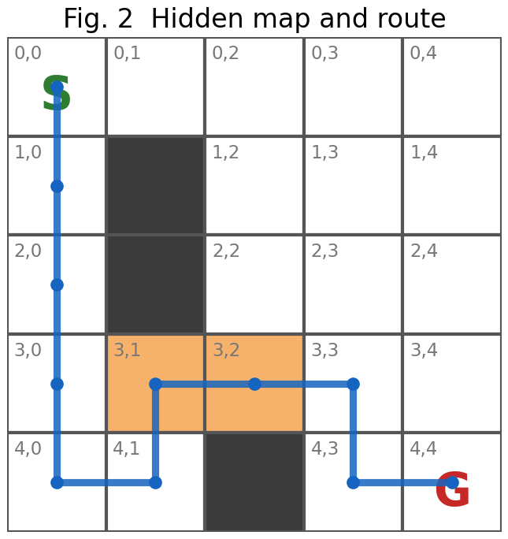
Worked example. Hidden map (Fig. 2): obstacles (1,1), (2,1), (4,2); risky cells (3,1), (3,2); S = (0,0), G = (4,4). Row = one sense-plan-act cycle.
# | Robot at | UCS plan cost | Moves to | Move cost | Total cost | Sensed on arrival (non-free cells)
1 | (0,0) | 8 | (1,0) | +1 | 1 | (1,1) blocked
2 | (1,0) | 7 | (2,0) | +1 | 2 | (2,1) blocked
3 | (2,0) | 6 | (3,0) | +1 | 3 | (3,1) risky
4 | (3,0) | 5 | (4,0) | +1 | 4 | -
5 | (4,0) | 4 | (4,1) | +1 | 5 | (4,2) blocked
6 | (4,1) | 7 | (3,1) | +3 | 8 | (3,2) risky
7 | (3,1) | 6 | (3,2) | +3 | 11 | -
8 | (3,2) | 3 | (3,3) | +1 | 12 | -
9 | (3,3) | 2 | (4,3) | +1 | 13 | -
10 | (4,3) | 1 | (4,4) | +1 | 14 | -

The robot goes down the left column because the plan is optimistic. At cycle 5 it senses that (4,2) is blocked, the plan cost jumps from 4 to 7 and the route is recomputed; at cycle 6 it senses that (3,2) is risky and the plan is corrected again. It reaches G with total cost 14. With full knowledge of the map the best route would cost 8 (via (0,1), (0,2), (1,2), (2,2), (2,3), (2,4), (3,4)); the extra cost is the unavoidable price of not knowing the map in advance, not a flaw in the rule, because no agent could have known about (4,2) before sensing it.
(c) Application of AI concepts
Concept | Application to the rescue robot
Intelligent agent (PEAS) | Performance: reach the survivor at G with minimum total cost (1 per move, +2 per risky cell) and without entering blocked cells. Environment: grid of rooms with obstacles and risky zones. Actuators: move Up / Down / Left / Right. Sensors: position and the status of the 4 adjacent cells.
Agent type | A model-based, goal-based and utility-based agent: it keeps an internal map (the model, updated from percepts), has a goal (G) and uses path cost as utility to choose among routes. A simple reflex agent fails because the current percept alone cannot show the way to G.
Rationality | A rational agent selects, for the percept sequence so far, the action expected to maximise its performance measure. Here it moves along the cheapest route on its current knowledge and re-plans when it learns more. Rationality means doing the best with available information, not knowing everything (omniscience); sensing before moving is also rational information gathering.
Environment type | Partially observable (only adjacent cells), single-agent, deterministic (a move goes where intended), sequential (each move affects later cost), static (map does not change during the run, but is initially unknown), discrete (grid cells and unit steps).
(d) Justification of the chosen approach
- Cost-aware and optimal: step costs are unequal (1 and 3), so BFS (which minimises the number of moves) and DFS (not optimal) can choose a cheap-looking but expensive route. UCS is complete and optimal for any positive step costs.
- Works without a full map: offline planning is impossible because the map is partially unknown. Re-running UCS after each sensing step handles new obstacles and risk information automatically (online search).
- Safe and simple: executing one move at a time into already-sensed cells keeps the robot safe; on a small grid the cost of repeated UCS is negligible. The Manhattan heuristic could be added (A*) to reduce expansions, as it stays admissible when every move costs at least 1, but UCS is sufficient and is the uninformed strategy required by CO1.
Conclusion: the three problems are solved with the right tool for each: backtracking CSP for scheduling (valid schedule: Morning D1, Afternoon D2, Night D3), BFS / A* for the grid path (optimal cost 8), and online UCS with replanning for the partially observable rescue robot.

