PhishShield – Mini Project Report
Team Name: ____________________
Course: UE25CS151A – Python for Computational Problem Solving

1. Problem Statement
PhishShield is a cybersecurity tool designed to detect phishing URLs and phishing emails using heuristics and machine learning.

2. Approach Used
• URL Detection: Heuristic rules
• Email Detection: TF-IDF + Logistic Regression
• Hybrid scoring mechanism
• Visualization of phishing risk

3. Architecture Diagram
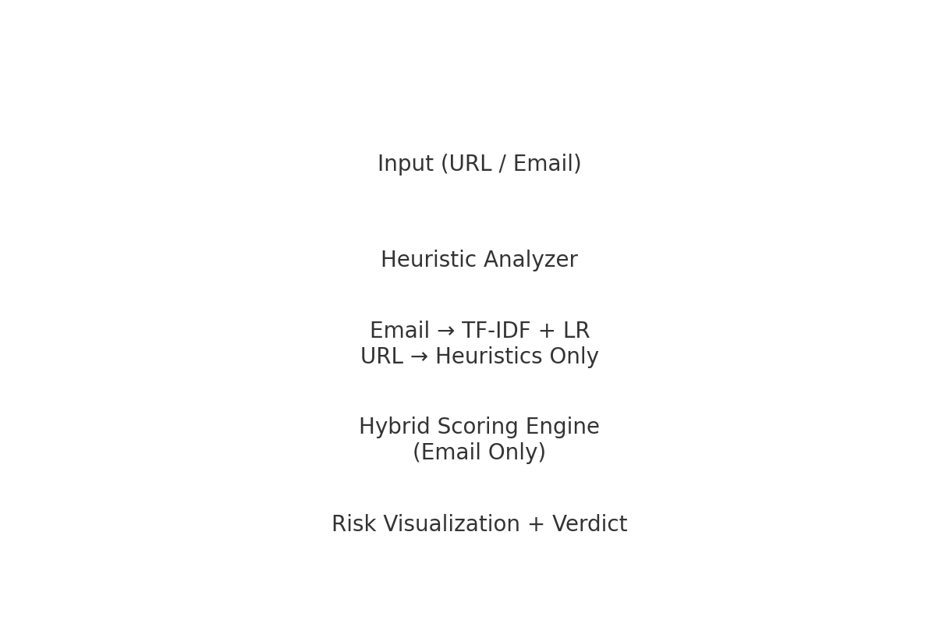

4. System Flowchart
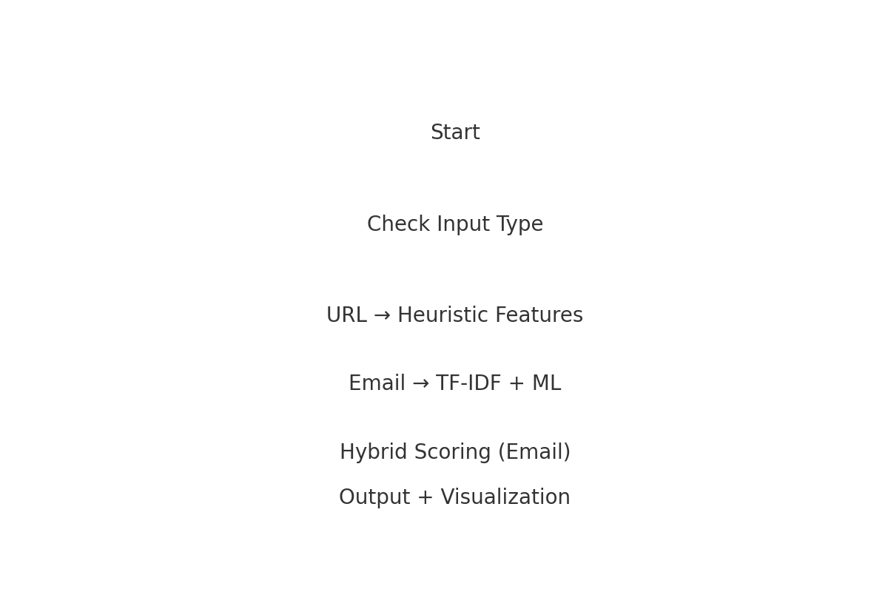

5. Sample Input/Output
Screenshots should be included here by the team.

6. Challenges Faced
• URL dataset unusable for ML; switched to heuristics.
• Email dataset required cleaning and label mapping.
• Feature alignment for ML models.

7. Conclusion
PhishShield successfully detects phishing attempts in URLs and emails using a hybrid approach and provides clear visualization.

