**EXPERT SYSTEM FOR ONLINE MEDICAL DIAGNOSIS OF SKIN DISEASE**

**Background and Objectives**

As the world is suffering from various diseases, it is better to take precautions earlier and take measures before it reaches catastrophic stage. An expert system is a computer system that emulates, or acts in all respects, with the decision-making capabilities of a human expert.

**Description of Project**

This is expert for Diagnoses of skin diseases. It contains a knowledge base as well as inference engine. This project embedded with graphical user interface so that user can interact with the system in a better way.

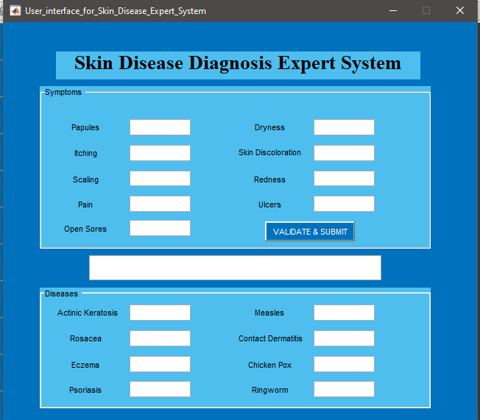

For this project we consulted with dermatologists via internet and get their views about some disease and with the help of internet we found the symptoms of particular diseases.

Following are the skin diseases which we have taken for this project: -

1. Actinic Keratosis
2. Rosacea
3. Eczema
4. Psoriasis
5. Measles
6. Contact Dermatitis
7. Chicken Pox
8. Ringworm

The Symptoms which were considered for diagnosing these diseases are:

1. Papules
2. Itching
3. Scaling
4. Pain
5. Open sores
6. Dryness
7. Skin discoloration
8. Redness
9. Ulcers

**References:**

1. Asghar, M. Z., Asghar, M. J., Saqib, S. M., Ahmad, B., & Ahmad, H. (2011). *Diagnosis of Skin Diseases using Online Expert System*. (October 2015).
2. <https://www.healthline.com/health/skin-disorders>
3. <https://www.medicinenet.com/skin/focus>
4. <https://www.mobihealthnews.com/content/first-derms-new-ai-app-helps-users-identify-skin-conditions>
5. <https://academic.oup.com/fampra/article/32/5/591/690569>
6. <https://medicalfuturist.com/digital-skin-care-top-8-dermatology-apps/>