1.Write a program to print the binary representation of a number using loops.

Code:

#include <stdio.h>

int main()
{
int n, binary[32], i = 0;

printf("Enter a number: ");
scanf("%d", &n);

if (n == 0) {
printf("Binary: 0");
return 0;
}

while (n > 0) {
binary[i] = n % 2;
n = n / 2;
i++;
}

printf("Binary: ");
for (int j = i - 1; j >= 0; j--) {
printf("%d", binary[j]);
}

return 0;
}

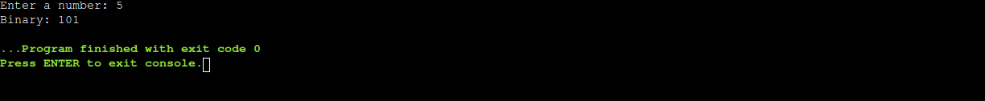
output:

