3.Write separate functions for addition, subtraction, multiplication, and division. Call these
functions from a menu-driven program.

Code:
#include <stdio.h>

float add(float a, float b) { return a + b; }
float sub(float a, float b) { return a - b; }
float mul(float a, float b) { return a * b; }
float div(float a, float b) { return a / b; }

int main() {
int ch;
float x, y;

printf("1.Add 2.Sub 3.Mul 4.Div\n");
printf("Enter choice: ");
scanf("%d", &ch);

printf("Enter two numbers: ");
scanf("%f %f", &x, &y);

switch (ch) {
case 1: printf("Result = %.2f", add(x, y)); break;
case 2: printf("Result = %.2f", sub(x, y)); break;
case 3: printf("Result = %.2f", mul(x, y)); break;
case 4:
if (y != 0)
printf("Result = %.2f", div(x, y));
else
printf("Division by zero!");
break;
default: printf("Invalid choice");
}
return 0;
}

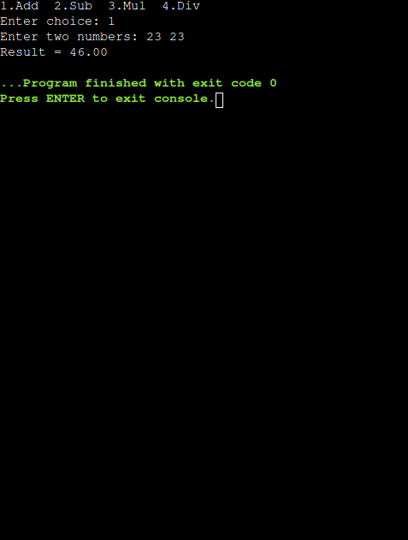
output:

