SQL PROJECT

NAME: Darnasi Rohith

# Session 2: Creating a Database

* 1. Create a database with the name: AbleJobs

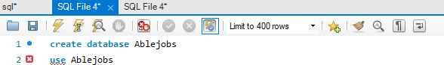

* 1. Create the following Table with the name: Sales1

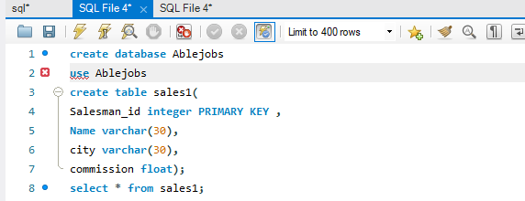

* 1. Display all the data in the above table

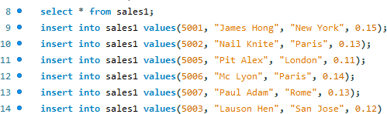

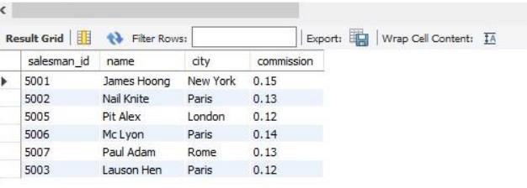

1. Create a database with the name: AbleJobs



1. 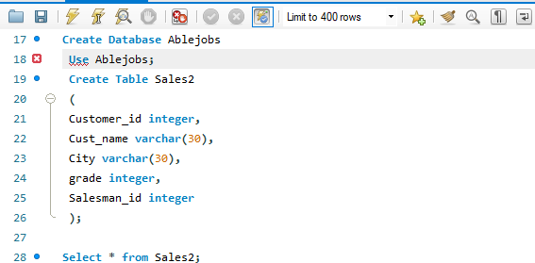Create the following Table with the name: Sales2
2. Display all the data in the above table

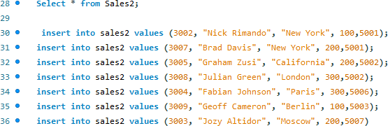

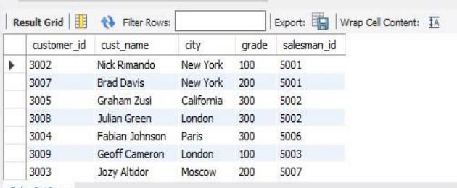

# Session 3: Other Basic Queries

* 1. Create a database with the name: AbleJobs



* 1. 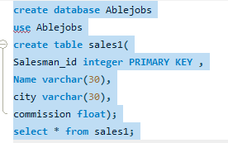Create the following Table with the name: Sales1

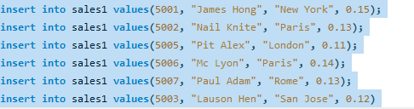

* 1. In the above table, write a SQL query to change the following data:
     1. Change commission of salesman with name of ‘Pit Alex’ to 0.22

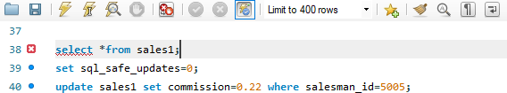

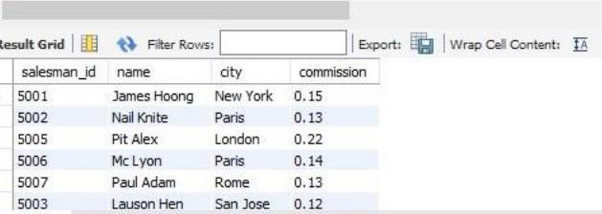

* + 1. Change city of salesman with salesman_id of ‘5003’ to Paris



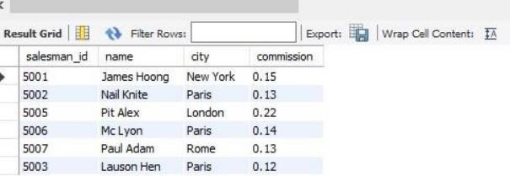

* 1. 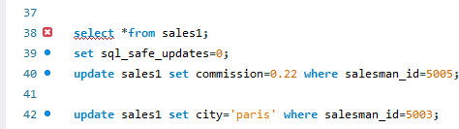Display all the data in the above table

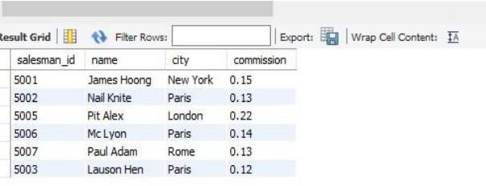

* 1. Create a database with the name: AbleJobs



* 1. Create the following Table with the name: Sales2

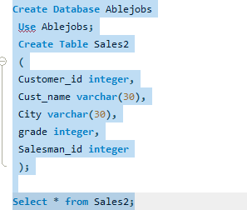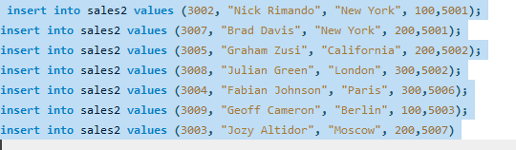

* 1. In the above table, write a SQL query to alter the following data:
     1. Change grade of customer with name of ‘Graham Zusi’ to 300



* + 1. Change city of customer with cust_id of ‘3009’ to London



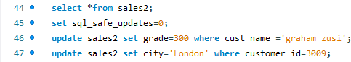e. Display all the data in the above table

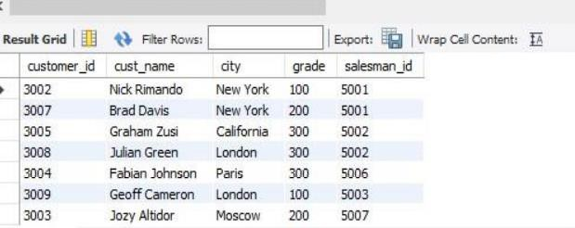

# Session 4: Functions and Wildcards

* 1. Create a database with the name: AbleJobs
  2. Create the following Table with the name: Sales1



* 1. From the above table, write a SQL query to find the details of those salespeople who come from the 'Paris' City or 'Rome' City. Return salesman_id, name, city, commission.

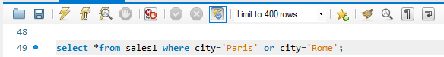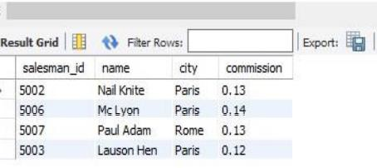

* 1. From the following table, write a SQL query to find the details of those salespeople who live in cities apart from 'Paris' and 'Rome'. Return salesman_id, name, city, commission.

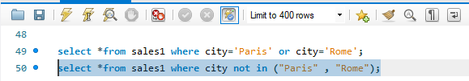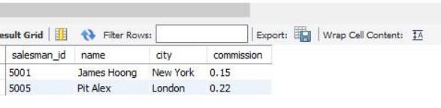

* 1. From the following table, write a SQL query to find the details of salespeople who get the commission in the range from 0.12 to 0.14 (begin and end values are included). Return salesman_id, name, city, and commission.

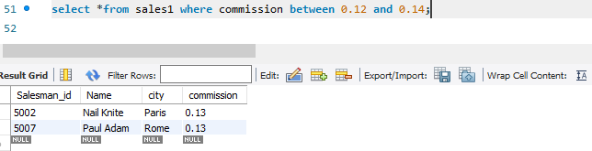

* 1. From the following table, write a SQL query to find the details of those salespeople whose name starts with any letter within 'A' and 'L' (not inclusive). Return salesman_id, name, city, commission.

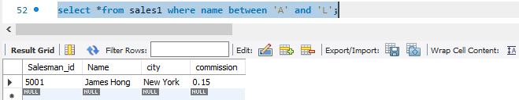

* 1. From the following table, write a SQL query to find the details of the customers whose name begins with the letter 'B'. Return customer_id, cust_name, city, grade, salesman_id.

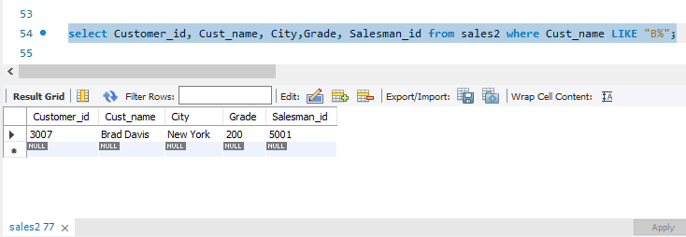

* 1. From the following table, write a SQL query to find the details of the customers whose names end with the letter 'n'. Return customer_id, cust_name, city, grade, salesman_id.

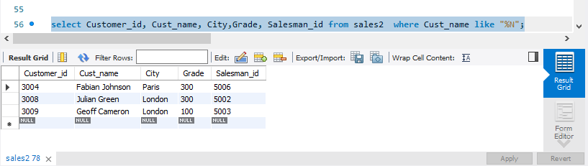

* 1. From the following table, write a SQL query to find the details of those salespeople whose name starts with ‘N’ and the fourth character is 'l'. Rests may be any character. Return salesman_id, name, city, commission.

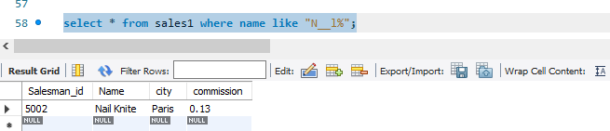

* 1. Create a database with the name: AbleJobs
  2. 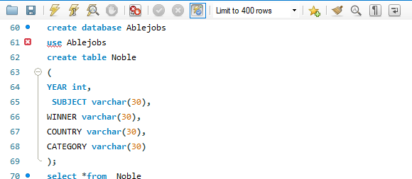Create the following Table with the name: Nobel

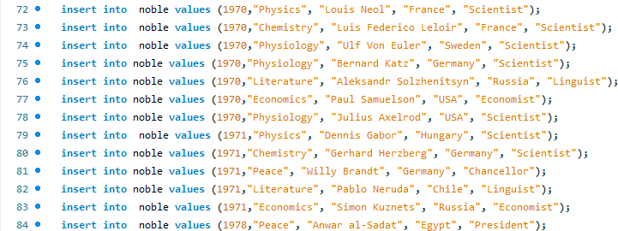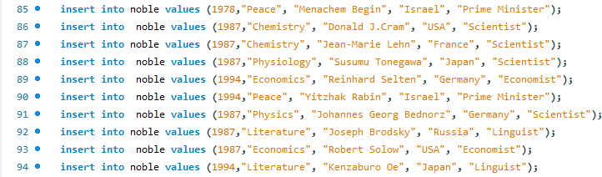

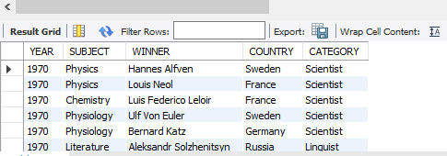

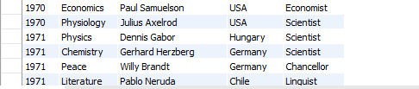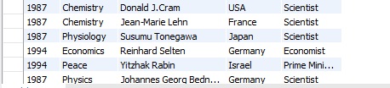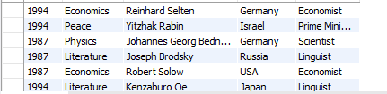

* 1. From the above table, write a SQL query to find the Nobel Prize winner(s) in the following years (Return year, subject and winner) :
     1. 1970

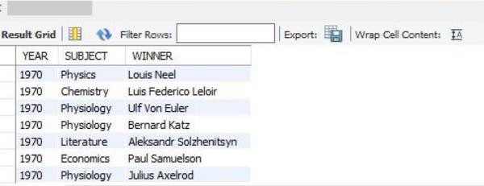

* + 1. 1987

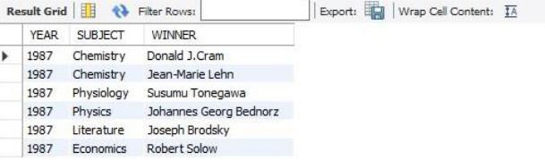

* 1. From the above table, write a SQL query to find the Nobel Prize winner in 'Literature' in the year 1971. Return winner.

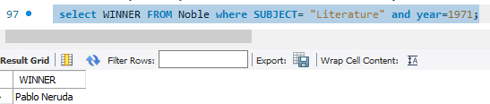

* 1. From the following table, write a SQL query to find the Nobel Prize winner 'Dennis Gabor'. Return year, subject.

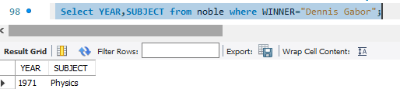

* 1. 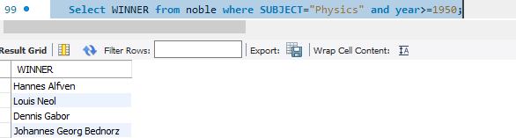From the following table, write a SQL query to find the Nobel Prize winners in 'Physics' since the year 1950. Return winner.
  2. From the following table, write a SQL query to find the Nobel Prize winners in 'Chemistry' between the years 1965 to 1975. Begin and end values are included. Return year, subject, winner, and country

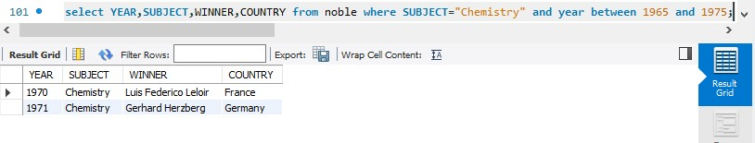

* 1. 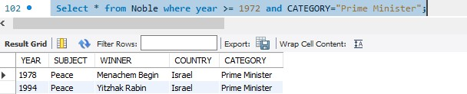Write a SQL query to show all details of the Prime Ministerial winners after 1972 of Menachem Begin and Yitzhak Rabin.
  2. 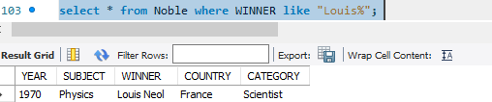From the following table, write a SQL query to find the details of the winners whose first name matches with the string 'Louis'. Return year, subject, winner, country, and category.
  3. From the following table, write a SQL query to find the details of the Nobel Prize winner 'Johannes Georg Bednorz'. Return year, subject, winner, country, and category.

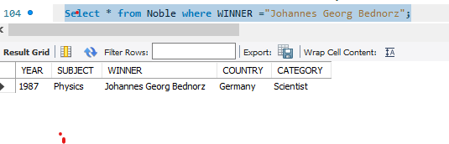

* 1. Create a database with the name: AbleJobs



* 1. Create the following Table with the name: Orders

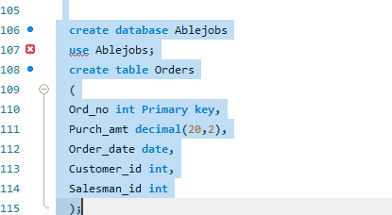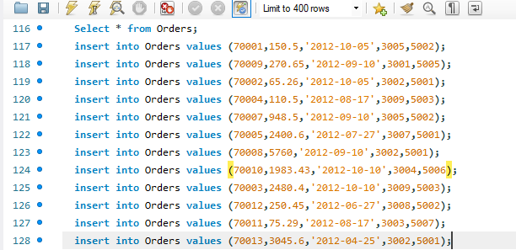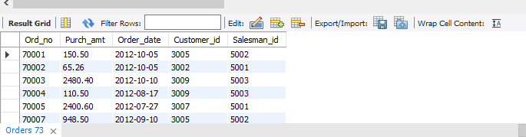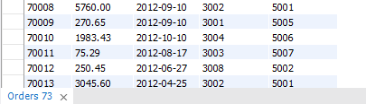

* 1. From the following table, write a SQL query to calculate total purchase amount of all orders. Return total purchase amount.

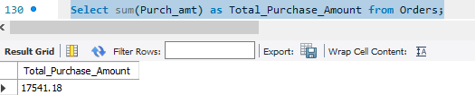

* 1. 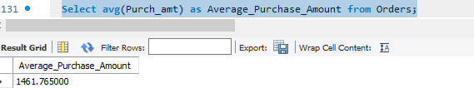From the following table, write a SQL query to calculate average purchase amount of all orders. Return average purchase amount.
  2. 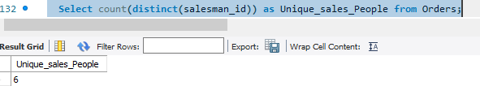From the following table, write a SQL query to count the number of unique salespeople. Return number of salespeople.
  3. From the following table, write a SQL query to count the number of customers. Return number of customers.

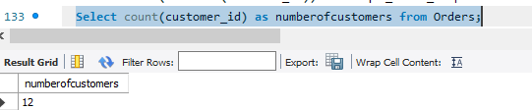

# Session 5: Union and Join

* 1. Create a database with the name: AbleJobs



* 1. Create the following Table with the name: Nobel

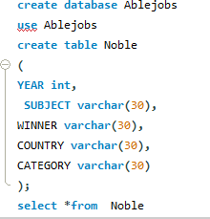

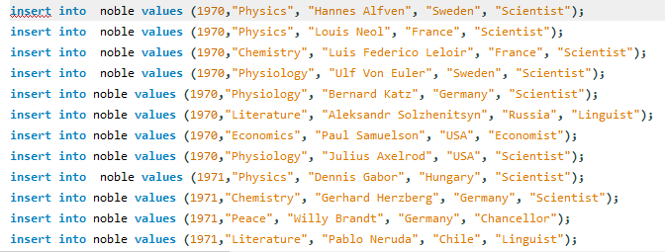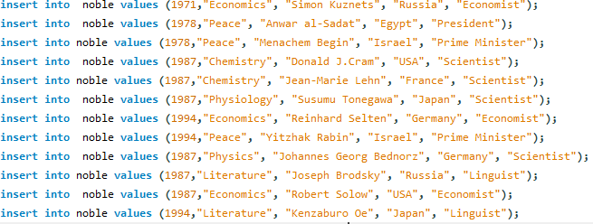

* 1. From the above table, write a SQL query to combine the winners in Physics, 1970 and in Economics, 1971. Return year, subject, winner, country, and category.

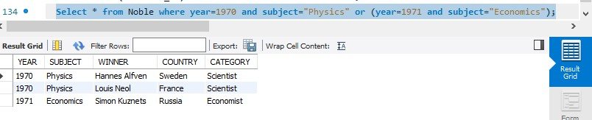

1. Create a database with the name: AbleJobs



1. Create the following Table with the name: Sales2

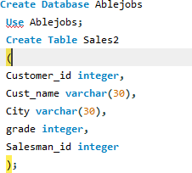

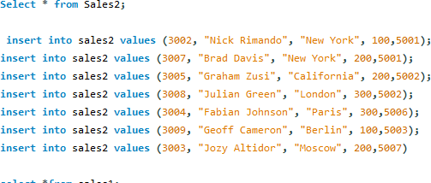

1. Create the following table with the name: Sales1

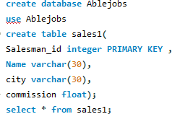

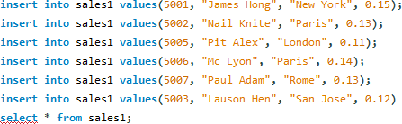

1. From the above tables write a SQL query to find the salesperson and customer who belongs to same city. Return Salesman, cust_name and city.

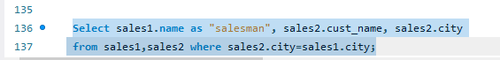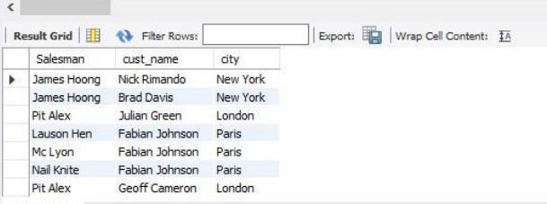

1. From the above tables write a SQL query to find the salesperson(s) and the customer(s) he handle. Return Customer Name, city, Salesman, commission.

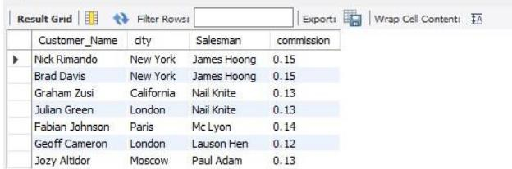

1. From the above tables write a SQL query to find those salespersons who received a commission from the company more than 12%.



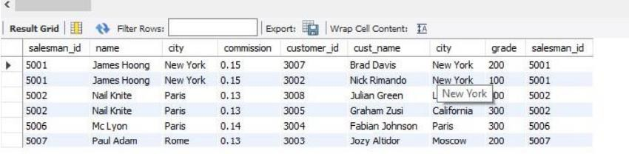

1. From the following tables write a SQL query to find those salespersons do not live in the same city where their customers live and received a commission from the company more than 12%. Return Customer Name, customer city, Salesman, salesman city, commission.

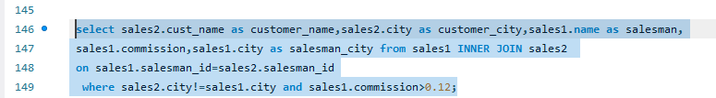

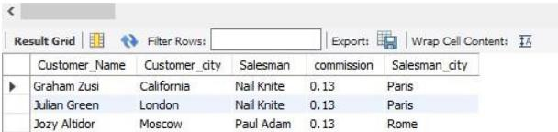

# Extra Practice Exercises/Test:

* + <https://www.w3schools.com/sql/trysql.asp?filename=trysql_asc>
  + <https://sqlzoo.net/wiki/SQL_Tutorial>
  + <https://app.testdome.com/t?GeneratorId=12>

# Online SQL editor for Self Practice:

* + <https://www.mycompiler.io/new/sql>
  + <https://www.sql-practice.com/>
  + <https://www.jdoodle.com/execute-sql-online/>

Submission Link: [https://drive.google.com/drive/folders/1Y9OcXU94n1btvXlVO1AOAXdIvmvwkeiS?usp=shari](https://drive.google.com/drive/folders/1Y9OcXU94n1btvXlVO1AOAXdIvmvwkeiS?usp=sharing) [ng](https://drive.google.com/drive/folders/1Y9OcXU94n1btvXlVO1AOAXdIvmvwkeiS?usp=sharing)

Submit the file in the following format:

Name_Course_Roll Number Example: Raju_Analyst_230501