# **Homework 2**

# **COSC 6342 Machine Learning**

# **University of Houston**

# **Department of Computer Science**

# **Sent on: Wednesday Oct 1, 2014**

**Due:Monday Oct 24, 2014**

|  |  |  |
| --- | --- | --- |
| Name | PeopleSoft Id. | Email |
| Anjani Swetha Settipalli | 1354349 | asettipa@uh.edu |
| Rohith Jidagam | 1641566 | rjidagam@uh.edu |

1)Write a report explaining the back propagation method with a pseudocode. The report must also include

--the method you used to shift the data,

-- the means of the clusters and the entire data after you have shifted the data

-- the value of the bias node

--the information of the parameters of the model (number of layers, number of nodes in the hidden layer, learning rate),

-- the outputs, as mentioned above, and

-- a graph showing the change in the accuracy after every 10 epochs. (you *may* include the generation of this graph in the code).

Pseudo code:

Initialize all weights (between -1 and 1)

    for every sample in the training set

        feed the sample to the network

       Propagate the input forward through the network:   
            for each layer in the network    
                for every node in the layer    
                    - Calculate the weight sum of the inputs to the node   
                    - Calculate the activation for the node    
                end    
            end

  Propagate the errors backward through the network   
             for every node in the output layer    
                calculate the error   
            end

            for all hidden layers    
                for every node in the layer    
                    - Calculate the node's signal error    
                    - Update each node's weight in the network    
                end    
            end

end

Method you used to shift the data

- Calculated the minimum value for each attribute.

- For each value(per attribute) in the sample data

- Compare the value with minimum

- if it is less than minimum value , update the value by subtracting minimum for it and

adding some constant value , so that all values will become positive.

- if it is greater than minimum value , use it as it is.

Means of clusters after shifting

X attribute :

Minimum = 10

Maximum = 577.58

Mean = 277.699

Standard Deviation = 160.484

Y attribute :

Minimum = 10

Maximum = 588.12

Mean = 267.6

Standard Deviation = 153.561

Value of the bias node

Bias value = 1 for all 400 samples in the data

Information of the parameters of the model

Number of layers: 3 (input, hidden and output)

Number of node3qqs in hidden layer: 17 (6+9+2)

Learning rate: 0.5

Initial Weights

Hidden weights: 3*17 = 51

initial_hidden_weight =

Columns 1 through 12

0.0512 -0.0299 0.0198 -0.0283 0.0398 0.0202 -0.0131 -0.0043 0.0312 -0.0033 0.0256 -0.0183

0.0159 0.0203 0.0225 -0.0319 -0.0180 -0.0570 0.0480 -0.0087 -0.0205 -0.0536 -0.0031 0.0124

0.0528 -0.0244 -0.0499 0.0194 0.0324 0.0118 -0.0576 -0.0045 0.0329 -0.0374 -0.0401 -0.0356

Columns 13 through 17

0.0275 -0.0267 -0.0245 0.0212 0.0167

-0.0297 0.0307 -0.0472 0.0054 0.0170

0.0482 -0.0360 0.0088 -0.0086 0.0207

Output Weight: 17*2 = 34

initial_output_weight =

0.0066 0.0055

0.0216 0.0040

-0.0141 0.0020

0.0102 0.0179

-0.0128 -0.0114

-0.0185 -0.0088

0.0052 -0.0185

-0.0024 0.0213

-0.0020 0.0071

0.0079 -0.0010

0.0131 0.0068

-0.0073 0.0022

0.0079 0.0071

-0.0041 0.0021

0.0166 0.0107

0.0161 0.0011

-0.0118 0.0239

Final Weights

Hidden weights : 3*17 = 51

hidden_weight =

Columns 1 through 12

0.2859 -10.3352 -0.1357 -0.4889 2.9854 1.5236 -3.5895 -0.4756 0.7399 -18.2443 3.0560 -0.2940

5.1479 13.5486 1.9839 0.7671 10.2746 -1.7892 -10.9506 1.1875 7.2409 -12.6714 10.4518 0.1294

-0.6813 -3.4318 -2.5272 -2.5876 -1.7204 -0.9456 1.9863 -2.6862 -0.7351 -3.1171 -1.7353 -2.2419

Columns 13 through 17

0.5706 -9.0614 -0.1324 -0.2543 -0.5589

4.1962 10.5541 1.7855 1.7299 1.0981

-1.2226 -3.3887 -2.5901 -2.6218 -2.6881

Output weights: 17*2 =34

output_weight =

-2.3092 2.3153

12.4358 -12.4280

-0.4976 0.4803

0.3375 -0.3143

-5.2838 5.2562

1.7770 -1.7999

8.4013 -8.3956

0.0565 -0.0428

-3.3964 3.3963

-15.9849 15.9821

-5.3698 5.3863

0.7493 -0.7584

-1.7972 1.8072

9.4035 -9.4196

-0.3499 0.3726

-0.3120 0.3240

0.1226 -0.1159

Accuracies output:

After 10th epoc : Accuracy = 50

After 100th epoc : Accuracy = 50

After 1000th epoc : Accuracy = 100

Graph showing the change in the accuracy after every 10 epochs

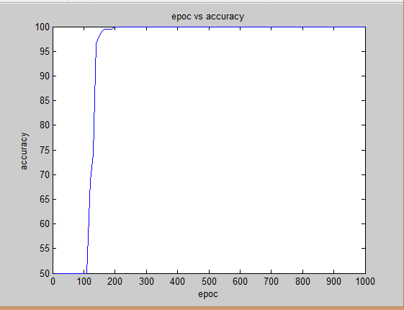

2)Train the shifted dataset (i.e, the dataset in the first quadrant after the shift) in Weka using the following algorithms ( by selecting ‘Use training set’ in ‘Classify’ tab from ‘Explorer’ in Weka)

* 1. J48 (under the Trees Folder)
  2. NaiveBayes (under the Bayes Folder)
  3. Multilayer Perceptron(under the Functions Folder)
  4. Support Vector Machine with polynomial Kernel of Degree 1 (under the Trees Folder with the name ‘SMO’)
  5. Support Vector Machine with polynomial Kernel of Degree 3 (under the Trees Folder with the name ‘SMO’).

Submit the arff file (data file), the models and the results as separate attachments. But include the accuracy, confusion matrix and the AUC of the models also in the report.

Draw a bar graph to compare the classification accuracies of these five models.

-All arff, model and result files are attached separately.

J48

Accuracy: 55.25%

Confusion matrix :

a b <-- classified as

200 0 | a = 0

179 21 | b = 1

AUC:

ROC Area = 0.559

Class 0 :

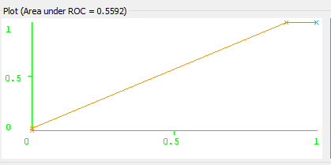

Class 1:

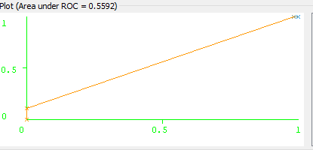

Naïve Bayes

Accuracy: 50.5%

Confusion matrix :

a b <-- classified as

102 98 | a = 0

100 100 | b = 1

AUC:

ROC Area = 0.559

Class 0:

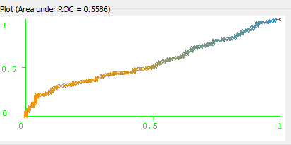

Class 1:

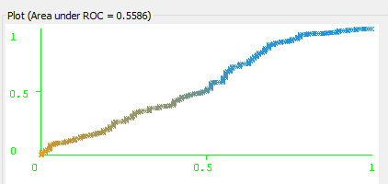

MultiLayer Perceptron

Accuracy: 98.5%

Confusion matrix :

a b <-- classified as

196 4 | a = 0

2 198 | b = 1

AUC:

ROC Area = 0.9989

Class 0:

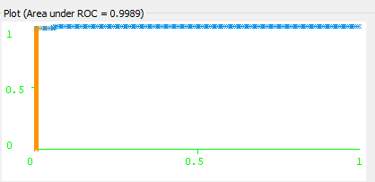

Class 1:

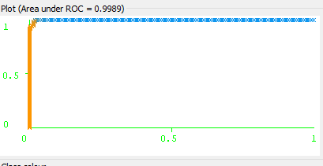

SMO degree 1

Accuracy: 53.75%

Confusion matrix :

a b <-- classified as

100 100 | a = 0

85 115 | b = 1

AUC:

ROC Area = 0.5375

Class 0:

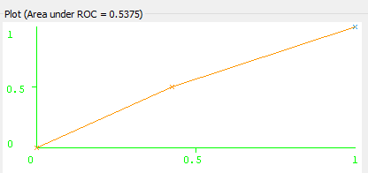

Class 1:

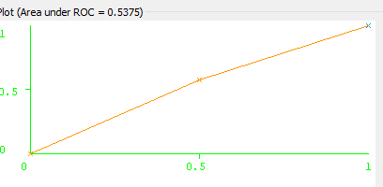

SMO degree 3

Accuracy: 92.75%

Confusion matrix :

a b <-- classified as

171 29 | a = 0

0 200 | b = 1

AUC:

ROC Area = 0.927

Class 0:

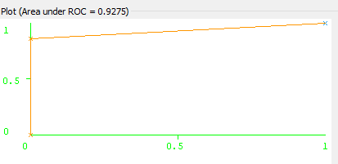

Class 1:

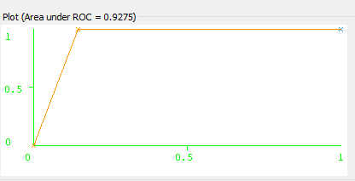

Bar graph to compare the classification accuracies of these five models

