# Essential Hardware Components: A Brief Overview

This document provides a brief overview of essential hardware components within a computer system. These components work together to execute instructions, store data, and interact with the user.

## 1. Central Processing Unit (CPU): The Brains of the Operation

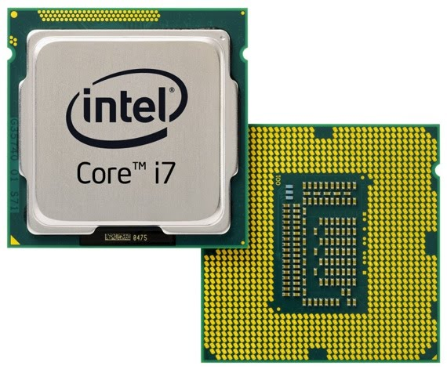

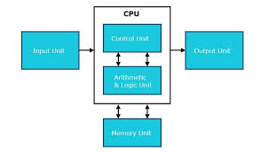

* **Function:** The CPU is the primary processing unit of a computer. It executes instructions from programs, performs calculations, and controls the operation of other components. It is responsible for the overall speed and performance of the system.
* **Key Components:**
  + **Arithmetic Logic Unit (ALU):** Performs arithmetic (addition, subtraction, multiplication, division) and logical (AND, OR, NOT) operations.
  + **Control Unit (CU):** Fetches instructions from memory, decodes them, and controls the execution of those instructions by coordinating other CPU components.
  + **Registers:** Small, high-speed storage locations within the CPU used to temporarily hold data and instructions during processing.
  + **Cache Memory:** A small amount of fast memory located near the CPU that stores frequently accessed data, allowing for quicker access than main memory (RAM). Often organized into L1, L2, and L3 levels.
* **Performance Metrics:**
  + **Clock Speed (GHz):** Indicates how many instructions the CPU can execute per second. A higher clock speed generally translates to faster performance, but it's not the only factor.
  + **Number of Cores:** Modern CPUs often have multiple cores, each of which can execute instructions independently, allowing for parallel processing and improved performance when running multiple tasks or applications.
  + **Cache Size:** Larger cache sizes can improve performance by reducing the need to access slower main memory.
  + **Architecture:** Refers to the design and organization of the CPU, which can significantly impact performance and efficiency. Examples include x86, ARM, and RISC-V.
* **Example:** An Intel Core i7-13700K processor is a high-performance CPU with multiple cores, high clock speeds, and a large cache, suitable for demanding tasks like gaming and video editing.

## 2. Memory (RAM): The Short-Term Storage

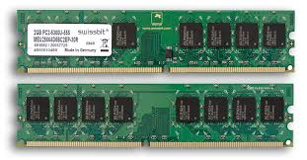

* **Function:** Random Access Memory (RAM) is the computer's main memory. It provides temporary storage for data and instructions that the CPU is actively using. It allows for rapid access and modification of data.
* **Key Characteristics:**
  + **Volatile:** Data stored in RAM is lost when the power is turned off.
  + **Random Access:** Any location in RAM can be accessed directly, allowing for fast data retrieval.
  + **Capacity (GB):** The amount of data RAM can hold. More RAM allows the system to run more programs simultaneously and handle larger datasets.
* **Types of RAM:**
  + **DRAM (Dynamic RAM):** The most common type of RAM, requiring periodic refreshing to maintain data.
  + **SRAM (Static RAM):** Faster and more expensive than DRAM, used primarily for CPU cache due to its high speed and low power consumption.
* **Performance Metrics:**
  + **Capacity (GB):** Larger capacity allows for more programs and data to be loaded into memory at once.
  + **Speed (MHz):** Indicates the data transfer rate of the RAM. Faster RAM can improve overall system performance.
  + **Latency (CAS Latency):** Measures the delay between requesting data and receiving it. Lower latency results in faster access times.
* **Example:** 16GB of DDR5 RAM operating at 5200MHz provides ample capacity and speed for most modern computing tasks.

## 3. Hard Disk Drive (HDD) and Solid State Drive (SSD): Long-Term Storage

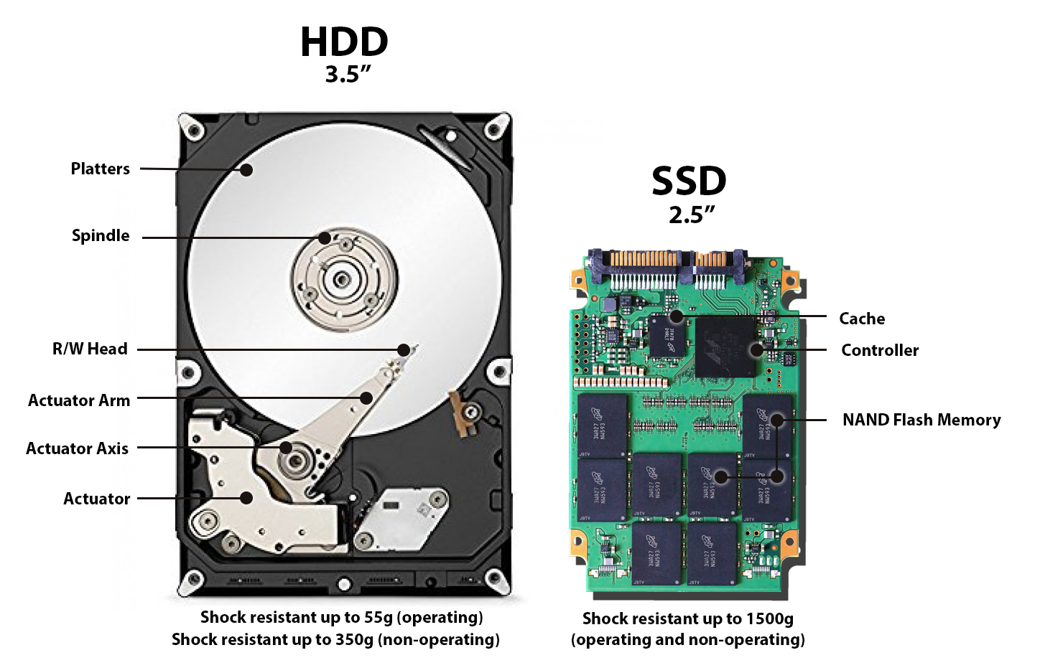

* **Function:** These storage devices provide persistent storage for data and programs, even when the computer is turned off.
* **Hard Disk Drive (HDD):**
  + **Mechanism:** Uses magnetic platters that spin at high speeds, with read/write heads accessing data on the platters.
  + **Characteristics:**
    - **Capacity (TB):** Can store large amounts of data.
    - **Relatively inexpensive per GB.**
    - **Slower access times compared to SSDs.**
    - **More susceptible to physical damage due to moving parts.**
  + **Performance Metrics:**
    - **RPM (Revolutions Per Minute):** Indicates how fast the platters spin. Higher RPM generally translates to faster read/write speeds.
    - **Average Access Time:** The average time it takes to locate and retrieve data.
* **Solid State Drive (SSD):**
  + **Mechanism:** Uses flash memory chips to store data electronically.
  + **Characteristics:**
    - **Significantly faster access times compared to HDDs.**
    - **More durable and resistant to physical damage.**
    - **Quieter operation (no moving parts).**
    - **More expensive per GB than HDDs.**
    - **Lower power consumption.**
  + **Performance Metrics:**
    - **Read/Write Speeds (MB/s):** Indicates how quickly data can be read from and written to the drive.
    - **IOPS (Input/Output Operations Per Second):** Measures the number of read/write operations the drive can perform per second.
* **Choosing between HDD and SSD:** SSDs are generally preferred for the operating system and frequently used applications due to their faster speed. HDDs are still viable for mass storage of data, such as large media files. Many systems use a combination of both for optimal performance and cost-effectiveness.
* **Example:** A 1TB NVMe SSD provides fast storage for the operating system and applications, while a 4TB HDD provides ample space for storing movies, music, and other large files.

## 4. Motherboard: The Central Hub

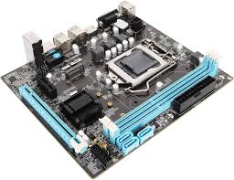

* **Function:** The motherboard is the main circuit board of the computer. It connects all the components together, allowing them to communicate with each other.
* **Key Components:**
  + **CPU Socket:** Where the CPU is installed.
  + **RAM Slots:** Where RAM modules are installed.
  + **Expansion Slots (PCIe):** Allow for the addition of expansion cards, such as graphics cards, sound cards, and network cards.
  + **Chipset:** A set of chips that control communication between the CPU, memory, and other peripherals.
  + **Storage Connectors (SATA, M.2):** Connect to hard drives, SSDs, and other storage devices.
  + **Front Panel Connectors:** Connect to the power button, reset button, and other front panel indicators.
  + **Rear Panel Connectors:** Provide connections for peripherals such as monitors, keyboards, mice, and network cables.
* **Form Factor:** The physical size and shape of the motherboard, which must be compatible with the computer case. Common form factors include ATX, Micro-ATX, and Mini-ITX.
* **Example:** An ATX motherboard with a Z790 chipset supports high-performance CPUs and multiple expansion cards, making it suitable for gaming and workstation PCs.

## 5. RAM Modules: Physical Memory Units

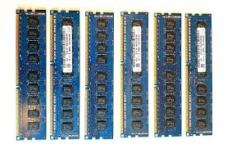

* **Function:** The physical modules that hold the RAM chips. They plug into the RAM slots on the motherboard.
* **Key Characteristics:**
  + **Form Factor (DIMM, SODIMM):** DIMM (Dual Inline Memory Module) is used in desktop computers, while SODIMM (Small Outline DIMM) is used in laptops.
  + **Capacity (GB):** The amount of memory the module holds (e.g., 8GB, 16GB).
  + **Speed (MHz):** The data transfer rate of the module.
  + **Timings (Latency):** Indicates the delay in accessing data from the module. Lower timings generally mean better performance.

## 6. Daughter Cards (Expansion Cards): Adding Functionality

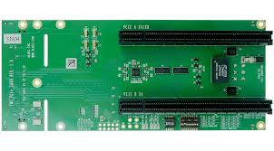

* **Function:** Expansion cards that plug into the motherboard's expansion slots (primarily PCIe slots) to add functionality to the computer.
* **Examples:**
  + **Graphics Card (GPU):** Responsible for rendering images and video.
  + **Sound Card:** Improves audio quality and provides additional audio inputs and outputs.
  + **Network Card:** Enables wired network connectivity (Ethernet).
  + **Wi-Fi Card:** Enables wireless network connectivity.
  + **Capture Card:** Allows recording video from external sources.

## 7. Bus Slots (PCIe): Connecting Expansion Cards

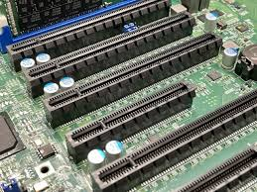

* **Function:** Physical slots on the motherboard that provide a standardized interface for connecting expansion cards.
* **Types:**
  + **PCIe (Peripheral Component Interconnect Express):** The most common type of expansion slot used in modern computers. Offers high bandwidth and supports various speeds (e.g., PCIe 3.0, PCIe 4.0, PCIe 5.0). Higher versions offer greater bandwidth.
  + **Older Slots:** AGP (Accelerated Graphics Port) and PCI (Peripheral Component Interconnect) were used in older systems.

## 8. SMPS (Switch Mode Power Supply): Providing Power

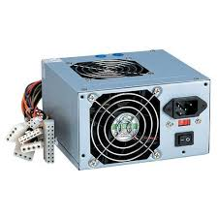

* **Function:** Converts AC power from the wall outlet into DC power that the computer components can use.
* **Key Characteristics:**
  + **Wattage:** The amount of power the SMPS can deliver. It's crucial to choose an SMPS with sufficient wattage to power all the components in the system.
  + **Efficiency:** Measures how efficiently the SMPS converts AC power to DC power. Higher efficiency means less energy is wasted as heat. Rated using standards such as 80+ Bronze, Silver, Gold, Platinum, and Titanium.
  + **Connectors:** Provides various connectors to power the CPU, motherboard, storage devices, and expansion cards.

## 

## 

## 9. Internal Storage Devices: Beyond the Primary Drive

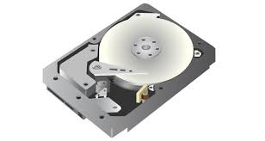

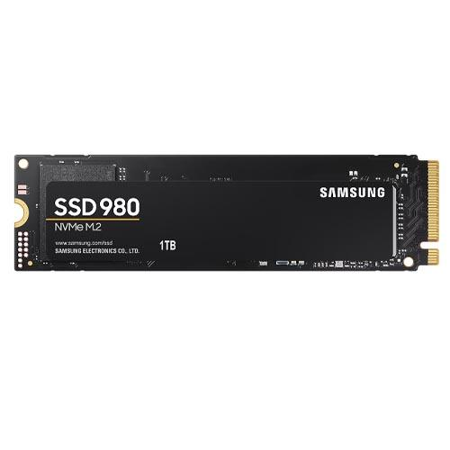

* **Function:** Additional storage devices that can be installed inside the computer case.
* **Examples:**
  + **HDDs:** For bulk storage of files.
  + **SSDs:** For faster access to frequently used files and applications.
  + **Optical Drives (DVD/Blu-ray):** For reading and writing data to optical discs (less common in modern computers).

## 10. Interfacing Ports: Connecting to the Outside World

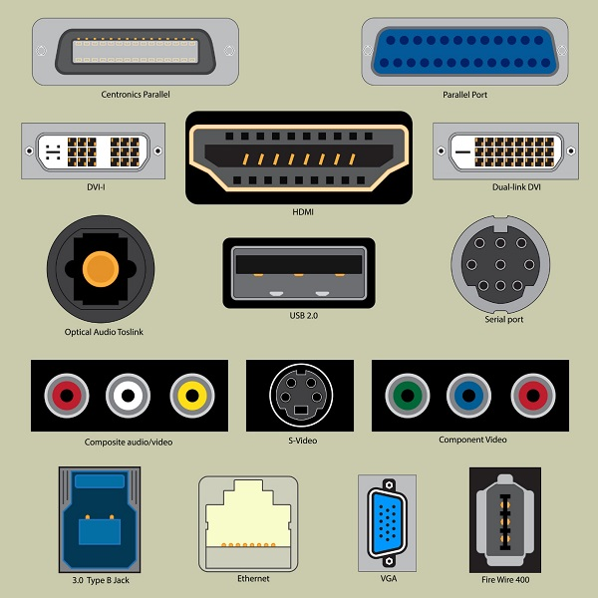

* **Function:** Connectors on the computer case that allow you to connect external devices.
* **Common Ports:**
  + **USB (Universal Serial Bus):** For connecting peripherals such as keyboards, mice, printers, external hard drives, and flash drives. Different versions exist (USB 2.0, USB 3.0, USB 3.1, USB 3.2, USB4) offering different speeds.
  + **HDMI (High-Definition Multimedia Interface):** For connecting monitors, TVs, and projectors. Transmits both video and audio signals.
  + **DisplayPort:** Another digital display interface similar to HDMI. Often preferred for high refresh rate gaming monitors.
  + **Ethernet (RJ45):** For connecting to a wired network.
  + **Audio Jacks:** For connecting headphones, speakers, and microphones.
  + **Serial Ports (COM) & Parallel Ports (LPT):** Older ports, rarely used in modern computers.
  + **PS/2 Ports:** Older ports for connecting keyboards and mice (also less common).

This document provides a basic understanding of the essential hardware components in a computer system. Choosing the right components and understanding how they work together is crucial for building a reliable and high-performing computer. Remember to research and compare different options before making any purchase decision