**Lab Cycle 4**

Open Excel to a blank worksheet.

**Problem-1**

Create a spreadsheet like the one below. Enter all the numbers.

* + Change the formatting of the numbers to dollars.
  + Make the grid around the cells visible.
  + Insert the title “Monthly Budget” and center and merge it.
    - Change the font to Baker Signet, size 18.
    - Make the text white and the fill black.
  + Insert the subtitle “January 2005 – June 2005.”
    - Change the font to Baker Signet, size 10
    - Make text white and fill black.
    - Center and merge it.
  + Total the expenses at the bottom of each month.
    - Widen columns if necessary so numbers can be seen.
  + Put a dark border around the edges of the document.
  + Change the amount for gasoline in June from $60 to $70.
  + Figure out the average for each row. You must know the formula on your own!
  + Center and bold the headings (months and average)
    - Change the font to BakerSignet on the headings
    - Bold the headings in column A.
    - Change the font to BakerSignet.
  + Add a header with your name, period, and FINAL PART A.
  + Print

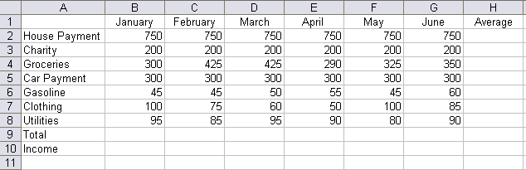

**Problem 2**

Keep the work from Part A open. You will be making two graphs from this information.

**Graph 1 – Pie Chart**

This graph will show the total amount of money spent on each category over a six month period.

To do this, you must total the amount spent on each item in column I. Do not include the average in your equation.

Next, highlight the expenses (house payment, gasoline, etc). Hold down the ctrl key and highlight your new totals.

Create a pie chart. Go to data labels and show the percentages.

Cut and paste all the information you need and the graph to a new sheet.

**Graph 2. – Bar Chart**

This will be a bar chart for income and expenses.

Below your total column, type Income in A12. Enter the income for each month. They are as follows:

January: 2,000

February: 2,100

March: 2,000

April: 1,900

May: 2,500

June: 2,200

Create a bar chart that looks like the one below. Include the chart you make and the date for the chart on the page you print. This page should include the two data sets and the two charts. Print preview to make sure it all prints on one page.



**Problem 3**

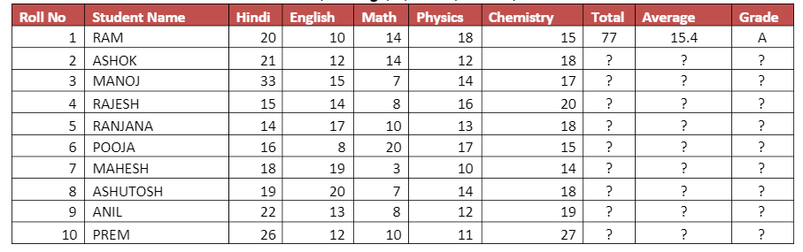

Q.1 Find the Total Number & Average in all Subjects in Each Student .

Q.2 Find Grade Using If Function - If Average Greater >15 then "A" Grade otherwise "B" Grade

Q.3 How Many Student "A" and "B" Grade

Use of Countif

Q.4 Student Ashok and Manoj Total Number and Average

Use of Sumif

Q.5 Count how many Students

Use of Counta

Q.6 How Many Student Hindi & English Subject Number Grater Then > 20 and <15

Use of Countif

Q.1 Find the Total Number & Average in all Subjects in Each Student.

Q.2 Find Grade Using If Function - If Average Greater >15 then "A" Grade otherwise "B" Grade

Q.3 How Many Student "A" and "B" Grade (*Use of Count if)*

Q.4 Student Ashok and Manoj Total Number and Average (*Use of Sum if)*

Q.5 Count how many Students

Q.6 How Many Student Hindi & English Subject Number Grater Then > 20 and <15 (*Use of Countif)*

**Problem 4**

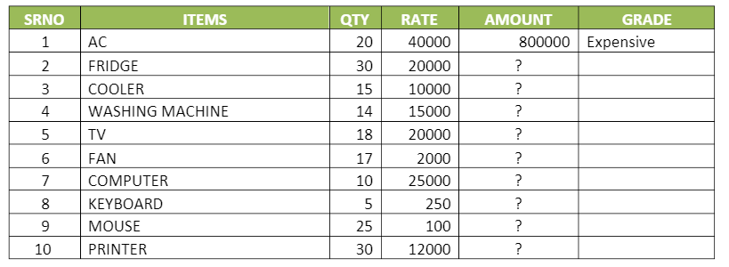

Q.1 Using of Product Fomula for Calculate Amount = Qty*Rate

Q.2 How Many Items in a List

Q.3 How Many Items qty Greate Then > 20 and Less Then <20

Q.1 Using of Product Fomula for Calculate Amount = Qty*Rate

Q.2 How Many Items in a List

Q.3 How Many Items qty Greate Then > 20 and Less Then <20

Q.4 Calculate Item Computer Qty, Rate and Amount using Sumif Formula

Q.5 If Items Amount is Greater > 500000, Then Items "Expensive" otherwise "Lets Buy it".

Q.4 Calculate Item Computer Qty, Rate and Amount using Sumif Formula

Q.5 If Items Amount is Greater > 500000, Then Items "Expensive" otherwise

"Let’s Buy it".

**Problem5**

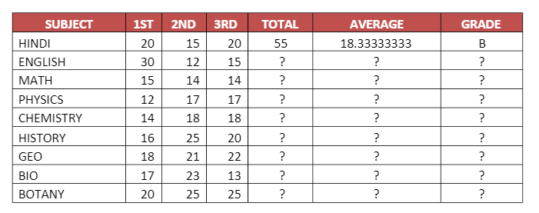

Q.1 how many subject?

Q.2 how many subject 1 paper greater than 20? *(use of count if)*

Q.3 subject hindi, math & english total no. & grade *(use of vlookup)*

Q.4 if ave. Greather than 20 then "a", if ave. Greatehr than 15 ave. "b" otherwise "c"

Q.5 subject physics, maths & english total /average *(use of vlookup)*

**Problem6**

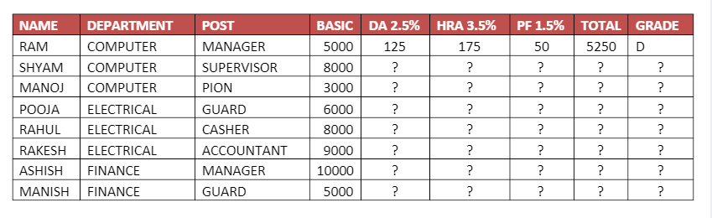

Q.1 HOW MANY EMPLOYEE IN COMPUTER, FINANCE, ELECTRICAL DEPARTMENT

Use of Countif

Q.2 HOW MANY BASIC SALARY IN COMPUTER DFPARTMENT ONLY?

Use of Sumif

Q.3 MANOJ, ASHISH POST & GRADE

Use of Vlookup

Q.4 IF TOTAL SALALRY IS GREATER THEN 20000 THEN "A", IF TOTAL SALARY GREATER THEN 10000 THEN "B",

OTHERWISE "C"

Q.1 how many employee in computer, finance, electrical department *(use of countif )*

Q.2 how many basic salaries in computer dfpartment only? *(use of sumif )*

Q.3 manoj, ashish post & grade *(use of vlookup )*

Q.4 if total salalry is greater then 20000 then "a", if total salary greater then 10000 then "b”, otherwise "c"

Q.5 how many employee is manager & guard?

Use of countif

Q.5 how many employee is manager & guard? *(use of countif)*

**Problem 7**

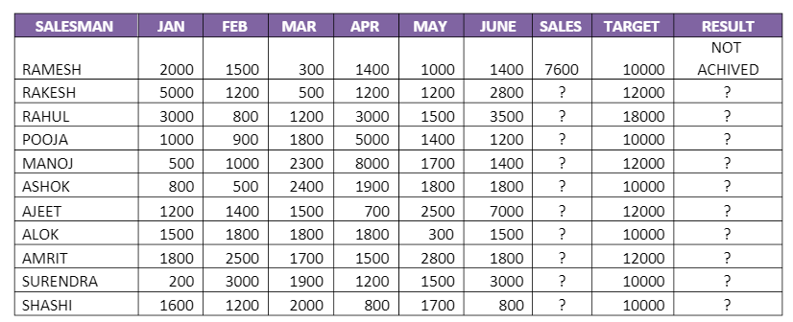

Q.1 How many salesman? Salesman Ajeet Targest & Result?

Q.2 If Sales Greater Than Target Then Target Achived otherwise Not Achived Use of If Function

Q.3 Rahul Pooja & Ashok Targest & result?  *(Use of Vlookup* )

Q.4 How Many Salesman Achived Target. *(Use of Countif )*

Q.5 Which Sales Man Jan Sales 2000, & Feb Sales is 2500? (Use of Lookup Function)

Q.1 How many salesman? Salesman Ajeet Targest & Result?

Use of Counta and Vlookup

Q.2 If Sales Greater Than Target Then Target Achived otherwise Not

Achived

Use of If Function

Q.3 Rahul Pooja & Ashok Targest & result?

Use of Vlookup

Q.4 How Many Salesman Achived Target.

Use of Countif

Q.5 Which Sales Man Jan Sales 2000, & Feb Sales is 2500?

Use of Lookup Function

**Problem 8**

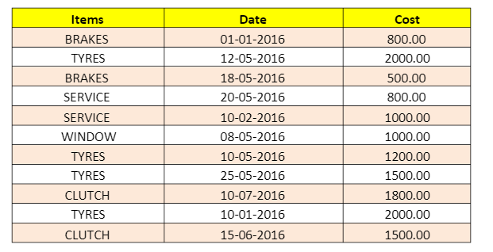

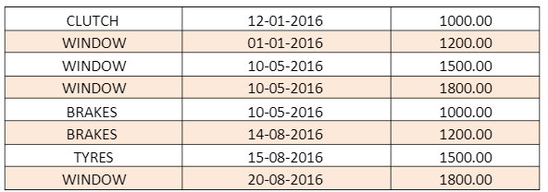

Q.1 how many items ?

Q.2 how many brake, window & tyres have been boughts? *(Use of countif )*

Q.3 how many items cost is >1000 & below > = 1000? *(Use of countif )*

Q.4 highlight tyres itesm & 500 between 2000 cost.

Q.5 total cost of window and brakes items?  *( Use of sumif)*

**Problem 9**

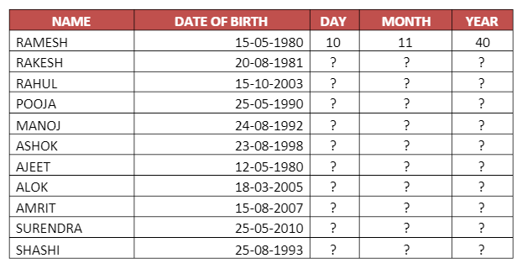

Q.1 HOW MANY STUDENT?

Use of

Counta

Q.2 STUDENT SURENDRA IS HOW MANY YEAR OLD?

Use of

Sumif

Q.3 HOW MANY STUDENT AGE GREATER THEN 20 YEARS?

Use of

Countif

Q.4 IF STUDENT AGE IS GREATHER THEN 20 THEN STUDENT ADULT / CHILD?

Q.5 HOW MANY STUDENT AGE IS >= 25 YEARS?

Use of

Counti

Q.1 how many student?

Q.2 student SURENDRA is how many year old? *(Use of sum if )*

Q.3 how many student age greater then 20 years? *(Use of countif )*

Q.4 if student age is greater then 20 then student adult / child?

Q.5 how many student age is >= 25 years? *(Use of countif)*

**Problem 10**

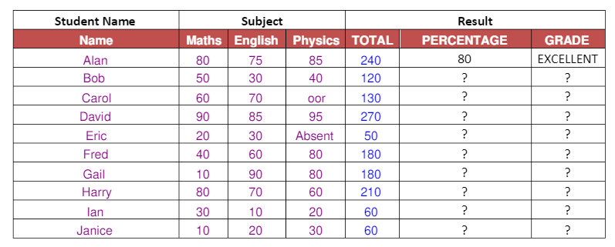

Q.1 how many student?

Q.2 how many student percentage greather then > 50 *(use formula countif )*

Q.3 student bob and eric total number? *(Use formula sumif)*

Q.4 if percentage greater then >70 then "excellent", if percentage greater then >50,"good", otherwise "bed"

Q.5 how many students good and bed in a list (*use formula countif)*

**Problem 11**

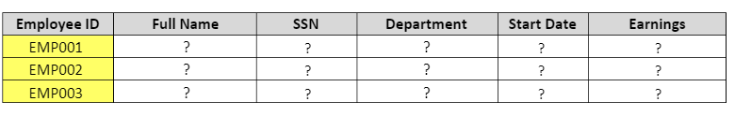 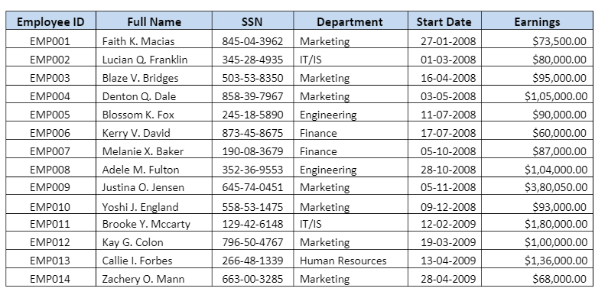

Q.1 How Many Employee in a List?

Q.2 How Many Employee work in Finance and Marketing Department? (Use of Formula Countif)

Q.3 Employee Blossom K. Fox Department and Earnings? (Use of Vlookup)

Q.4 Employee Blossom K. SSN No.? (Use of Vlookup)

Q.5 How Many Amount Earnings Marketing Department? (Use of Sumif)