- First, Add a global variable TASK_AFFINITY = "" the file /opt/apps/fabric/workspace/project/Implementation/SharedObjects/Java/src/com/k2view/cdbms/usercode/common/TDM/SharedGlobals.java.
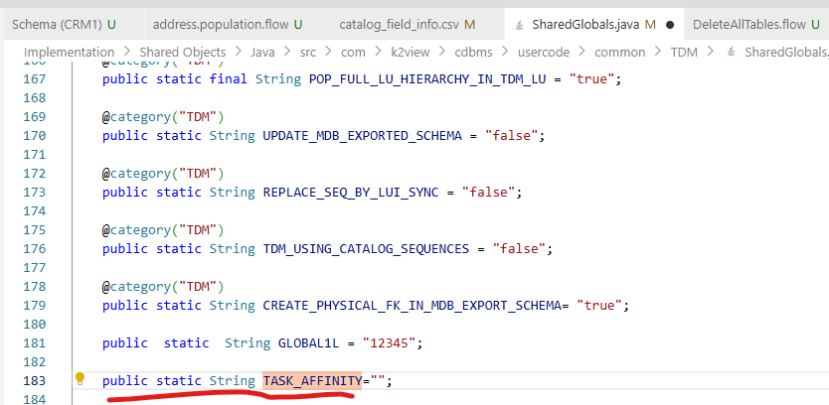
- Import both flows into the TDM_TableLevel LU in your project under TDM_TableLevel->Broadway Directory
  - TableLevelExtractOnlyTask.flow
  - TableLevelLoadOnlyTask.flow

- Deploy the LUs.
- In TDM GUI, set the environment variable TASK_AFFINITY to your affinity node/DC for both source and target environment
- Execute the Table level task

