PES University – Dept. of CSE
Lab 1: Requirements Engineering & UML Use-Case Modelling
Problem Statement #39 – Second-Hand Product Escrow Marketplace
Domain: Retail, E-Commerce & Finance
Student Name | Rohith Karning
SRN | PES1UG24AM229
Email | rohithkarning@gmail.com
Target Actors | Buyer, Inspection Agent (+ Seller, Payment Gateway, Dispute Admin as supporting actors)

1. Problem Context
A secure peer-to-peer trading marketplace where buyer payments are held in escrow, independent third-party inspectors certify product condition, and funds release only upon buyer sign-off. This removes the two biggest risks in second-hand trading – buyers paying for misrepresented items, and sellers shipping without payment guarantee – by inserting an independent verification and escrow layer between the two parties.

2. Requirements Table
Functional Requirements (FR-001 – FR-005)
ID | Type | Description | Priority | Acceptance Criteria | Rationale
FR-001 | Functional | The system shall lock the buyer's payment in escrow and set the order status to “Under Inspection” immediately after checkout, holding funds until both the Inspection Agent and the Buyer sign off. | High | Pass: Funds held in escrow and not released until dual verification is complete.  Fail: Funds reach the seller before both sign-offs are recorded. | Protects the buyer from paying for misrepresented goods while assuring the seller that payment is guaranteed once verified.
FR-002 | Functional | Upon a successful escrow lock, the system shall automatically assign an available, independent Inspection Agent to the order within 24 hours and notify both parties. | High | Pass: An agent is assigned and notified within 24 hours of payment.  Fail: No agent assigned within the SLA window. | Ensures timely, unbiased third-party verification, the core trust mechanism of the marketplace.
FR-003 | Functional | The system shall allow the assigned Inspection Agent to submit a structured condition report (checklist and photos) against the listing within the inspection window. | High | Pass: Report with checklist and at least 3 photos is stored and linked to the order.  Fail: A report lacking checklist or photo evidence is accepted. | Structured evidence reduces disputes and gives the buyer objective grounds for approval or rejection.
FR-004 | Functional | After the inspection report is published, the system shall let the buyer either approve the product (triggering escrow release) or reject it (triggering a dispute) within the review window. | High | Pass: Buyer decision is recorded and the correct downstream workflow (release/dispute) fires within the window.  Fail: No action taken, or the wrong workflow is triggered. | Gives the buyer final control over fund release, completing the trust loop the escrow model depends on.
FR-005 | Functional | The system shall let the buyer or seller raise a dispute on a rejected/contested order, freeze escrow funds, and route the case to a Dispute Admin for resolution (partial/full refund or release). | Medium | Pass: Escrow is frozen immediately on dispute creation and resolved with a documented decision.  Fail: Funds move while a dispute is open. | Provides a fair, auditable resolution path when buyer and seller disagree on product condition.

Non-Functional Requirements (NFR-001 – NFR-002)
ID | Type | Description | Priority | Acceptance Criteria | Rationale
NFR-001 | Security | Dispute tickets must freeze escrow funds within 5 seconds and block withdrawals during an active investigation; payment and personal data must be encrypted at rest and in transit (AES-256 / TLS 1.2+). | High | Pass: Simulated dispute freezes funds within 5s and blocks withdrawal attempts; audit confirms encryption in place.  Fail: A withdrawal succeeds during an open dispute, or data is found unencrypted. | Financial and identity data safeguards are essential since the platform holds real escrowed funds and verification documents.
NFR-002 | Performance & Scalability | The platform shall maintain 99.5% uptime and process order-status transitions (payment → inspection → release) with a server response time under 2 seconds at up to 500 concurrent users. | Medium | Pass: Load testing confirms <2s p95 response time and 99.5% uptime over a 30-day window.  Fail: Response time or uptime falls outside the target. | Buyers and sellers need a responsive, reliable platform to trust it with time-sensitive, escrowed transactions.

3. UML Use-Case Diagram
Primary actors: Buyer, Inspection Agent. Secondary actors: Seller, Payment Gateway (external system), Dispute Admin. The diagram below models all actors, the primary use cases, and includes three «include» relationships (Place Order → Make Payment; Place Order → Authenticate User; Request Inspection → Send Notification) and one «extend» relationship (Raise Dispute extends Reject Product).
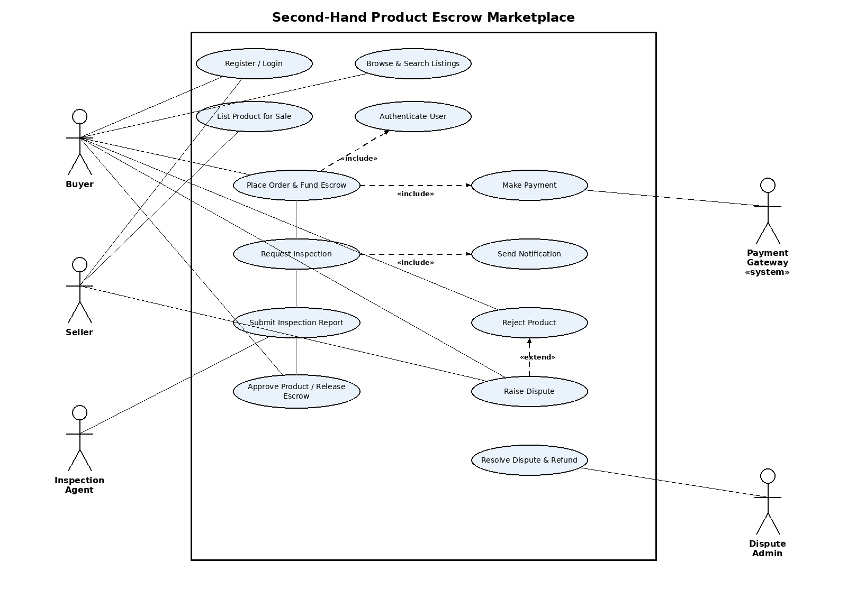
Actors & Use Cases summary:
- Buyer (primary): Register/Login, Browse & Search Listings, Place Order & Fund Escrow, Approve Product / Release Escrow, Reject Product, Raise Dispute
- Inspection Agent (primary): Submit Inspection Report
- Seller (secondary): Register/Login, List Product for Sale, Raise Dispute
- Payment Gateway (secondary, system actor): Make Payment
- Dispute Admin (secondary): Resolve Dispute & Refund
- System-internal use cases: Authenticate User, Request Inspection, Send Notification

4. Use-Case Flow Specification
Use Case: Approve Product & Release Escrow Funds
Primary Actor: Buyer | Supporting Actors: Inspection Agent, System (Escrow Engine)
Preconditions:
- The buyer has placed an order and payment is held in escrow (see FR-001).
- The assigned Inspection Agent has submitted a completed inspection report (see FR-003).
- The order status is “Inspection Complete” and is within the buyer review window.
Postconditions (on success):
- Escrow funds are transferred from the escrow account to the seller's linked account.
- Order status is updated to “Completed”.
- Buyer and seller each receive a confirmation notification.
Main Success Scenario:
- 1. Buyer receives a notification that the inspection report is ready for review.
- 2. Buyer opens the order and reviews the inspection report (condition checklist and photos).
- 3. Buyer selects “Approve Product.”
- 4. System validates that the order status is “Inspection Complete” and that the action is within the review window.
- 5. System releases the escrowed funds to the seller's account.
- 6. System updates the order status to “Completed.”
- 7. System sends confirmation notifications to both buyer and seller.
- 8. Use case ends.
Alternate Flow – A1: Buyer Rejects the Product (branches at step 3):
- 3a. Buyer selects “Reject Product” and enters a reason with supporting evidence.
- 3b. System sets the order status to “Disputed” and immediately freezes the escrow funds (extends into the Raise Dispute use case).
- 3c. System notifies the seller and routes the case to the Dispute Admin queue.
- 3d. Use case ends; resolution continues under “Resolve Dispute & Refund.”

