PES UNIVERSITY
100 Feet Ring Road, BSK 3rd Stage, Bengaluru 560085

Department of Computer Science and Engineering
(AI & ML)
B. Tech. CSE – 5th Semester
Aug – Dec 2026

UE23CS351A
DATABASE MANAGEMENT SYSTEMS (DBMS)

PROJECT REPORT ON
TalentMatch
AI-Assisted Resume-to-Job Matching and Recruitment Management System
Submitted by:
SRN | Name | Section
PES1UG24AM229 | Rohith Karning | D
PES1UG24AM237 | Saanvi Maharana | D

Class of Prof. Devna Sumesh

Abstract
Recruiters often receive more resumes than they can manually review, while keyword-based filters can miss candidates whose relevant experience is described using different terminology. TalentMatch is a recruitment management web application that ranks candidates using semantic similarity between resumes and job descriptions. Resume and job text are converted into 384-dimensional embeddings using the all-MiniLM-L6-v2 model and stored in PostgreSQL through the pgvector extension. Candidate ranking is performed inside the database using cosine distance, together with relational filters and skill information.
The platform supports three roles: candidate, recruiter and administrator. Candidates manage profiles and skills, upload resumes, search jobs, inspect skill gaps, apply and track application progress. Recruiters publish jobs, review ranked applicants, manage interviews and issue offers. Administrators manage companies and recruiter accounts and view hiring analytics.
The database implementation contains 16 tables, 22 foreign keys, 57 CHECK constraints, 8 UNIQUE constraints, 46 indexes (including two HNSW vector indexes), 19 triggers, 6 stored functions and 3 views. Database constraints enforce workflow rules, prevent duplicate applications and validate vector data. The report records seeded-data examples in which the Machine Learning Engineer role ranks Aditi Sharma first with similarity 0.7819 and 3/3 required skills. The reported test run passed 85/85 unit tests and 147/147 integration tests, in addition to SQL constraint and advanced-feature tests.
Keywords: PostgreSQL, pgvector, semantic search, sentence embeddings, cosine similarity, HNSW, triggers, transactions, Next.js.

Table of Contents
Sl. No. | Topic | Page No.
1 | Introduction and Problem Statement | 4
2 | User Requirements Specification and Technology Stack | 5
3 | E-R Model | 7
4 | Relational Model | 9
5 | SQL DDL Statements | 11
6 | SQL DML Statements | 13
7 | NoSQL / Vector Database Commands | 15
8 | Results | 17
9 | Next.js Project Tree Structure | 23
10 | Sample Screenshots of Application Code and Demo | 24
11 | Evaluation Rubrics – Completion Status | 26

1. Introduction

1.1 Problem Statement
Recruitment teams must review large volumes of resumes for every job opening. Traditional keyword matching is brittle: candidates may possess relevant skills and experience but describe them using different words from those in the job description. Manual screening is time-consuming and can overlook suitable applicants. In addition, recruitment requires a reliable workflow for applications, interviews, offers, notifications and role-based access.

1.2 Proposed Solution
TalentMatch combines semantic resume-to-job matching with a complete recruitment workflow. It generates embeddings for resume and job text, stores them in pgvector, and ranks candidates by cosine similarity. The relational database remains responsible for user profiles, skills, jobs, applications, interviews, offers, notifications, integrity constraints and analytics.

1.3 Main Objectives
- Provide semantic matching beyond exact keyword overlap.
- Allow candidates to manage profiles, skills, resumes, job searches and applications.
- Allow recruiters to publish jobs, rank applicants, schedule interviews and make offers.
- Provide administrators with company/recruiter management and hiring analytics.
- Enforce application status transitions, ownership, uniqueness and data integrity at the database and API layers.
- Combine relational queries with vector similarity search in one PostgreSQL-backed system.

1.4 Scope
The application covers candidate, recruiter and administrator workflows. It includes resume text extraction from PDF/TXT uploads, local embedding generation, vector storage and retrieval, SQL-based analytics, authentication, authorization, validation and testing. The submitted report identifies PostgreSQL 17 and pgvector 0.8.7 as the database implementation.

2. User Requirements Specification

2.1 Functional Requirements
ID | User role | Requirement
FR-01 | Candidate | Register, log in and maintain a candidate profile.
FR-02 | Candidate | Add skills with proficiency levels and upload/manage resumes.
FR-03 | Candidate | Browse and filter open jobs; inspect job details and skill gaps.
FR-04 | Candidate | Apply once per job and track application status/history.
FR-05 | Recruiter | Create, edit and manage job postings with required skills.
FR-06 | Recruiter | View applicants ranked by semantic similarity and skill matches.
FR-07 | Recruiter | Move applications through permitted stages, schedule interviews and issue offers.
FR-08 | Admin | Manage companies and recruiter accounts; view hiring analytics.
FR-09 | System | Generate resume/job embeddings and support vector similarity retrieval.
FR-10 | System | Send in-app notifications for application and status events.

2.2 Non-Functional Requirements
- Security: bcrypt password hashes, JWT session in an httpOnly cookie, server-side role checks and parameterised SQL.
- Integrity: foreign keys, CHECK/UNIQUE constraints, triggers and transactions enforce business rules.
- Performance: indexes support common relational filters; HNSW indexes support approximate nearest-neighbour vector retrieval.
- Maintainability: 24 ordered database migrations, documented queries, modular Next.js routes and tests.
- Privacy and correctness: embeddings are computed locally on the server; invalid or missing embeddings are not replaced with fabricated similarity scores.

2.3 Technology Stack and Justification
Layer | Technology | Purpose / justification
Frontend | Next.js 16.4.0, React 19.3.0, Tailwind CSS 4 | App Router pages and responsive role-specific dashboards, forms, tables, search and filters.
Backend/API | Next.js Route Handlers | 36 API route files; server-side authentication, authorization, validation and application logic.
Relational DB | PostgreSQL 17 | Stores users, companies, candidates, recruiters, skills, jobs, applications, interviews, offers and notifications with strong constraints and transactions.
Vector DB | pgvector 0.8.7 | Stores 384-dimensional resume/job vectors in the same PostgreSQL database; supports cosine distance and HNSW indexing.
DB driver | pg (node-postgres) 8.23 | Connection pooling and parameterised SQL without an ORM.
Embedding model | @huggingface/transformers 4.3; all-MiniLM-L6-v2 | Computes local sentence embeddings without an external embedding API.
Resume parsing | pdfjs-dist 6.4 | Extracts text from uploaded PDF resumes.
Validation | zod 4.6 | Validates request payloads in the API layer before database operations.
Authentication | bcryptjs 3.0, jose 6.2 | Password hashing and HS256 JWT session tokens in httpOnly cookies.
Testing/tooling | node:test, SQL scripts, Docker Compose, Git/GitHub | Unit/integration testing, reproducible PostgreSQL environment and version control.

2.4 Database Choice Justification
PostgreSQL is used for transactional recruitment data because users, companies, jobs, applications, interviews and offers have well-defined relationships and integrity requirements. pgvector is selected instead of a separate vector service because embeddings belong directly to resume and job records. Storing vectors in the same database enables foreign-key ownership, cascading deletion, transactional consistency and a single query that combines cosine distance with relational filters.

3. E-R Model

3.1 Entities
Entity | Classification | Description
users | Strong | Account identity, email, password hash, name, role and active state.
companies | Strong | Hiring company details.
recruiters | Subtype/profile | Recruiter profile linked 1:1 to users and to a company.
candidates | Subtype/profile | Candidate profile linked 1:1 to users.
skills | Strong | Master list of skills and categories.
jobs | Strong | Job postings created for a company by a recruiter.
resumes | Strong | Uploaded resume metadata and extracted text.
applications | Strong | Candidate application to a job; unique per job/candidate pair.
interviews | Strong | Interview rounds associated with applications.
offers | Strong | Offer associated with an application.
notifications | Strong | In-app notifications for users and application events.
application_status_history | Strong / dependent | Audit history generated when application status changes.
candidate_skills | Associative | Many-to-many relation between candidates and skills, with proficiency.
job_skills | Associative | Many-to-many relation between jobs and skills, with required flag and minimum proficiency.
resume_embeddings | Dependent vector record | One vector per resume; primary key is also a cascading foreign key.
job_embeddings | Dependent vector record | One vector per job; primary key is also a cascading foreign key.

3.2 Relationships (high-level)
- One user has one candidate profile or one recruiter profile according to role.
- One company can have multiple recruiters and multiple jobs.
- Candidates and skills have a many-to-many relationship through candidate_skills.
- Jobs and skills have a many-to-many relationship through job_skills.
- A candidate can submit applications to many jobs; each job can receive many applications.
- An application can have interview rounds, an offer and status-history records.
- A resume can have one associated resume embedding; a job can have one associated job embedding.
- Users can receive multiple notifications.

3.3 Non-simple Attributes
- users: created_at and role; email is constrained to lowercase format.
- jobs: salary range, work mode, employment type, status and dates are represented as validated attributes.
- candidate_skills: proficiency level (1–5).
- job_skills: required flag and minimum proficiency.
- applications: status, match_score, applied_at and updated_at.
- resume_embeddings/job_embeddings: vector(384), model_name, chunk_count, source_hash and created_at.

3.4 ER Diagram Snapshot
Figure 3.1. Entity-relationship diagram generated from the entities, attributes and cardinalities documented in this report and the repository artifact references (docs/er-diagram.md; new_changes/er-diagram-chen.png).
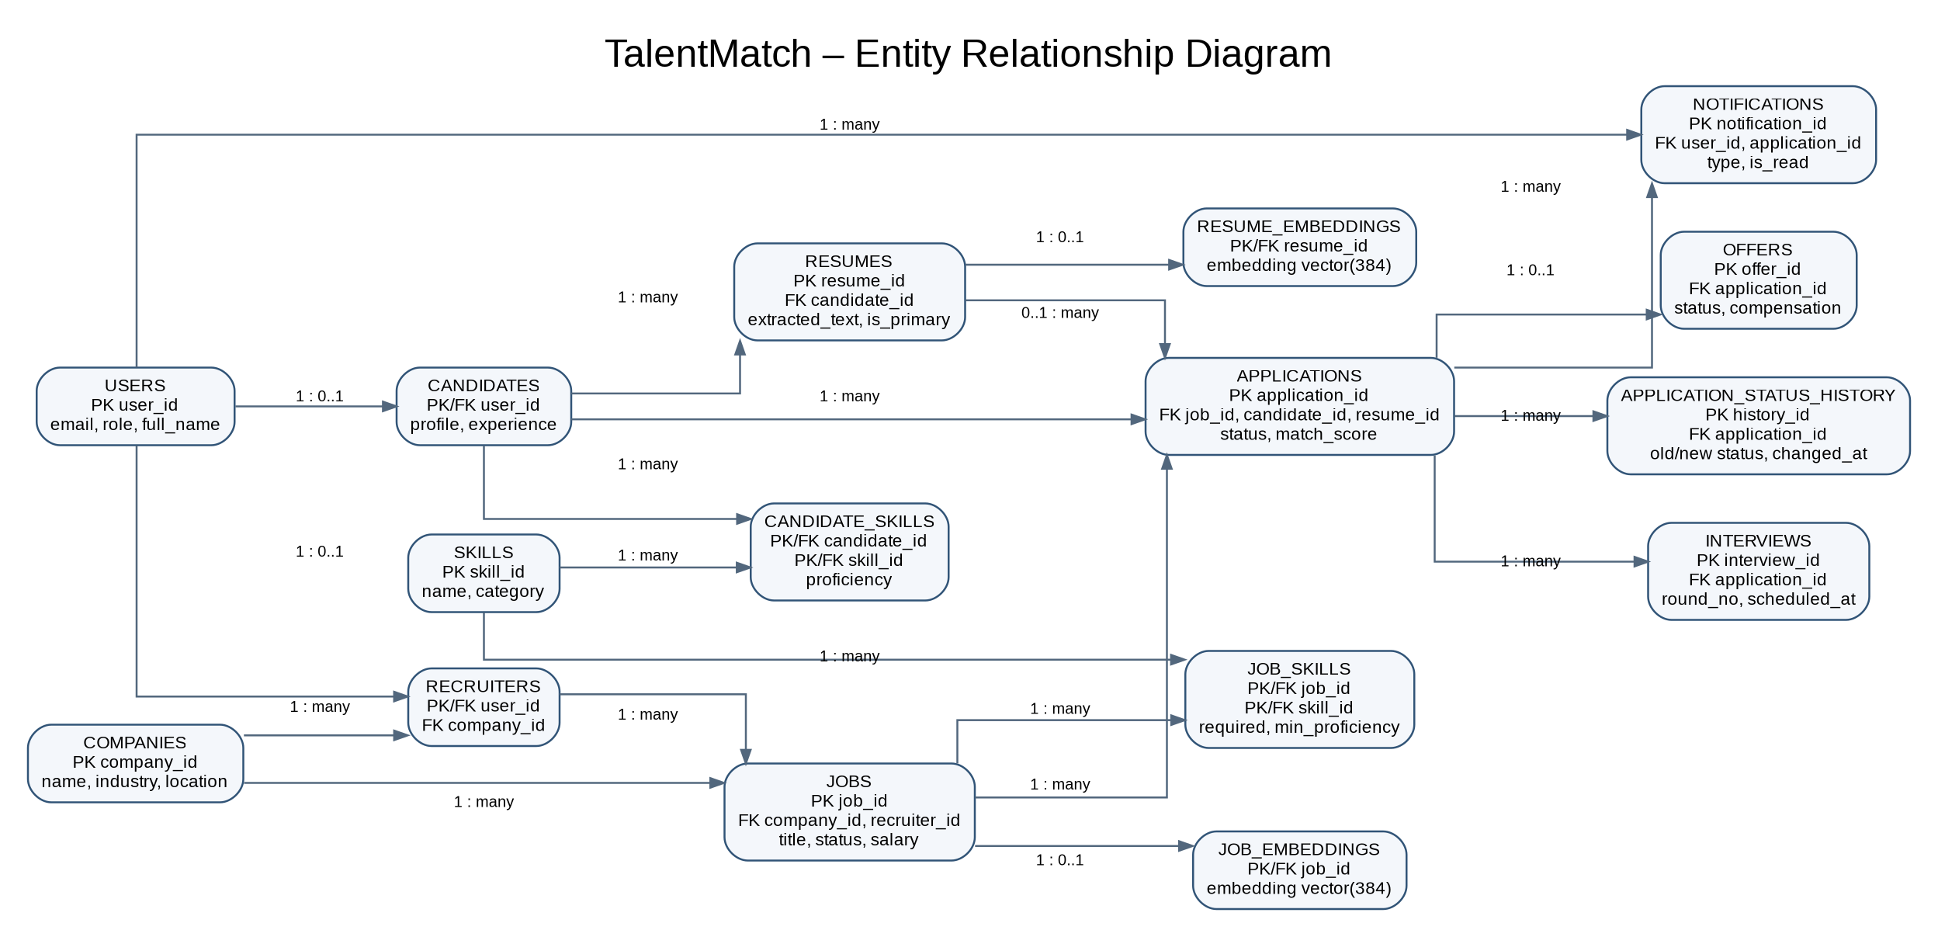

4. Relational Model

4.1 Relations
Relation | Primary key | Important constraints / relationships
users | user_id (PK) | UNIQUE email; UNIQUE(user_id, role); role CHECK
companies | company_id (PK) | UNIQUE name
recruiters | user_id (PK, FK) | FK (user_id, role) → users; company_id FK
candidates | user_id (PK, FK) | FK (user_id, role) → users
skills | skill_id (PK) | Master skill list
candidate_skills | (candidate_id, skill_id) PK | Associative relation; proficiency 1–5
jobs | job_id (PK) | FK company/recruiter; status, salary and date constraints
job_skills | (job_id, skill_id) PK | Associative relation; required and minimum proficiency
resumes | resume_id (PK) | Candidate FK; partial unique index for one primary resume
applications | application_id (PK) | UNIQUE(job_id, candidate_id); job/candidate/resume FKs
application_status_history | history key (PK) | Audit trail; written by trigger
interviews | interview_id (PK) | Application FK; UNIQUE(application_id, round_no)
offers | offer_id (PK) | Application FK; one offer per application
notifications | notification_id (PK) | User and optional application FKs
resume_embeddings | resume_id (PK, FK) | vector(384); cascading FK to resumes
job_embeddings | job_id (PK, FK) | vector(384); cascading FK to jobs

4.2 Relations not represented as independent conceptual entities
candidate_skills and job_skills are associative relations used to resolve the many-to-many relationships between candidates/skills and jobs/skills. resume_embeddings and job_embeddings are dependent vector-storage relations keyed by their parent resume/job. application_status_history is an audit relation populated by triggers.

4.3 Schema Diagram
Figure 4.1. Relational schema overview showing the 16 relations, primary keys, foreign keys and major references. Diagram prepared from the relation and key inventory in this report; detailed column definitions remain in docs/relational-schema.md and docs/data-dictionary.md.
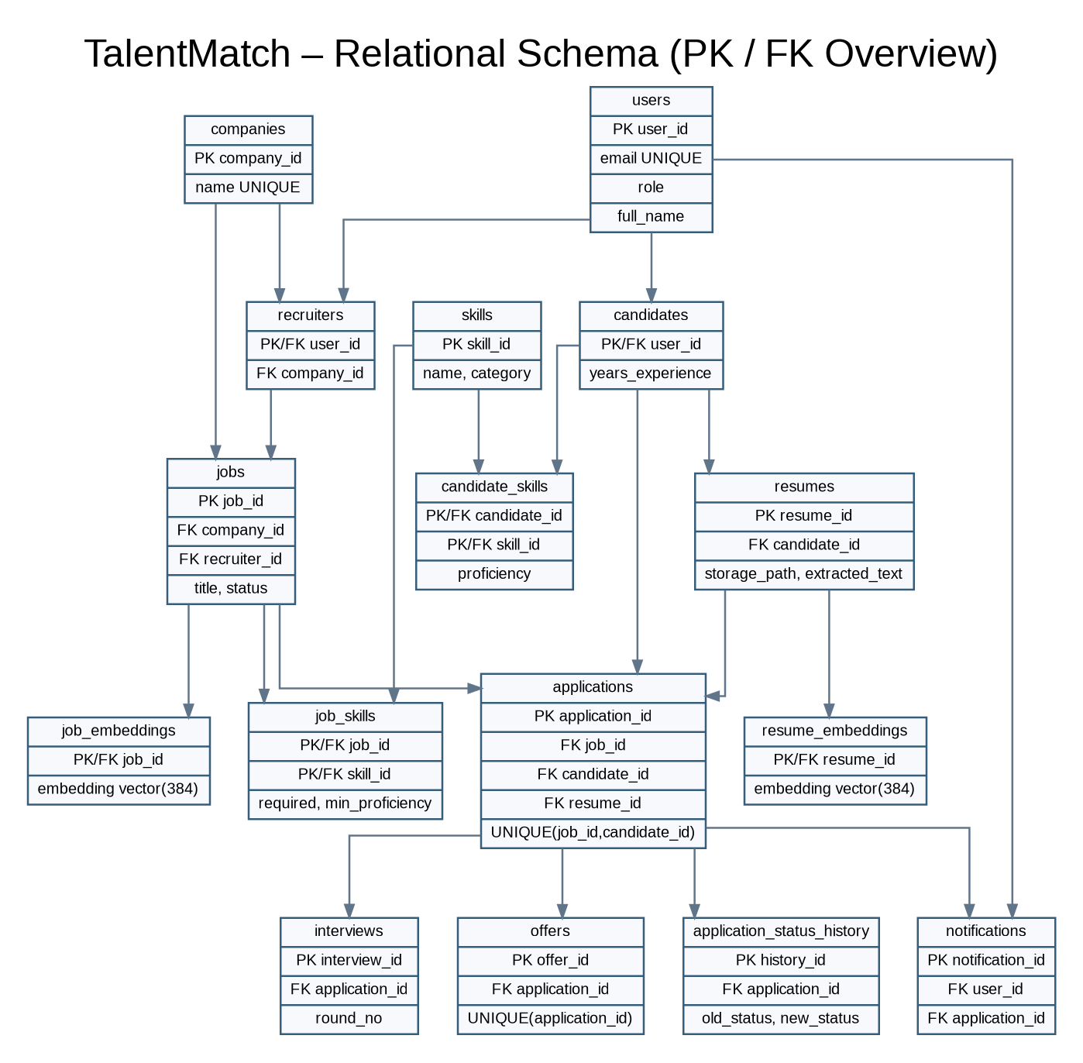

5. SQL DDL Statements
The schema is created through 24 ordered migrations in db/migrations/ and can be applied with npm run db:migrate. The reset script drops views, child tables, parent tables, functions and migration metadata in dependency-safe order.

5.1 Database Objects at a Glance
Object | Count | Notes
Tables | 16 | Core recruitment, audit and vector tables.
Foreign keys | 22 | Referential integrity across related entities.
CHECK constraints | 57 | Role, status, ranges, formats and vector validity.
UNIQUE constraints | 8 | Email, job-candidate application pair and other unique business keys.
Indexes | 46 | Includes two HNSW vector indexes.
Triggers | 19 | Status guard, history, applicant counts and workflow rules.
Stored functions | 6 | Status changes, candidate ranking, match score and other operations.
Views | 3 | Company hiring summary, recruiter pipeline and candidate application view.

5.2 Representative CREATE TABLE Statements
The users table stores every account. It enforces unique lowercase email, bcrypt hash format, valid roles and a composite unique key used by role-specific profile foreign keys.
CREATE TABLE IF NOT EXISTS users (
user_id BIGINT GENERATED ALWAYS AS IDENTITY PRIMARY KEY,
email VARCHAR(255) NOT NULL UNIQUE,
password_hash VARCHAR(100) NOT NULL,
full_name VARCHAR(120) NOT NULL,
role VARCHAR(20) NOT NULL,
is_active BOOLEAN NOT NULL DEFAULT TRUE,
created_at TIMESTAMPTZ NOT NULL DEFAULT now(),
CHECK (email = lower(email)
AND email ~ '^[^@\\s]+@[^@\\s]+\\.[^@\\s]+$'),
CHECK (password_hash ~ '^\\$2[aby]\\$[0-9]{2}\\$.{53}$'),
CHECK (btrim(full_name) <> ''),
CHECK (role IN ('admin', 'recruiter', 'candidate')),
UNIQUE (user_id, role)
);
The applications relation prevents duplicate applications and constrains status and similarity score. Its delete rules preserve jobs with applications, cascade candidate deletion and retain the application if a resume is deleted.
CREATE TABLE IF NOT EXISTS applications (
application_id BIGINT GENERATED ALWAYS AS IDENTITY PRIMARY KEY,
job_id BIGINT NOT NULL,
candidate_id BIGINT NOT NULL,
resume_id BIGINT,
cover_letter TEXT,
status VARCHAR(15) NOT NULL DEFAULT 'applied',
match_score NUMERIC(5,4),
applied_at TIMESTAMPTZ NOT NULL DEFAULT now(),
updated_at TIMESTAMPTZ NOT NULL DEFAULT now(),
UNIQUE (job_id, candidate_id),
CHECK (status IN
('applied','shortlisted','interviewed','offered','rejected')),
CHECK (match_score IS NULL OR match_score BETWEEN -1 AND 1),
CHECK (updated_at >= applied_at),
FOREIGN KEY (job_id) REFERENCES jobs(job_id) ON DELETE RESTRICT,
FOREIGN KEY (candidate_id) REFERENCES candidates(user_id) ON DELETE CASCADE,
FOREIGN KEY (resume_id) REFERENCES resumes(resume_id) ON DELETE SET NULL
);

5.3 ALTER, DROP and Indexes
- ALTER TABLE migrations add employment_type with a CHECK constraint, add min_experience_years with a range check, add last_login_at, widen companies.industry and add a closing-date constraint.
- CREATE INDEX statements cover role, application status, interview schedule and notification retrieval.
- Partial indexes cover open jobs ordered by posting date and unread notifications.
- db/reset.sql drops the three views first, then vector and dependent tables, parent tables, functions and migration metadata.
CREATE INDEX IF NOT EXISTS jobs_open_posted_at_idx
ON jobs (posted_at DESC) WHERE status = 'open';

CREATE INDEX IF NOT EXISTS notifications_unread_idx
ON notifications (user_id) WHERE NOT is_read;

5.4 Advanced Database Objects
- Views: company_hiring_summary, recruiter_pipeline_view and candidate_application_view.
- Stored functions: update_application_status(), rank_candidates_for_job(), compute_match_score() and other documented functions.
- Triggers: validate status transitions, write status history, maintain applicant_count and enforce stage-record requirements.
- Transactions: registration, profile updates, resume operations, job operations, applications, interviews and offers use BEGIN/COMMIT/ROLLBACK.

6. SQL DML Statements

6.1 INSERT
Seed data is inserted through db/seed/seed.sql. The script uses ON CONFLICT DO NOTHING so it can be re-run safely. Company and person names in the seed data are fictional.
INSERT INTO companies (name, industry, location, website, description)
VALUES
('Nimbus Analytics Pvt Ltd', 'Data & AI Consulting', 'Bengaluru, Karnataka',
'https://nimbusanalytics.example',
'Builds analytics platforms and machine-learning solutions.'),
('Kestrel Software Labs', 'SaaS Product Development', 'Pune, Maharashtra',
'https://kestrellabs.example',
'Builds collaboration and scheduling software.')
ON CONFLICT (name) DO NOTHING;

6.2 UPDATE and DELETE
UPDATE notifications
SET is_read = TRUE
WHERE user_id = $1 AND NOT is_read;

-- Resume deletion is performed in a transaction after checking ownership.
BEGIN;
DELETE FROM resumes
WHERE resume_id = $1 AND candidate_id = $2;
COMMIT;
The application binds parameters through node-postgres rather than concatenating user input. Resume deletion checks ownership and promotes the newest remaining resume if the primary resume is removed. Deleting a company that still has recruiters is rejected by ON DELETE RESTRICT.

6.3 SELECT, JOIN, GROUP BY and HAVING
SELECT j.job_id, j.title, c.name AS company, u.full_name AS recruiter,
j.location, j.work_mode, j.posted_at::date AS posted
FROM jobs j
JOIN companies c ON c.company_id = j.company_id
LEFT JOIN users u ON u.user_id = j.recruiter_id
WHERE j.status = 'open'
ORDER BY j.posted_at DESC;

SELECT status, COUNT(*) AS applications,
ROUND(100.0 * COUNT(*) / SUM(COUNT(*)) OVER (), 1) AS pct_of_total
FROM applications
GROUP BY status
ORDER BY status;

SELECT c.name AS company, j.title, COUNT(a.application_id) AS applicants
FROM jobs j
JOIN companies c ON c.company_id = j.company_id
JOIN applications a ON a.job_id = j.job_id
GROUP BY c.name, j.job_id, j.title
HAVING COUNT(a.application_id) >= 3
ORDER BY applicants DESC;

6.4 Query Results Recorded in the Source Report
Query | Recorded result
Applications by status | applied: 6 (33.3%); shortlisted: 3 (16.7%); interviewed: 3 (16.7%); offered: 2 (11.1%); rejected: 4 (22.2%).
Jobs with at least 3 applicants | Four jobs returned: Machine Learning Engineer (4), Backend Engineer (3), Data Analyst (3), Frontend Developer (3).
Candidates above average experience | Karthik Subramanian (6.0), Rohan Verma (5.0), Vikram Chauhan (4.5), Neha Bhatt (4.0); platform average 3.08 years.

6.5 Subqueries and Transactions
The project report documents 41 SQL queries in db/queries/important_queries.sql, including JOINs, NOT EXISTS, correlated subqueries, EXCEPT, LAG, views, functions and transactions. The transaction demonstration inserts a candidate and application, deliberately attempts a duplicate application, then rolls back. The failed transaction leaves no user, candidate or application row and restores applicant_count.

7. NoSQL / Vector Database Commands

7.1 Vector Data Design
Design aspect | TalentMatch implementation
Embedded data | Resume extracted text; job title, description and required skill names.
Model | sentence-transformers/all-MiniLM-L6-v2 via @huggingface/transformers, run locally in Node.js.
Dimensions | 384 dimensions.
Chunking | Up to 254 tokens per chunk with 32-token overlap; chunk vectors are weighted-averaged and L2-normalised.
Storage | resume_embeddings and job_embeddings; vector(384), model name, chunk count, SHA-256 source hash and timestamp.
Similarity | Cosine similarity = 1 - (a <=> b), where <=> is pgvector cosine distance.
Retrieval | rank_candidates_for_job() orders by vector distance and joins candidate profile, skills and application data.

7.2 Enable Extension and Create Vector Tables
CREATE EXTENSION IF NOT EXISTS vector;

CREATE TABLE IF NOT EXISTS resume_embeddings (
resume_id BIGINT PRIMARY KEY,
embedding vector(384) NOT NULL,
model_name VARCHAR(100) NOT NULL
DEFAULT 'sentence-transformers/all-MiniLM-L6-v2',
chunk_count SMALLINT NOT NULL CHECK (chunk_count >= 1),
source_hash CHAR(64) NOT NULL
CHECK (source_hash ~ '^[0-9a-f]{64}$'),
created_at TIMESTAMPTZ NOT NULL DEFAULT now(),
CHECK (abs(vector_norm(embedding) - 1) < 0.001),
FOREIGN KEY (resume_id) REFERENCES resumes(resume_id)
ON DELETE CASCADE
);

7.3 HNSW Indexes
CREATE INDEX IF NOT EXISTS resume_embeddings_embedding_hnsw_idx
ON resume_embeddings USING hnsw (embedding vector_cosine_ops);

CREATE INDEX IF NOT EXISTS job_embeddings_embedding_hnsw_idx
ON job_embeddings USING hnsw (embedding vector_cosine_ops);
The source report records both HNSW indexes in the PostgreSQL catalog. With the small seeded set of 12 resumes, PostgreSQL selected a sequential scan (reported as 0.13 ms); forcing the index returned the same top-five results. The planner may choose the index as the dataset grows.

7.4 Upsert and Similarity Search
INSERT INTO resume_embeddings
(resume_id, embedding, model_name, chunk_count, source_hash)
VALUES ($1, $2::vector, $3, $4, $5)
ON CONFLICT (resume_id) DO UPDATE
SET embedding = EXCLUDED.embedding,
model_name = EXCLUDED.model_name,
chunk_count = EXCLUDED.chunk_count,
source_hash = EXCLUDED.source_hash,
created_at = now();

SELECT round((1 - (re.embedding <=> je.embedding))::numeric, 4)
FROM resume_embeddings re
CROSS JOIN job_embeddings je
WHERE re.resume_id = $1 AND je.job_id = $2;

7.5 Recorded Semantic Ranking
Job | Ranked candidate | Similarity | Required skills matched
Machine Learning Engineer | Aditi Sharma | 0.7819 | 3/3
Machine Learning Engineer | Rohan Verma | 0.6658 | 1/3
Machine Learning Engineer | Divya Krishnan | 0.5032 | 3/3
Frontend Developer (React / Next.js) | Sneha Kulkarni | 0.7552 | 3/3
Frontend Developer (React / Next.js) | Aditi Sharma | 0.2619 | Not stated in source excerpt

The source report notes that the Frontend Developer job reverses the ranking order: Sneha Kulkarni ranks first and Aditi Sharma eighth. Similarity and explicit skill matches are shown together so semantic relevance does not replace skill-level evidence.

8. Results

8.1 Database and Test Results
Metric | Reported result
Unit tests | 85 / 85 passed
Integration tests | 147 / 147 passed
Constraint tests | 8 / 8 passed
Advanced SQL tests | 27 PASS
Documented SQL queries | 41; full script reported to run with exit code 0
Application pages | 19 across three roles
API Route Handler files | 36
Database migrations | 24

8.2 Integrity Checks
- An invalid user role is rejected by users_role_check.
- A second application to the same job is rejected by the UNIQUE(job_id, candidate_id) constraint.
- An invalid application status jump (applied → offered) is rejected by the status-transition trigger.
- An application cannot reach interviewed status without an interview record; a deferred constraint trigger checks this.
- A company with dependent recruiter records cannot be deleted because of ON DELETE RESTRICT.
- Non-unit vectors and vectors with dimensions other than 384 are rejected.

8.3 Application Screenshots
The source PDF contains application demo screenshots on pages 29–33. The source report identifies the following demonstrated flows:
- Authentication: login and candidate registration.
- Candidate: job search and filters, skill-gap view, application with cosine match score, application status history.
- Recruiter: job form with required skills, applicants ranked by pgvector similarity, semantic search, offer creation, invalid status change refused by trigger, interview scheduling.
- Candidate response and administration: offer acceptance, recruiter account management, admin dashboard and company deletion restriction.
- Responsive/mobile layouts: candidate jobs, ranked applicants and admin dashboard.
Source application demonstration – PDF page 29
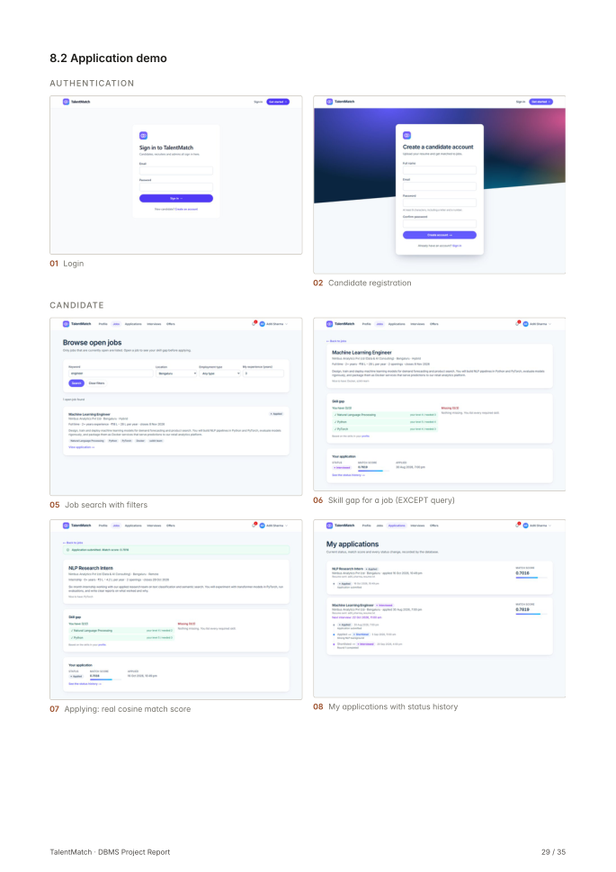

Source application demonstration – PDF page 30
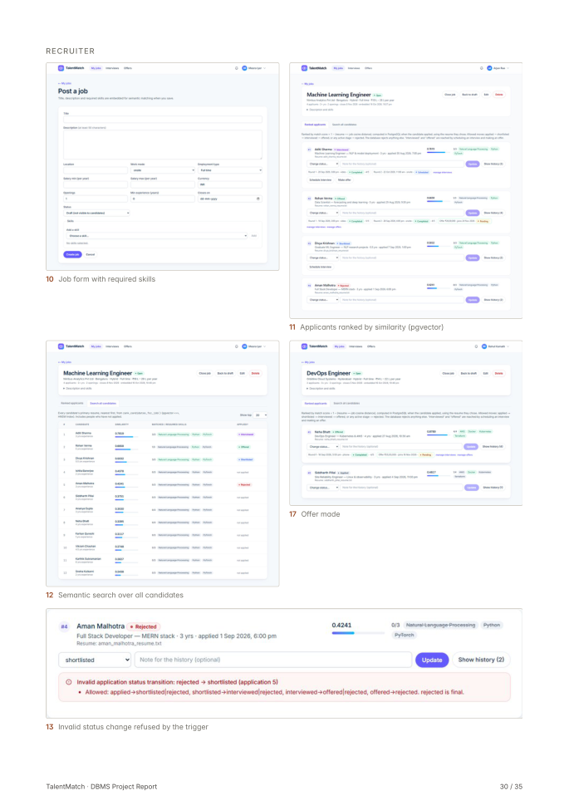

Source application demonstration – PDF page 31
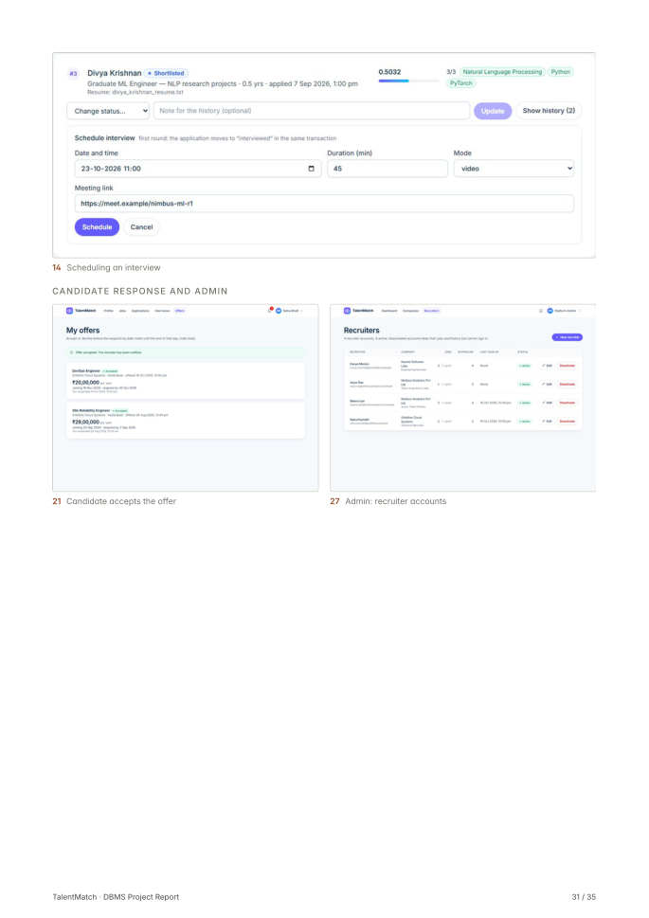

Source application demonstration – PDF page 32
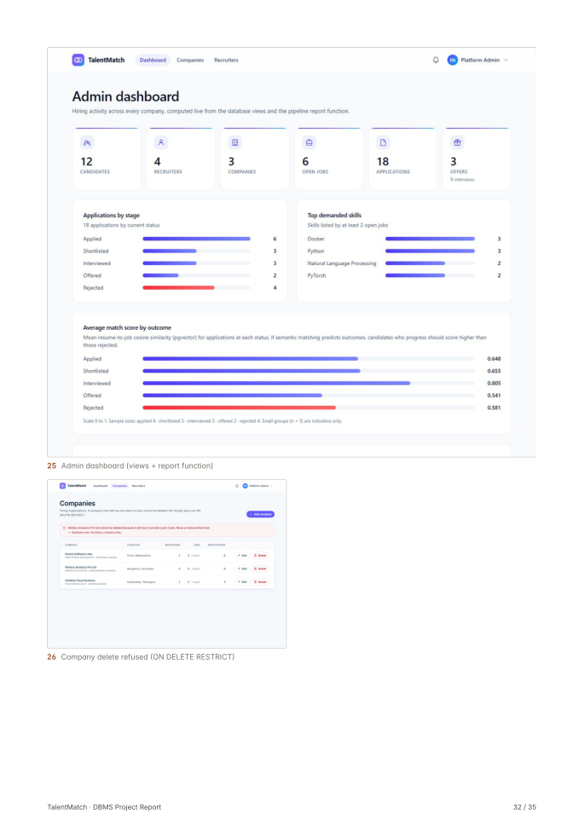

Source application demonstration – PDF page 33
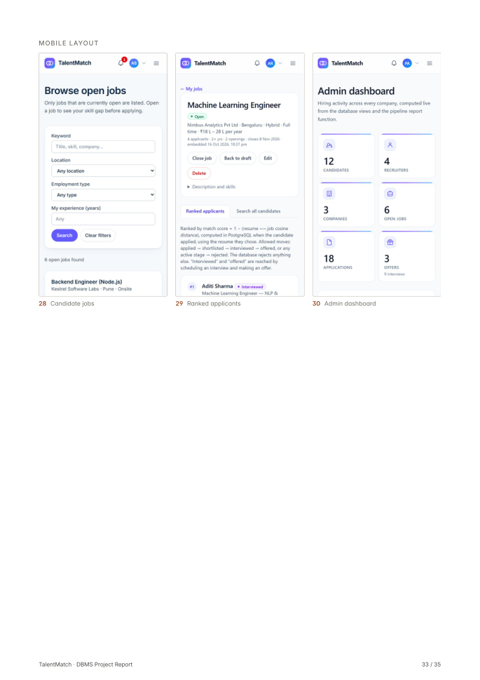

9. Next.js – Project Tree Structure
The project uses the Next.js App Router. Folders containing page.js define application pages; folders containing route.js define API Route Handlers. Browser-facing components are under src/components, while server-side database and business logic are under src/lib.
TalentMatch/
├── db/
│ ├── init/001_enable_pgvector.sql
│ ├── migrations/ # 24 ordered migrations
│ ├── seed/seed.sql
│ ├── queries/important_queries.sql # Q1–Q41
│ ├── demos/transaction_demo.sql
│ ├── tests/
│ └── reset.sql
├── docs/ # report, ERD, schema, tests, screenshots
├── new_changes/ # handout answers, statistics, diagrams
├── public/
├── scripts/ # migrate, seed, embed-seed, reset
├── src/
│ ├── app/
│ │ ├── admin/ # admin pages
│ │ ├── api/ # Route Handlers
│ │ ├── candidate/ # candidate pages
│ │ ├── recruiter/ # recruiter pages
│ │ ├── login/page.js
│ │ ├── register/page.js
│ │ └── page.js
│ ├── components/ # role-specific React components
│ └── lib/
│ ├── admin/
│ ├── api/
│ ├── auth/
│ ├── candidate/
│ ├── recruiter/
│ ├── applications.js
│ ├── db.js
│ ├── embeddings.js
│ ├── interviews.js
│ ├── offers.js
│ └── vector-store.js
├── tests/ # unit, integration, fixtures
├── .env.example
├── docker-compose.yml
├── package.json
└── README.md

10. Sample Screenshots of Application Code and Demo

10.1 Database Connection
A shared PostgreSQL connection pool is created from DATABASE_URL. The environment file .env.local is gitignored; the repository contains only .env.example with placeholders.
import { Pool } from "pg";

export function getPool() {
if (!globalForDb.talentmatchPool) {
const connectionString = process.env.DATABASE_URL;
if (!connectionString) throw new Error("DATABASE_URL is not set");
globalForDb.talentmatchPool = new Pool({ connectionString, max: 10 });
}
return globalForDb.talentmatchPool;
}

10.2 Authentication and Authorization
Protected Route Handlers use withAuth. The server loads the session user and checks the required role before invoking the handler. The source report records 401 for an invalid session and 403 for an incorrect role.
export function withAuth(options, handler) {
const roles = options?.roles;
return async function authenticatedRoute(request, context) {
await connection();
const user = await requireUser(request);
if (roles) assertRole(user, roles);
const params = context?.params ? await context.params : {};
return await handler(request, { user, params });
};
}

10.3 Application Transaction
Applying to a job uses BEGIN/COMMIT with ROLLBACK on failure. The transaction locks and validates the job, verifies resume ownership, inserts the application with compute_match_score(), notifies the recruiter and commits.
await client.query("BEGIN");
try {
// Validate job and resume ownership.
const inserted = await client.query(
`INSERT INTO applications
(job_id, candidate_id, resume_id, cover_letter, match_score)
VALUES ($1, $2, $3, $4, compute_match_score($3, $1))
RETURNING application_id, status, match_score`,
[jobId, candidateId, resumeId, coverLetter]
);
// Create recruiter notification in the same transaction.
await client.query("COMMIT");
} catch (err) {
await client.query("ROLLBACK");
throw err;
} finally {
client.release();
}

10.4 Embedding Generation and Ranking API
Resume and job text are embedded locally. The embedding function chunks text, obtains mean-pooled normalized vectors, checks the expected 384 dimensions and combines chunk vectors using a token-weighted normalized mean. The recruiter matching API checks job/company ownership and calls rank_candidates_for_job().

10.5 Demo Evidence
The five source-PDF page images embedded in Section 8 preserve the original application demo evidence. They cover the candidate, recruiter, administrator and mobile layouts described in the source report.

11. Evaluation Rubrics – Completion Status
# | Criteria | Distribution / expectation | Status
1 | Database Design | ER diagram, relational schema with keys, relationships and constraints | Met – ERD/schema artifacts referenced in repository
2 | Database Creation | SQL implementation, DDL constraints, vector database creation and technology justification | Met – PostgreSQL 17 + pgvector 0.8.7; 16 tables
3 | SQL Operations and Queries | DML, nested/correlated queries, joins, grouping and aggregates | Met – 41 documented SQL queries
4 | Advanced Database Concepts | Procedures/functions, triggers, CTEs and vector feature RUD | Met – 6 functions, 19 triggers, 3 views, transactions and vector search
5 | Web Application and Database Integration | Next.js interface, backend/API and database integration | Met – 19 pages and 36 API route files
6 | Authentication and Authorization | Authentication and at least two roles with role-based access | Met – admin, recruiter and candidate roles
7 | Documentation, Git/GitHub, Demonstration, Testing and Originality | Documentation, contributions, testing and demo | Met – report, README, test evidence and repository

11.1 Team Contributions
Team member | Reported contribution
Rohith Karning (PES1UG24AM229) | Database design, database implementation, backend/API and semantic matching.
Saanvi Maharana (PES1UG24AM237) | Frontend implementation.

11.2 Repository and Setup
GitHub repository: https://github.com/rohithkarning-debug/TalentMatch
cp .env.example .env.local
docker compose --env-file .env.local up -d
npm install
npm run db:migrate
npm run db:seed
npm run db:embed
npm run dev

