Class Room Activity
Name: Rohith Manikanta Rellu
Reg No: 192425326
Questions
Activity 1: Design a Star Schema (15 Marks)
Question 1: A college wants to develop a data warehouse to analyze student academic performance across different departments, courses, and semesters. Design a Star Schema for this application. Identify the fact table and dimension tables, specify the attributes of each table, and indicate the primary and foreign keys. Draw a neat star schema diagram to represent the relationships among the tables.
Activity 2: Perform ETL Operations (10 Marks)
Question 2: A college collects student information from admission, examination, and attendance systems. The collected data contains missing values, duplicate records, inconsistent department names, and different date formats. Explain and demonstrate the Extract, Transform, and Load (ETL) process required to integrate this data into a data warehouse. Show sample input records, the transformations performed, and the final cleaned data loaded into the target table.
Activity 3: Demonstrate OLAP Operations (15 Marks)
Question 3: Consider a data warehouse containing sales information with the dimensions Time, Product, and Location, along with sales amount as a measure. Construct a sample dataset and demonstrate the following OLAP operations with suitable examples and output tables:
a) Roll-up – Summarize monthly sales into yearly sales.
b) Drill-down – Display yearly sales as month-wise sales.
c) Slice – Retrieve sales data for one specific product.
d) Dice – Retrieve sales data for selected products, locations, and time periods.
e) Pivot – Change the orientation of rows and columns to compare sales across products and locations.

Activity 4: Draw Data Warehouse Architecture (10 Marks)
Question 4: A hospital wants to integrate patient registration, laboratory, pharmacy, and billing data to support management decision-making. Design a Data Warehouse Architecture for the hospital. Draw a neat, labelled diagram showing the data sources, ETL process, staging area, central data warehouse, data marts, OLAP tools, and reporting tools. Briefly explain the function of each component and describe how the architecture supports decision-making.
Answers
1. Design a Star Schema
1. Aim
To design a Star Schema for a college data warehouse to analyze student academic performance across departments, courses, and semesters.
2. Star Schema diagram
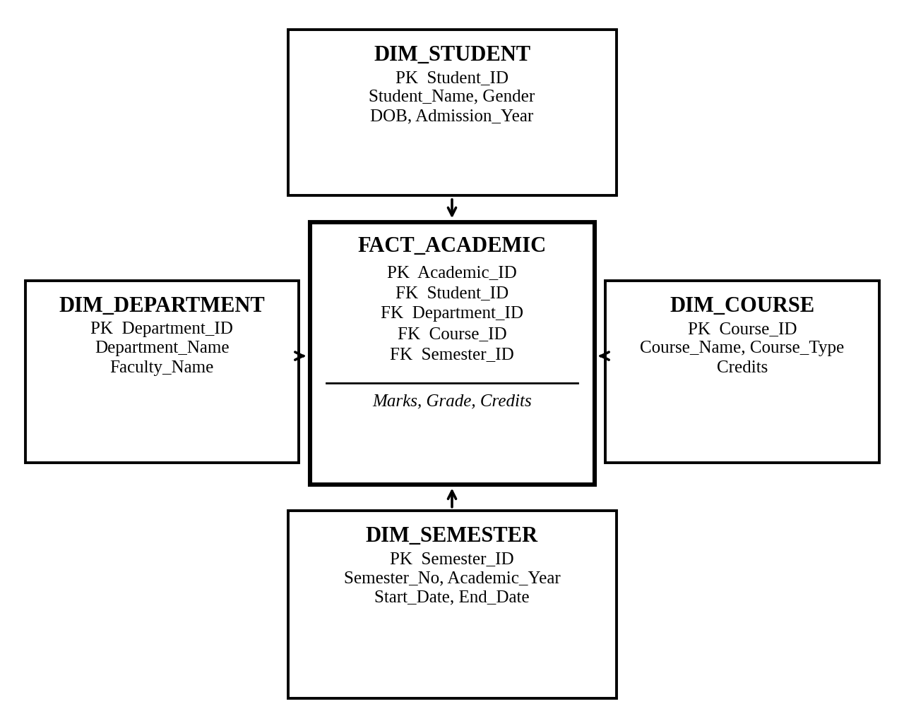
Figure 1: Star Schema for student academic performance
3. Fact table
FACT_ACADEMIC stores measurable academic performance information.
Attribute | Key / Description
Academic_ID | PK – unique record ID
Student_ID | FK – references DIM_STUDENT
Department_ID | FK – references DIM_DEPARTMENT
Course_ID | FK – references DIM_COURSE
Semester_ID | FK – references DIM_SEMESTER
Marks | Marks obtained
Grade | Grade achieved
Credits | Course credits earned

4. Dimension tables
DIM_STUDENT
Attribute | Key / Description
Student_ID | PK
Student_Name | Student's name
Gender | Student's gender
DOB | Date of birth
Admission_Year | Year of admission

DIM_DEPARTMENT
Attribute | Key / Description
Department_ID | PK
Department_Name | Department name
Faculty_Name | Faculty or department head

DIM_COURSE
Attribute | Key / Description
Course_ID | PK
Course_Name | Name of the course
Course_Type | Core or elective
Credits | Course credit value

DIM_SEMESTER
Attribute | Key / Description
Semester_ID | PK
Semester_No | Semester number
Academic_Year | Academic year
Start_Date | Semester start date
End_Date | Semester end date

5. Explanation and uses
- The fact table stores academic performance measures such as marks and credits.
- Dimension tables provide descriptive information about students, departments, courses, and semesters.
- Primary keys uniquely identify records in each table.
- Foreign keys establish relationships between the fact table and dimension tables.
- The college can compare average marks by department, identify top-performing courses, and track student performance across semesters.
Conclusion: The Star Schema provides a simple and efficient structure for analyzing academic performance and generating college management reports.
2. Perform ETL Operations
1. Definition
ETL stands for Extract, Transform, and Load. It is a process used to collect data from different sources, clean and standardize it, and store the prepared data in a data warehouse.
2. ETL process diagram
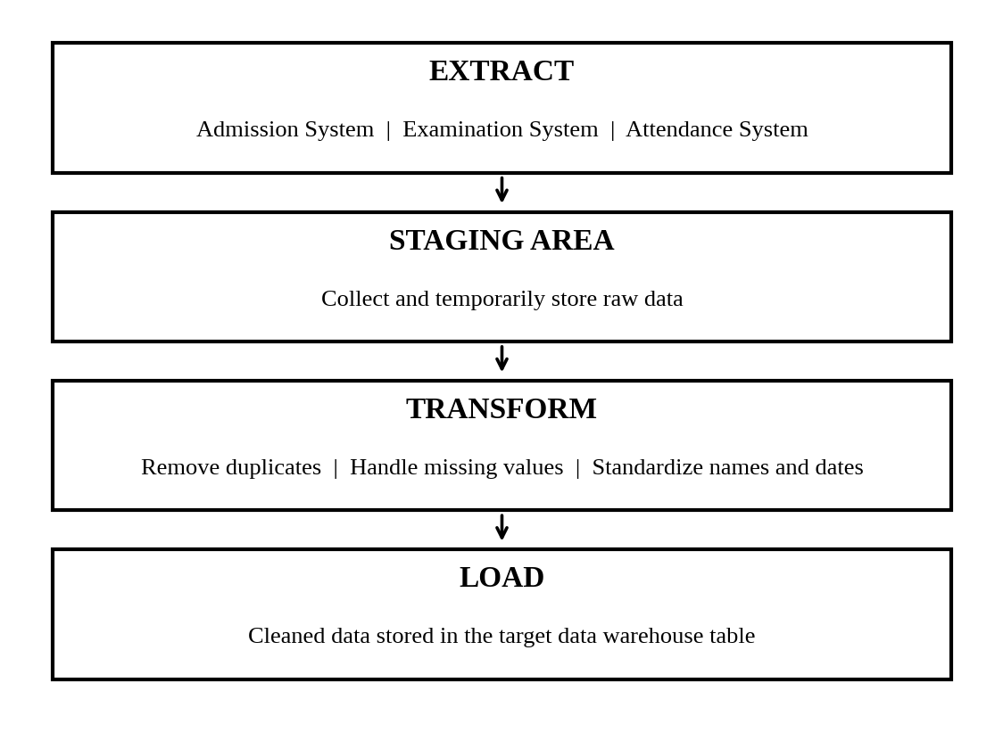
Figure 2: ETL process
3. Sample input records
Suppose the college collects student information from admission, examination, and attendance systems.
Student_ID | Name | Department | Marks | Attendance | Date
101 | Arun | CSE | 85 | 90 | 15-07-2025
102 | Banu | Computer Science | NULL | 80 | 2025/07/16
101 | Arun | CSE | 85 | 90 | 15-07-2025
103 | Charan | ECE | 72 | NULL | 17 Jul 2025

Problems identified:
- Missing marks for student 102.
- Missing attendance for student 103.
- Duplicate record for student 101.
- Inconsistent department names such as CSE and Computer Science.
- Different date formats.
4. ETL operations
Step 1: Extract
- Collect student details from the admission system.
- Collect marks from the examination system.
- Collect attendance records from the attendance system.
- Combine the extracted records in a staging area.
Step 2: Transform
- Remove duplicate records using Student_ID and the relevant record details.
- Replace Computer Science with the standard department name CSE.
- Convert all dates into the YYYY-MM-DD format.
- Handle missing marks using the examination system's verified result, if available; otherwise, keep the value NULL until it is verified.
- Handle missing attendance using the attendance system's verified data; do not assume an attendance value without evidence.
- Validate records and ensure data types are consistent.
Step 3: Load
- Load the cleaned and validated records into the target data warehouse table.
5. Final cleaned data loaded into the target table
Assume the missing values are verified from the original systems before loading. For demonstration, the missing marks and attendance are assumed to have been verified as 78 and 85, respectively.
Student_ID | Name | Department | Marks | Attendance | Date
101 | Arun | CSE | 85 | 90 | 2025-07-15
102 | Banu | CSE | 78 | 80 | 2025-07-16
103 | Charan | ECE | 72 | 85 | 2025-07-17

6. Benefits of ETL
- Improves data quality and consistency.
- Removes duplicate records.
- Integrates information from multiple systems.
- Makes data suitable for analysis and reporting.
- Supports reliable decision-making.
Conclusion: ETL integrates data from admission, examination, and attendance systems into a consistent, accurate, and usable data warehouse.
3. Demonstrate OLAP Operations
1. Definition
OLAP (Online Analytical Processing) is a technology used to analyze multidimensional data and summarize information for decision-making. Here, the dimensions are Time, Product, and Location, and the measure is Sales Amount.
2. Sample dataset
Month | Product | Location | Sales Amount (₹)
Jan-25 | Laptop | Chennai | 50,000
Feb-25 | Laptop | Chennai | 60,000
Jan-25 | Mobile | Chennai | 30,000
Feb-25 | Mobile | Chennai | 40,000
Jan-25 | Laptop | Bangalore | 45,000
Feb-25 | Laptop | Bangalore | 55,000
Jan-25 | Mobile | Bangalore | 25,000
Feb-25 | Mobile | Bangalore | 35,000
Jan-26 | Laptop | Chennai | 70,000
Feb-26 | Laptop | Chennai | 80,000

(a) Roll-up – Monthly sales into yearly sales
Definition: Roll-up summarizes detailed data into a higher level of aggregation.
Example: Monthly sales are combined to calculate yearly sales for each product and location.
Year | Product | Location | Yearly Sales (₹)
2025 | Laptop | Chennai | 1,10,000
2025 | Mobile | Chennai | 70,000
2025 | Laptop | Bangalore | 1,00,000
2025 | Mobile | Bangalore | 60,000
2026 | Laptop | Chennai | 1,50,000

Result: Roll-up provides summarized yearly sales instead of month-wise details.
(b) Drill-down – Yearly sales into monthly sales
Definition: Drill-down displays more detailed information by moving from a higher level to a lower level.
Example: The 2025 yearly sales of laptops in Chennai are ₹1,10,000.
Year | Month | Product | Location | Sales (₹)
2025 | January | Laptop | Chennai | 50,000
2025 | February | Laptop | Chennai | 60,000
Total |  |  |  | 1,10,000

Result: Drill-down helps identify monthly changes in sales.
(c) Slice – Sales data for one product
Definition: Slice selects one specific value from a dimension to produce a smaller data view.
Example: Select only the Laptop product.
Month | Product | Location | Sales (₹)
Jan-25 | Laptop | Chennai | 50,000
Feb-25 | Laptop | Chennai | 60,000
Jan-25 | Laptop | Bangalore | 45,000
Feb-25 | Laptop | Bangalore | 55,000
Jan-26 | Laptop | Chennai | 70,000
Feb-26 | Laptop | Chennai | 80,000

Result: Slice displays sales information for laptops only.
(d) Dice – Sales data for selected products, locations, and time periods
Definition: Dice selects specific values or ranges from two or more dimensions to create a smaller multidimensional dataset.
Example: Select Laptop and Mobile, Chennai, and January–February 2025.
Month | Product | Location | Sales (₹)
Jan-25 | Laptop | Chennai | 50,000
Feb-25 | Laptop | Chennai | 60,000
Jan-25 | Mobile | Chennai | 30,000
Feb-25 | Mobile | Chennai | 40,000

Result: Dice retrieves sales records that satisfy the selected product, location, and time conditions.
(e) Pivot – Change rows and columns
Definition: Pivot changes the orientation of a data table to provide a different view of the same information.
Example: Compare product sales across Chennai and Bangalore during January 2025.
Product | Chennai Sales (₹) | Bangalore Sales (₹)
Laptop | 50,000 | 45,000
Mobile | 30,000 | 25,000

Result: Pivot makes it easier to compare the sales of different products across locations.
Conclusion
OLAP operations help analyze large volumes of data from different perspectives. Roll-up summarizes data, drill-down provides details, slice selects one dimension value, dice filters multiple dimensions, and pivot changes the presentation of data for comparison.
4. Draw Data Warehouse Architecture
1. Aim
To design a hospital data warehouse that integrates patient registration, laboratory, pharmacy, and billing data to support management decision-making.
2. Data warehouse architecture diagram
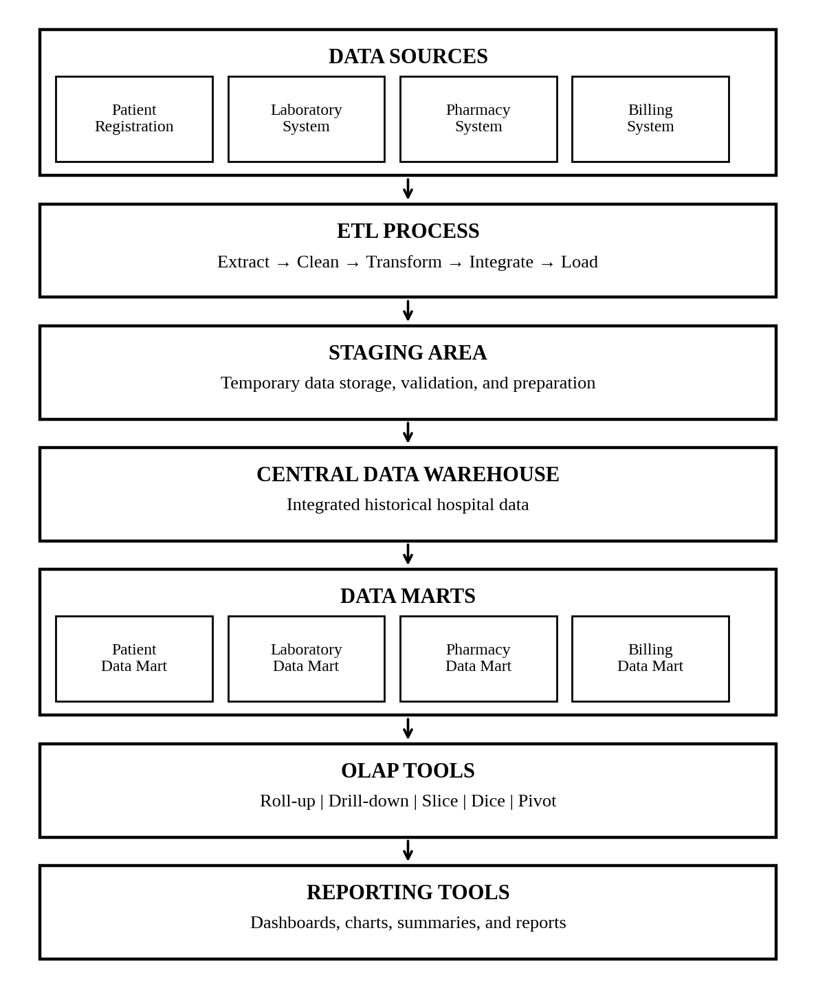
Figure 3: Hospital data warehouse architecture
3. Functions of each component
1. Data sources
Patient registration, laboratory, pharmacy, and billing systems provide the original hospital data. Each system maintains information relevant to its activities.
2. ETL process
ETL extracts data from different systems, cleans missing or inconsistent values, standardizes formats, and integrates the data before loading it into the warehouse.
3. Staging area
The staging area temporarily stores extracted data. It supports data cleaning, validation, and preparation before the data is loaded into the central warehouse.
4. Central data warehouse
The central data warehouse stores integrated, consistent, historical hospital data. It allows management to analyze information across multiple departments.
5. Data marts
Data marts organize data for specific departments, such as patient services, laboratory operations, pharmacy inventory, and billing. They make department-specific analysis easier.
6. OLAP tools
OLAP tools support multidimensional analysis, such as comparing monthly billing totals, analyzing laboratory test trends, and studying pharmacy usage.
7. Reporting tools
Reporting tools generate dashboards, charts, summaries, and reports that help hospital managers monitor performance and make decisions.
4. How the architecture supports decision-making
- Helps management analyze patient numbers and service usage.
- Identifies trends in laboratory tests and pharmacy demand.
- Supports billing analysis and revenue monitoring.
- Reduces inconsistent information across departments.
- Provides historical data for planning staff, medicines, and hospital resources.
Conclusion
The hospital data warehouse integrates data from multiple systems into a central repository. Data marts, OLAP tools, and reporting tools convert this integrated data into useful information for effective planning and management decision-making.

