MR DEFENDERS

Technical Project Documentation
Team: MR DEFENDERS
Project: AI LEGAL GUIDE
System type: Offline-first legal-information guidance platform

1. Project Overview
Ai Legal Guide is a local legal-information assistant designed to help citizens understand verified first steps for common legal questions. It accepts natural-language questions, identifies a supported legal domain, retrieves relevant local legal records, and presents grounded guidance with source citations.
The system is designed for three initial domains:
- Consumer complaints
- Criminal procedure basics, including FIR and bail information
- Family-law basics, including marriage registration and dowry-law information
The platform is informational only. It does not replace a qualified advocate, legal-aid provider, court, police officer, or other competent authority. High-risk situations such as immediate danger, an arrest in progress, or an active case requiring case-specific strategy are routed to urgent professional or emergency support.

2. Architecture Explanation

2.1 System architecture

Architecture flow source
flowchart TD
U[Citizen question] --> F[React and Vite frontend]
F --> API[FastAPI REST API]
API --> S[Safety and crisis router]
S -->|urgent risk| E[Escalation guidance]
S -->|safe query| C[Domain classifier]
C --> Q[Follow-up question layer]
Q -->|enough facts| R[Hybrid retrieval]
R --> L[Lexical retrieval]
R --> V[Chroma semantic retrieval]
L --> M[Verified legal records]
V --> M
M --> G[Local Qwen model through llama.cpp]
G --> Guard[Citation and claim guard]
Guard --> B[Adaptive response blocks]
B --> F

2.2 Frontend
The frontend is a React application built with Vite. It provides:
- A natural-language question field.
- A local API request to the backend.
- Domain and confidence display.
- Adaptive response blocks.
- Step-by-step procedural guidance.
- Source citations and official-source links.
- Follow-up questions when more facts are required.
- Persistent legal-information disclaimers.
The frontend does not make legal decisions. It renders the structured response returned by the backend.

2.3 Backend API
The backend is implemented with FastAPI and Uvicorn. The primary routes are:
Route | Purpose
GET /api/v1/health | Reports corpus, vector-store, model, and runtime readiness.
POST /api/v1/chat | Accepts a legal question and returns grounded guidance.
POST /api/v1/corpus/reindex | Rebuilds the local Chroma collection from verified records.
GET /api/v1/sources/{source_id} | Returns one source record for traceability.

The service layer coordinates safety assessment, domain selection, clarification, retrieval, local generation, citation validation, confidence handling, and response assembly.

2.4 Safety and domain routing
The safety router checks for immediate danger, arrest-related risk, domestic violence, self-harm indicators, and active-case requests. Escalated queries bypass normal model generation.
Safe questions are classified into the supported legal domains. The classifier can request more information when a short or ambiguous question does not identify a sufficient fact pattern.

2.5 Retrieval
Retrieval uses two local paths:
- Semantic retrieval: MiniLM embeddings are searched in the persistent Chroma vector store.
- Lexical retrieval: Exact terms, Act names, section identifiers, and procedural metadata are matched deterministically.
Both paths are compared so a weak semantic similarity score does not suppress a stronger exact legal-term match. Only records with verification_status: "verified" are eligible to support an answer.

2.6 Local model and response guard
The local Qwen model is loaded through llama.cpp from a GGUF inference file. The model receives only retrieved verified records and is instructed not to invent legal claims.
The response guard checks generated references against retrieved Act and Section metadata. If generation is unavailable or fails grounding checks, the service returns a clearly labelled retrieval-safe fallback.
Responses use adaptive blocks. The model may choose which blocks are relevant, while the backend supports:
- Explanation
- Verified legal basis
- Responsible authority
- Step-by-step procedure
- Required documents
- Forms or application method
- Timeline
- Fees
- Warnings
- Sources
When a required procedural field is absent from the verified corpus, the response states that the detail is unavailable instead of fabricating it.

3. AI Design Decisions

Offline-first operation
The system is designed to run without a hosted LLM API at runtime. This protects sensitive legal questions from being transmitted to third-party providers and supports demonstrations in low-connectivity environments.

Retrieval-augmented generation
Legal answers must be grounded in traceable source material. RAG supplies the relevant statutory or official procedural text to the model and allows the application to display the supporting Act, Section, and source URL.

Local Qwen SLM
Qwen3-4B-Instruct is selected as a compact locally runnable model suitable for an offline prototype. A GGUF version is used for llama.cpp inference. The original Hugging Face model snapshot is retained as the training base for optional QLoRA adaptation; GGUF is an inference artifact and is not used as the fine-tuning base.

Hybrid retrieval decision
Semantic retrieval handles paraphrased questions, while lexical retrieval is important for exact legal terms such as Section 173, BNSS, FIR, or District Commission. Combining both reduces the risk of returning a semantically related but legally irrelevant provision.

Verified-only answering
Automated PDF extraction produces needs_review candidates. Those records are excluded from answer retrieval until a human has confirmed the text, jurisdiction, source, and procedural metadata. This separates source discovery from legal approval.

Adaptive answers with fixed safeguards
The answer format is not forced into one template. The response can emphasize the sections relevant to the question. The grounding rules are fixed: the system must not invent an Act, Section, authority, form, document, fee, deadline, or contact.

Confidence and refusal
Confidence represents retrieval and evidence quality, not legal certainty. Incomplete procedural evidence lowers the maximum confidence. When the verified corpus does not support a safe answer, the system returns a low-confidence response and recommends qualified assistance.

Safety and citation decisions
High-risk queries bypass generation. Generated citations are checked against the retrieved records. Source cards expose the official URL and excerpt used for the response.

4. Dataset and Model Documentation

4.1 PDF source collection
The legal source collection is stored at:
G:\DO_TOUCH\Programmes\Legal_SLM_Dataset
It contains Acts and citizen-facing government guides for the consumer, criminal-procedure, and family-law domains. The ingestion utility reads PDFs with pypdf, records provenance, detects duplicate files by SHA-256, and extracts section-level source candidates.

4.2 Canonical documents and provenance
Where multiple PDFs represent the same Act or guide, one canonical version should be selected for indexing. Duplicate files remain provenance/reference material and are recorded in the dataset manifest rather than indexed as separate legal authorities.
Each extracted candidate records:
- Source file and SHA-256 hash
- Domain
- Page count and extracted character count
- Duplicate relationship, when present
- Document type

4.3 Legal source registry
The application corpus uses records with fields including:
{
"id": "consumer-cpa-35",
"domain": "consumer",
"act_name": "Consumer Protection Act, 2019",
"section_number": "Section 35",
"section_text": "Verified statutory text",
"jurisdiction": "India - Central",
"authority": "District Consumer Commission",
"procedure": "Verified procedure text",
"documents": ["Verified document requirement"],
"forms": ["Verified form or filing method"],
"fees": "Verified fee information",
"timeline": "Verified timeline information",
"source_url": "https://official-source.example",
"source_type": "statute",
"verification_status": "verified"
}
The live corpus contains only approved records. Extracted records remain needs_review until human review fills or confirms the source URL, authority, procedure, document, form, fee, timeline, and jurisdiction fields.

4.4 Vector indexing
Verified records are embedded with the local sentence-transformers MiniLM model and stored in ChromaDB under the project data directory. Reindexing is required whenever the approved corpus changes. Empty optional metadata values are omitted because Chroma accepts only valid scalar or non-empty list metadata.

4.5 Instruction dataset
QLoRA records use JSONL format:
{
"instruction": "User question",
"context": "Verified legal passages and procedure records",
"response": "Grounded answer",
"cited_sections": ["Act name, Section number"]
}
Every cited section must occur in the supplied context. Reviewed records are divided deterministically into training, validation, and test files. Placeholder records generated by PDF ingestion are review aids and must not be trained directly.

4.6 QLoRA lifecycle
Local Hugging Face Qwen snapshot
↓
QLoRA adapter training
↓
Adapter and held-out response validation
↓
Merge adapter with base model
↓
Convert merged model to GGUF
↓
Quantize for llama.cpp
↓
Local inference through the FastAPI service

5. System Operation

First-time setup
cd G:\DO_TOUCH\Programmes\TechSpark_Vcx
G:\DO_TOUCH\Programmes\.dumpEnv\Scripts\python.exe -m pip install -r backend\requirements.txt

Source ingestion and validation
G:\DO_TOUCH\Programmes\.dumpEnv\Scripts\python.exe scripts\ingest_legal_pdfs.py `
--input G:\DO_TOUCH\Programmes\Legal_SLM_Dataset `
--output-corpus G:\DO_TOUCH\Programmes\Legal_SLM_Dataset\Training_Data\legal_corpus_candidates.json `
--output-manifest G:\DO_TOUCH\Programmes\Legal_SLM_Dataset\Training_Data\legal_dataset_manifest.json `
--output-training-candidates G:\DO_TOUCH\Programmes\Legal_SLM_Dataset\Training_Data\legal_training_candidates.jsonl

G:\DO_TOUCH\Programmes\.dumpEnv\Scripts\python.exe scripts\validate_corpus.py
G:\DO_TOUCH\Programmes\.dumpEnv\Scripts\python.exe scripts\validate_training.py
Only reviewed records should be copied into the live corpus and final training file.

Reindexing
G:\DO_TOUCH\Programmes\.dumpEnv\Scripts\python.exe scripts\reindex.py

Starting the services
Backend terminal:
G:\DO_TOUCH\Programmes\.dumpEnv\Scripts\python.exe -m uvicorn app.main:app --app-dir backend --reload
Frontend terminal:
pnpm --dir frontend dev
The user interface is available at http://127.0.0.1:5173. The API is available at http://127.0.0.1:8000.

Model fallback behavior
The configured GGUF path is:
G:\OllaMa\FH_Models\qwen3-4b-instruct-2507-q4_k_m.gguf
If the file is missing or cannot be loaded, the service does not fabricate a model answer. It returns a retrieval-safe fallback and identifies the response mode accordingly.

6. Legal Safety and Privacy
- The interface and API state that responses are general legal information, not legal advice.
- Immediate-danger, arrest-in-progress, domestic-violence, self-harm, and active-case indicators are routed to escalation guidance.
- No query is sent to an external hosted LLM at runtime.
- The embedding model, vector store, and inference model are intended to run locally.
- Query logging is disabled by default through configuration.
- Source records retain official URLs, source files, and verification metadata for traceability.
- Automated candidates remain excluded until human review.
- Missing legal details are surfaced as unavailable rather than generated as facts.
- Users are directed to qualified legal professionals or legal-aid services for case-specific action.

7. References
- Software Requirements Specification
- Project README
- Dataset inventory report
- Model asset instructions
- Consumer Protection Act source
- Bharatiya Nagarik Suraksha Sanhita source
- Dowry Prohibition Act source
- Hindu Marriage Act source

Output:
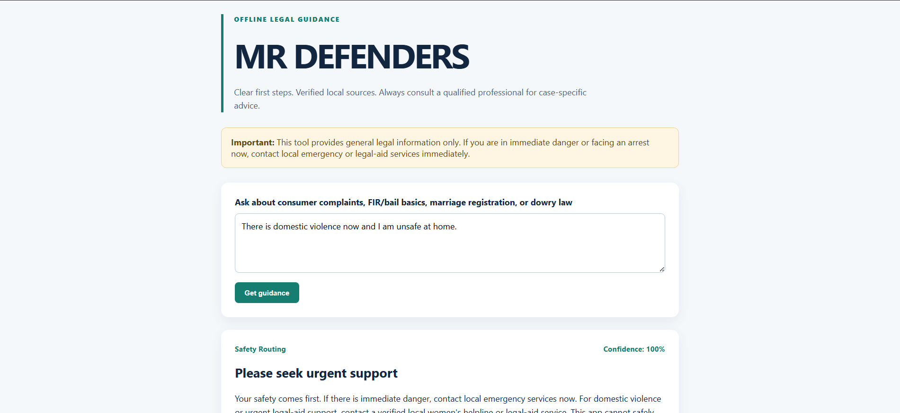
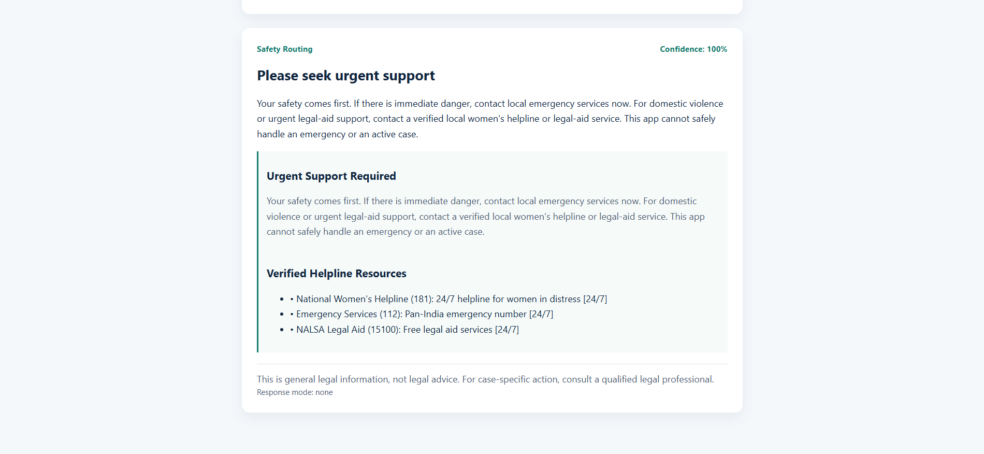

Git Link: https://github.com/rohithmm279/MR-DEFENDERS.git

