SOFTWARE REQUIREMENTS SPECIFICATION
AI-Powered Legal Assistance Platform Using a Domain-Specific Small Language Model
Multi-Domain Citizen Legal Guidance System

Team Name: MR DEFENDERS

Team Members: ROHITH M
SARAN V
PUZHAL MANI S
SANJAY RATHINAM MARIMUTHU NITHYA

1. Introduction

1.1 Purpose
This document specifies the functional and non-functional requirements for a citizen-facing legal assistance platform. The platform is built around a domain-specific Small Language Model (SLM) that runs entirely on local infrastructure, using retrieval-augmented generation (RAG) over a curated legal corpus and a fine-tuned local model. Hackathon problem statement "AI Development — Legal Assistance using Domain-Specific SLMs."

1.2 Document Scope
This SRS covers a system that answers citizen legal questions and provides step-by-step procedural guidance across Three domains: consumer complaints filing, basic criminal procedure (FIR process and bail basics), family law basics (marriage registration and dowry law).
1.3 Intended Audience
- Hackathon evaluators and judges assessing technical scope and feasibility
- Development team members responsible for data, modeling, and UI
- Future maintainers extending the system beyond the hackathon

1.4 Definitions, Acronyms, and Abbreviations
SLM | Small Language Model — a compact, locally-runnable language model (typically 4B–7B parameters).
RAG | Retrieval-Augmented Generation — grounding model output in retrieved source text.
LoRA / QLoRA | Low-Rank Adaptation — an efficient fine-tuning technique requiring a fraction of full model VRAM.
FIR | First Information Report — the document recording information about a cognizable criminal offence.
FR / NFR | Functional Requirement / Non-Functional Requirement.
Vector store | A database indexing text by semantic embedding for similarity search.

1.5 References
- The Consumer Protection Act, 2019
- The Right to Information Act, 2005
- The Bharatiya Nagarik Suraksha Sanhita, 2023 (and predecessor Code of Criminal Procedure, 1973, for reference material)
- The Dowry Prohibition Act, 1961; relevant provisions of the Bharatiya Nyaya Sanhita, 2023
- Hindu Marriage Act, 1955 / Special Marriage Act, 1954 (marriage registration provisions)
- State-level Rent Control Acts (jurisdiction-dependent)
- India Code portal (indiacode.nic.in) as primary source of statutory text

2. Overall Description

2.1 Product Perspective
The system is a standalone, self-contained application. It consists of a local inference server hosting a fine-tuned, quantized SLM; a local vector store built from a curated multi-domain legal corpus; and a web-based chat interface. It is designed to run fully offline after initial setup, making it suitable for demonstration in low-connectivity environments and aligned with a rural/citizen-access use case.

2.2 Product Functions (Summary)
- Accept a citizen's legal question in natural language (text, optionally voice)
- Classify the question into one of three supported legal domains
- Retrieve the most relevant legal provisions from a local, curated corpus
- Generate a grounded, cited answer using a fine-tuned local SLM
- Provide step-by-step procedural guidance (documents, authority, timeline, fees)
- Flag low-confidence answers and escalate to "consult a professional"

2.3 User Classes and Characteristics
General citizen (primary) | Little to no legal background; needs plain-language answers and clear next steps.
NGO / legal-aid worker (secondary) | Uses the system to triage citizen queries quickly and point them to the right process.
Student / maintainer (tertiary) | Extends the corpus, retrains adapters, or adds new domains after the hackathon.

2.4 Operating Environment
- Local machine with a CUDA-capable GPU (6GB VRAM class, e.g. RTX 4050, sufficient for a quantized 4–7B model)
- Windows 11 or Linux host
- Modern web browser for the chat interface
- No internet connectivity required at runtime after initial model and corpus setup

2.5 Design and Implementation Constraints
- No calls to third-party hosted LLM APIs (OpenAI, Anthropic, Google, etc.) — all inference is local
- Model and vector store must fit within available GPU memory on demo hardware
- Corpus limited to publicly available statutory text and case summaries within the hackathon timeline
- System must not present itself as a substitute for a licensed legal professional

2.6 Assumptions and Dependencies
- An open-weight SLM (e.g. Phi-3.5-mini, Llama-3.2-4B, Gemma-2-2B) is available under a license permitting fine-tuning and local redistribution for the demo
- A sufficient set of instruction-tuning examples (target: 200–500 pairs) can be curated or synthesized and verified within the timeline
- Demo hardware provides a CUDA GPU with at least 6GB VRAM

3. System Features (Functional Requirements)
Requirements are grouped by legal domain and by cross-cutting pipeline capability. Each requirement carries a unique ID and a priority (High / Medium / Low) reflecting hackathon MVP scope.

3.1 Query Intake & Classification
ID | Requirement | Priority
FR-1 | The system shall accept a natural-language legal query via a text input field. | High
FR-2 | The system shall optionally accept spoken queries and convert them to text using a local speech-to-text engine. | Medium
FR-3 | The system shall classify each query into one of the three supported legal domains, or flag it as out of scope. | High
FR-4 | The system shall route a classified query to the corresponding domain-specific retrieval index. | High

3.2 Consumer Complaints
ID | Requirement | Priority
FR-5 | The system shall answer questions on consumer rights under the Consumer Protection Act, 2019, including defective goods, deficient services, and e-commerce complaints. | High
FR-6 | The system shall provide step-by-step guidance for filing a complaint with a District Consumer Forum or the National Consumer Helpline. | High
FR-7 | The system shall cite the specific Act and section supporting each substantive claim in a consumer-complaint answer. | High

3.3 Criminal Procedure Basics (FIR, Bail)
ID | Requirement | Priority
FR-8 | The system shall explain the FIR filing process, including the Zero FIR provision and remedies if police refuse to register a complaint. | High
FR-9 | The system shall explain general concepts of bailable vs. non-bailable offences and anticipatory bail, as background information only. | High
FR-10 | The system shall display a mandatory disclaimer directing the user to a criminal lawyer for any case-specific action. | High

3.4 Family Law Basics
ID | Requirement | Priority
FR-11 | The system shall explain the marriage registration process and required documents under the applicable marriage law. | Medium
FR-12 | The system shall explain protections under the Dowry Prohibition Act, 1961 and related penal provisions, and where to report violations. | High
FR-13 | For queries indicating domestic violence or immediate personal risk, the system shall prioritize directing the user to a women's helpline or legal aid service over generated content. | High

3.5 Retrieval-Augmented Answer Generation
ID | Requirement | Priority
FR-14 | The system shall retrieve the top-k most relevant passages from the domain-specific vector store for every query. | High
FR-15 | The system shall generate the final answer using the fine-tuned local SLM, conditioned on the retrieved passages. | High
FR-16 | The system shall not present any Act, section number, or case citation that is not present in the retrieved corpus. | High

3.6 Step-by-Step Procedural Guidance
ID | Requirement | Priority
FR-17 | The system shall present multi-step guidance as a numbered checklist covering required documents, the responsible office or authority, applicable timeline, and fees. | High
FR-18 | The system shall allow the user to ask a follow-up question about any individual step without losing the original context. | Medium

3.7 Citations & Confidence
ID | Requirement | Priority
FR-19 | The system shall display the source Act and Section for every substantive claim in its answer. | High
FR-20 | The system shall display a confidence indicator with each answer; below a defined threshold, it shall recommend professional consultation instead of a direct answer. | High

3.8 Disclaimer & Escalation
ID | Requirement | Priority
FR-21 | The system shall display a persistent disclaimer stating that it does not replace professional legal advice. | High
FR-22 | The system shall detect high-stakes queries (e.g. active court case, arrest in progress) and prioritize escalation guidance over generated content. | High

4. Non-Functional Requirements
ID | Category | Requirement
NFR-1 | Performance | End-to-end response latency shall not exceed 10 seconds on the target demo hardware (6GB-class GPU).
NFR-2 | Security | No query content shall be transmitted to any external server or third-party API at runtime.
NFR-3 | Privacy | User queries shall not be persisted beyond the active session unless the user explicitly opts in to logging.
NFR-4 | Reliability | The system shall degrade gracefully to an 'unable to answer confidently' message rather than fabricate an answer.
NFR-5 | Usability | Procedural guidance shall be written at an accessible reading level suitable for a non-legal audience.
NFR-6 | Portability | The system shall run on both Windows and Linux with a documented local setup procedure.
NFR-7 | Maintainability | The ingestion, embedding, retrieval, and generation stages shall be modular so new legal domains can be added without redesigning the pipeline.
NFR-8 | Extensibility | The architecture shall support adding new Acts or domains by extending the corpus and retraining/re-indexing, without code-level changes to the core pipeline.
NFR-9 | Offline capability | The system shall be fully functional without an internet connection after initial setup and model download.

5. Data Requirements

5.1 Legal Corpus Schema
Each entry in the source corpus shall carry the following fields:
domain | One of: consumer, criminal, family
act_name | Full name of the statute (e.g. "Consumer Protection Act, 2019")
section_number | Section or clause identifier
section_text | Verbatim statutory text
jurisdiction | Central or state-specific, with state name if applicable
source_url | Reference link (e.g. India Code entry) for traceability

5.2 Fine-Tuning Dataset Schema
- instruction — the user-style legal question
- context — retrieved passage(s) used to ground the answer
- response — the target answer, written in the desired tone and structure
- cited_sections — list of Act/Section references the response must include

5.3 Vector Store Schema
- embedding_id — unique identifier for the chunk
- chunk_text — the chunked passage used for retrieval
- metadata — domain, act_name, section_number for filtering and citation

6. System Architecture Overview
The system follows a linear pipeline: the legal corpus is preprocessed and chunked along section boundaries; chunks are embedded and indexed in a local vector store; at query time, the classified query is used to retrieve the top-k relevant passages; the fine-tuned local SLM generates an answer conditioned on those passages; the answer is returned with citations, a confidence indicator, and — where applicable — a step-by-step procedural checklist. No stage in this pipeline depends on an external network call.

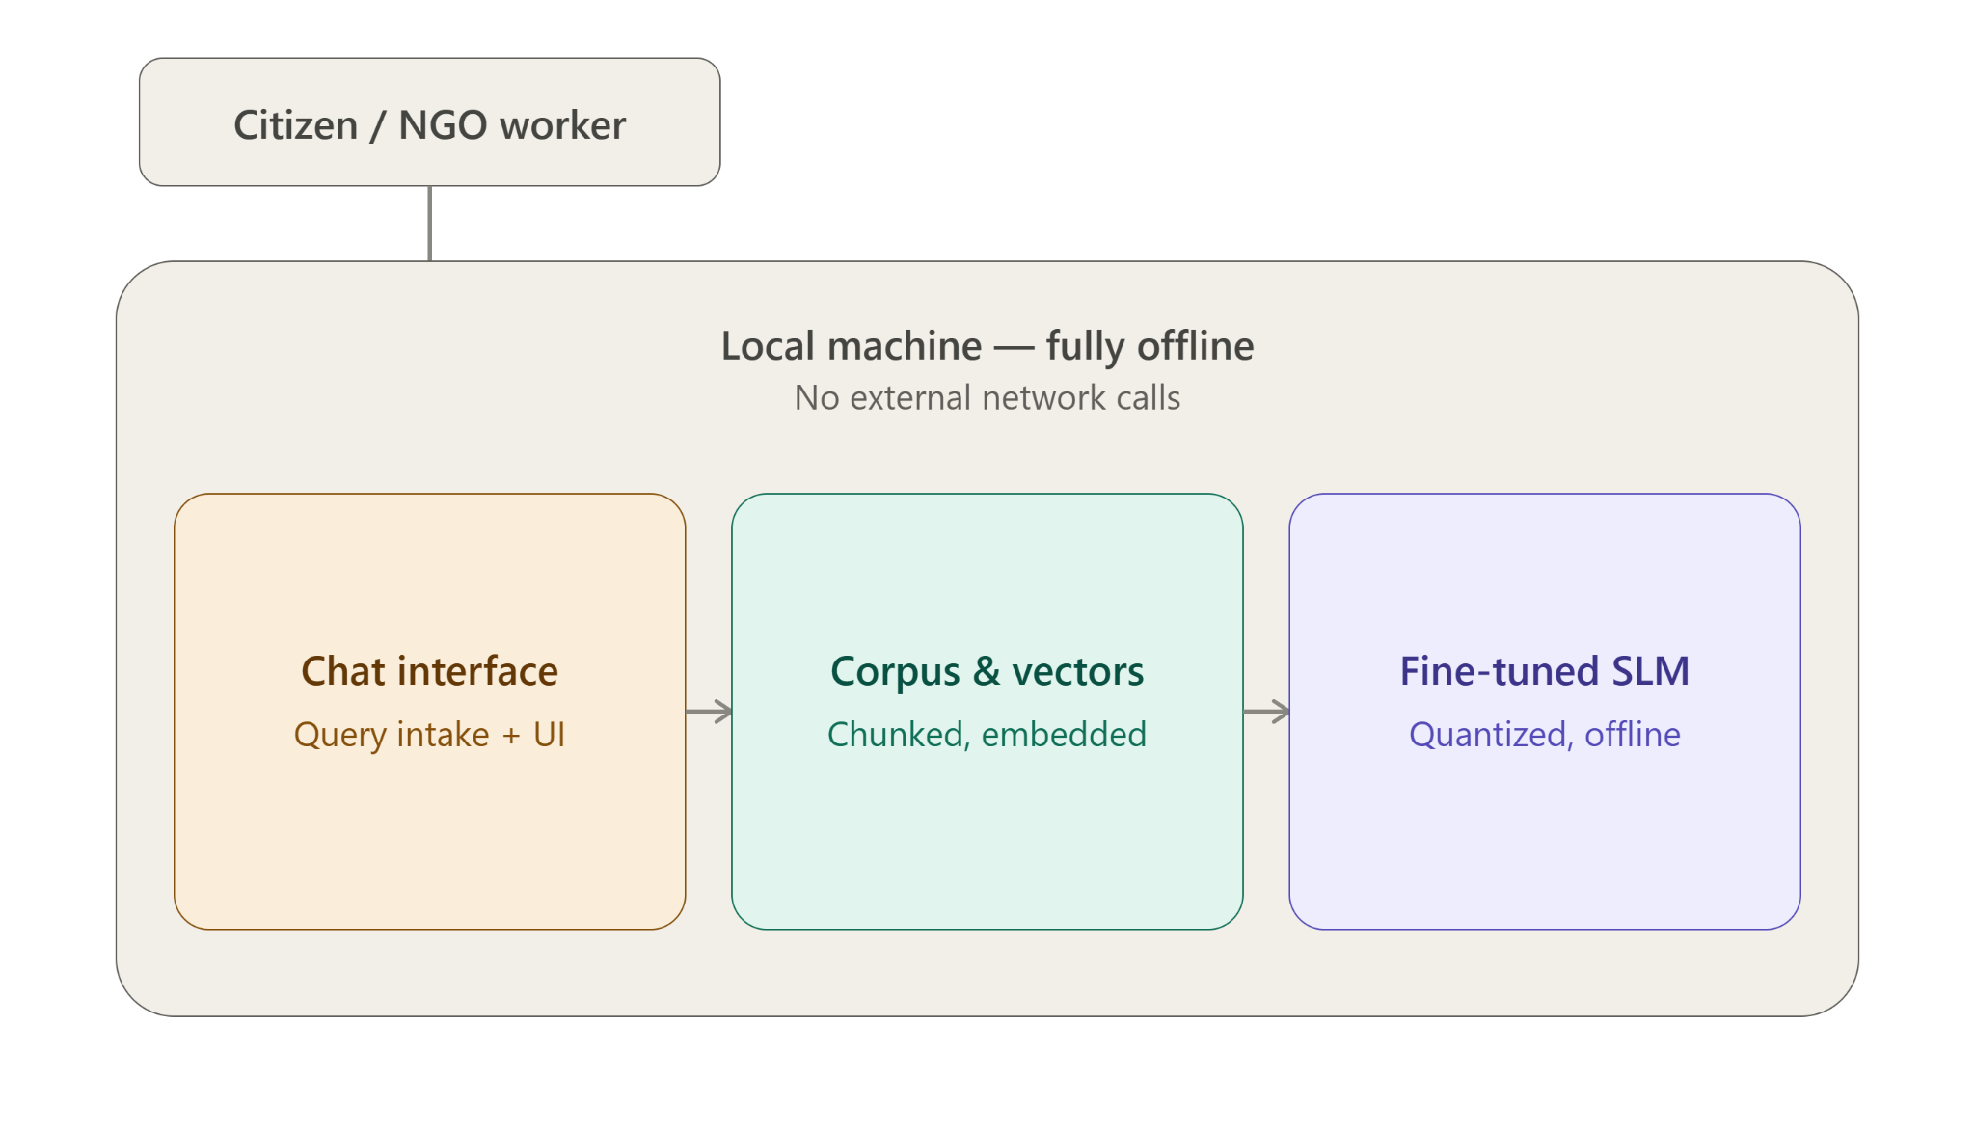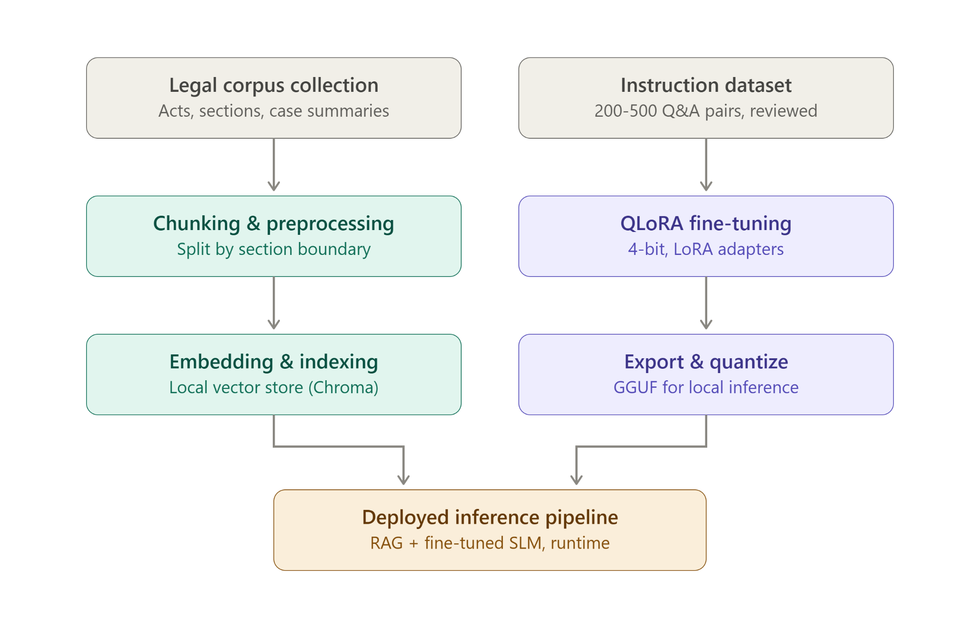

7. Phase-by-Phase Technical Workflow

Phase 1: Ingestion & Vector Indexing (Preparation Phase)
- Corpus Extraction & Chunking: Public statutory legal documents (Consumer Protection Act, BNSS, Dowry Prohibition Act, etc.) are parsed into text chunks aligned with section boundaries.
- Metadata Tagging: Each chunk is tagged with its corresponding domain (consumer, criminal, or family), act_name, section_number, and jurisdiction.
- Local Embedding Generation: A local embedding model vectorizes the chunks and persists them into a local vector store (e.g., ChromaDB) for offline similarity search.

Phase 2: Model Fine-Tuning (Setup Phase)
- Dataset Curation: A dataset of 200–500 instruction-context-response pairs grounded in statutory text is prepared.
- QLoRA Adaptation: An open-weights small language model (4B–7B parameters, e.g., Llama-3.2 / Phi-3.5) is fine-tuned locally using QLoRA to output structured, cited legal responses without exceeding GPU memory constraints.

Phase 3: Real-Time Query Processing & Routing (Runtime Phase)
- Input Handling: The chat interface receives the user query via text or optional local speech-to-text conversion.
- Safety & Crisis Check: High-risk queries (e.g., active domestic violence or active arrest) trigger immediate escalation to helpline contacts, bypassing generation.
- Domain Classification: General queries are classified into one of the 3 legal domains and routed to the corresponding metadata filter in the vector store.

Phase 4: Retrieval-Augmented Generation & Post-Processing (Output Phase)
- Context Retrieval: The top-k relevant legal chunks are retrieved from the local vector database using semantic similarity matching.
- SLM Generation: The fine-tuned local SLM generates a response strictly conditioned on the retrieved context, adhering to strict anti-hallucination guardrails.
- Formatted Response Delivery: The final output is rendered with a plain-language summary, a step-by-step procedural checklist, source citations (Act and Section), a confidence score, and a mandatory legal disclaimer.

