Distributed and Cloud Computing

ASSIGNMENT 2

NAME: ROHITH M S R

REG NO: 2019115081

1. **Implement RMI (Remote Method Invocation)**

Remote Method Invocation (RMI) is a mechanism that allows an object to invoke a method on an object that exists in another address space, which could be on the same machine or on a remote machine. I am using **Java RMI API** to implement RMI. Through RMI, an object running in a JVM present on a computer (Client-side) can invoke methods on an object present in another JVM (Server-side). The **communication** between client and server is handled by using two intermediate objects: Stub object (on client side) and Skeleton object (on server-side)

**Stub Object:**The stub object on the client machine builds an information block and sends this information to the server.

**Skeleton Object:**The skeleton object passes the request from the stub object to the remote object.

**Steps to implement RMI (Pascal’s triangle printer)**

1. Defining a remote interface

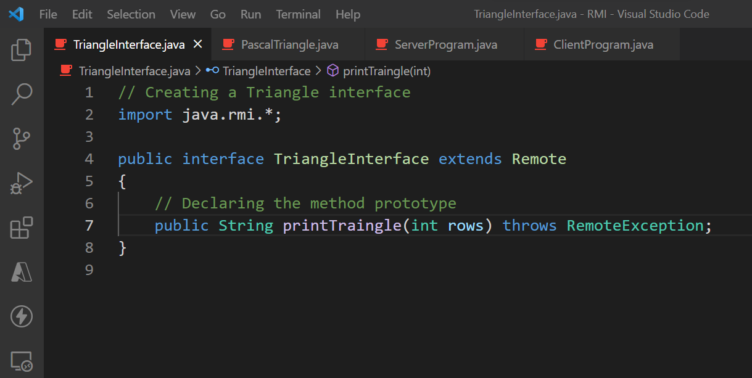

1. Implementing the remote interface

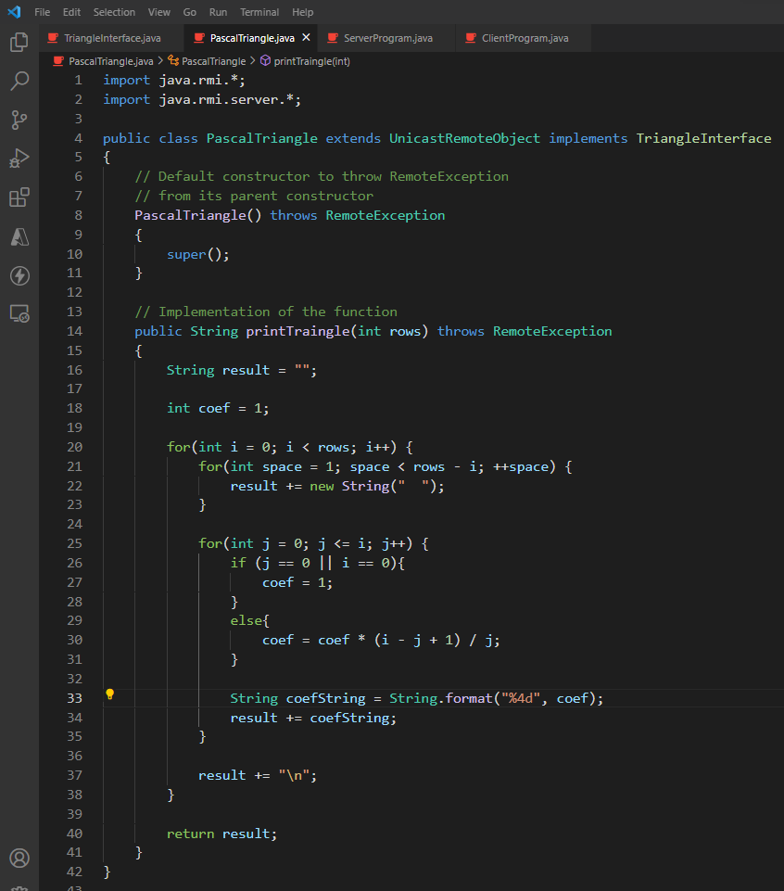

1. Creating the server application program

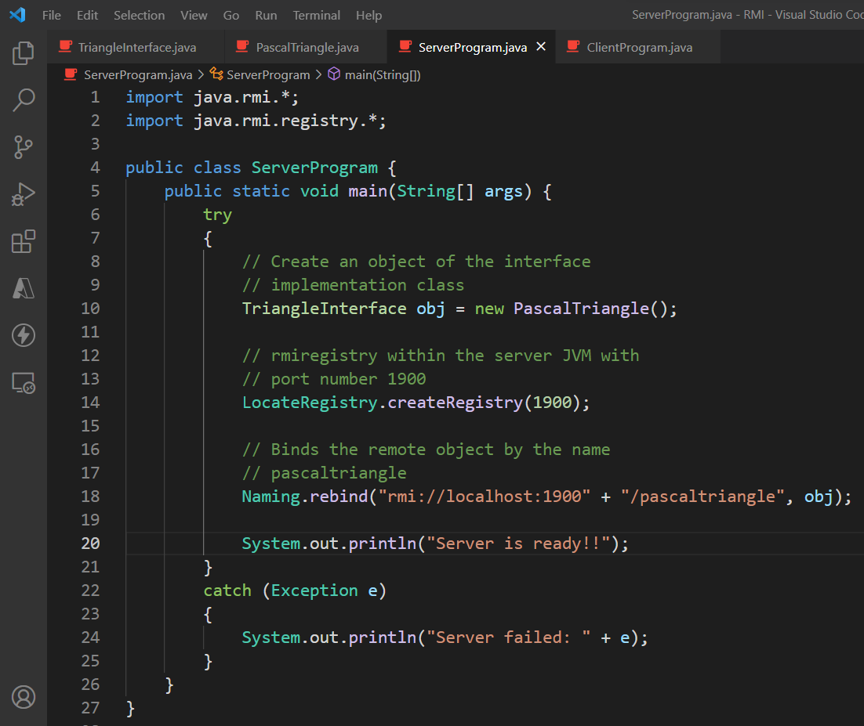

The Naming.rebind() function pushes the reference and the other details of the all the methods which are going to be used in RMI

1. Creating the client application program.

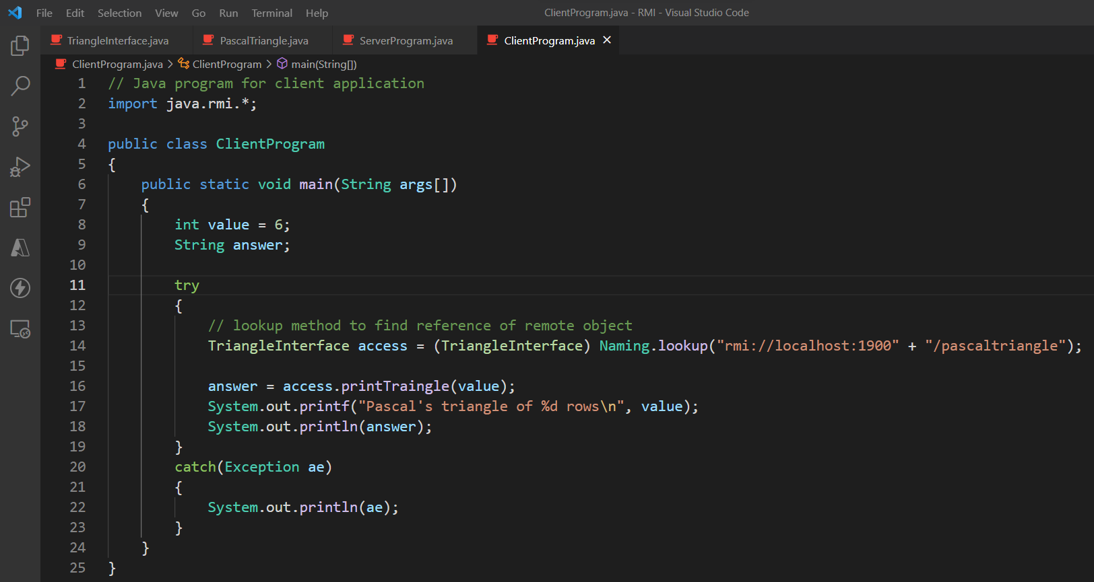

The Naming.lookup() function looks up the RMI registry finds the function which has to be invoked in the remote system

RMI registry is a table which has the name of the method which used for RMI and the relevant local reference

1. Creating Stub and Skeleton objects from the implementation class using rmic (RMI compiler)

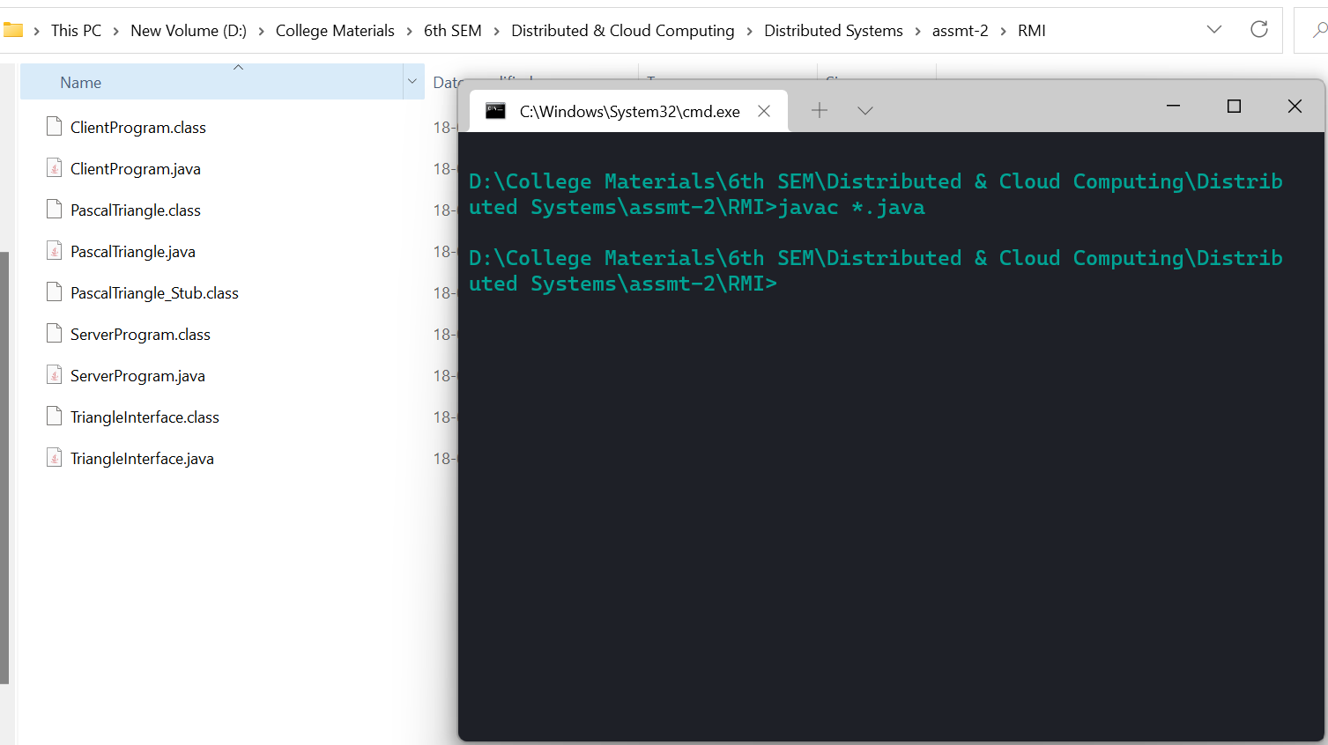

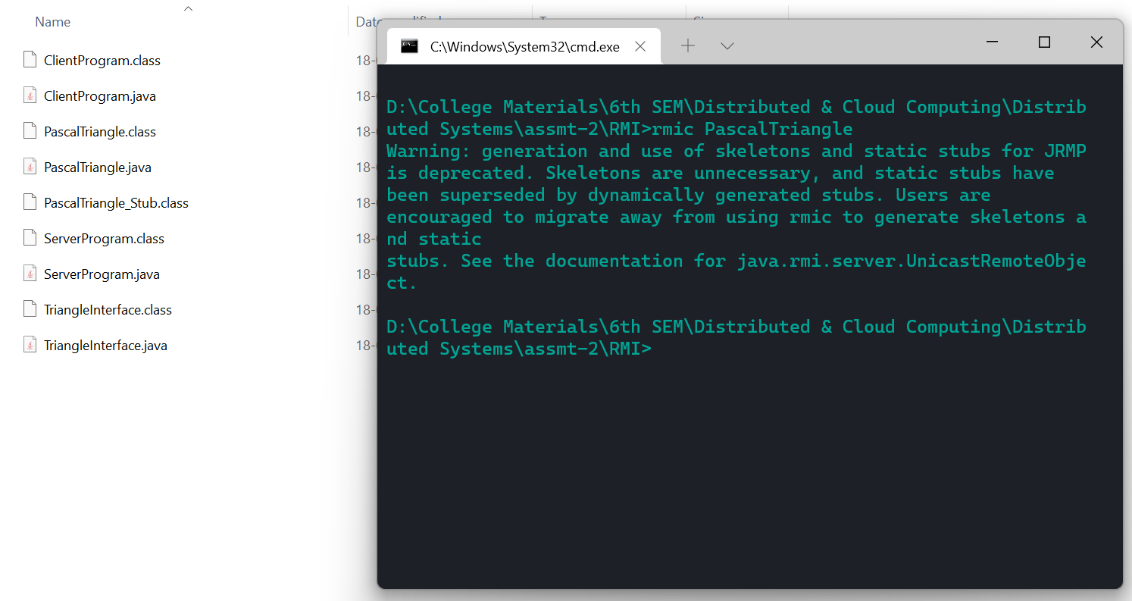

1. Start the rmiregistry

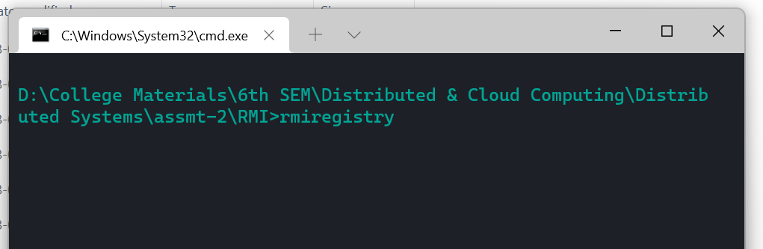

1. Execute the server application program

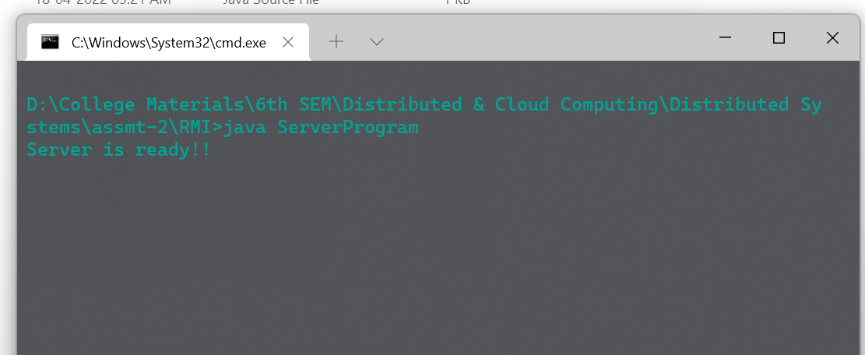

1. Execute the client application program.

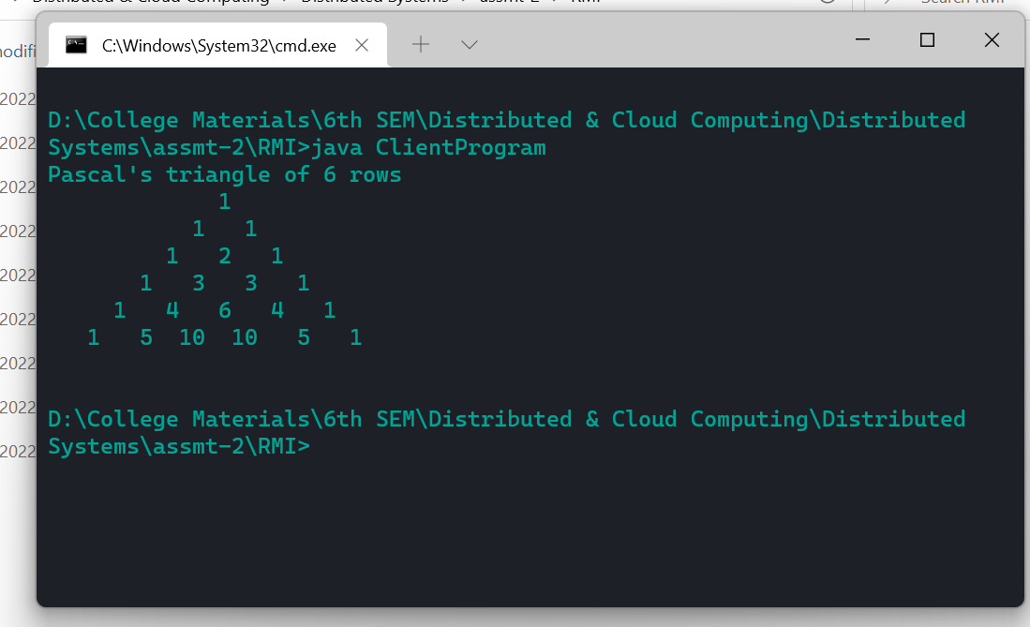

1. **Use Google Collaboration tools & share it with others**

**Google Docs** for listing out the requirements

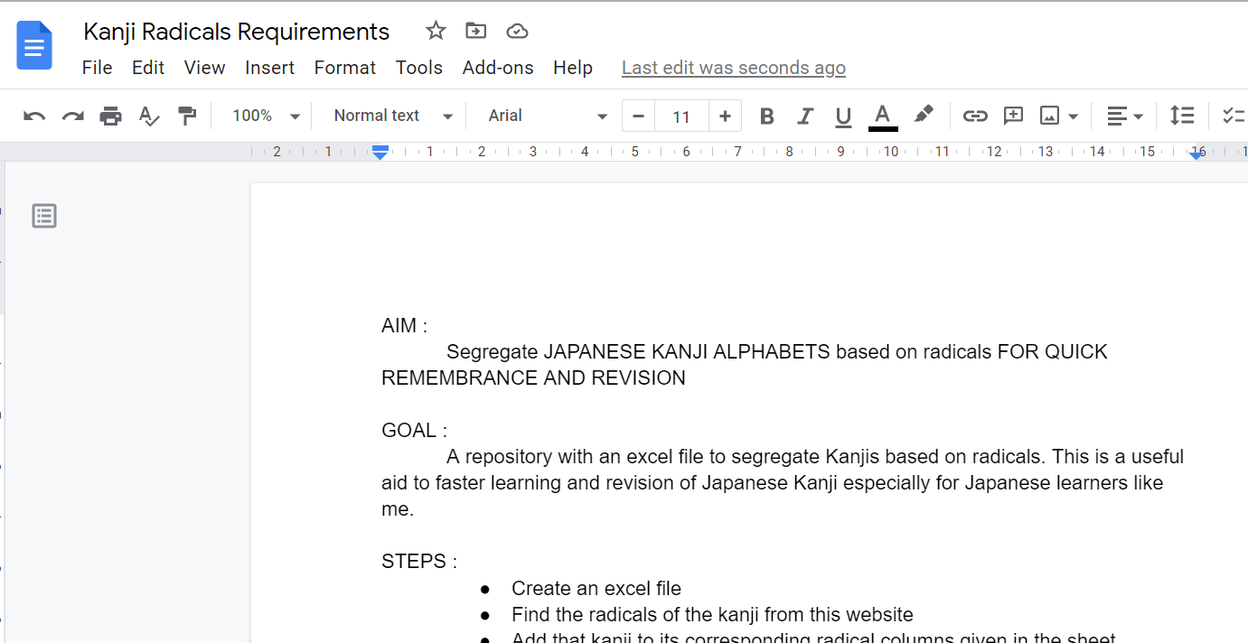

**Google Colab** for building an .xlsx document

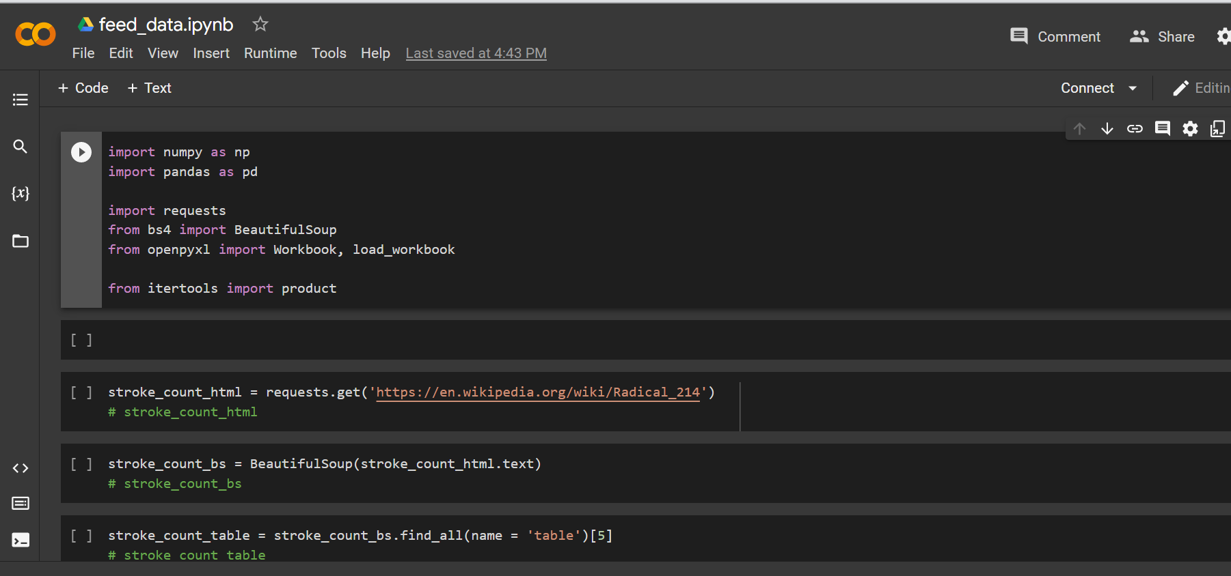

**Google Sheets** to view the created .xlsx sheet

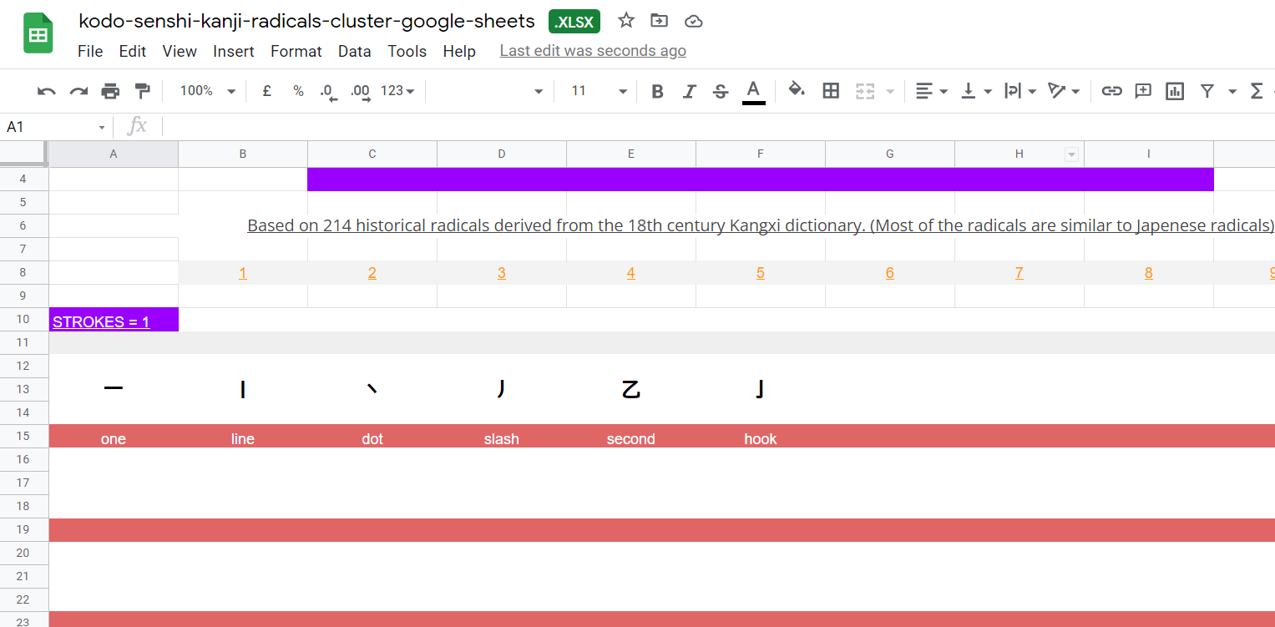

Share the docs, colab file and sheet with others!!

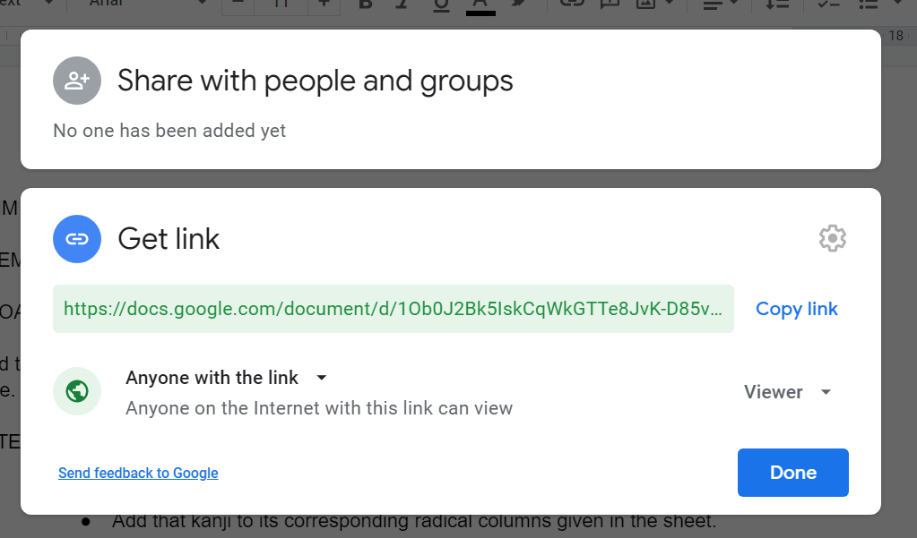

1. **Explore public cloud services**

**DIFFERENCES:**

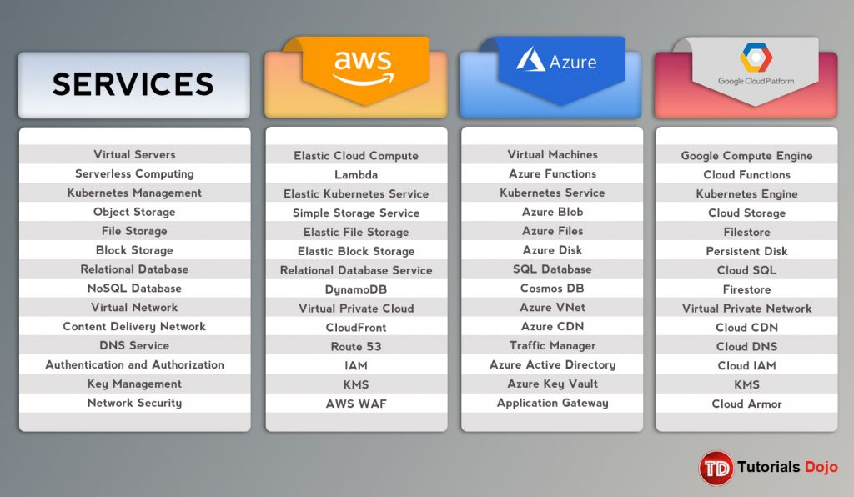

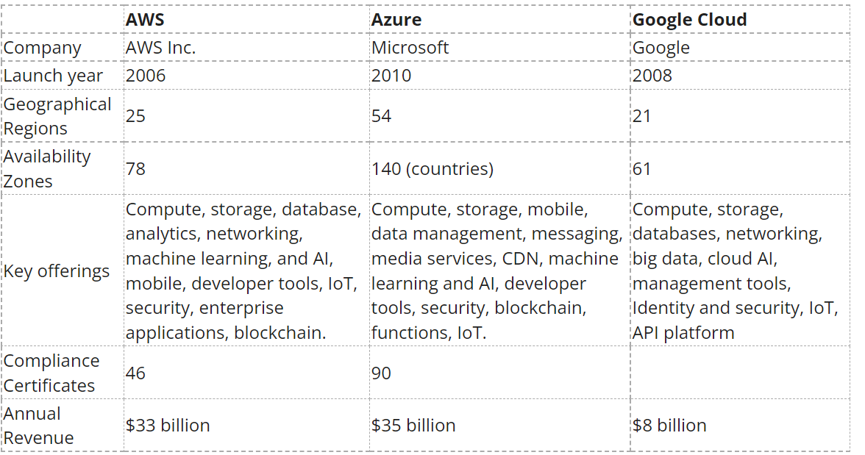

**FUN-FACT:**

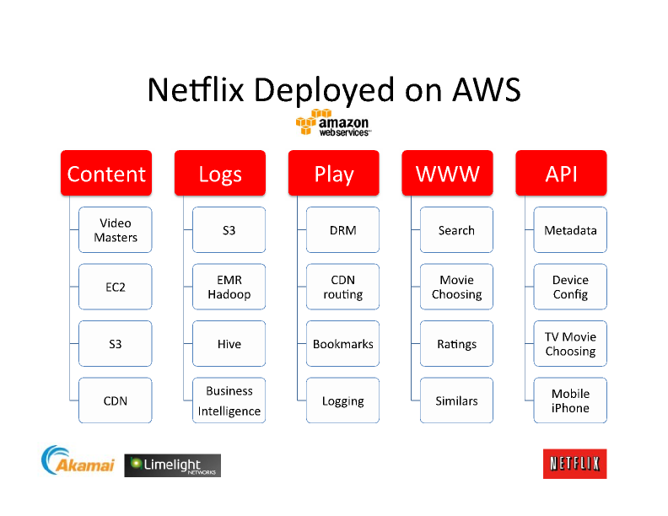

Netflix uses AWS. Amazon has Amazon Prime! Amazon Prime and Netflix are OTT competitors, still some part of the revenue of Netflix goes to Amazon. Power of Cloud!!

Source: Netflix ‘s official blog= <https://about.netflix.com/en/news/completing-the-netflix-cloud-migration>

**HANDS-ON WITH AZURE:**

Microsoft Azure provides 30 days free trial for new users but for students, when applied through GitHub Student Developer Pack, there is a free 12-months student subscription, so **no credit card/international payment supported debit cards** were required for me to create an account!

**Creating a Windows VM in Azure**

Microsoft Learn platform has an excellent blog that guides you through to create a VM through sandbox!! = <https://docs.microsoft.com/en-us/learn/modules/create-windows-virtual-machine-in-azure/3-exercise-create-a-vm>

