Mini Project entitled

APPLOCKER

Submitted in partial fulfillment of academic requirements for the award of the degree of

Bachelor of Engineering (Computer Science and Engineering)

By

U AMITH SAI 2451-12-733-044

T SAI KIRAN 2451-12-733-028

P.V.K ROHITH 2451-12-733-025



Department of Computer Science and Engineering

M.V.S.R. ENGINEERING COLLEGE

(Affiliated to Osmania University & Recognized by AICTE) Nadergul, Saroor Nagar Mandal, Hyderabad – 501 510
2014-15.
Mini Project entitled

APPLOCKER

Submitted in partial fulfilment of academic requirements for the award of the degree of

Bachelor of Engineering (Computer Science and Engineering)

By

U AMITH SAI 2451-12-733-044

T SAI KIRAN 2451-12-733-028

P.V.K ROHITH 2451-12-733-025

Department of Computer Science and Engineering

M.V.S.R. ENGINEERING COLLEGE

(Affiliated to Osmania University & Recognized by AICTE) Nadergul, Saroor Nagar Mandal, Hyderabad – 501 510
2014-15.
Department of Computer Science and Engineering

M.V.S.R. ENGINEERING COLLEGE
(Sponsored by Matrusri Education Society, Estd. 1980) (Affiliated to Osmania University & Recognized by AICTE)
Nadergul, Saroor Nagar Mandal, Hyderabad – 501 510



CERTIFICATE

This is to certify that the project entitled “APPLOCKER”, is being submitted by Mr.U AMITH SAI (2451-12-733-044),T SAI KIRAN(2451-12-733-028) and P.V.K ROHITH (2451-12-733-045) in partial fulfillment of academic requirements for the award of the degree of BACHELOR OF ENGINEERING in COMPUTER SCIENCE AND ENGINEERING from MVSR Engineering College, affiliated to OSMANIA UNIVERSITY, is a record of bonafide work carried out by him under the guidance and supervision of the faculty (CSED). The results embodied in this project report have not been submitted to any other University or Institute for the award of any degree or diploma to the best of my knowledge and belief.

Guide Project Coordinator D KAVITHA B Venkataramana Assistant Professor, Assistant Professor Dept. of CSE. Dept. of CSE.
MVSR Engineering College MVSR Engineering College

ACKNOWLEDGMENT

I take this opportunity to express my profound and sincere gratitude to all those who helped us in carrying out this project successfully.

At the very outset, I am thankful to our principal Sri Dr.P.A SASTRY and Sri J.Prasanna Kumar, Professor and Head, Department of Computer Science and Engineering, MVSR Engineering College, Hyderabad for their consent to do the project work as a part of our B.E Degree (CSE). We thank them for their valuable suggestions and advice throughout our stay at the college, during our project work.

I would like to thank our Internal Project Guide Ms. D.KAVITHA, Assistant Professor, Department of Computer Science and Engineering, MVSR Engineering College for his/her useful suggestions, guidance and encouragement.

We thank the teaching and non-teaching staff of CSE for extending their support.

Finally we are thankful to our parents for their cooperation and support throughout all endeavours in our life.

U AMITH SAI( 2451-12-733-044) T SAI KIRAN(2451-12-733-028) P.V.K ROHITH( 2451-12-733-045)
ABSTRACT

AppLocker contains new capabilities and extensions that allow you to create rules to allower deny applications from running based on unique identities of files and to specify which users or groups can run those applications.

Applocker is an application used to provide security.This is like a general locker where we have a keypad of colours in which we need to enter 4 colours to open something.we will assign each number one colour and.The user of the app will be able to see only the colours but not numbers.But the background process will run on the numbes.

This is a new paradigm which replaces the existing security pattern which works in a different way than the existing ones.
Table of Contents

Sno | Content | Page no.
1 | Introduction | 07-08
2 | Requirement Analysis | 09
3 | Design | 10
4 | Coding | 11-14
5 | Screen Shots | 16-17
6 | Conclusion & Future work | 18

6
1 . INTRODUCTION

AppLocker contains new capabilities and extensions that allow you to create rules to allower deny applications from running based on unique identities of files and to specify which users or groups can run those applications.

Using AppLocker, you can control the following types of applications: executable files (.exe and .com), scripts (.js, .ps1, .vbs, .cmd, and .bat), Windows Installer files (.msi and .msp), and DLL files (.dll and .ocx).

Define rules based on file attributes derived from the digital signature, including the publisher,product name, file name, and file version. For example, you can create rules based on the publisher attribute that is persistent through updates, or you can create rules for a specific version of a file.Assign a rule to a security group or an individual user.

Create exceptions to rules. For example, you can create a rule that allows all Windows processes to run except Registry Editor (Regedit.exe).Use audit-only mode to deploy the policy and understand its impact before enforcing it.

Import and export rules. The import and export affects the entire policy. For example, if you export a policy, all of the rules from all of the rule collections are exported, including the enforcement settings for the rule collections. If you import a policy, all criteria in the existing policy are overwritten.Streamline creating and managing AppLocker rules by using Windows PowerShell cmdlets.

AppLocker helps reduce administrative overhead and helps reduce the organization's cost of managing computing resources by decreasing the number of help desk calls that result from users running unapproved application

1.1. PROPOSED SYSTEM
The idea is to use colors instead of numbers or text. However the background process runs on the numbers. Using GUI (Graphical User Interface) assigning color to each number and hiding that number from being visible so that user can see only the color but not number.
2. REQUIREMENT ANALYSIS

2.1. SOFTWARE REQUIREMENTS

• JDK (JAVA DEVELOPMENT KIT)

• NOTEPAD

• WORDPAD

2.2. HARDWARE REQUIREMENTS

• 512MB RAM

• INTEL CELRON PROCESSOR

For this project we need JDK for developing the code in java and compiling and running it.In this we use applets for our projects.we use applets because there are some components in this through which use interact with the system.It need RAM and Processor .
3. DESIGN

3.1. FLOWCHART

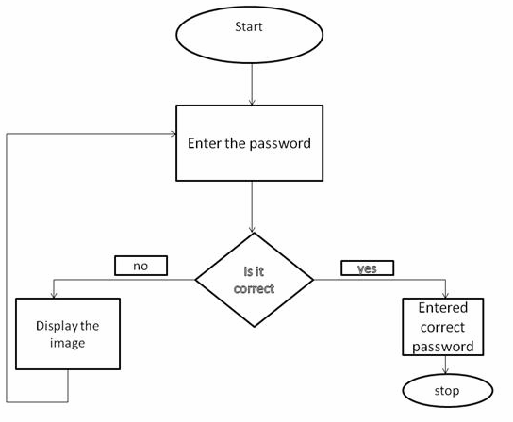

This flow chart explains about how the sequence of steps will work. First user need to enter the password then the system checks for the validation of the password i.e whether the password is correct or not.If it is correct then it show correct password on screen otherwise it will display the image and screen of entering password will appear again.

import java.awt.*; import java.applet.*; import java.awt.event.*;
4 .CODING

<applet code="Applock" width=400 height=300>
<param name="img" value="img.jpg">
</applet>
*/
public class Applock extends Applet implements ActionListener
{
Label l; TextField t,t1;
Button b1,b2,b3,b4,b5,b6,b7,b8,b9,b10,b11,b0; Panel p1,p2,p4,p3,p5,p6;
String msg="",key="1234",entered="",text="",a,b,str; Image img;
public void init()
{
l=new Label("Enter the Passcode");
t=new TextField(6); t1=new TextField(20); b0=new Button("BACK"); b1=new Button(" 1 "); b2=new Button(" 2 "); b3=new Button(" 3 "); b4=new Button(" 4 "); b5=new Button(" 5 "); b6=new Button(" 6 "); b7=new Button(" 7 "); b8=new Button(" 8 "); b9=new Button(" 9 "); b10=new Button(" OK ");
b11=new Button("CANCEL");
p1=new Panel(); p2=new Panel(); p3=new Panel(); p4=new Panel(); p5=new Panel(); p6=new Panel();
p1.setLayout(new FlowLayout(FlowLayout.CENTER));
p2.setLayout(new FlowLayout(FlowLayout.CENTER)); p3.setLayout(new FlowLayout(FlowLayout.CENTER)); p4.setLayout(new FlowLayout(FlowLayout.CENTER)); p5.setLayout(new FlowLayout(FlowLayout.CENTER)); p6.setLayout(new FlowLayout(FlowLayout.CENTER)); p1.add(l);
p1.add(t); p1.add(b0); p2.add(b1);

p2.add(b2); p2.add(b3); p3.add(b4); p3.add(b5); p3.add(b6); p4.add(b7); p4.add(b8); p4.add(b9); p5.add(b10); p5.add(b11); p6.add(t1);
setLayout(new GridLayout(6,1,0,0));
add(p1); add(p2); add(p3); add(p4); add(p5); add(p6);
b1.setBackground(Color.red); b1.setForeground(Color.red); b2.setBackground(Color.pink); b2.setForeground(Color.pink); b3.setBackground(Color.cyan); b3.setForeground(Color.cyan); b4.setBackground(Color.magenta); b4.setForeground(Color.magenta); b5.setBackground(Color.yellow); b5.setForeground(Color.yellow); b6.setBackground(Color.orange); b6.setForeground(Color.orange); b7.setBackground(Color.green); b7.setForeground(Color.green); b8.setBackground(Color.blue); b8.setForeground(Color.blue); b9.setBackground(Color.darkGray); b9.setForeground(Color.darkGray); b1.addActionListener(this); b2.addActionListener(this); b3.addActionListener(this); b4.addActionListener(this); b5.addActionListener(this); b6.addActionListener(this); b7.addActionListener(this); b8.addActionListener(this); b9.addActionListener(this); b10.addActionListener(this); b11.addActionListener(this); b0.addActionListener(this);
img = getImage( getDocumentBase() , getParameter("img"));
}
public void actionPerformed(ActionEvent ae)
{ str=ae.getActionCommand(); if (str.equals(" 1 ")
{
msg+="*"; entered+="1"; t.setText(msg); t1.setText("");
}
if (str.equals(" 2 "))
{
msg+="*"; entered+="2"; t.setText(msg); t1.setText("");
}
if (str.equals(" 3 "))
{
msg+="*"; entered+="3"; t.setText(msg); t1.setText("");
}
if (str.equals(" 4 "))
{
msg+="*"; entered+="4"; t.setText(msg); t1.setText("");
}
if (str.equals(" 5 "))
{
msg+="*"; entered+="5"; t.setText(msg); t1.setText("");
}
if (str.equals(" 6 "))
{
msg+="*"; entered+="6"; t.setText(msg); t1.setText("");
}
if (str.equals(" 7 "))
{
msg+="*"; entered+="7"; t.setText(msg);
t1.setText("");
}
if (str.equals(" 8 "))
{
msg+="*"; entered+="8"; t.setText(msg); t1.setText("");
}
if (str.equals(" 9 "))
{
msg+="*"; entered+="9"; t.setText(msg); t1.setText("");
}
if (str.equals(" OK "))
{
if (key.equals(entered))
{
text="Correct Password";
t1.setText(text);
entered="";
}
else
{
t1.setText("Incorrect Password");
entered=""; msg=""; t.setText(msg); remove(p1); remove(p2); remove(p3);
remove(p4);
remove(p5);
remove(p6);
}
}
if (str.equals("CANCEL"))
{ msg=""; text=" ";
t.setText(msg); t1.setText(text); entered="";
}
if (str.equals("BACK"))
{ c=msg.length(); c=c-1;
msg=msg.substring(0,c); t.setText(msg); c=entered.length();
c=c-1;
entered=entered.substring(0,c);
}
repaint();
}
public void paint(Graphics g)
{
if (str.equals(" OK "))
{
if (key.equals(entered))
{
text="Correct Password";
t1.setText(text);
entered="";
}
else{
g.drawImage(img,30,2,this);
}
}
}
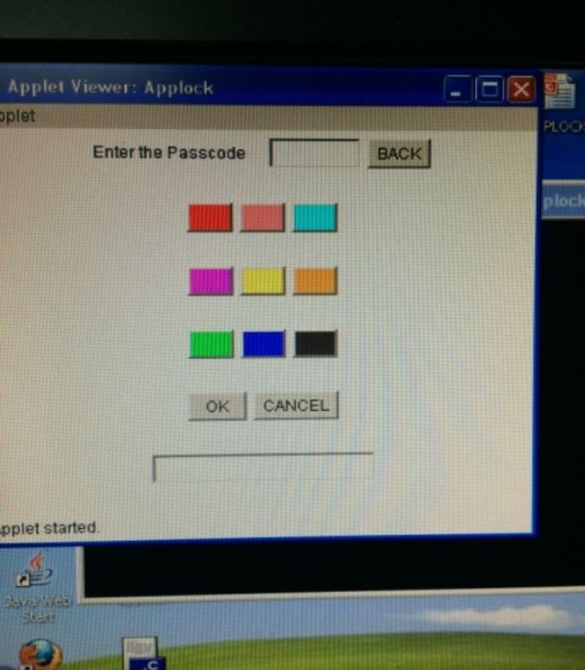
5.SCREEN SHOTS

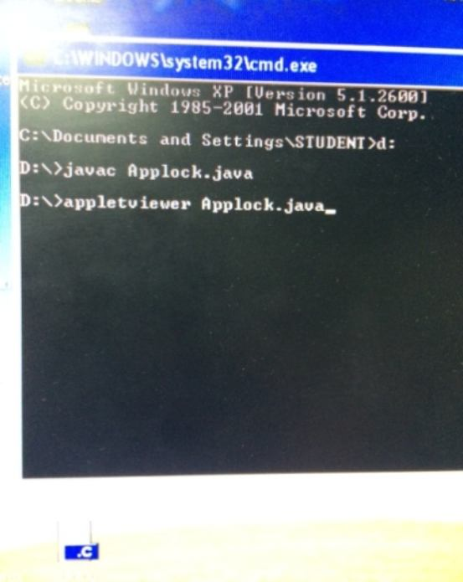

Fig 5.1 Compilation Fig 5.2 Entering of Data

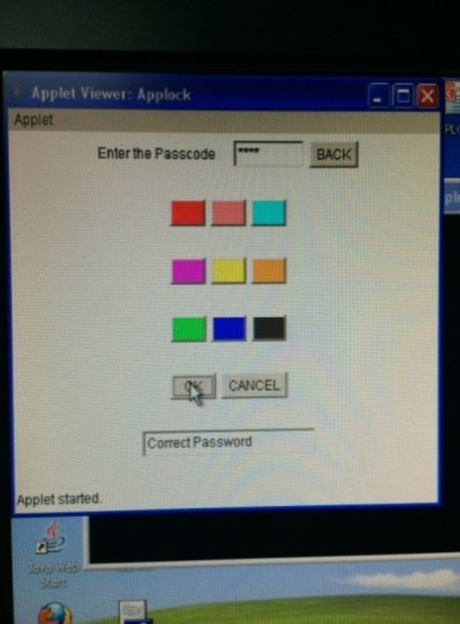
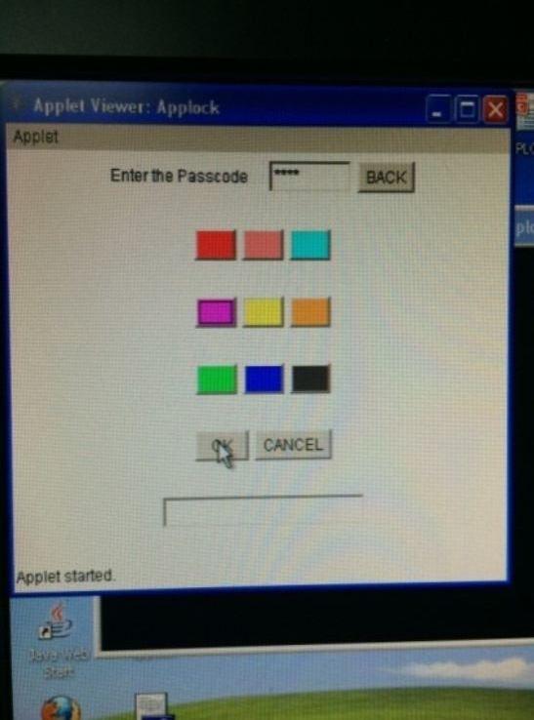
Fig 5.3 Entering Data Fig 5.4 Check Password
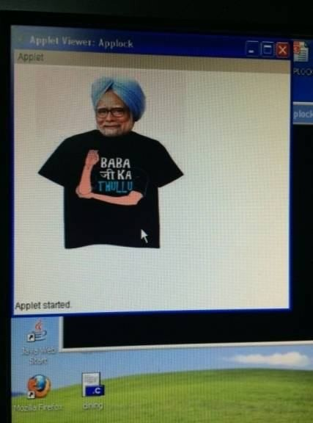

Fig 5.7 Displaying Image for entering the wrong password
6. CONCLUSION AND FUTURE WORK

This is a new paradigm which replaces the existing security pattern which works in a different way than the existing ones. In future, this can be developed in such a way that for every access of the application the colors that are associated with the buttons gets shuffled which provides more security from the other who could trace the pattern.

