# Problem 1 Poisson MLE

**1.1**

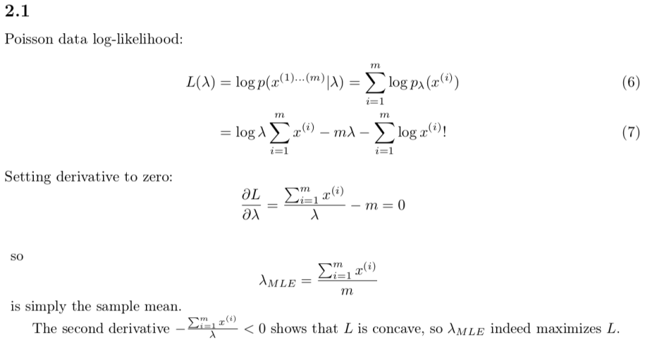

**1.2**

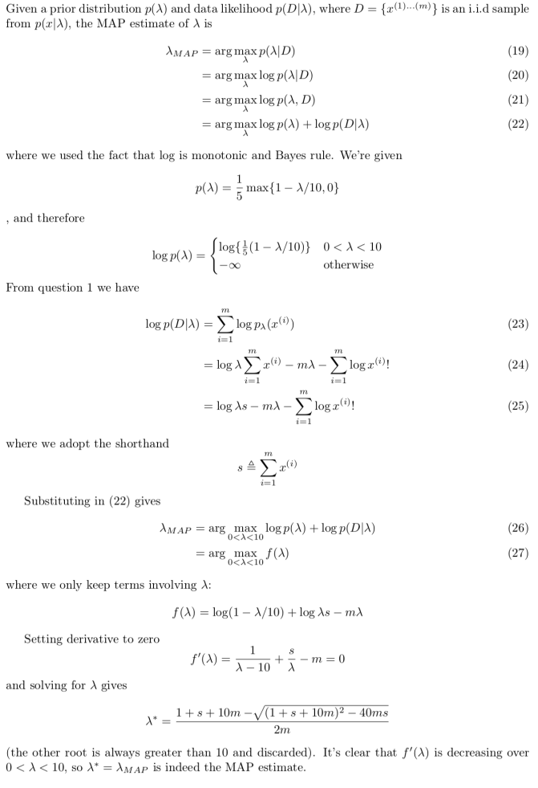

**1.3**

Any reasonable answer worth full credit. Example: we don’t favor this prior cause it greatly changes the form of MLE estimator, a conjugate prior like Gamma distribution can be used.

# Problem 2 Log-Normal MLE

**2.1**

The log-likelihood is simply

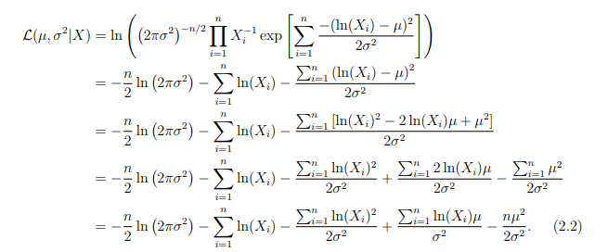

**2.2**

Take derivative respect to $μ$, we can get the MLE estimator,

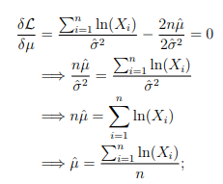

Take derivative respect to $σ^{2}$, we can get the MLE estimator (note that $μ$ is fixed to $\hat{μ}$ ),

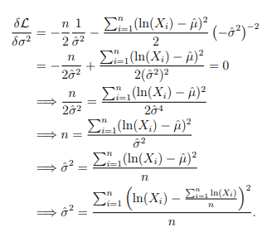

To prove these are the MLE estimators, we also need to show that

* This is a local maxima, this is done by showing that the hessian matrix of likelihood function $L$ is negative-semidefinite at the point $\hat{μ}$ and $\hat{σ^{2}}$
* Show that the boundary points of $L$ cannot achieve higher value.

Details are omitted here, for reference, you can check the attachments in this solution.

**2.3**

This is a log-normal distribution where



To put it in the another form, we have



This means

$$E\left(\hat{u}\right)=\frac{\sum_{i}{E(\ln\left(X_{i}\right))}}{n}=\frac{n×μ}{n}=μ$$

Thus, $\hat{u}$ is unbiased.

Similarly, you can prove

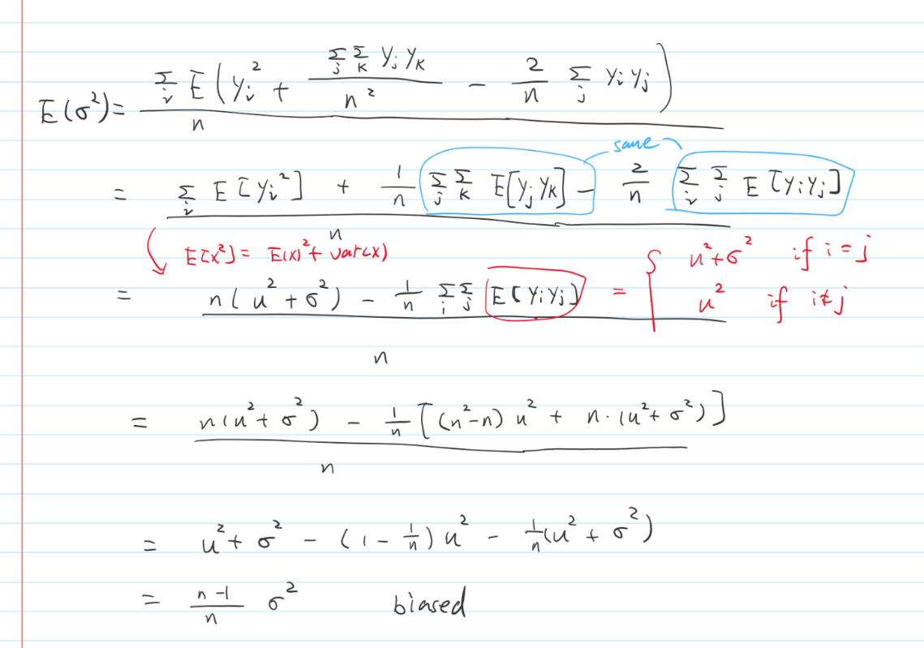

Note that the $y_{i}$ means $ln⁡(x_{i})$

**2.4**

Any reasonable response worth full credit. Example: note that the observations are always greater than zero, therefore the parameter $μ$ can never be negative. However, Gaussian distribution always assign probability mass for negative values, so it should not be preferred.

# Problem 3 Logistic Regression

**3.1**

The accuracy on test set is 0.769.

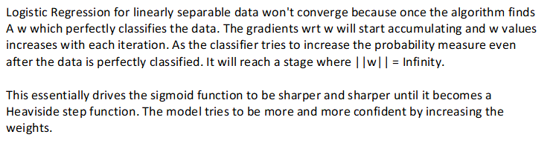

(From Krishnateja Killamsetty)

**3.2**

I pick $λ=0.5$ as regularization constant, the result is shown below (my code has more results)

Train accuracy: 1.0

Valid accuracy: 0.7692307692307693

Test accuracy: 0.7884615384615384

Learned W:

1.03,0.27,-1.31,1.06,-0.27,-0.79,-0.46,-1.11,1.38,0.14,0.43,0.72,0.63,0.01,-0.15,-0.81,-0.88,0.31,0.40,0.91,-0.41,-0.04,1.22,0.37,-0.22,-0.58,-0.22,0.38,0.20,0.21,-1.38,0.63,0.56,-0.64,-0.24,-0.73,-0.48,0.60,-0.18,-0.85,0.03,-0.39,0.33,0.50,0.50,-0.13,0.40,0.97,1.19,-1.36,0.77,0.62,0.32,0.27,-0.87,0.50,-0.83,1.07,0.14,0.30

Learned b: 0.5860328876576976

**3.3**

I pick $λ=0.5$ as regularization constant, the result is shown below (my code has more results)

Train accuracy: 0.9903846153846154

Valid accuracy: 0.75

Test accuracy: 0.8076923076923077

Learned W:

1.23,0.00,-1.28,1.11,0.00,-1.10,-0.09,-1.34,1.65,-0.00,0.01,0.75,0.75,-0.00,-0.00,-0.85,-0.66,0.01,0.01,1.21,-0.31,0.00,1.16,0.01,0.00,-0.74,-0.01,0.22,0.01,0.29,-0.99,0.58,0.11,-0.46,-0.01,-0.88,-0.01,0.00,-0.01,-0.69,-0.00,-0.00,0.01,0.78,0.01,-0.00,-0.00,0.98,1.33,-1.38,1.14,0.56,0.18,0.14,-0.78,0.61,-0.87,0.95,0.06,0.17

Learned b: 0.46684986876493856

**3.4**

It is clear that L1 regularization tends to generate sparser results.

# Problem 3 Naïve Bayes

**4.1**

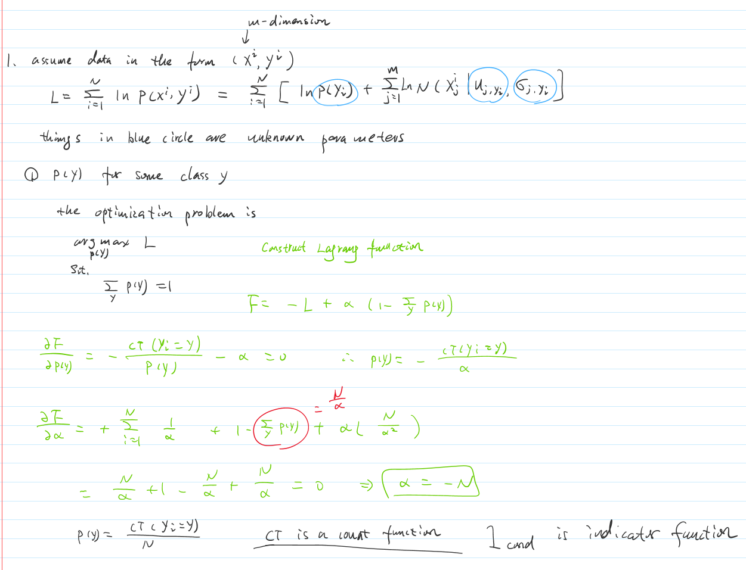

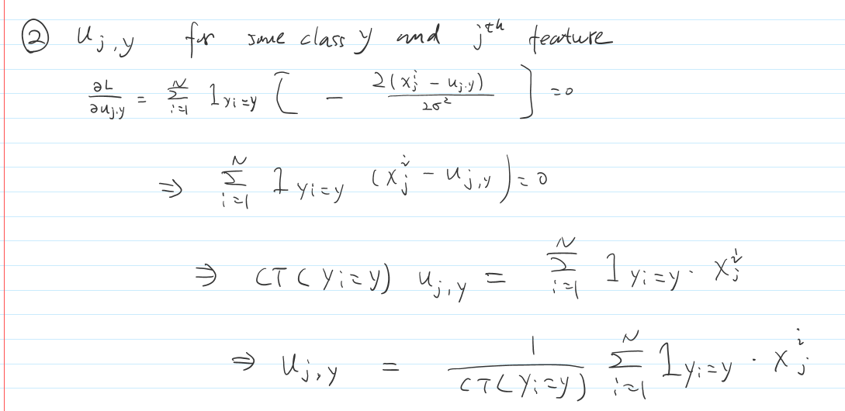

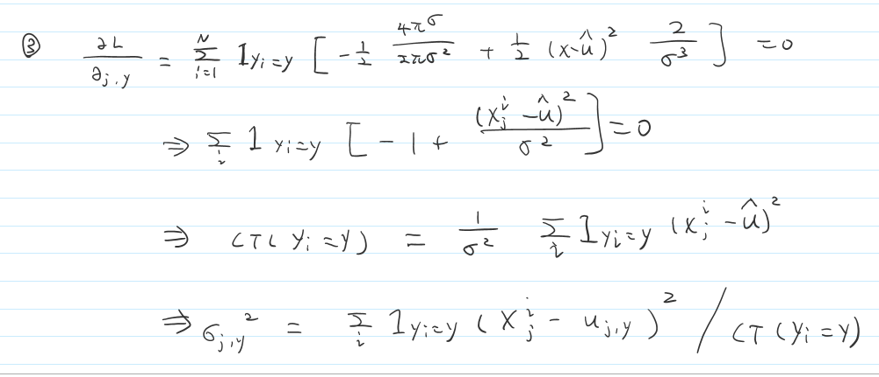

**4.2**

The accuracy is 0.6923

**4.3**

Any reasonable answer worth full credit. Example: we can use Normal-inverse-gamma distribution, which is the conjugate prior for normal distribution with unknown mean and variance parameters.

**4.4**

Any reasonable answer worth full credit. Example: This assumption inside naïve bayes is that all features are independent, which is almost impossible for a dataset with 60 features. Thus, its performance is kind of limited and we can see the test accuracy is not very high.