SIMATS ENGINEERING
ASSESSMENT TOOL 1
COURSE NAME: Database Management Systems COURSE CODE: CSA0506
COURSE OUTCOME COVERED
CO2: Apply the relational model, relational algebra, SQL query structures, and views to solve database querying and data manipulation problems. (BL3, BL6)
Activity Tool : Analytical Problem Solving (High) Assessment Tool Weightage: 35%
Dr. Hemavathi R
QUESTIONS Total Marks: 50
Q.No | Question | Bloom's Level | Marks
1 | Apply relational algebra operations (σ, π, ∪, -, ×, ⋈) on the given Employee and Department relations to retrieve required records. | BL3 – Apply | 5
2 | Write SQL DDL statements to create STUDENT(SID, Name, DOB, DeptID) and DEPARTMENT(DeptID, DeptName) tables with all appropriate constraints. | BL3 – Apply | 5
3 | Formulate SQL queries using GROUP BY, HAVING, and aggregate functions (COUNT, SUM, AVG, MAX, MIN) on a given Sales  dataset. | BL3 – Apply | 5
4 | Write a correlated sub-query to find employees earning more than the average salary of their own department. | BL3 – Apply | 5
5 | Apply all types of JOIN operations (INNER, LEFT OUTER, RIGHT OUTER, FULL OUTER, CROSS) on Employee and Project tables. | BL3 – Apply | 5
6 | Create a view 'DeptSalaryView' that displays department name, total employees, and average salary. Write a query on this view. | BL6 – Create | 5
7 | Construct a relational algebra expression for the following: Find names of students who are enrolled in all courses offered. | BL6 – Create | 5
8 | Write SQL DML statements (INSERT, UPDATE, DELETE) with | BL3 – Apply | 5

 | integrity constraint enforcement for a given scenario.
9 | Apply tuple relational calculus to express a query: Find all employees who work in the 'IT' department and earn more than 50000. | BL3 – Apply | 5
10 | Design a relational schema for an Airline Reservation System and write 5 SQL queries demonstrating joins, sub-queries, and views. | BL6 – Create | 5
Code of Conduct:
I P Rohith(192572013) (Name / Reg No) certify that this submission is my original work and that I have adhered to the guidelines specified for this assessment. I understand that any violation of academic integrity rules will result in disciplinary action.
Signature of the student:
P Rohith
1.Apply relational algebra operations (σ, π, ∪, -, ×, ⋈) on the given Employee and Department
relations to retrieve required records.
Assume:
Employee(EmpID, EmpName, DeptID, Salary)
EmpID | EmpName | DeptID | Salary
101 | Rahul | D1 | 60000
102 | Priya | D2 | 45000
103 | Amit | D1 | 55000
Assume:
Employee(EmpID, EmpName, DeptID, Salary)
DeptID DeptName
D1 IT
D2 HR
(a) Selection (σ)
Employees earning more than 50000
𝝈𝑺𝒂𝒍𝒂𝒓𝒚>𝟓𝟎𝟎𝟎𝟎(𝑬𝒎𝒑𝒍𝒐𝒚𝒆𝒆)
(b) Projection (π)
Display employee names only
𝝅𝑬𝒎𝒑𝑵𝒂𝒎𝒆(𝑬𝒎𝒑𝒍𝒐𝒚𝒆𝒆)
(c) Union (∪)
Employees from IT and HR
𝑰𝑻𝑬𝒎𝒑𝒍𝒐𝒚𝒆𝒆𝒔∪𝑯𝑹𝑬𝒎𝒑𝒍𝒐𝒚𝒆𝒆𝒔
(d) Set Difference (−)
Employees not working in IT

(e) Cartesian Product (×)
(f) Join (⋈)

𝑬𝒎𝒑𝒍𝒐𝒚𝒆𝒆−𝝈𝑫𝒆𝒑𝒕𝑰𝑫=′𝑫𝟏^{′(𝑬𝒎𝒑𝒍𝒐𝒚𝒆𝒆)}
𝑬𝒎𝒑𝒍𝒐𝒚𝒆𝒆× 𝑫𝒆𝒑𝒂𝒓𝒕𝒎𝒆𝒏𝒕

Employee details with department names
𝑬𝒎𝒑𝒍𝒐𝒚𝒆𝒆⋈𝑬𝒎𝒑𝒍𝒐𝒚𝒆𝒆.𝑫𝒆𝒑𝒕𝑰𝑫=𝑫𝒆𝒑𝒂𝒓𝒕𝒎𝒆𝒏𝒕.𝑫𝒆𝒑𝒕𝑰𝑫𝑫𝒆𝒑𝒂𝒓𝒕𝒎𝒆𝒏𝒕

2.Write SQL DDL statements to create STUDENT(SID, Name, DOB, DeptID) and DEPARTMENT(DeptID, DeptName) tables with all appropriate constraints
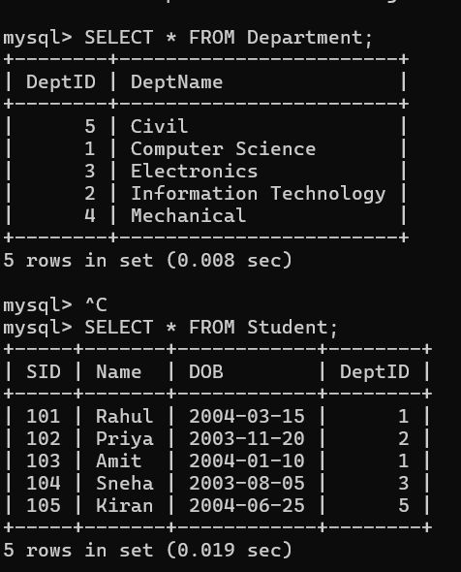

3.Formulate SQL queries using GROUP BY, HAVING, and aggregate functions (COUNT, SUM, AVG, MAX, MIN) on a given Sales dataset.
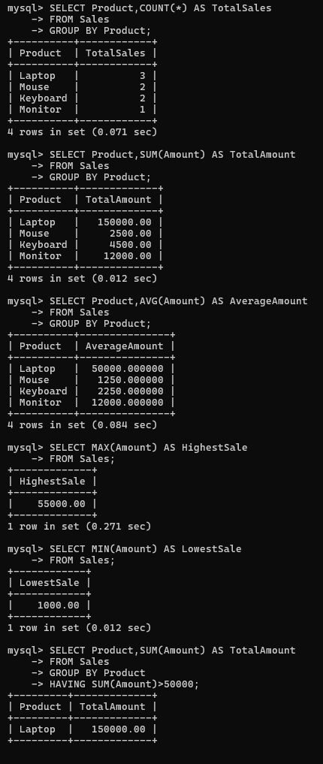

4. Write a correlated sub-query to find employees earning more than the average salary of their own department.
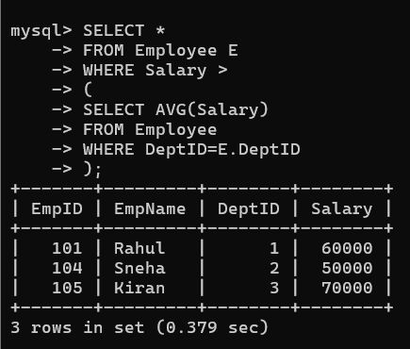

5. Apply all types of JOIN operations (INNER, LEFT OUTER, RIGHT OUTER, FULL OUTER, CROSS) on Employee and Project tables.
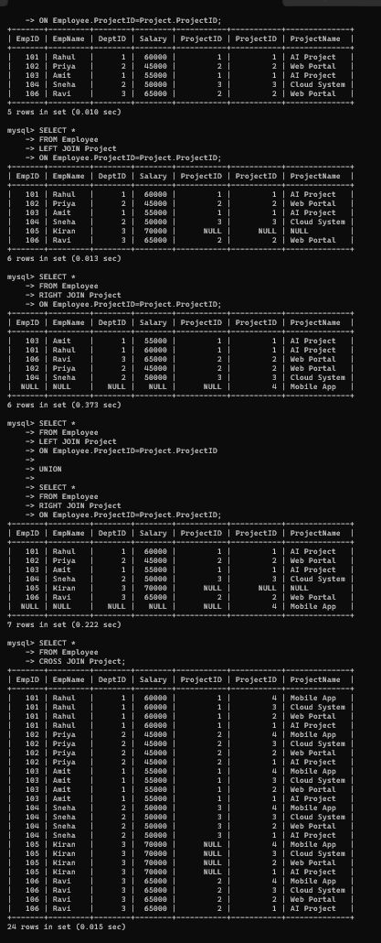

6. Create a view 'DeptSalaryView' that displays department name, total employees, and average salary. Write a query on this view.
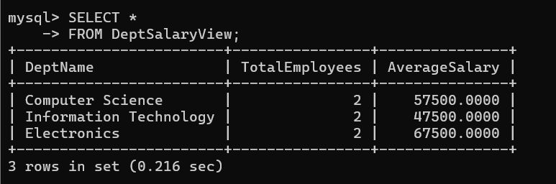
7. Construct a relational algebra expression for the following: Find names of students who are enrolled in all courses offered.
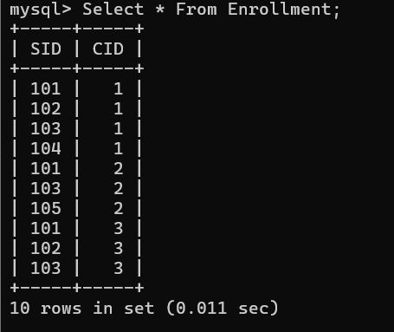

8. Write SQL DML statements (INSERT, UPDATE, DELETE) with integrity constraint enforcement for a given scenario.
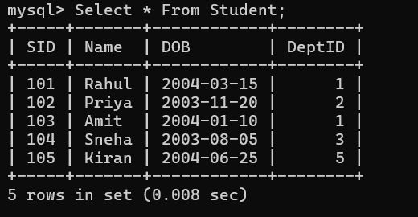
9. Apply tuple relational calculus to express a query: Find all employees who work in the 'IT' department and earn more than 50000.
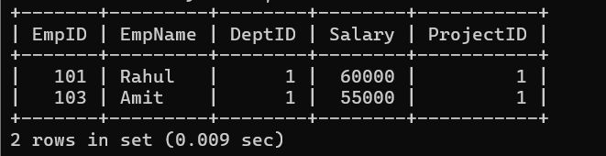
10. Design a relational schema for an Airline Reservation System and write 5 SQL queries demonstrating joins, sub-queries, and views.
