ABSTRACT

Keywords: Sign Language; Image processing techniques; Gesture Recognition; Text to speech synthesizer; Hand movement; Vision based.
Human beings eagerly interact with each other to express their ideas, feelings, and experiences to the people around. This is not the same case for deaf and mute people. Sign language paves way for communication. Through sign language deaf and mute people communicate without the means of acoustic sounds. The aim behind this work is to develop a system to recognize the sign language, which provides communication between speech impaired people and normal people. Compared to other gestures hand gesture plays an important role.
Sign Languages are a set of predefined actions and movements to convey a sign or a message. These languages are developed to aid verbally challenged people. They use a simultaneous combination of movements and orientation of hands, hand shapes etc. Different regions have different sign languages. We focus on ISL in this project.
In this project, we aim to recognize various alphabets from a database of images (containing signs). Database consists of images clicked in different light conditions and different hand orientations. With such a divergent data set, we train our system to obtain good results. The system uses image processing techniques to process the data and predict the result. This will convert the sign to an understandable language.

CHAPTER 1
INTRODUCTION

Deaf and mute people need to communication as it is a survival. They use sign language to communicate with other people. However, it is possible only for trained people to understand the language. Sign language uses gestures and other means of non-verbal techniques to convey their intended message. It involves combination of hand shapes, orientation and movements of hands, arms or body, and facial expressions to fluidly express thoughts. The idea is to create a sign to speech conversion system, using which the gestures made by a deaf-mute person can be presentably conveyed to a normal person. The main objective of this work is to design and implement a system using recognition and synthesis techniques (to translate finger spelling or sign to speech). The modules presented in the proposed system are, a. Finger spelling (gesture) recognition module b. Text-to-Speech synthesis module.
A. Vision-based gesture recognition system
In this system a camera is used, to capture the image or video of the gesture. The captured content is processed through image processing techniques when it is sent to the image processing unit. Features are extracted and they are trained using static images for which the corresponding gestures. They use different recognition algorithms. Compared to this system sensor-based gesture recognition is more sensitive and accurate as it gives 360 degree freedom for hand movement. This sensor-based approach is more advantageous over vision-based. It requires only a motion sensor rather than a camera which makes the device portable with low cost. It provides fast responses in recognition which in turn reduces the computational time in applications. In real time flex-sensor-based system can achieve 99% recognition rate.

B. Proposed sensor-based gesture recognition system
The proposed system is a gesture recognition system which uses flex sensors to sense the hand movements. The flex sensor is interfaced with the digital ports of microcontroller (Atmega328). The output from the microcontroller is the recognized text which should be fed as input to the SS (speech synthesizer). (Arduino) Microcontroller processes the data for each gesture that is made. The system is trained for different voltage values (for each letter). Gestures performed by multiple users have been tested for all the letters in ASL.
In this system flex sensors are used to measure “degree of bent”. Accelerometer is used as a tilt sensing element which finds the degree tilt. Tactile sensor is used for sensing the physical interaction between fingers. The outputs from the sensors are sent to the AM (Arduino microcontroller) unit. In AM unit, derived data from the sensor output is compared with the pre-defined values. The corresponding matched gestures are sent to the TTS (text-to-speech) conversion module in the form of text. The output of TTS synthesis system is heard via a speaker.

1.1 Problem Definition
Human beings eagerly interact with each other to express their ideas, feelings, and experiences to the people around. This is not the same case for deaf and mute people. Sign language paves way for communication. Through sign language deaf and mute people communicate without the means of acoustic sounds. The aim behind this work is to develop a system to recognize the sign language, which provides communication between speech impaired people and normal people. Compared to other gestures hand gesture plays an important role.

1.2 Objectives of the project:
The aim behind this work is to develop a system to recognize the sign language, which provides communication between speech impaired people and normal people. Compared to other gestures hand gesture plays an important role. In this project, we aim to recognize various alphabets from a database of images (containing signs). Database consists of images clicked in different light conditions and different hand orientations. With such a divergent data set, we train our system to obtain good results. The system uses image processing techniques to process the data and predict the result. This will convert the sign to an understandable language.

CHAPTER 2
LITERATURE SURVEY

Various hand gestures were recognized by different researchers in different methods which were implemented in different fields. The recognition of gestures were done by different approaches like vision-based approaches, data glove based approaches, soft computing approaches (like Artificial Neural Network, Fuzzy logic, Genetic Algorithm and others like PCA, Canonical Analysis, etc.). The recognition techniques are divided into 3 broad categories. They are Hand segmentation approaches, Feature extraction approaches and Gesture recognition approaches.
“Application research on face detection technology uses Open CV technology in mobile AR” in introduction to the typical technology. (Open source computer vision library) Open CV is a cross-platform library on computer vision based open source distribution. Data gloves and Vision based method are commonly used for human computer interaction to interpret gestures. The sensors attached to a glove that finger flexes into electrical signals to determine the hand posture in the data gloves technique. The camera is used to capture the gestures in images in the vision-based technique. The vision-based reduces the difficulties that are faced in the glove based. “Hand talk-a sign language recognition based on accelerometer and semi data” this paper introduces ASL conventions. It is part of the “deaf culture” which includes its own system of puns, inside jokes, etc. It is very difficult to understand Japanese by a English speaker. ASL approximately consists of 6000 gestures of common words with signs used to communicate obscure words or proper nouns.
“Hand gesture recognition and voice conversion system for dumb people” proposed to lower the communication gap between the mute community and the additional world. The projected methodology interprets sign language into speech. The system overcomes difficulties of dumb people to improves their manner. In comparison with existing system the projected system is simple as well as compact to carry to any places. This system converts the language in associate text and voice. The language interprets into some text displayed on the monitor, to facilitate the deaf people. In application this system is helpful for deaf and dumb who cannot communicate.
Sign language recognition system is an important application of. Sign language recognition has two different approaches; Glove based and Vision based approaches. In Glove based approaches signers are required to wear a sensor glove / colored glove. The task is simplified during segmentation process by wearing a glove. The drawback is that the signer has to wear the sensor hardware and the glove during the operation of the system. Image processing algorithms are used in vision-based technique to detect and track signs and expressions of the signer. This technique is easier since the signer need not wear any extra hardware. However, there are accuracy problems (IP)and these problems are yet to be modified.

CHAPTER 3
SYSTEM DESIGN

System design consists of the various existing systems, disadvantages in them, proposed system with advantages and the feasibility study along with system requirements and system models for this project.

3.1 Existing System
“Hand talk-a sign language recognition based on accelerometer and semi data” this paper introduces ASL conventions. It is part of the “deaf culture” which includes its own system of puns, inside jokes, etc. It is very difficult to understand Japanese by a English speaker. ASL approximately consists of 6000 gestures of common words with signs used to communicate obscure words or proper nouns.

3.1.1 Drawbacks
Existing techniques are not highly accurate

3.2 Proposed Work
In this project, we aim to recognize various alphabets from a database of images (containing signs). Database consists of images clicked in different light conditions and different hand orientations. With such a divergent data set, we train our system to obtain good results. The system uses image processing techniques to process the data and predict the result. This will convert the sign to an understandable language.

3.2.1 Advantages of the proposed system
1. This will greatly improve their productivity, streamline their activity , and eventually upgrade the framework performance.
2. The proposed technique will do the proposed work effectively and accurately.

3.3 Feasibility Study
A significant result of starter examinations is an assurance for the attainability of framework solicitation. “The possibility of the venture is dampened down in this stage and strategic agreement is advanced with a general agreement for the task and price evaluations. During framework investigation the attainability investigation of the proposed framework is to be done. This can be ensured that the proposed framework isn't a weight to the organization. For attainability investigation, some comprehension of the important necessities for the framework are essential”. The prime feasibility considerations are:

3.3.1 Technical feasibility:
This examination is done to check the practicality. “Any framework created should not have an intense interest on the accessibility of specialized assets. This will prompt the levels of popularity being put on the customer. The created framework must have a low necessity or even just negligible or changes that are invalid are required for actualizing this framework”.

3.3.2 Economical feasibility:
This investigation is done to check the financial effect on the association framework. “The measure of reserves that the organization can fill with the innovation framework is restricted. The uses should be defended. In this manner the framework created inside the spending limit was accomplished in the fact that the vast majority of the innovations that are utilized are openly accessible. Just the modified items are to be bought”.

3.3.3 Social feasibility:
This part of the study is to check the degree of acknowledgment of the framework by the client. This way incorporates towards preparing the client to utilize the framework productively. The client must not feel undermined by the framework, rather it should necessarily acknowledge. The degree of acknowledgment by the clients exclusively relies upon the strategies that are utilized to instruct the client about the framework and to create him reception with it. His degree of certainty must be raised with the goal that he's additionally able to make some useful analysis, which is invited, as he's the last client of the framework.

3.3.4 Operational feasibility:
This area of feasibility makes sure that the project satisfies all the requirements that were discussed during requirement analysis phase. Our project met all the requirements proposed earlier. It made sure that the modules discussed during the proposed system were implemented with stable accuracy and without any errors.

3.4 SYSTEM REQUIREMENTS
Let’s discuss about the requirements that are needed in order to complete the project without any hassle. We need to consider the hardware and software requirements for any project.

3.4.1 Hardware Requirements
- Processor: Intel
- Hard Disk: Min 160 GB
- Ram: Min 4GB
- Mouse: Optical Mouse
- Monitor: LED/LCD

3.4.2 Software requirements:
Windows operating System
Python
PyCharm IDE

3.5 SYSTEM MODEL
This section consists of the UML diagrams related to the modules developed such as Activity diagram, Sequence diagram and Use case diagram.

3.5.1 Sequence Diagram
A grouping outline in UML is a sort of association chart that shows how procedures work with each other and in what request. “It is built of Message Sequence Charts. Succession outlines are now and again called occasion charts, occasion situations, and timing graphs”.

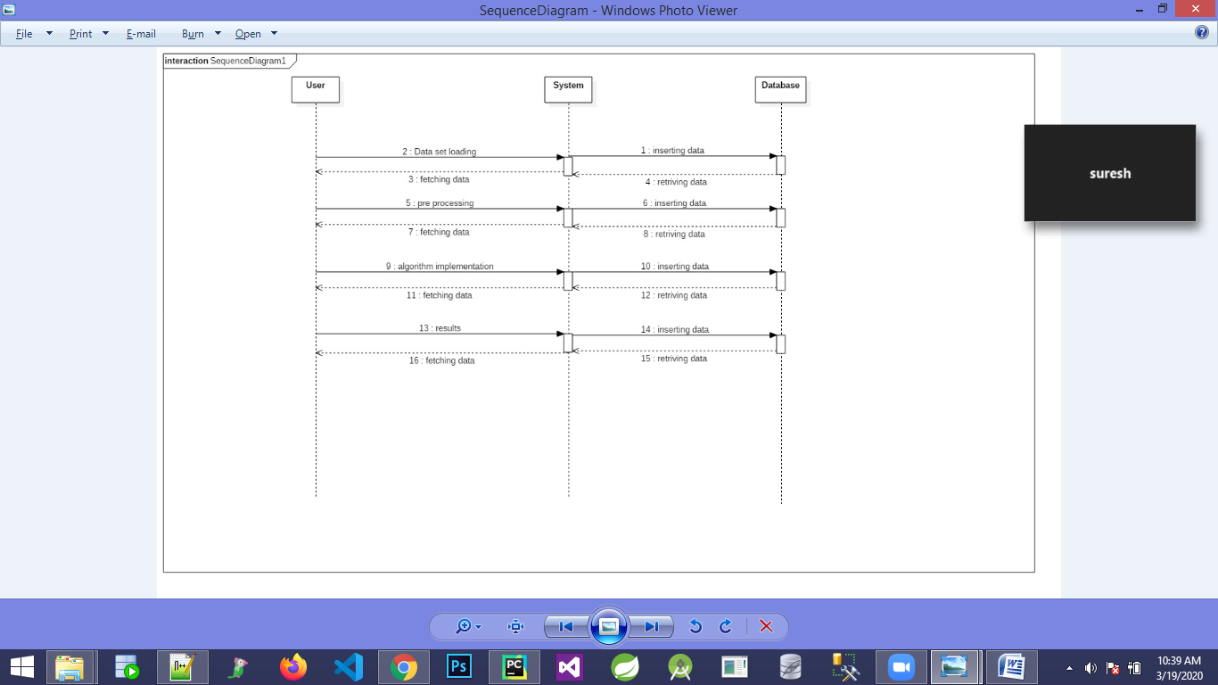
Figure 3.5.1 Sequence Diagram

3.5.2 Use Case Diagram
Utilization case outline in the UML is a sort of conduct graph characterized by and made from a Use-case examination. Its principle is to introduce a graphical diagram given by a framework regarding on-screen characters and their objectives, and any conditions between those utilization cases. The fundamental motivation behind utilization case outline is to indicate what framework capacities are performed for which on-screen character. Jobs of the on-screen characters in the framework can be delineated.

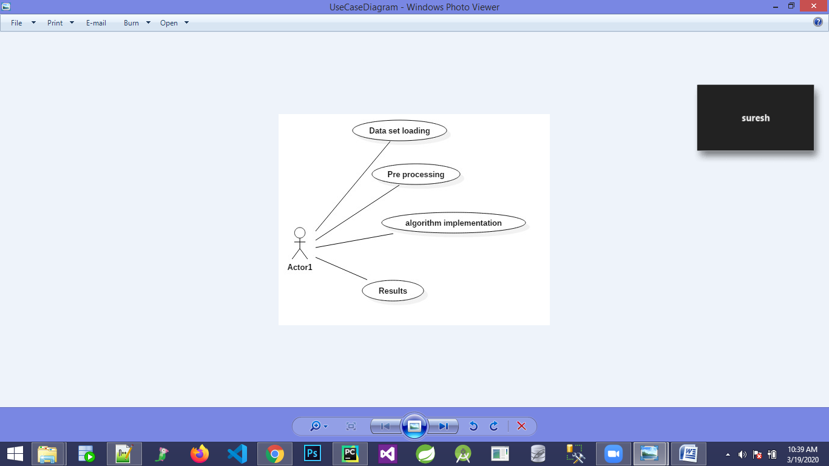
Figure 3.5.2 Use case diagram
3.5.3 Activity Diagram
Movement charts are graphical representations of work processes for step wise exercises and activities that will help in decisions and emphasis. In the Unified Modeling Language, movement graphs can be utilized to depict the business and operational bit by bit work processes of parts in a framework. A movement chart demonstrates the general progression of control.

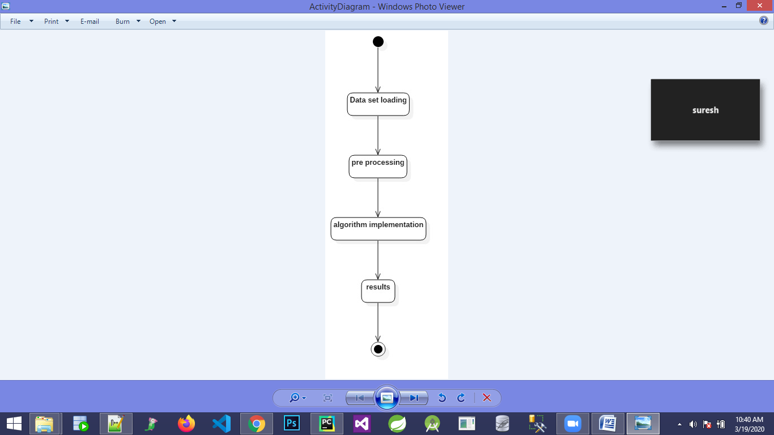
Figure 3.5.3 Activity diagram

3.5.4 Class Diagram
In software building, a class chart in the UML is a sort of static structure graph that portrays the structure of a “framework by demonstrating the framework's classes, their traits, activities (or techniques), and the connections among the classes. It clarifies which class contains data”.

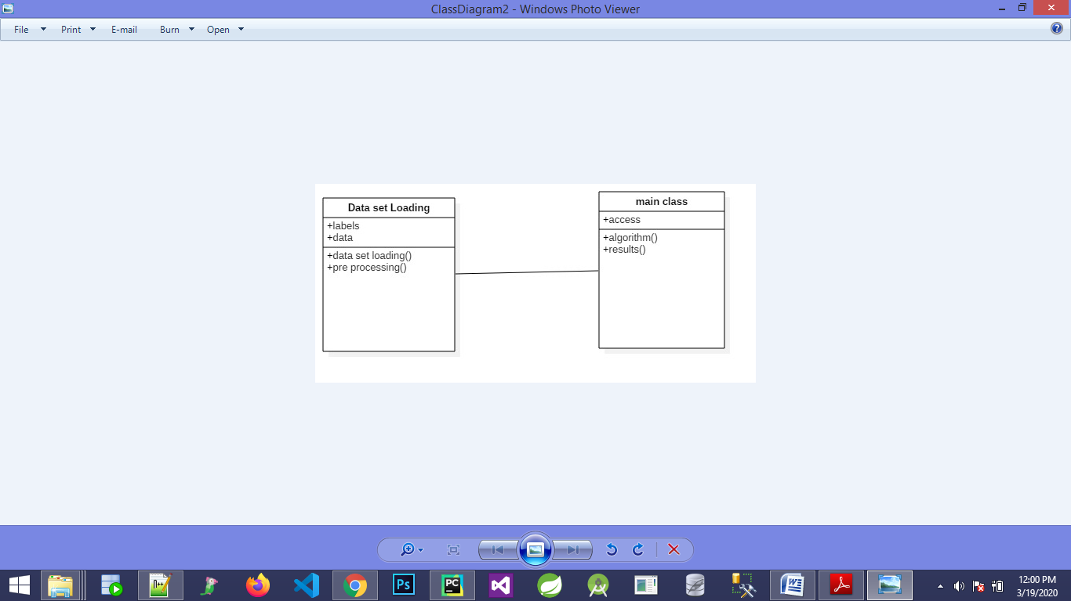

Figure 3.5.4Class diagram

CHAPTER 4
IMPLEMENTATION

Implementation compromises of various technologies used, installation of required software and libraries, architecture diagram of the project and various models, algorithm of the prime model used and sample coding of the project.

4.1 Modules
- Dataset Loading
- Raw data collection and pre processing
- Implement the ML Algorithm
- Validate The results

4.2 Algorithm
This project designs a recognizer for sign language using Python. OpenCV and tensor flow are used for training InceptionV3 model (a convolutional neural network model for classification). A generic image classification program that uses Google's Machine Learning library, TensorFlow and a Convolutional Neural Network model called Inception. This model has been pre-trained for the ImageNet Large Visual Recognition Challenge (with the help of data from 2012). It can differentiate between thousand different classes (like Dalmatian, dishwasher etc.). The program applies Transfer Learning to this existing model and re-trains to classify a new set of images.

4.3 about Python
Python is an object-oriented abnormal state programming language with dynamic semantics. It is used as a scripting or paste language to associate existing parts together. Python is straightforward, simple to learn and in this manner, it diminishes the expense of program support. Python bolsters modules and bundles, which supports code reuse and measured quality. The Python mediator and standard library are accessible in source or paired structure without charge for each and every stage, and this can be openly conveyed”.

Usually software engineers experience passionate feelings for Python as a result of the expanded profitability it gives. Since there is no arrangement the alter test-troubleshoot cycle is amazingly quick. Investigating Python projects is simple. A bug or awful info will never cause a division shortcoming. When the mediator finds a mistake, it raises a special case. At that point when the program doesn't get the special case, the mediator prints a stack follow.

4.3.1 Python Applications
Python is known for its helpful nature that makes it fitting in for all intents and purposes each zone of programming headway. Python can be considered to be used in all things to hover any of the progress.

Applications zones where python can be connected.

1) Web Applications
We can make use of Python to create web apps. “It gives libraries to deal with web conventions, for example, HTML and XML, JSON, Email preparing, demand, beautiful Soup, Feed parser and so forth. It additionally gives Frameworks, for example, Django, Pyramid, Flask and so forth to plan and develop online applications. Some significant improvements are: PythonWikiEngines, Pocoo, PythonBlogSoftware and so on”.

2) Desktop GUI Applications
Python gives “Tk GUI library" to create User Interface in python-based application. Some other valuable toolboxswxWidgets, Kivy, pyqt that are useable on a few stages. The Kivy is mainstream for composing multitouch applications.

3) Software Development
Python is useful for software advancement process. It fills in as a help language and can be utilized for assemble control and the board, testing and so on.

4) Scientific and Numeric
Python is well known and is generally used in logical and numeric registering. Some helpful library and bundle are SciPy, Pandas, IPython and so on. SciPy is a gathering of bundles of design, science and arithmetic.

5) Business Applications
Python is used to build Business applications like ERP and online business structures. Tryton is an irregular state application organizes.

6) 3D CAD Applications
Fandango is a genuine application which gives complete highlights of CAD.

7) Enterprise Applications
Python can make applications which can be used inside an Enterprise or an Organization. Some constant applications are: OpenErp, Tryton, Picalo and so on.

Libraries Used:

NumPy:
NumPy stands for ‘Numerical-Python’ or ‘Numeric-Python’. It is often pronounced as num-pai or num-pee. This is a library for the Python programming language which is mainly used for interacting with multidimensional and large arrays and matrices. It has a large number of built in mathematical functions which can be used on the large arrays for analyzing them. It is a very good package that can be used on any mathematical and statistics related operation. It works well with multi-dimensional array, data science programming, linear-algebra, random number problems, Fourier-transform etc. This library is more efficient in terms of memory and can manage large amount of data than any other library.

Pandas:
Pandas is also a library used for dealing with data in data science. Apart from Numpy which deals with multi-dimensional arrays, Pandas deals with data in tabular form i.e. data in the form of rows and columns. In this library a 1D array called as Series, a 2D-table called as DataFrames and the combination of DataFrames called as Panel objects are used. We can edit the Series by adding or deleting elements into the array like objects. We can even add, delete or edit the rows and columns in the DataFrame. In similar lines with Numpy, Pandas also provides the primary mathematical operations such as adding subtracting, conditional-operations and even broadcasting.

NLTK:
NLTK is the abbreviation for Natural Language Toolkit. It is often a platform that is used to build the python programs that function with data represented in human language. It is mainly used for Natural Language Processing. It mainly comprises of libraries used in tokenizing, classifying, parsing, stemming, tagging, lemmatization, punctuation and also semantic reasoning. It consists of a large number (>50) of corpora and the lexical sources. It is available free as it an open source and community driven project.

TensorFlow:
TensorFlow is a framework for generating ML models. It is an open source platform mainly used in Machine Learning. The word Tensor means the n-dimensional array which we give as input and then we develop a flow of operations in between the input and the output. The input we give goes through all these operations and produces an output at the other end. So we call this as TensorFlow. The TensorFlow architecture comprises of mainly three parts. They are a) Preprocess the data, 2) Building the model and 3) Training the model and then estimating it.

About the dataset:
Dataset contains images of different positions for alphabet sign symbols. It contains images for all alphabets from a to z. It contains for every specific alphabet 1000 images in different positions in sign language.
In order to start the transfer learning process, in the root of the project folder a folder named dataset needs to be created . This folder will contain the image data sets for all the subjects, where the classification is to be performed.
Create the Dataset folder and add images for all the data sets in the following manner:
|
---- /dataset
| |
| |
| ---- /A
| | A1.jpg
| | A2.jpg
| | ...
| |
| |
| ---- /B
| B1.jpg
| B2.jpg
| ...
|
This enables classification of images between the A and B data sets.

Example for A:


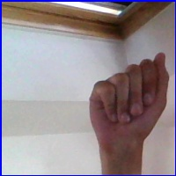

4.4 Architecture Diagram
In this section we present the design of a system which detects abnormal spam messages using support vector machine algorithm.
Figure 4.4 System Architecture

4.5 SAMPLES

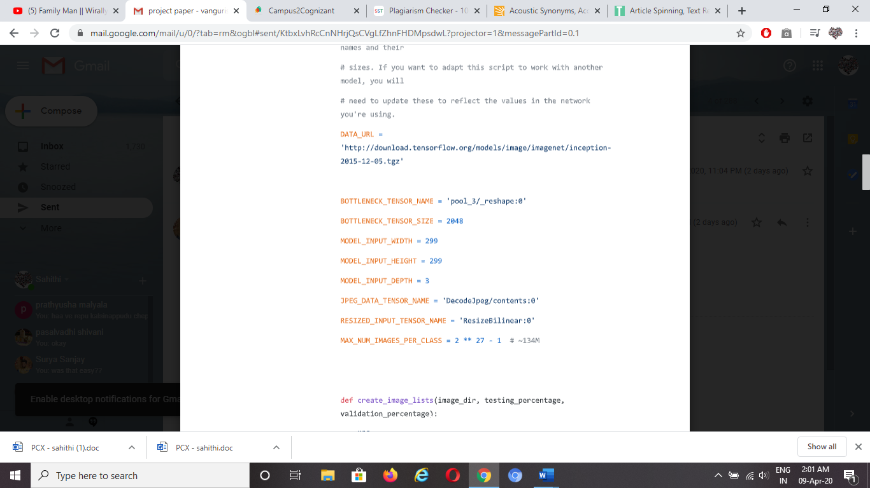
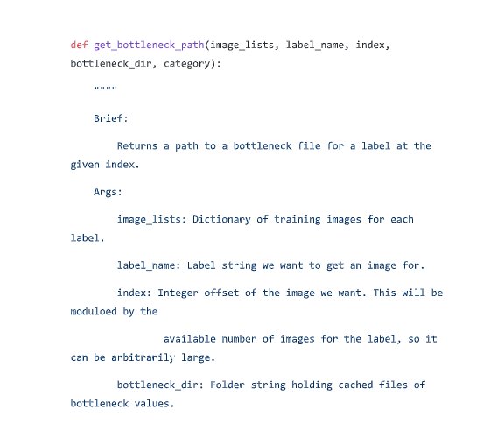

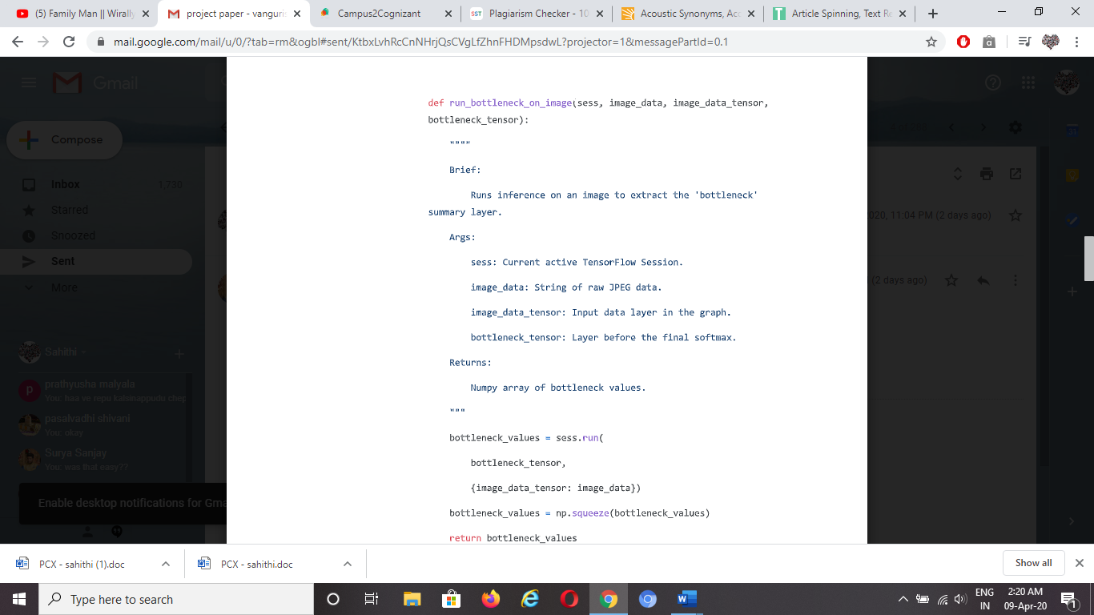
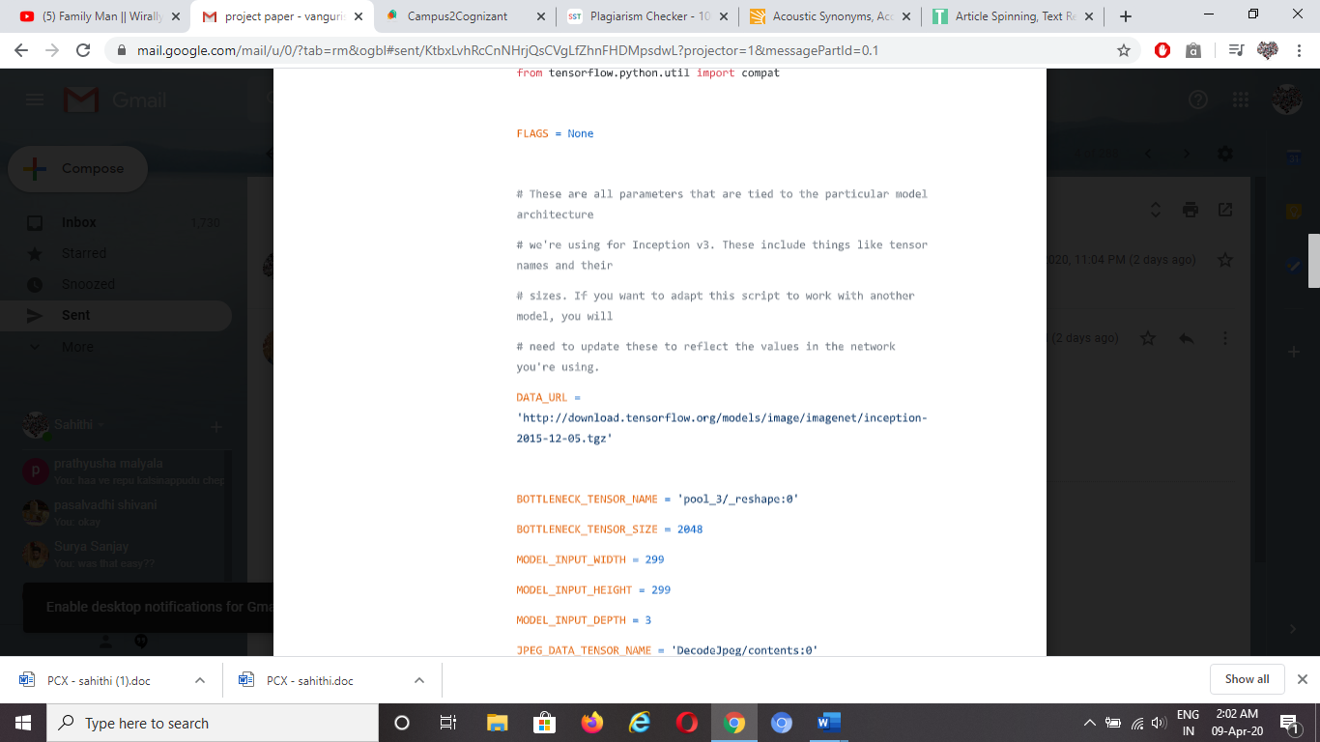

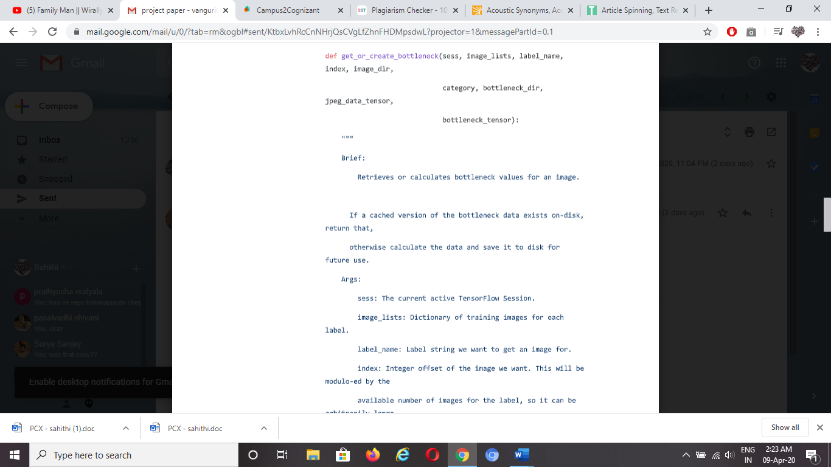

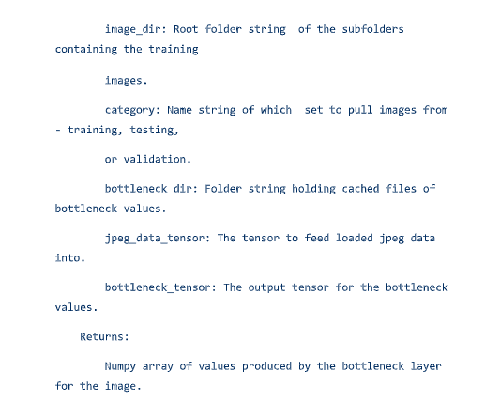

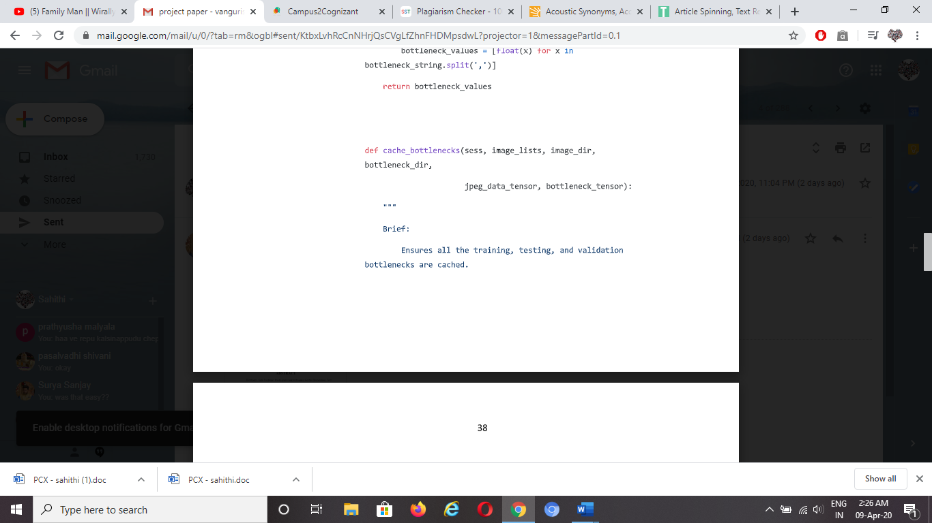
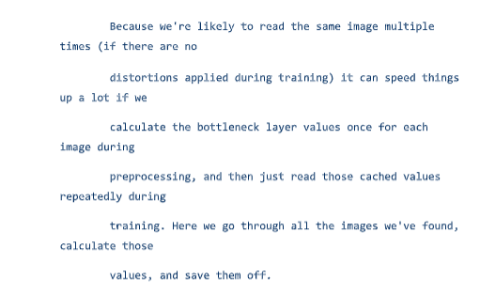

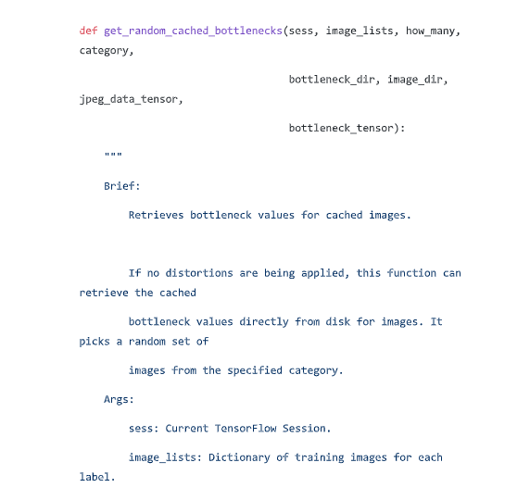

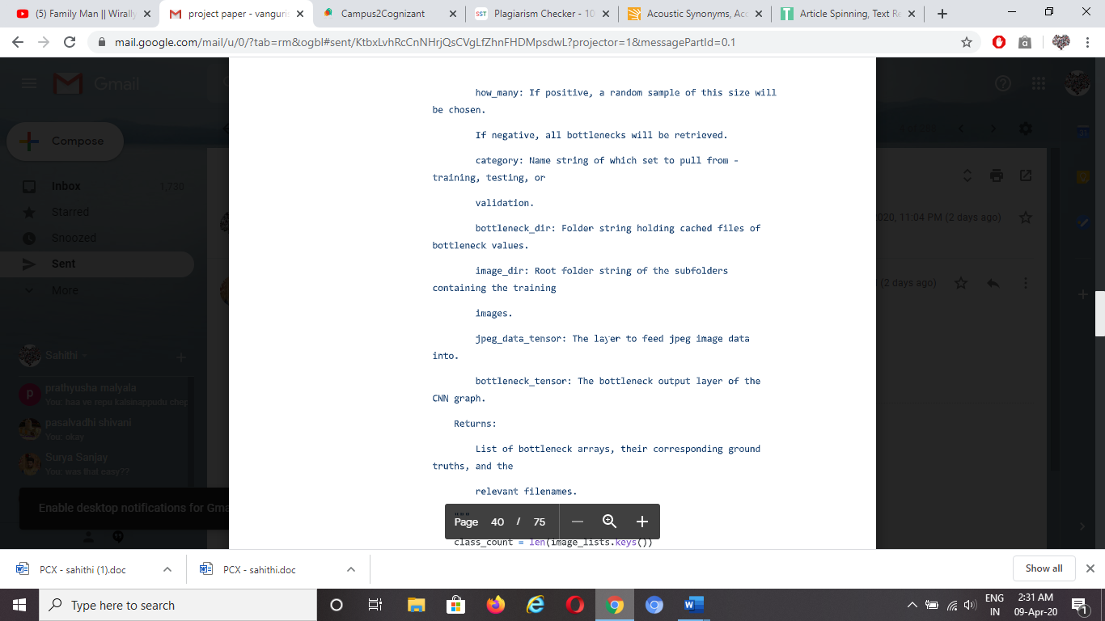

4.6 TESTING
The reason for testing is to find blunders. Testing is the way toward attempting to find each possible shortcoming or shortcoming in a work item. It gives a way to check the usefulness of parts, sub congregations, gatherings or potential accomplished item .It is the way toward practicing software with the plan of guarantying that the Software framework reaches up to its prerequisites and client desires do not bomb in an unsuitable way. There are different kinds of test”. Each test type tends to a particular testing necessity.

4.7 Types of Testing
The different kinds of testing performed on the developed project are listed below:

4.7.1 Unit Testing
Unit testing includes the plan of experiments that approve that the inward program rationally working appropriately and that program information sources produce substantial yields. All choices and interior code stream ought to be approved. It is the trying of individual software units of the application .it is done after the finishing of an individual unit before joining. This is an auxiliary testing, that depends on information of its development and is obtrusive. Unit tests perform essential tests at part level and test a particular business procedure, application, as well as framework design. Unit tests guarantee that every novel way of a business procedure performs precisely to the reported particulars and contains unmistakably characterized sources of info and anticipated outcomes”.

4.7.2 Integration Testing:
Coordination tests are intended to test incorporated. Software segments are used to decide whether they really keep running as one program. Testing is occasion driven and is increasingly worried about the essential result of screens or fields. Coordination tests exhibit that in spite of the fact that the segments were exclusively fulfillment, as appeared by effectively unit testing, the mix of segments is right and reliable”. Coordination testing is explicitly planned for uncovering the issues that emerge from the blend of segments.

Practical testing is focused on the accompanying things:
Legitimate Input: recognized classes of substantial information must be acknowledged.
Invalid Input: distinguished classes of invalid information must be rejected.
Capacities: recognized capacities must be worked out.
Yield: recognized classes of use yields are to be worked out.
Frameworks/Procedures: interfacing frameworks or systems must be summoned.

Association and arrangement of utilitarian tests is “centered around prerequisites, key capacities, or uncommon experiments. Moreover, efficient inclusion relating to recognize Business procedure streams; information fields, predefined procedures, and progressive procedures must be considered for testing. Before utilitarian testing is finished, extra tests are recognized and the viable estimation of current tests is resolved”.
System Test
Framework testing guarantees that the whole coordinated software framework meets prerequisites. It tests to design a guarantee and unsurprising outcomes. A case of framework testing is the design situated framework reconciliation test. Framework testing depends on procedure portrayals and streams, underlining pre-driven procedure connections and combination focuses.

White Box Testing
White Box Testing is a testing in which the software analyzer knows about the inward operations, structure and language of the software. It is used to test regions that can't come to, from a discovery level.

Block Testing
Discovery Testing will be trying the software with no information of the internal operations, structure or language of the module being tried. As most different sorts of tests are composed from an authoritative source record, for example, particular or prerequisites report, detail or necessities archive. It is trying where the software under test is dealt with, as a discovery. you can't "see" into it. The test gives data sources and reacts to yields without thinking about how the software functions.

Unit Testing:
“Unit testing is normally led as a feature of a joined code and unit test period of the software lifecycle, in spite of the fact that it isn't remarkable for coding and unit testing to be directed as two unmistakable stages”.
Test methodology and approach
Field testing will be performed physically and practical tests will be written in detail.

Test goals
• All field passages must work appropriately.
• Pages must be actuated from the recognized connection.
• The section screen, messages and reactions must not be noted.
Highlights to be tried
• Verify that the sections are of the right design
• No copy sections ought to be permitted
• All the connections should take client to the right page.

Integration Testing
Software reconciliation testing is the gradual mix testing of at least two coordinated software parts on a solitary stage to deliver disappointments brought about by interface deserts.

The undertaking of the reconciliation test is to watch that segments or software applications, for example parts in a software framework or – one stage up – software applications at the organization level – collaborate without blunder.
Test outcomes: All the experiments referenced (above)passed effectively. No imperfections experienced.

Acceptance Testing
Client Acceptance Testing is basic for any task and requires critical cooperation by the end client. It additionally guarantees that the framework meets the utilitarian prerequisites”.
Test outcomes: All the experiments referenced above passed effectively. No imperfections experienced.

MAINTAINENCE
This covers a wide scope of exercises including rectifying code and structure blunders. Contingent upon the prerequisites, this framework has been created to fulfill the requirements to the biggest conceivable degree. With improvement in innovation, it might be conceivable to include a lot more highlights based the necessities in future. The coding and planning is basic and straightforward which will make support simpler.

TESTING STRATEGY:
A procedure for framework testing coordinates framework experiments and “structure systems into a very much arranged arrangement of steps that outcomes in the effective development of software. The testing methodology must co-work test arranging, experiment configuration, test execution, and the resultant information gathering and assessment. A procedure for software testing must suit low-level tests that are important to check that a little source code fragment has been accurately actualized just as abnormal state tests that approve significant framework capacities against client prerequisites”.

CHAPTER 5
RESULTS AND DISCUSSIONS

Fig 5.1 Input Image

Fig 5.2 Input image with threshold values
Fig 5.3 Gray Image
Fig 5.4 CFSU Image
Fig 5.5 Output Image

CHAPTER 6
CONCLUSIONS AND FUTURE SCOPE

6.1 Conclusions:
Deaf-mute people face a lot of difficulty in communicating with normal people who don't understand sign language. To overcome this barrier this work proposes a ML-based system for deaf-mute people using image processing technology. First this (system) will convert the gesture to the corresponding text and then the speech is synthesized for the corresponding text by using the TTS (text-to-speech synthesizer). The system consumes low power and is portable.

6.2 Future Scope:
We can further improve the performance and accuracy.

