Hi,  
  
Please have the CORS unblock enabled on google chrome before executing the code snippet submitted by me

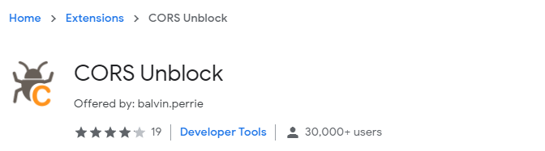

Please follow the below steps

1. Provide the search parameter in the given textbox from goodreads.com and click on Get External Content  
     
   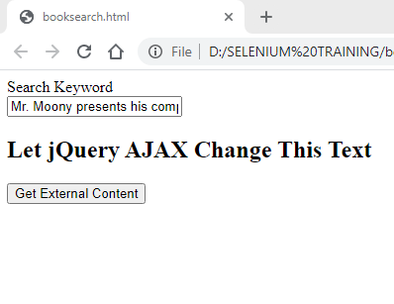
2. The result will the book from which quote was provided as shown in the below screenshot.  
   The parameter is also classified as quote as shown below

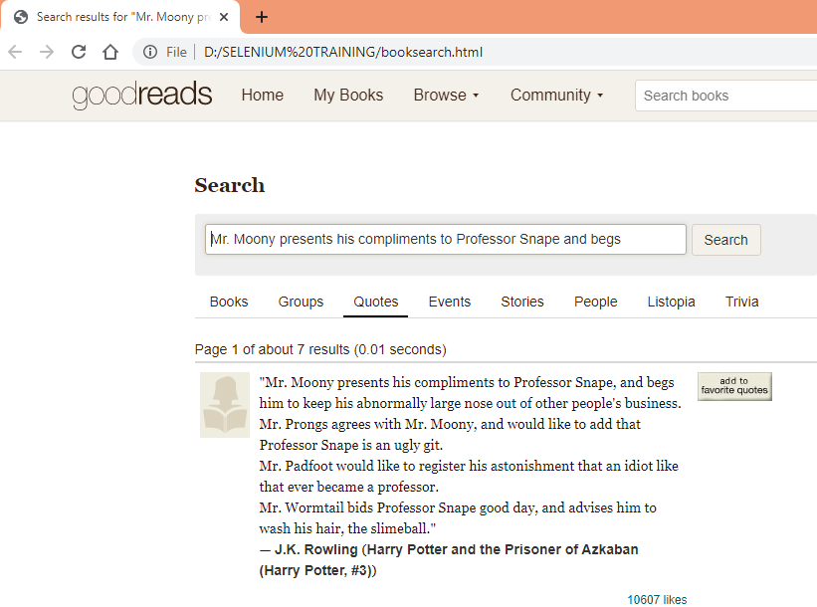

1. On providing the author name I get the list of books by same author as shown below

