BCSE203E | Web Programming
Digital Assignment II
Winter Semester 2025-2026
MATCH-POINT
Tennis Match Tracker
Official Project Report

Name | Rohith Ram V
Registration Number | 24BCE0543
Course | BCSE203E - Web Programming
Assessment | Digital Assignment II

Repository and Deployment Links

Link Type | URL
GitHub Repository | https://github.com/rohithramv2024/Match-Point
GitHub Pages (Live) | https://rohithramv2024.github.io/Match-Point/

Table of Contents

1. | Project Title, Objectives and Key Features
2. | Technologies Used
3. | Project File Structure and Version History
4. | Development Process
4.1 | V1.0 - Base HTML and CSS
4.2 | V1.1 - JavaScript and Core Functionality
4.3 | V1.2 - Animations and localStorage
4.4 | V1.3 - Reset Modal, Polish and Testing
4.5 | V1.4 - Advanced Stats, Cursor and Hover Animations
5. | Resources and References
6. | Learning Reflections
7. | Screenshots

1. Project Title, Objectives and Key Features

Project Title
Match-Point | Personal Tennis Match Tracker

Objectives
Match-Point solves a practical problem: recreational tennis players have no lightweight, private tool to track their match history and analyse performance over time. The project accomplishes the following:
- Allow players to log match results with opponent details, set scores, surface type, and optional notes.
- Display a live dashboard showing win rate, current streak, and performance broken down by court surface.
- Track head-to-head records against recurring opponents automatically.
- Store all data in the browser so the app works offline and data persists without any account or server.
- Demonstrate that HTML5, CSS3, and Vanilla JavaScript alone are sufficient for a fully polished, data-persistent web application.

Key Features
Feature | Description
Landing Page | Animated Clay Court Sunset theme, SVG court lines, floating balls, staggered text reveal, custom cursor.
Dashboard | 5 stat cards with count-up, win rate bar, recent matches, surface breakdown, head-to-head, advanced averages.
Log Match | Form with opponent, date, sets, surface, result toggle, notes, and expandable Advanced Stats section (6 metrics).
Match History | Full match log with surface-coloured filters, solid W/L badges, surface pills, expandable stats, per-match delete.
Form Validation | Field-level validation with shake animation and inline errors. Cross-field check ensures result matches set score.
Data Persistence | All data in localStorage. Survives refresh. Custom reset modal with Escape key and backdrop support.
Animations | Card zoom hovers, tab slide-in, count-up stats, court line draw, smooth scroll on every tab switch.

2. Technologies Used

Technology / Tool | Role in Project
HTML5 | Semantic page structure, form elements, inline SVG, meta tags, favicon link, tab panel layout.
CSS3 | Design tokens via custom properties, CSS Grid and Flexbox, keyframe animations, transitions, pseudo-element effects, custom scrollbar, responsive media queries.
Vanilla JavaScript (ES6+) | DOM manipulation, event handling, form validation, tab switching, dashboard rendering, filter logic, count-up via setInterval, cursor via mousemove.
Browser localStorage | Client-side persistence. Matches stored as JSON string. Wrapped in try/catch for private browsing and quota handling.
SVG (Inline) | Court background lines on landing page, tennis ball illustrations, and the unified arrow-ball custom cursor element.
Google Fonts | Bebas Neue for display headings and numeric values. DM Sans for body text, labels, and UI copy.
GitHub | Version control. Each version committed separately for traceability.
GitHub Pages | Static site hosting. index.html served from repository root with no build step required.

3. Project File Structure and Version History

File Structure

File | Description
index.html | Landing page, app shell, all three tab panels, reset modal, and custom cursor element.
style.css | All styling: CSS custom property tokens, all keyframe definitions, component styles, responsive rules, hover effects, form error states, and surface colour system.
script.js | All JavaScript: cursor, navigation, tab switching, form save/validate/reset, dashboard rendering, history render and filter, localStorage, modal, and quick-fill test data.
icon.png | Browser tab favicon.
README.md | Project overview, feature list, version history, local setup instructions, and GitHub Pages deployment steps.

Version History

Version | Summary
V1.0 | Base HTML across all panels and full CSS stylesheet. Three-file project established. Clay Court Sunset theme defined. No JavaScript written.
V1.1 | All JavaScript added: navigation, tab switching, Win/Loss toggle, form save, dashboard rendering, history filters, delete, and toast notifications.
V1.2 | CSS keyframe animations added throughout. Court lines draw on load, landing staggers in, panels slide in. localStorage persistence added.
V1.3 | Custom reset modal, Quick Fill testing button, input focus rings, custom scrollbar, match notes field, and final polish.
V1.4 | Advanced match stats with toggle, dashboard averages card, custom cursor, card zoom hovers, field-level validation, surface colour system, solid W/L badges, smooth scroll.

4. Development Process

4.1 V1.0 - Base HTML and CSS
Development began with a complete HTML skeleton covering every section before any JavaScript was written. CSS custom properties defined the colour palette, spacing, shadow levels, and border radii as reusable tokens at the :root level. The landing page used a full-viewport flex container with an SVG for court lines, three positioned tennis ball divs, and a centred content block. The app section was set to display:none. The dashboard used a two-column CSS Grid with a five-column stat strip on the left and a sidebar on the right.

4.2 V1.1 - JavaScript and Core Functionality
The script.js file covered tab switching, form flow, and all rendering logic. Match data was modelled as an array of objects holding an ID, opponent, date, set scores, surface, result, optional notes, and an optional advanced stats block. The dashboard computed and rendered every panel from this single array. The Win/Loss toggle recorded selection in a module-level variable and toggled CSS classes. The advanced stats section used a boolean toggle pattern with a CSS class on the container.

4.3 V1.2 - Animations and localStorage
All keyframe definitions were placed in a single block at the top of style.css. Court lines used stroke-dasharray / stroke-dashoffset with staggered animation-delay per element to simulate a draw-in effect. Landing content used opacity:0 as base state, animated to opacity:1 via fadeUp with timed delays. The golden underline used a growLine keyframe scaling scaleX from 0 to 1. localStorage reads and writes were wrapped in try/catch. The count-up effect used setInterval over 24 steps across 600ms.

4.4 V1.3 - Reset Modal, Polish and Testing
The native browser confirm() was replaced with a custom overlay modal using pointer-events:none by default. The modal box animated in with a custom modalIn keyframe. Three close paths were implemented: Cancel button, backdrop click, and Escape key. The Quick Fill button generated sample matches using a daysAgo() helper producing ISO date strings relative to today. Custom scrollbar rules used ::-webkit-scrollbar pseudo-elements. Input focus rings used box-shadow: 0 0 0 3px with a clay colour.

4.5 V1.4 - Advanced Stats, Cursor and Hover Animations
The custom cursor was a single SVG with both the arrow polygon and ball circle, positioned as a fixed div. The OS cursor was hidden via cursor:none on body. The SVG moved with mousemove and the arrow tip was aligned to the real click coordinate by subtracting the tip's SVG position (x=5, y=2) from mouse coordinates. Card hover effects combined translateY() and scale(). Surface colour-coding applied to blocks, filter chips, and match card pills. W/L badges rebuilt as solid-fill circles at 52px. Form validation rebuilt field-level with shake animations, inline errors, and a cross-field result/score mismatch check.

5. Resources and References

Resource | Used For
CSS-Tricks - css-tricks.com | Flexbox and Grid layout guides, SVG line draw animation technique, and CSS custom cursor implementation.
Google Fonts - fonts.google.com | Bebas Neue and DM Sans font imports via stylesheet link.
W3Schools - w3schools.com | HTML5 input attributes, select elements, and JavaScript event listener syntax.
GitHub Docs - docs.github.com | Repository setup, commit workflow, and GitHub Pages deployment from repository root.
Stack Overflow - stackoverflow.com | SVG coordinate alignment with CSS positioning and localStorage exception handling in private browsing.

6. Learning Reflections

The following ten points reflect the key technical and practical lessons gained from building Match-Point across all four development versions.

- Writing the complete HTML structure before touching CSS or JavaScript forced a clearer architectural decision upfront. Every section, panel, and modal was defined structurally first, which prevented costly mid-project reworks and made the CSS and JavaScript easier to reason about when they were added later.

- CSS custom properties proved more powerful than expected at this project scale. Defining the colour palette and spacing as tokens at :root meant that the primary clay colour propagated across more than 1300 lines of CSS by changing a single value, with no search-and-replace work required.

- Building the match data model as a self-contained array of flat objects in V1.1, with a reserved adv field defaulting to null, was a deliberate forward-planning decision. When V1.4 introduced the advanced stats feature, not a single existing match object needed migration. Good data modelling at the start pays dividends later.

- Understanding when to use CSS transitions versus keyframe animations became clear in practice. Transitions handled class-driven state changes such as hover effects and modal open/close. Keyframes handled timed one-shot sequences such as the court line draw-in and landing stagger. Mixing them up would have required JavaScript to handle work that CSS already manages.

- The SVG stroke-dasharray trick for animating line drawing was a new technique encountered during this project. Setting stroke-dashoffset equal to the total path length and animating it to zero creates the illusion of a line being drawn. Using a large fixed value of 3000 that exceeds every line's length made the technique work uniformly without measuring each element.

- Building form validation as a field-level system rather than a single error toast was more work but produced a measurably better result. The investment in setError(), clearError(), inline error messages, and shake animations made the form feel professional. The cross-field mismatch check between result and set score prevented logically inconsistent data from entering the system entirely.

- localStorage has important limitations that are not obvious until they are encountered in a real project: it is synchronous, stores only strings, and throws exceptions in private browsing mode. Wrapping all storage calls in try/catch and using JSON.stringify and JSON.parse became a pattern that should apply by default to any client-side persistence implementation.

- The custom cursor implementation required working in two coordinate spaces simultaneously: SVG viewBox coordinates for drawing and CSS pixel coordinates for page positioning. The key insight was that the cursor element needed offsetting by the exact pixel position of the arrow tip within the SVG, not the element top-left which the browser uses by default.

- The Quick Fill testing button was not in the original plan but became the single most time-saving addition during development. Manually entering eight realistic matches every time localStorage was cleared would have slowed every test cycle. Automating repeatable test setup is a habit worth carrying into any future project regardless of technology stack.

- Deploying to GitHub Pages completed the full production lifecycle for the first time: local development, a meaningful commit history tracking each version, a remote repository, and a publicly accessible URL. The fact that the project required no build tools or package manager meant deployment was a single settings change in the repository, which was a deliberate result of constraining the technology stack from the start.

7. Screenshots

Landing Page
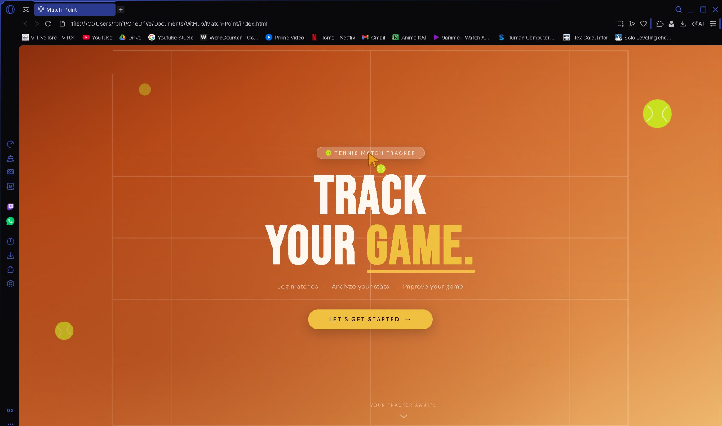
Figure 1: Landing page showing the Clay Court Sunset theme, animated court lines, floating tennis balls, custom cursor, and the CTA button.

Dashboard - Empty State
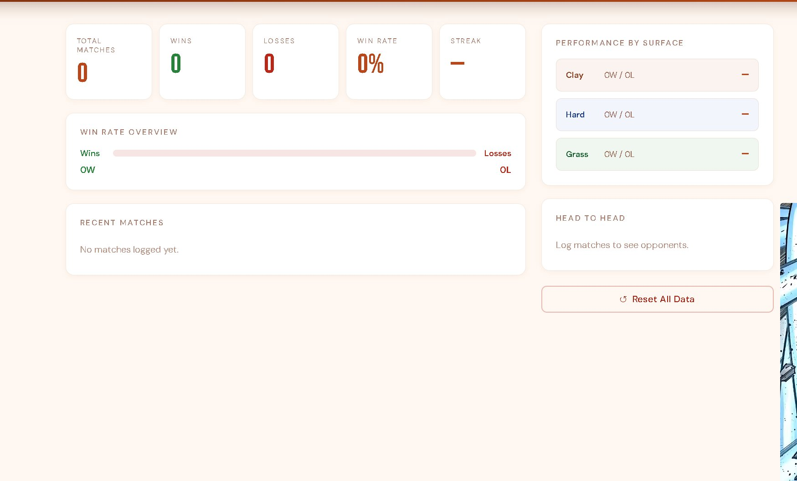
Figure 2: Dashboard on first load with all stat cards at zero, empty surface breakdown, and empty head-to-head panel.

Dashboard - Populated with Data
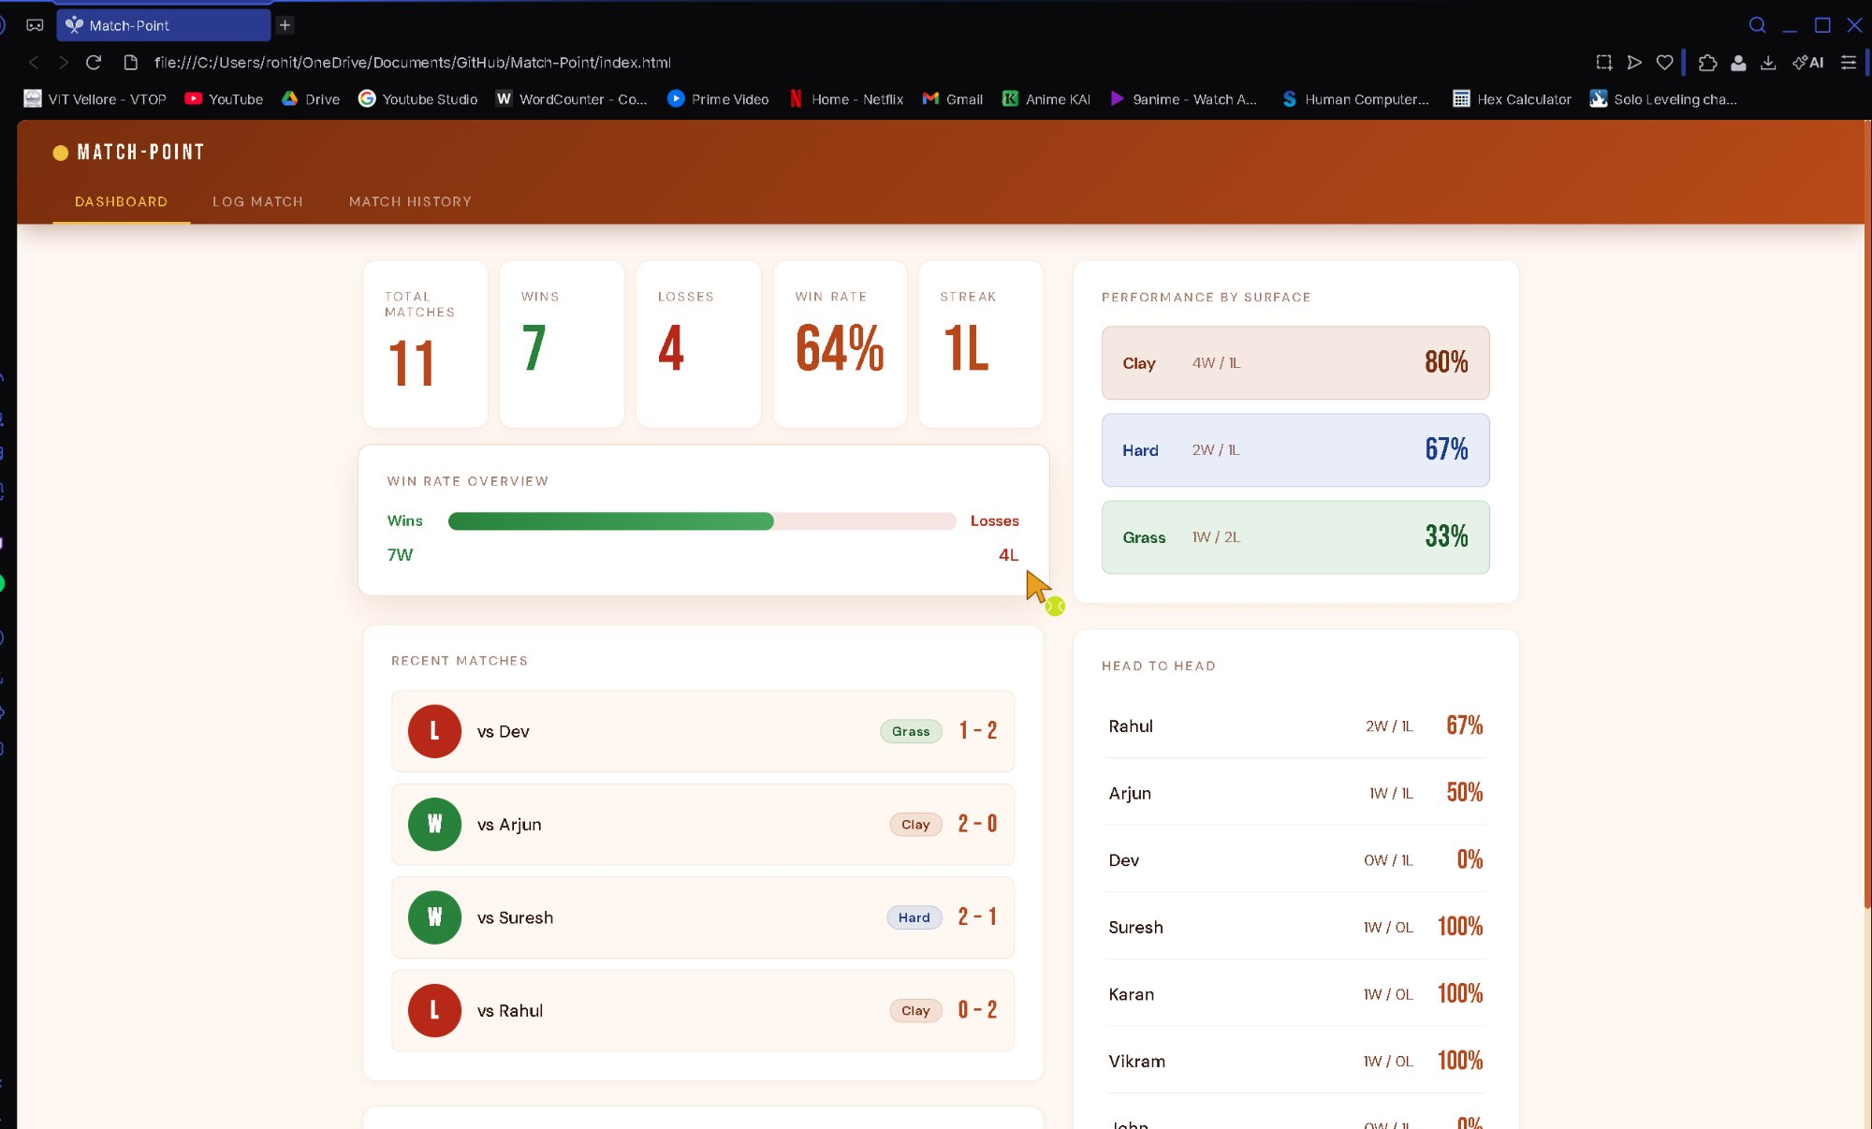
Figure 3: Dashboard after Quick Fill showing stat cards, win rate bar, surface breakdown with percentages, recent matches, and head-to-head records.

Advanced Stats Averages Card
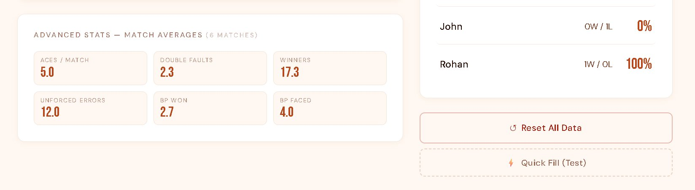
Figure 4: Advanced Stats averages card on the dashboard showing per-match means for all six metrics.

Log Match - Standard Form
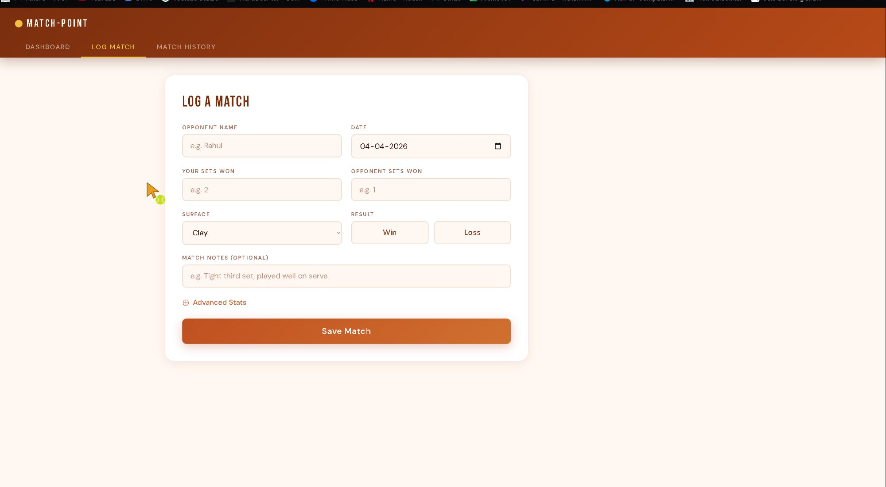
Figure 5: Log Match tab showing opponent name, date, set scores, surface selector, Win/Loss toggle, and match notes field.

Log Match - Advanced Stats Expanded
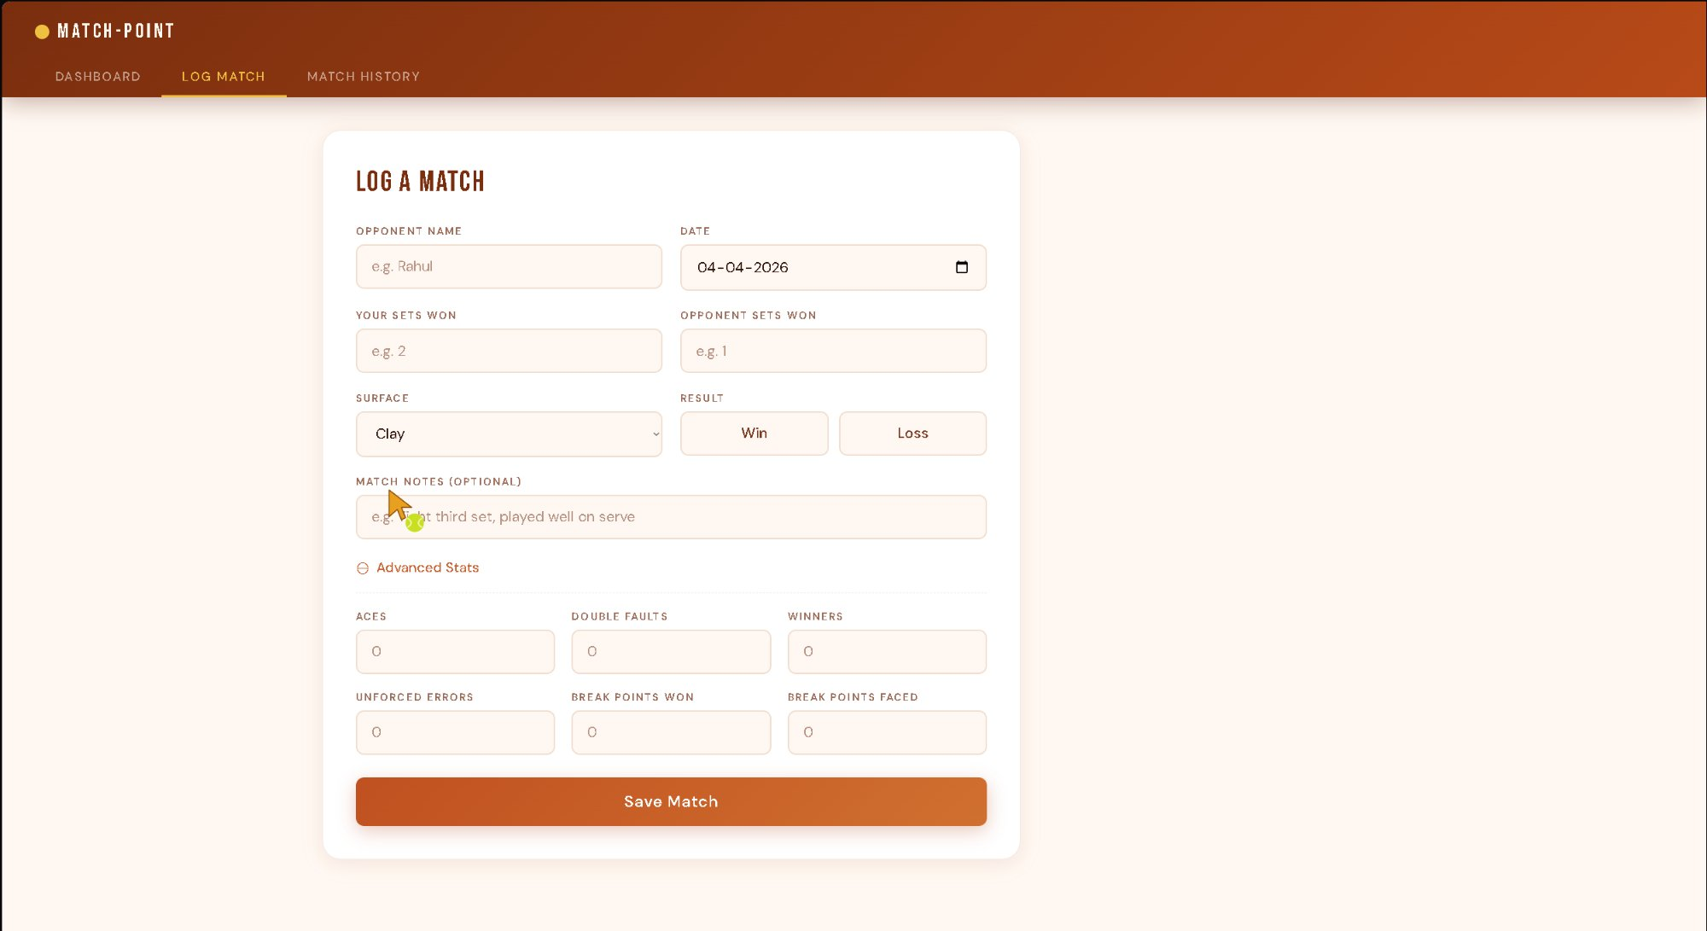
Figure 6: Log Match with the Advanced Stats section expanded, showing aces, double faults, winners, unforced errors, break points won and faced.

Match History
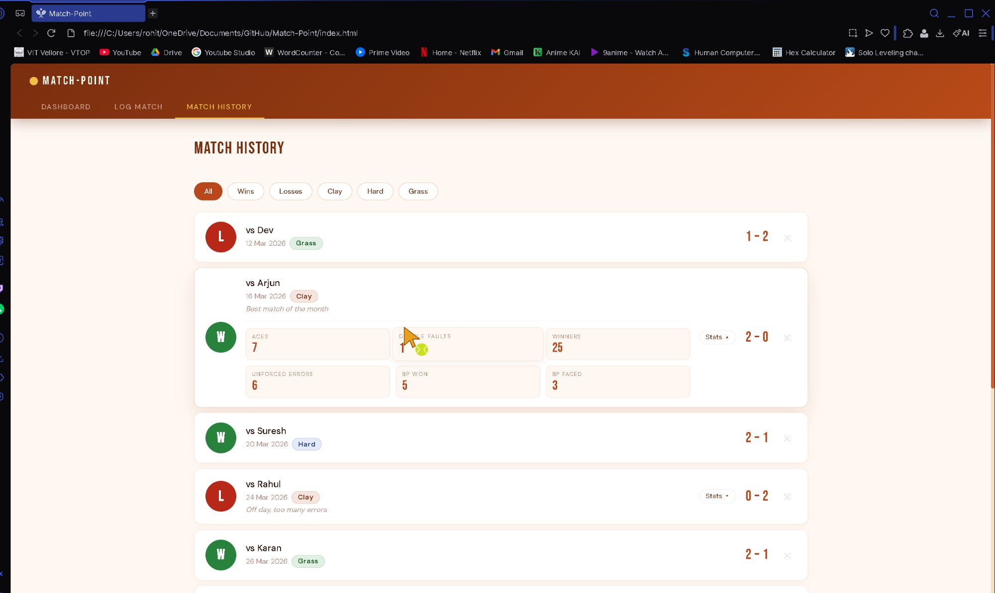
Figure 7: Match History tab showing the full match log with solid W/L badges, colour-coded surface pills, scores, notes, and an expanded advanced stats panel.

