**CS 6314.0U2 - Assignment 1**

**Due Date:** June 16, 2017, 11:59 PM

**Create your personal homepage**

Create your personal homepage (file should be named **index.html**) and upload it to utdallas.edu. Instructions for uploading process are provided below.

The web page should contain legitimate information about you (background information, hobbies, interests etc.) and should not contain any HTML code that is generated by a web design tool (FrontPage, PageMaker, and etc.)

1. In your page’s HTML, make sure to include following elements:

* <img> : On your home page put your profile picture and float it to the left. (in the middle part where you see Welcome heading)
* <meta> for description of your web page
* <meta> for the keywords associated with your page
* favorites icon ("favicon")

2. Your page layout should have the same layout given in below picture. In the header section, you will have menu items Home, About, Projects and Contact. (You can omit Logo and Login)

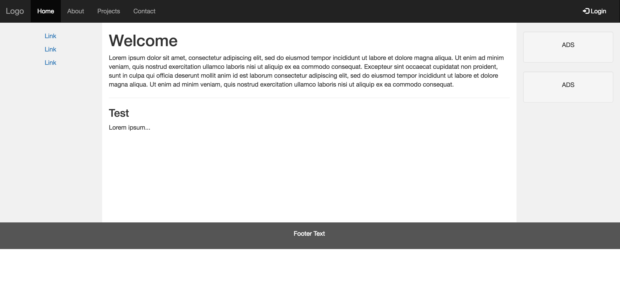

3.For style of your page, use an external css file (filename: index.css) and define your style sheet rules within that file.

4. Links on the top menu should take the user to the corresponding section within the same page. Links on the left can be to external websites.

**NOTES:**

**1.** Your page should be laid out using Bootstrap grid structure. You can use Bootstrap for other style properties as well.

**2.** You can use colors of your choice for your home page. For different color schemes, check following link: <http://www.colorschemer.com/schemes>

**3.** Your page will not be tested on Microsoft Internet Explorer or other browsers that do not comply with the web standards. It will be only tested on latest versions of Mozilla Firefox or Google Chrome.

**4.** For full credit, your pages must pass the W3C HTML validator with no errors (a green bar). Choose appropriate HTML tags to match the structure of the content on the page. Do not express style information in HTML with inline styles or presentational HTML tags such as *b* or *font*.

Use following site for validation of your pages:

http://validator.w3.org/ (for HTML)

**Instructions for setting up a web page**

You can find instructions for setting up your home page here:

<http://www.utdallas.edu/ir/howto/personal-webpage/>

For makeweb command (this command will create the public_html folder under your account)**,** you can use Mac Terminal instead of putty: ssh -l nxy140530 giant.utdallas.edu

**Submission**:

1. Zip your index.html, index.css and screenshot of your html page into one zip file and send it through eLearning. Name the zip file as “yournetid-HW1.zip”.

2. Upload your index.html, index.css and image files (favicon and profile picture) to UTD web server. TA will check your pages on UTD web server by visiting utdallas.edu/~yournetid. Your submission on eLearning will be used only for validation purposes.