#### A Project report on

COVID-19 TRACKER

###### A Dissertation submitted to JNTU Hyderabad in partial fulfillment of the academic requirements for the award of the degree.

**Bachelor of Technology**

### IN

**Computer Science and Engineering**

Submitted by

G. ARCHITH KUMAR (19H51A05D5) MOHD IFTEQUARUDDIN (19H51A05E0)

R. ROHITH REDDY (19H51A05E8)

Under the esteemed guidance of (MAJOR Dr. V.A. NARAYANA -PROFESSOR, PRINCIPAL)

**Department of Computer Science and Engineering CMR COLLEGE OF ENGINEERING AND TECHNOLOGY**

(An Autonomous Institution under UGC & JNTUH, Approved by AICTE, Permanently Affiliated to JNTUH, Accredited by NBA.)

KANDLAKOYA, MEDCHAL ROAD, HYDERABAD - 501401.

2019- 2023

**CMR COLLEGE OF ENGINEERING & TECHNOLOGY**

KANDLAKOYA, MEDCHAL ROAD, HYDERABAD – 501401

DEPARTMENT OF COMPUTER SCIENCE AND ENGINEERING



**CERTIFICATE**

This is to certify that the Project report "**COVID-19 TRACKER**” being submitted by **G. ARCHITH KUMAR (19H51A05D5)**, **MOHD IFTEQUARUDDIN (19H51A05E0)**, **R. ROHITH REDDY**

**(19H51A05E8)**, in partial fulfillment for the award of Bachelor of Technology in Computer Science and Engineering record of Bonafede work carried out his/her under my guidance and supervision.

The results embodies in this project report have not been submit any other University or Institute for the award of any Degree.

**Dr. SIVA SKANDHA SANAGALA**

**-ASSOCIATE PROFESSOR, HOD**

**Dept. of CSE**

**MAJOR Dr. V.A. NARAYANA**

**-PROFESSOR, PRINCIPAL**

**Dept. of CSE**

##### ACKNOWLEDGEMENT

With great pleasure I want to take this opportunity to express my heartfelt gratitude to all the people who helped in making this project work a grand success.

We are grateful to **Dr. V A Narayana**, Principal, Dept of Computer Science and Engineering for his valuable technical suggestions and guidance during the execution of this project work.

We would like to thank **Dr. S. Siva Skandha,** Head of the Department of Computer Science and Engineering, CMR College of Engineering and Technology, who is the major driving forces to complete my project work successfully.

We are very grateful to **Dr. Vijaya Kumar Koppula**, Dean-Academic, CMR College of Engineering and Technology, for his constant support and motivation in carrying out the project work successfully.

We are highly indebted to **Dr. V A Narayana,** Principal, CMR College of Engineering and Technology, for giving permission to carry out this project in a successful and fruitful way.

We would like to thank the Teaching & Non- teaching staff of Department of Computer Science and Engineering for their co-operation

Finally, I express my sincere thanks to Mr. Ch. Gopal Reddy, Secretary, CMR Group of Institutions, for his continuous care. I sincerely acknowledge and thank all those who gave support directly and indirectly in completion of this project work.

G. ARCHITH KUMAR (19H51A05D5) MOHD IFTEQUARUDDIN (19H51A05E0)

R. ROHITH REDDY (19H51A05E8)

### TABLE OF CONTENTS

|  |  |  |
| --- | --- | --- |
| **CHAPTER NO.** |  | **PAGE NO.** |
|  | **LIST OF FIGURES** | i |
|  | **ABSTRACT** | 1 |
| **1** | **INTRODUCTION** | 2 |
| **2** | **BACKGROUND WORK** | 3 |
| **3** | **PROPOSED SYSTEM** | 4-5 |
|  | 3.1 - The Need For Reliable, Real-Time Data | 4 |
|  | 3.2 - Collecting And Sharing COVID-19 Data | 4 |
|  | 3.3 - System Requirements | 5 |
| **4** | **DESIGNING** | 6 |
|  | 4.1 - Proposed System Architecture | 6 |
|  | 4.2 - Data Taken | 6 |
| **5** | **RESULTS AND DISCUSSION** | 7-8 |
|  | 5.1 - Top 5 Countries | 7 |
|  | 5.2 - Single Country | 8 |
|  | 5.3 - Discussion | 8 |
| **6** | **CONCLUSION AND FUTUREWORK** | 9 |
|  | 6.1 – Conclusion | 9 |
|  | 6.2 - Future Work | 9 |
| **7** | **REFERENCES** | 10 |

##### LIST OF FIGURES

|  |  |  |
| --- | --- | --- |
| **FIGURE NO.**  **4.1**  **4.2**  **5.1**  **5.2** | **TITLE**  **PROPOSED SYSTEM ARCHITECTURE DATA TAKEN**  **TOP 5 COUNTRIES**  **SINGLE COUNTRY** | **PAGE NO.**  **6**  **6**  **7**  **8** |

**ABSTRACT**

The novel coronavirus (COVID-19) that was first reported at the end of 2019 has impacted almost every aspect of life as we know it. It is a novel infection with serious clinical manifestations, including death, and it has reached at least 124 countries and territories. Although the ultimate course and impact of Covid-19 are uncertain, it is not merely possible but likely that the disease will produce enough severe illness to overwhelm the worldwide health care infrastructure.

Modeling the Covid-19 pandemic spread is challenging. But there are data that can be used to project resource demands. With this data we are going to analyze each country which is affected to covid19, and we’ll analyze the number of deaths per hour and which country has highest recovery rate, which country affected most all this.

## CHAPTER 1

##### INTRODUCTION

COVID-19 (also known as coronavirus disease) is a respiratory disease caused by the SARS-CoV-2 (Severe Acute Respiratory Syndrome Corona Virus 2). The first case was reported in Alberta, Canada on March 5th, 2020; just six days later, the World Health Organization declared the outbreak of COVID19 a global pandemic. Many countries have had significant outbreaks before the virus reached Alberta. Because of these outbreaks, various countries implemented policies that were put in place to reduce the spread of the virus, such as mandating the closure of all non-essential services, implementing social distancing rules, and affecting city-wide lockdown procedures.

In light of the pandemic, Albertan and Canadian policymakers reached out to the Centre for Health Informatics (CHI) at the University of Calgary and requested ongoing surveillance information about the spread of COVID-19. At the time, there wasn’t any dashboard that compared the provinces, which was valuable to those making decisions, and the CHI was well-equipped to develop such a tool as well as appropriately positioned to collect and sort the overwhelming amount of information from a variety of sources. As a result, a multidisciplinary team of software developers, epidemiologists, designers, visualization experts, and statisticians was assembled to create a COVID-19 dashboard or “Tracker”. The Tracker was then streamlined to one website for a standardized source of education and information.

The Tracker visualizes various components of the current COVID-19 pandemic and includes the policy interventions of various countries alongside case count. All graphs and figures on the Tracker are specifically designed with a sense of visual clarity to ensure policymakers and the general public can easily interpret the data. From this, policymakers can be well informed to make appropriate decisions that will affect the health and well- being of the broader population, or gauge the efficacy of interventions

## CHAPTER 2

##### BACKGROUND WORK

###### BACKGROUND STUDY

The COVID-19 pandemic is ravaging the world, with over 1 million people currently infected. Currently roughly 1 in 4 cases around the world is in the US, which has more confirmed COVID-19 cases than any other country. Current projections predict millions of infected Americans and several hundred thousand deaths from the pandemic in the US alone. These alarming numbers are sadly on the low end— they apply only if the population strictly adheres to the government’s social-distancing precautions and stay-at- home messages; due to a number of factors, actual numbers may be much higher.

It is thus imperative that people in America understand and follow the public health guidelines of their local, state, and federal government. For example, there is clear evidence that social distancing can and will mitigate the pandemic, yet not all individuals are adhering to it. If we could better understand the psychological factors that account for this heterogeneity in behaviour, we could inform better policy strategies.

It is well established that human decision-making is influenced by emotional factors, especially in times of crisis. Some of the factors that affect decision making will be explicit—in the sense that people can readily report them consciously. Others are known to be implicit—i.e., affecting people’s behaviour outside of their awareness. Both explicit and implicit emotions are hypothesized to be strongly modulated as the pandemic sweeps through the US. A main translational goal of our project is to help to improve messaging and compliance to public health regulations through a better understanding of the emotional factors that influence people’s decision-making.

A large body of work in social science has demonstrated that people have reliable and often strong emotional biases that influence how they behave. For instance, political party affiliation, race, gender, and social status are well-known to induce biases that are typically negative towards groups other than one’s own. People also acquire emotional biases for other objects (flowers are more liked than insects; people differ over cats and dogs as good pets). Moreover, much of these biases are inaccessible to the subject, and often denied by the subject: white people generally show a reliable bias against blacks, and men against women, even though they deny these biases on explicit questionnaires. However, the biases are revealed with implicit tasks, and in the decisions that people make.

These questions are not merely of interest to basic research in social science but have very important practical implications. Shifting people’s emotional attitudes towards other groups (Chinese, Republicans, health-care workers, rich people) has consequences both for public policy in preventing the spread of COVID-19 (targeted interventions depend on which groups of people are trusted, for instance), and for social and economic unrest.

# CHAPTER 3

##### PROPOSED SYSTEM

###### PROPOSED SYSTEM

The **COVID – 19 Tracker Project** was a collaborative volunteer-run effort to track the ongoing COVID-19 pandemic. It maintained a daily-updated dataset of world-level information related to the outbreak, including counts of the number of cases, tests, and deaths, the racial and ethnic demographic breakdowns of cases and deaths, and cases and deaths in long-term care facilities.

Data was updated by hand from world health department webpages, press conferences, and outreach to state health officials. The project reported data from all states.

The COVID Tracking Project’s data and analysis became a definitive source of COVID-19 data. The data was used in over 80,000 news reports and 1,000 academic articles. In June 2020, the CDC released a report stating that The COVID Tracking Project’s race and ethnicity data may be more complete than the agency’s dataset.

###### - The need for reliable, real-time data:

COVID-19 has shone a spotlight on the need for a centralized, accurate, and up-to- date data source to understand the virus and how it’s spreading. The COVID Tracking Project team notes that while many other countries have implemented widespread testing and data collection strategies to contain the virus.

Even though data on COVID-19 seems straightforward—a matter of collecting information on cases, deaths, and hospitalizations—it’s much [more complicated](https://www.tableau.com/about/blog/2020/4/conversation-epidemiologist-5-things-keep-mind-when-you-look-numbers-covid-19) than that. The definition of a positive case can vary from one confirmed by a laboratory test to one that’s probable on the basis of symptoms and exposure. Some states won’t count a death as COVID-related if the person did not have a laboratory-confirmed test. And because hospital systems all report their own data, it can be difficult to collect a full picture.

The COVID Tracking Project, Kissane says, works to be as thorough as possible in explaining the data, how they source it, and if and when they introduce errors into the process, and if there are errors present in the data they pull from. “This is messy data,” Kissane says. For instance, Florida’s testing rates dipped recently due to a hurricane, and California recently disclosed that their state IT system that collects reports from labs has not been catching all the test results the labs have sent. “They don’t know how much data was missed, but they expect that once they’re able to account for it, they’ll be able to scoop it up from their spreadsheets and that will affect their positivity rate and understanding of the outbreak,” Kissane says. Essentially, doing this work is like hitting a constantly moving target. “Our function is to annotate the data and explain what’s happening as best as possible, and also produce a state-based dataset that can be used to provide accountability.

###### - Collecting and sharing COVID-19 data:

The COVID Tracking Project has also been instrumental in meeting another critical need for data around the pandemic: Almost as soon as COVID-19 hit, it became clear that

the virus was [disproportionately impacting](https://www.tableau.com/about/blog/2020/5/covid-19-disproportionately-affecting-communities-color-here-data-explains-why) people of color in the United States. But data on COVID by race and ethnicity was inconsistent and hard to come by.

Starting in April, the COVID Tracking Project partnered with the [Center for](https://www.bu.edu/antiracism-center/) [Antiracist Research](https://www.bu.edu/antiracism-center/)—which takes a data-driven and research-based approach to developing strategies for dismantling racism—to develop the COVID-19 Racial Data Tracker. This dashboard contains information from every state on what percent of COVID cases and deaths have been reported with race and ethnicity data. While nearly every state reports race/ethnicity data for cases and deaths, that was not always the case—and the Racial Data Tracker clearly shows that few states are hitting the goal of 100% reporting in this area.

“Even with the incomplete data that we do have, we see that in many parts of the country the pandemic has disproportionately affected different groups,” Kissane says. “So the big data science challenge for the COVID Racial Data Tracker is figuring out how to convey what we know, while also conveying where the ambiguities are so great that you shouldn’t trust the numbers. How can we flag and annotation so that it’s clear that in a state that only gives us race and ethnicity data for 10% of the cases, we don’t have enough data to really make any claims.”

Because there are still significant gaps in the data, Kissane says that part of the aim of the Racial Data Tracker is to create accountability for states to improve the amount of race and ethnicity data they provide with COVID data. “Getting data is required to move policy,” she says. “We’ve certainly been applying pressure as much as we can, but we don’t have the authority to make anyone change reporting practices,” noting that public visibility can highlight opportunities for improvement.

###### - SYSTEM REQUIREMENTS:

**HARDWARE REQUIREMENTS:**

PROCESSOR: DUAL CORE 2 DUOS RAM: 4 GB DD

HARD DISK: 250 GB

###### SOFTWARE REQUIREMENTS:

OPERATING SYSTEM: WINDOWS 7/8/10/11

PLATFORM: GOOGLE COLAB PROGRAMMING LANGUAGE: PYTHON WITH DATA ANALYSIS

# CHAPTER 4

##### DESIGNING

###### - PROPOSED SYSTEM ARCHITECTURE:

This is the process of the project, firstly we collect the data and use that data in the form of the data sets then we will import that data sets and perform some data analysis algorithms and finally gets the result.

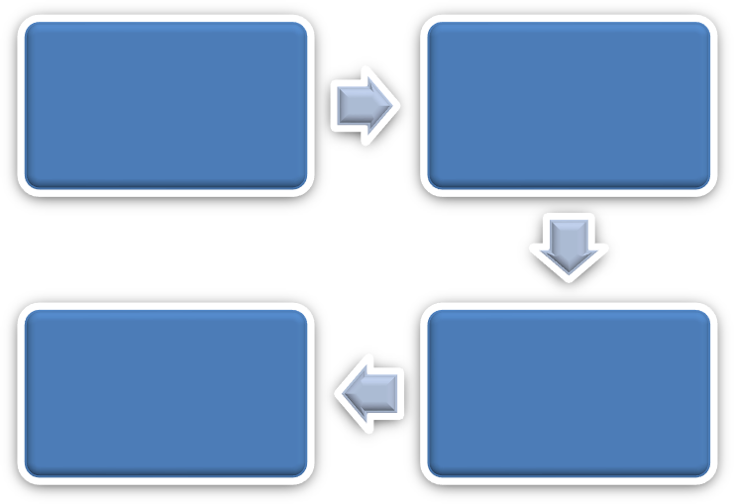

Data Collection

Data Pre-Processing

Conclusion

Exploratory Data Analysis

###### Figure: 4.1

###### (Architecture of the proposed system)

* 1. 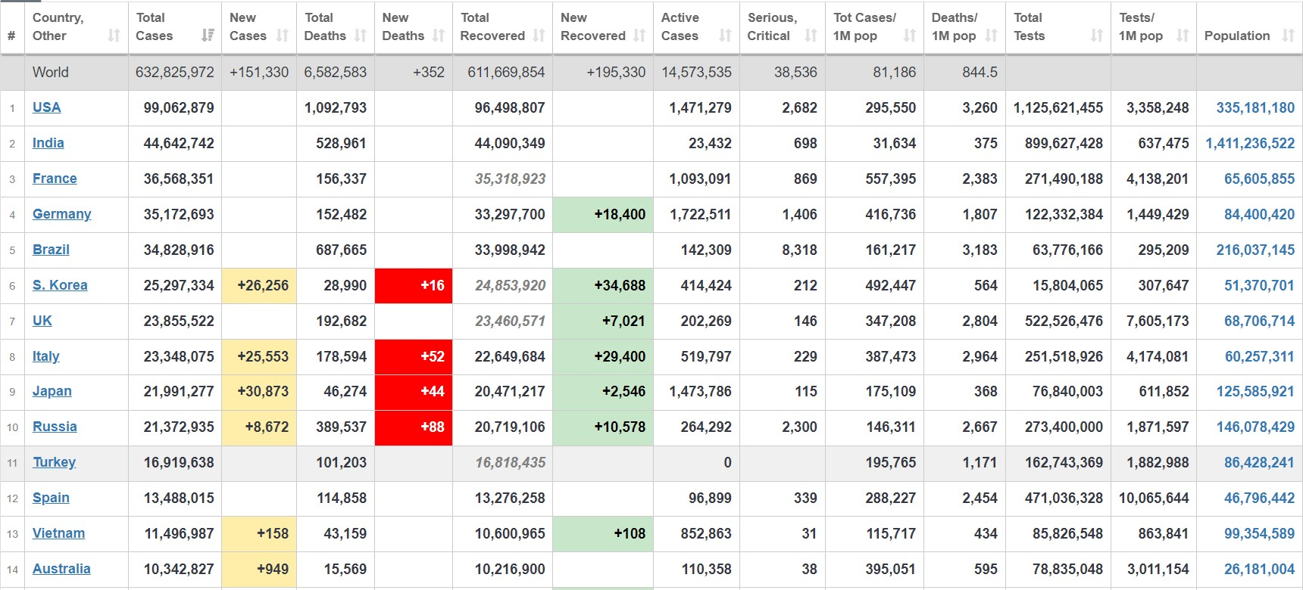**- DATA TAKEN:**

**Figure: 4.2**

(**SOURCE – [** [**https://www.worldometers.info/coronavirus/**](https://www.worldometers.info/coronavirus/) **]**)

# CHAPTER 5

##### RESULTS AND DISCUSSION

In the Figure 1, the number of daily new cases for a selected provincial jurisdiction is charted along with the cumulative number of total confirmed cases, new cases, total deaths, total recovered, new recovered, active cases, serious/critical cases, total cases/1M, deaths/1M, total tests, test/1M, population. This graph helps to inform the overall trend of new COVID-19 cases in a provincial jurisdiction. For example, Canada’s initial peak of new cases occurred on April 23rd with 319 new cases in one day. a similar figure is available where the viewer can select to see cases by country wise like India, USA, France etc.

**TOP 5 COUNTRIES**

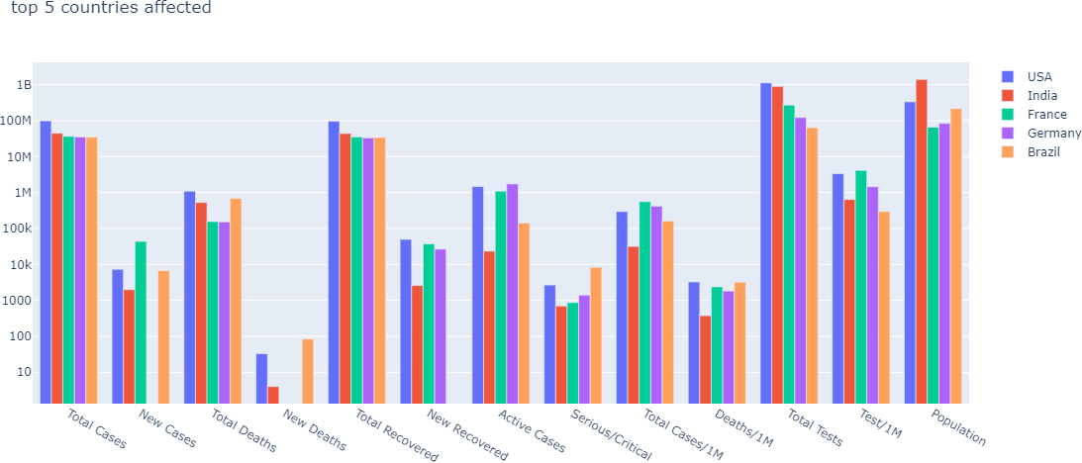

###### Figure: 5.1

###### (This bar graph shows the top 5 countries affected by COVID-19)

In the Figure 2 we can see the country wise total cases, new cases, total deaths, total recovered, new recovered, active cases, serious/critical cases, total cases/1M, deaths/1M, total tests, test/1M, population. This will be very user-friendly for the user to utilize the features in simple way.

**SINGLE COUNTRY**

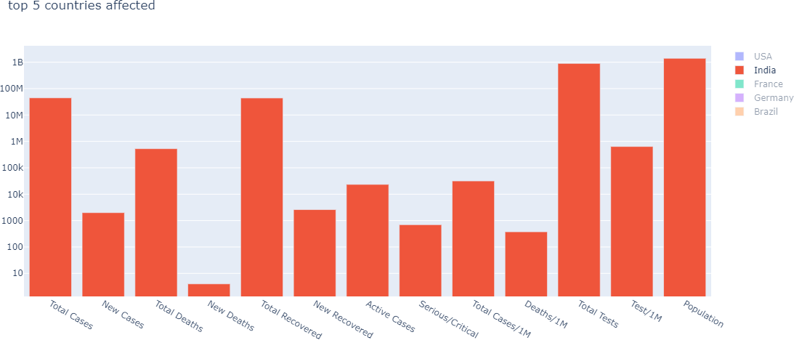

**Figure: 5.2**

###### (This bar graph shows the selected country which is affected by COVID-19)

* 1. **- DISCUSSION**

Building a user-friendly yet informative dashboard can be a daunting task and requires a diverse team of experts to collaborate. The University of Calgary’s COVID-19 Task Force was assembled and included biostatisticians, epidemiologists, software engineers, health economists, infectious disease experts, and health services researchers to successfully build a COVID-19 Tracker. This Tracker has been a useful tool in both keeping the public informed and guiding the decisions of policymakers across the world. The information displayed in the Tracker enables key stakeholders to make decisions and policy changes using real-time data that protect the health. The data were quickly collected from publicly available sources in order to develop advanced algorithms and user-friendly graphics.

# CHAPTER 6

##### CONCLUSION AND FUTURE WORK

###### - CONCLUSION

With this project, we hope to educate people on how easily viruses can be transmitted and infect an entire population and how social distancing and home isolation are key strategies in halting the spread of the virus. This education is made even more vital due to the widespread increases in mental illness, substance abuse, and economic hardships.

This project will help people to know the situation of their country and, they come to know where exactly the covid spreading rapidly and they will plan according to that.

###### - FUTURE WORK

* + - In future may the tracking analysis will change with the different technologies developing day by day and lot of features can add.
    - This tracker can be developed in so many ways for example the tracking will not only in countries but also can develop in states and districts.

# CHAPTER 7

##### REFERENCES

1. [*COVID-19 Coronavirus Pandemic*](https://www.worldometers.info/coronavirus/#countries)
2. [*NY Times COVID-19 data*](https://github.com/nytimes/covid-19-data)
3. Ferguson, N., and the Imperial College COVID-19 Response Team, [*Impact of non-*](https://www.imperial.ac.uk/media/imperial-college/medicine/sph/ide/gida-fellowships/Imperial-College-COVID19-NPI-modelling-16-03-2020.pdf)[*pharmaceutical interventions (NPIs) to reduce COVID19 mortality and healthcare*](https://www.imperial.ac.uk/media/imperial-college/medicine/sph/ide/gida-fellowships/Imperial-College-COVID19-NPI-modelling-16-03-2020.pdf)[*demand.*](https://www.imperial.ac.uk/media/imperial-college/medicine/sph/ide/gida-fellowships/Imperial-College-COVID19-NPI-modelling-16-03-2020.pdf) *16 March 2020*.
4. Tian, H., et al., [*An investigation of transmission control measures during the first 50*](https://science.sciencemag.org/content/early/2020/03/30/science.abb6105)[*days of the COVID-19 epidemic in China*](https://science.sciencemag.org/content/early/2020/03/30/science.abb6105)*.* Science, March 31, 2020.
5. [*Coronavirus Live Updates: White House Debates How Far to Go on Face Mask*](https://www.nytimes.com/2020/04/02/world/coronavirus-live-%20news-updates.html#link-494b341e)[*Guidelines*.](https://www.nytimes.com/2020/04/02/world/coronavirus-live-%20news-updates.html#link-494b341e) [cited 2020 April 2]
6. [*Mason, J. Do social distancing better, White House doctor tells Americans. Trump*](https://www.reuters.com/article/us-health-coronavirus-trump-birx/do-social-%20distancing-better-white-house-doctor-tells-americans-trump-objects-idUSKBN21L08A)[*objects.*](https://www.reuters.com/article/us-health-coronavirus-trump-birx/do-social-%20distancing-better-white-house-doctor-tells-americans-trump-objects-idUSKBN21L08A)
7. Tversky, A. and D. Kahneman, [*Judgment under uncertainty: heuristics and biases.*](https://science.sciencemag.org/content/185/4157/1124)

Science, 1974. 185: 1124-1131.

1. Kugler, T., T. Connolly, and L.D. Ordóñez, [*Emotion, decision, and risk: Betting on*](https://onlinelibrary.wiley.com/doi/abs/10.1002/bdm.724)[*gambles versus betting on people.*](https://onlinelibrary.wiley.com/doi/abs/10.1002/bdm.724) Journal of Behavioral Decision Making, 2012. 25: 123- 134.
2. Anderson, D.J. and R. Adolphs, [*A framework for studying emotions across species.*](https://www.ncbi.nlm.nih.gov/pubmed/24679535)

Cell, 2014. 157: 187-200.

1. Lu, Y. and Y.-H.C. Huang, [*Getting emotional: An emotion-cognition dual-factor*](https://www.semanticscholar.org/paper/Getting-emotional%3A-An-emotion-cognition-dual-factor-Lu-Huang/ca5a9e7e6ee7217eaa73546de3517a210267c583)[*model of crisis communication.*](https://www.semanticscholar.org/paper/Getting-emotional%3A-An-emotion-cognition-dual-factor-Lu-Huang/ca5a9e7e6ee7217eaa73546de3517a210267c583) Public Relations Review, 2018. 44: 98-107.
2. Greenwald, A.G., Banaji, M.R., Rudman, L.A., Farnham, S.D., Nosek, B.A., and Mellott, D.S. (2002). [*A unified theory of implicit attitudes, stereotypes, self-esteem, and*](https://www.ncbi.nlm.nih.gov/pubmed/11863040)[*self-concept.*](https://www.ncbi.nlm.nih.gov/pubmed/11863040) Psychol. Rev. 109, 3–25.
3. Banaji, M. R., & Greenwald, A. G. (2013). [*Blindspot: Hidden biases of good people*](https://blindspot.fas.harvard.edu/)*.*

New York: Delacorte Press.

1. Stanley, D. A., Sokol-Hessner, P., Banaji, M. R., & Phelps, E. A. (2011). *I*[*mplicit race*](https://www.ncbi.nlm.nih.gov/pubmed/21518877)[*attitudes predict trust- worthiness judgments and economic trust decisions.*](https://www.ncbi.nlm.nih.gov/pubmed/21518877) Proceedings of the National Academy of Sciences, USA, 108, 7710–7715.
2. Baron, A. S., & Banaji, M. R. (2006). [*The development of implicit attitudes: Evidence*](https://www.ncbi.nlm.nih.gov/pubmed/16371144)[*of race evaluations from ages 6 and 10 and adulthood*](https://www.ncbi.nlm.nih.gov/pubmed/16371144). Psychological Science, *17*, 53–58.