INSODE 2012
Hadoop optimization for massive image processing: case study face detection
İlginç Demir ª , Ahmet Sayar ^{b}
ªInformation Technologies Institute, The Scientific and Technological Research Council of Turkey, Turkey
^{b}Computer Engineering Department, Kocaeli University, Turkey

Abstract
Face detection applications are widely used for searching, tagging and classifying people inside very large image databases. This type of applications require processing of relatively small sized and large number of images. On the other hand, Hadoop Distributed File System (HDFS) is originally designed for storing and processing large-size files. Huge number of small-size images causes slowdown in HDFS by increasing total initialization time of jobs, scheduling overhead of tasks and memory usage of the file system manager (Namenode). The study in this paper presents two approaches to improve small image file processing performance of HDFS. These are (1) converting the images into single large-size file by merging and (2) combining many images for a single task without merging. We also introduce novel Hadoop file formats and record generation methods in order to develop these techniques.

© 2012 Published by Elsevier Ltd.

Keywords:Hadoop, MapReduce, Cloud Computing, Face Detection, OpenCV;
- Introduction
In the last decade, multimedia usage has increased very quickly, especially as parallel to high usage rate of the Internet. Multimedia data, stored by Flicker, YouTube and social networking sites like Facebook, has reached enormous size. Today search engines facilitate searching of multimedia content on large data sets. So these servers has to manage storing and processing this much data.
Distributed systems are generally used to store and process large scale multimedia data in a parallel manner. Distributed systems have to be scalable for both adding new nodes and for running different jobs simultaneously. Images and videos are the largest set of these multimedia contents. So, image processing jobs are required to run in distributed systems to classify, search and tag the images. There are some distributed systems enabling large scale data storing and processing. Hadoop distributed file system (HDFS) [1] is developed as an open-source project to manage storage and parallel processing of large scale data.
HDFS parallel processing infrastructure is based on MapReduce programming model that is introduced firstly by Google File System (GFS) [2] in 2004. MapReduce [3] is a framework for processing highly distributable problems across huge data sets using a large number of computers (nodes), collectively referred to as a cluster.
In this paper, we describe techniques to achieve large scale face detection and storage of detected faces into HDFS. A novel Hadoop interface for parallel image processing is developed in which new file I/O operation formats and record generation classes are implemented. In order to create an input from each binary image file without splitting, an input file format called ImageFileInputFormat is developed. A new record generator class called ImageFileRecordReader is also developed in order to read the content of image and create whole image data as an input record to MapTask [4].
We develop two approaches. First approach is based on combining multiple small size files into a single Hadoop SequenceFile. Second approach proposes a technique to combine many images as a single input to MapTask without merging. This technique does not require special input file format as SequenceFile, so that images can be used as in their original format. To achieve this, we introduce novel image input format and an image record reader. These two approaches together with the naive approach are going to be applied on distributed face detection applications on images. The effectiveness of the proposed techniques are proven by the test cases and performance evaluations. Remaining of this paper is organized as follows. Section 2 explains the distributed computing infrastructure of Hadoop. Section 3 presents interface design. Section 4 evaluates the performances of techniques; Section 5 gives the summary and conclusion.
- Distributed Computing With Hadoop
HDFS is a scalable and reliable distributed file system consisting of many computer nodes. The node running NameNode is the master node and nodes running DataNode are worker nodes. DataNodes manage local data storage and report feedbacks about the state of the locally stored data. HDFS has only one NameNode but can have thousands of DataNodes.
Hadoop uses worker nodes as both local storage units of file system and parallel processing nodes. Hadoop runs jobs parallel by using MapReduce programming model. This model consists of two stages which are Map and Reduce whose input and outputs are records as <key, value> pairs. Users create jobs by implementing Map and Reduce functions and by defining the Hadoop job execution properties. After having defined, jobs are executed on worker nodes as MapTask or ReduceTask. JobTracker is the main process of Hadoop for controlling and scheduling tasks. JobTracker gives roles to the worker nodes as Mapper or Reducer task by initializing TaskTrackers in worker nodes. TaskTracker runs the Mapper or Reducer task and reports the progress to JobTracker.
Hadoop converts the input files into InputSplits and each task processes one InputSplit. InputSplit size should be configured carefully, because InputSplits can be stored more than one block if InputSplit size is chosen to be larger than HDFS block size. In that way, distant data blocks need to be transferred over network to MapTask node to create InputSplit.
Hadoop map function creates output that becomes the input of the reducer. So, the output format of the map function is same with the input format of the reduce function. All Hadoop related file input formats derive the FileInputFormat class of Hadoop. This class holds the data about InputSplit. InputSplit does not become input directly for the map function of the Mapper class. Initially, InputSplits are converted into input records consisting of <key, value> pairs. For example, in order to process text files as InputSplit, RecordReader class makes text lines of the file as an input record in <key, value> format where key is the line number and value is the textual data of each line. The content of the records can be changed by implementing another derived class from RecordReader class.
In distributed systems, the data to be processed is generally not located at the node that processes that data and this situation causes performance decrease in parallel processing. One of the ideas behind the development of HDFS is making the data processed in the same node where it is stored. This principle is called data locality which increases the parallel data processing speed in Hadoop [4].
HDFS is specialized in storing and processing large-size files. Small-size files storage and processing ends up with performance decrease in HDFS. NameNode is the file system manager in HDFS master node which registers file information as metadata. When using massive number of small-size files, the memory usage of Namenode increases so leading master node to be unresponsive for file operation requests from client nodes [5]. Moreover, number of tasks to process these files increases and Hadoop JobTracker and TaskTrackers, which initialize and execute tasks, have more tasks to schedule. In that way, total HDFS job execution performance decreases. For these reasons, storing and processing massive number of images require different techniques in Hadoop.
Using massive number of small size files causes shortage of memory in master node due to increasing sizes of Namenode’s metadata file. Moreover, as the number of files increases, the number of tasks to process these files increases and the system ends up with workload increases in Hadoop’s JobTracker and TaskTrackers, which are responsible for initialization, execution and scheduling of the tasks. These might lead master node to be unresponsive for file operation requests from client nodes [5]. In brief, storing and processing massive number of images require different techniques in Hadoop.
- Interface Design
In order to apply face detection algorithm to each image, map function has to get the whole image contents as single input record. HDFS creates splits from input files according to the configured split-size parameter. These InputSplits become the input to the MapTasks. Creating splits from files causes some files to be divided into more than one split, if their file size is larger than the split-size. Moreover, a set of files can become one InputSplit if the total size of input files is smaller than split size. In other words, some records may not be represented as the binary content of each file. This explains why new classes for input format and record reader have to be implemented to enable MapTask to process each binary file as a whole.
In this paper, ImageFileInputFormat class is developed by deriving the FileInputFormat class of Hadoop. ImageFileInputFormat creates FileSplit from each image file. Because, each image file is not splitted, binary image content is not corrupted. In addition, ImageFileRecordReader class is developed to create image records from FileSplits for map function by deriving Hadoop’s RecordReader class. Map function of the Mapper class applies the face detection algorithm to image records. Haar Feature-based Cascade Classifier for Object Detection algorithm defined in OpenCV library is used for face detection [6]. Java Native Interface (JNI) is used to integrate OpenCV into interface. Implementation of map function is presented below. "FaceInfoString" is the variable that contains the information about detection properties such as image name and coordinates where faces detected.

Class: Mapper:
Function: Map(TEXT key=filename, BytesWritable value=imgdata, OutputCollector output){
getImgBinaryData_From_Value;
convertBinaryData_To_JavaImage;
InitializeOpenCV_Via_JNIInterface;
runOpenCV_HaarLikeFaceDetector;
foreach (DetectedFace)
createFaceBuffer_FaceSize;
copyFacePixels_To_Buffer;
create_FaceInfoString;
collectOutput:
set_key_FaceInfoString;
set_value_FaceImgBuffer;
end_foreach
}

Hadoop generates name of output file as a string with job identification number (eg: part–0000). After face detection, our image processing interface creates output files as detected face images. In order to identify these images easily, the output file names should contain detected image name and detection coordinate information (eg: SourceImageName_(100,150).jpg ). ImageFileOutputFormat class is developed to store output files as images with desired naming. ReduceTask is not used for face extraction because each MapTask generates unique outputs to be stored in the HDFS. Each task processes only one image, creates output and exits. This approach degrades the system performance seriously. The overhead comes from initialization times of huge number of tasks.
In order to decrease the number of tasks, firstly, converting small-size files into single large-size file and process technique is implemented. SequenceFile is a Hadoop file type which is used for merging many small-size files [7]. SequenceFile is the most common solution for small file problem in HDFS. Many small files are packed as a single large-size file containing small-size files as indexed elements in <key, value> format. Key is file index information and value is the file data. This conversion is done by writing a conversion job that gets small-files as input and SequenceFile as output. Although general performance is increased with SequenceFile usage, input images do not preserve their image formats after merging. Preprocessing is also required for each addition of new input image set. Small files cannot be directly accessed in SequenceFile, whole SequenceFile has to be processed to obtain an image data as one element [8].
Secondly, combining set of images as one InputSplit technique is implemented to optimize small-size image processing in HDFS. Hadoop CombineFileInputFormat can combine multiple files and create InputSplits from this set of files. In addition to that, CombineFileInputFormat selects files which are in the same node to be combined as InputSplit. So, amount of data to be transferred from node to node decreases and general performance increases. CombineFileInputFormat is an abstract class that does not work with image files directly. We developed CombineImageInputFormat derived from CombineFileInputFormat [9] to create CombineFileSplit as set of image. MultiImageRecordReader class is developed to create records from CombineFileSplit. This record reader uses ImageFileRecordReader class to make each image as single record to map function. The technique is exhibited in figure 1 below. ImageFileOutputFormat is used to create output files from detected face images and stores into HDFS.

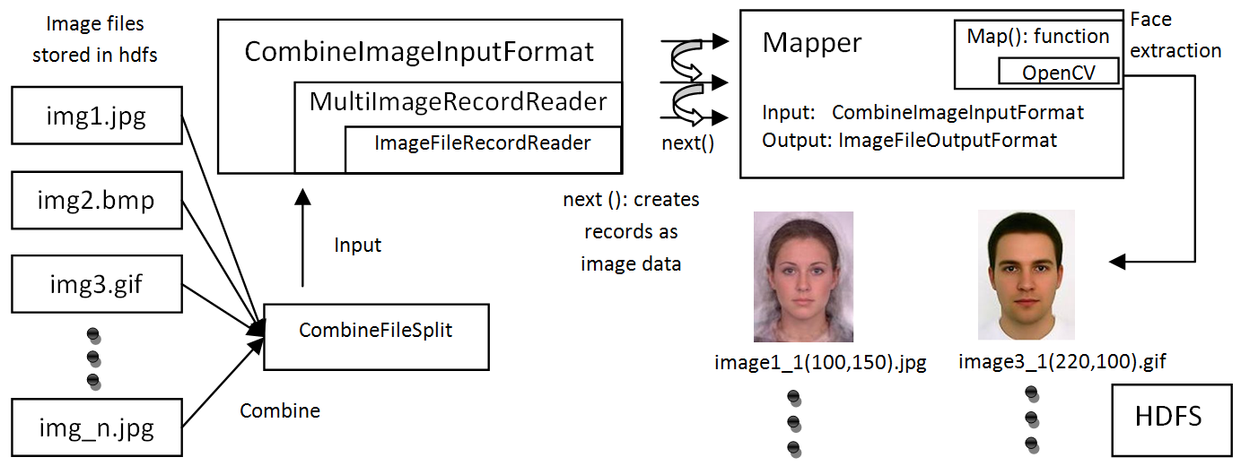

Fig. 1. Combine and Process Images Technique

- Performance Evaluations
HDFS cluster is set up with 6 nodes to run face detection jobs on image sets. Each node has a Hadoop framework installed on a virtual machine with software listed in Table 1. Although virtualization causes some performance loss in total execution efficiency, installation and management of Hadoop become easier by cloning virtual machines. Table 2 exhibits the hardware setup of the nodes. MapTasks require large dynamic memory space when map-function for the image processing executes. Default Java Virtual Machine (JVM) heap size is not enough for large size images. So, maximum JVM size for Hadoop processes is increased to 600 Mb.
Table 1. Hardware and Software Specifications
Software | Version
Operating System | Ubuntu 10.04 LTS
HDFS | Hadoop 0.20.2
Java | JRE 1.6.0_26
OpenCV | OpenCV-2.3.0
Virtualization Tool | Oracle Virtual Box 4.1.8
Table 2. Hardware Specifications
Hardware | Feature
CPU | 2.3Ghz Intel i7 2820QM 8MB Cache
Memory | 1GB
Harddisk | 20 GB
Network | VirtualBox Bridged JMicron Gigabit Ethernet Adaptor

Five different small size images are used as input files. Distribution of the images according to file sizes are preserved in input folders as can be seen in figure 2 (a) below. The images in the input folders went through the face detection job with the three types of approaches in HDFS. These are (1) one task per image brute-force approach (for comparison only), (2) SequenceFile processing approach and (3) combine and process images approach. Performance results in figure 2 (b) are obtained as job completion times.
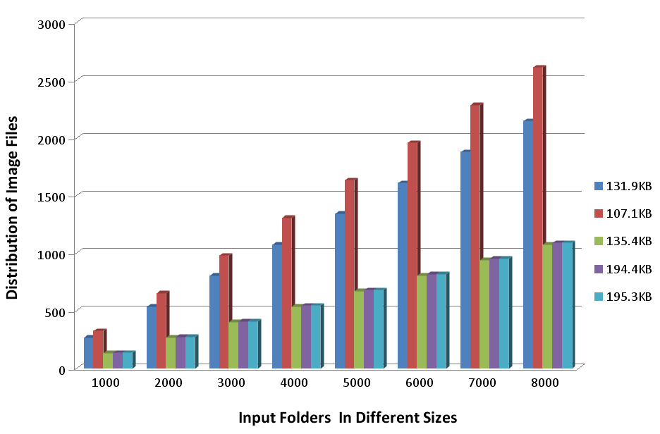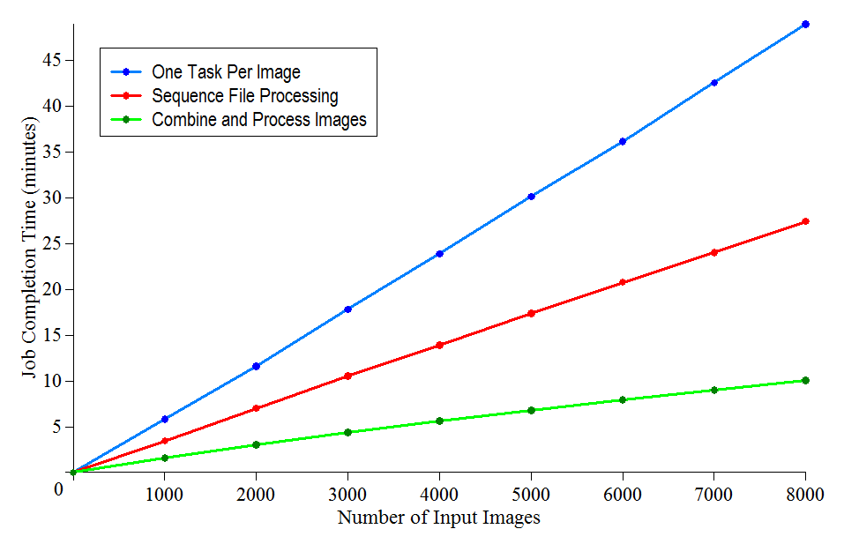
Fig. 2. (a) Distribution of Images In Input Folders ; (b) Performance Comparison

- Conclusion
The effectiveness of the proposed technique has been proven by the test cases and performance evaluations. As Figure 2 (b) shows, the proposed approach, combine images and then process, has become the most effective method in processing image files in HDFS. The SequenceFile processing is slower than the combining technique due to the fact that CombineImageInputFormat enforces creation of InputSplits by combining images in the same node. Additionally, in SequenceFile approach, InputSplits to be processed in MapTask does not always consist of datablocks in the same node. So some datablocks may be transferred from other storage node to MapTask node. Extra network transfer causes performance loss in total job execution. On the contrary, SequenceFile approach has better performance against the task per image approach, because small number of input files decreases number of created tasks. In that way, job initialization and bookkeeping overheads of tasks are decreased.
The slope of the job completion time curve for Task per image approach has increased as number of input images increases. But slopes of curves of other two techniques have slightly decreased by increasing number of input images, because task per image approach causes heavy burden on initialization and bookkeeping by increasing number of tasks. On the contrary, number of tasks is not increased as proportional to the number of images in SequenceFile and combine images techniques. Small number of tasks has been able to process more images when number of input images is increased.
Consequently, image processing like face detection on massive number of images can be achieved efficiently by using the proposed I/O formats and record generation techniques discussed in this paper. In the future, we plan to enhance and apply the proposed technique on face detection in video streaming data.
- References
- The Apache Hadoop website. [Online]. Available: http://hadoop.apache.org/
- S. Ghemawat, H. Gobioff, and S. Leung, “The Google File System”, Proc. of the 19th ACM Symp., pp.29–43, 2003.
- J. Dean and S. Ghemawat, “MapReduce: Simplified data processing on large clusters,” Communications of the ACM, vol. 51, no. 1, pp. 107–113, 2008.
- T.White, Hadoop: The Definitive Guide. O’Reilly Media, Inc. June 2009.
- T.White, The Small Files Problem. [Online]. Available: http://www.cloudera.com/blog/2009/02/02/ the-small-files-problem/
- The OpenCV Wiki website. [Online]. Available: http://opencv.willowgarage.com/wiki/
- SequenceFile webpage. [Online]. Available: http://wiki.apache.org/hadoop/SequenceFile/
- L. Xuhui, H. Jizhong, Z. Yunqin, H. Chengde, and H. Xubin,“Implementing WebGIS on Hadoop: A Case Study of Improving Small File I/O Performance on HDFS,” Proc. of the 2009 IEEE Conf.on Cluster Computing, pp.1-8, 2009.
- CombineFileInputFormat webpage. [Online]. Available: http://hadoop.apache.org/common/docs/current/api/org/

Corresponding author. Tel.: +090-262-6753070 E-mail address: ilginc.demir@bte.tubitak.gov.tr

