Task on VPC
Notes: Create a Jira ticket for this assignment, work on the tasks listed below, and submit the task completion document by EOD with clear steps and required evidence (outputs/screenshots)

- Create VPC with 2 private and 2 public subnets.
VPC created my-vpc-01
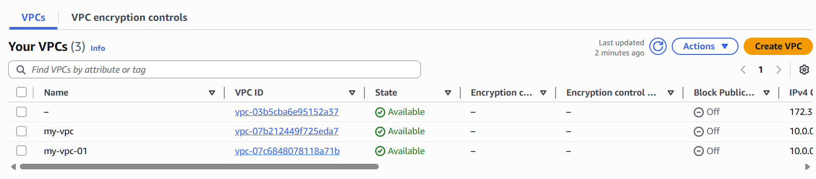

2 public and 2 private subnets created under the VPC
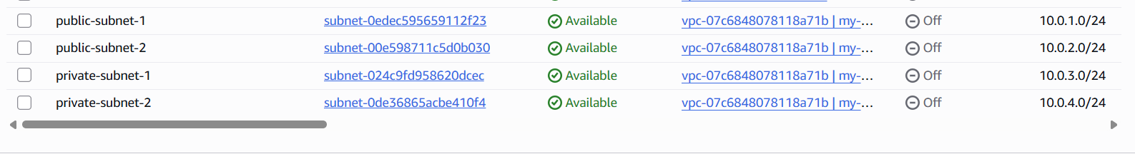

- Enable DNS Hostname in VPC.

🪜 Steps (AWS Console)
- Go to VPC Dashboard
- Click on Your VPCs
- Select your VPC (my-vpc-1)
- Click on Actions
- Select Edit VPC Settings
- Enable:
  - ✅ Enable DNS Hostnames
  - (Also ensure DNS Resolution is enabled)
- Click Save

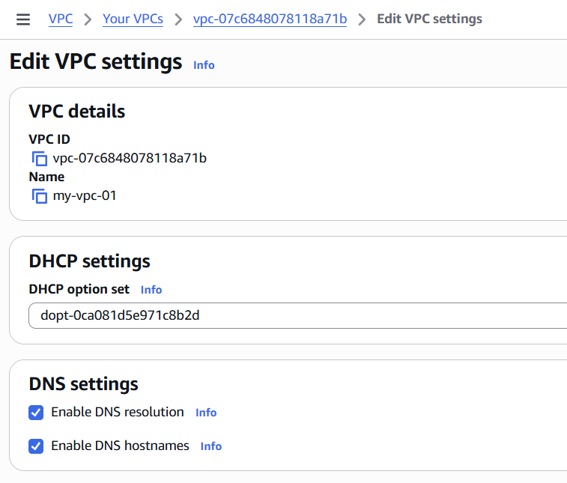
- Enable Auto Assign Public IP in 2 public subnets.
This setting ensures:
👉 Any EC2 launched in a public subnet automatically gets a Public IP
Without this:
- EC2 will not have internet access
- You cannot SSH or access it from browser

🪜 Steps (AWS Console)
- Go to VPC Dashboard
- Click on Subnets
- Select your public subnet (public-subnet-1)
- Click Actions → Edit Subnet Settings
- Enable:
  - ✅ Auto-assign Public IPv4 address
- Click Save
👉 Repeat same steps for:
- public-subnet-2

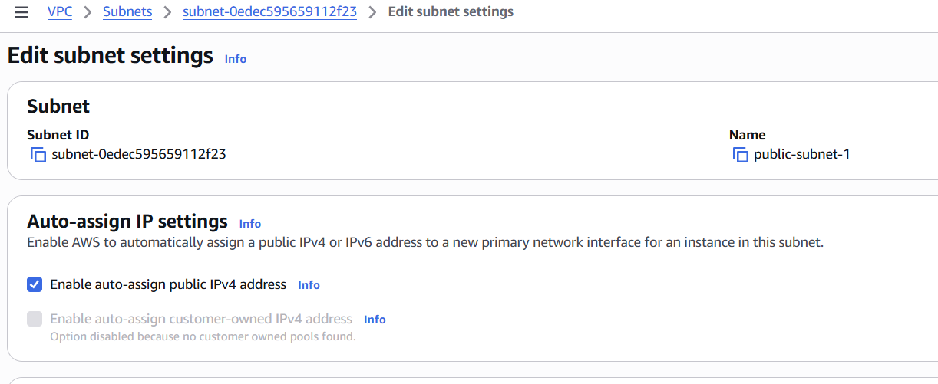

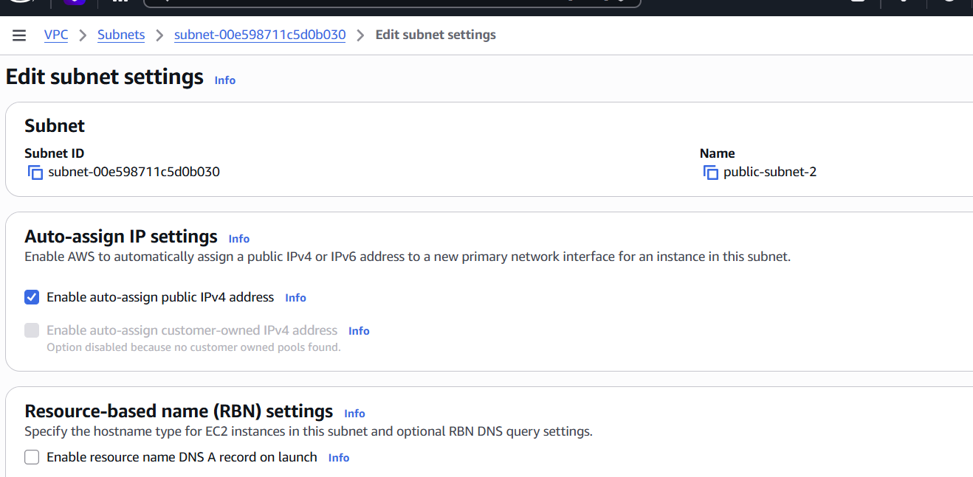

- Add 2 private subnets in private route table.

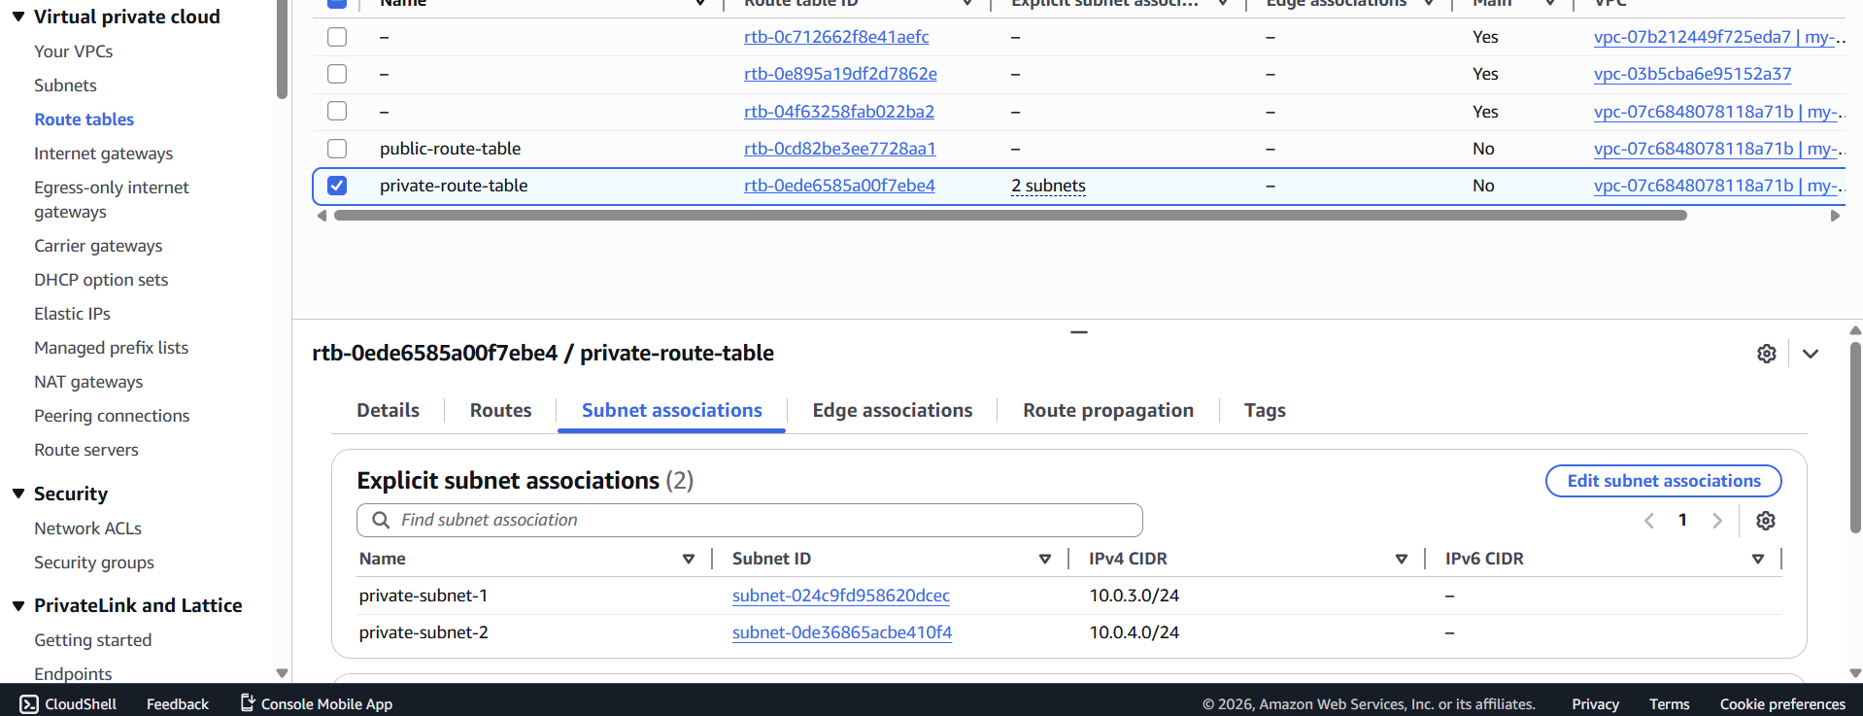

- Add 2 public subnets in public route table.

🪜 Steps (AWS Console)

🔹 Attach Public Subnets
- Go to Route Tables
- Select public-route-table
- Go to Subnet Associations tab
- Click Edit Subnet Associations
- Select:
  - ✅ public-subnet-1
  - ✅ public-subnet-2
- Click Save

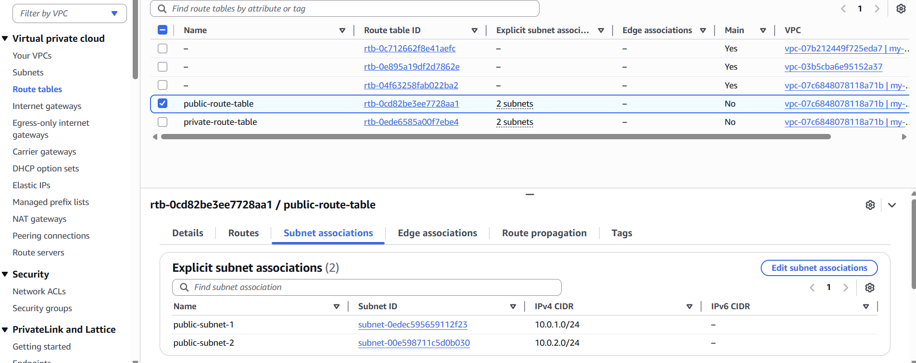
- Public route table will have the routes to internet and local.

🪜 Steps (AWS Console)

🔹 Step 1: Create Internet Gateway
- Go to VPC Dashboard
- Click Internet Gateways
- Click Create Internet Gateway
- Enter:
  - Name: my-igw
- Click Create

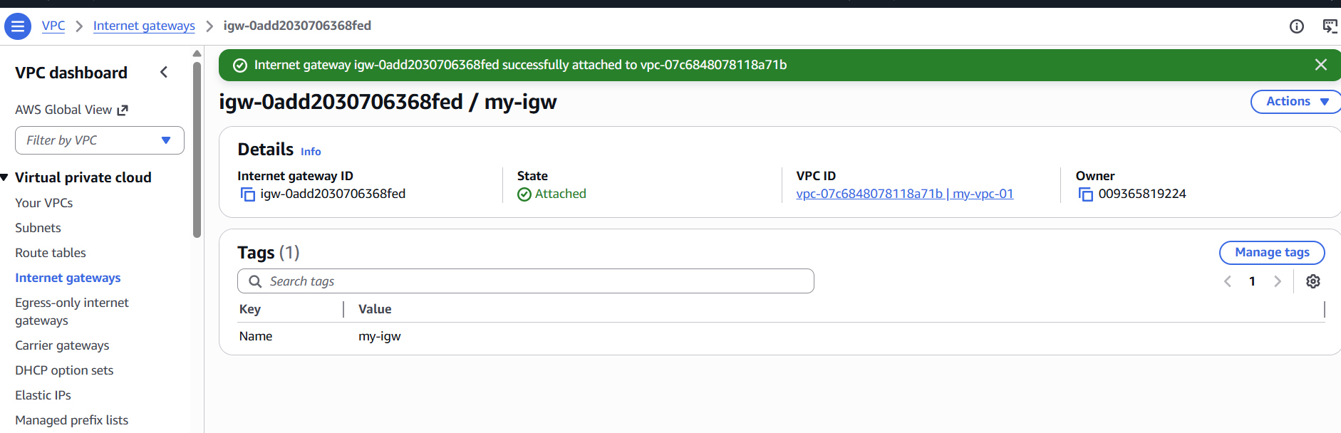
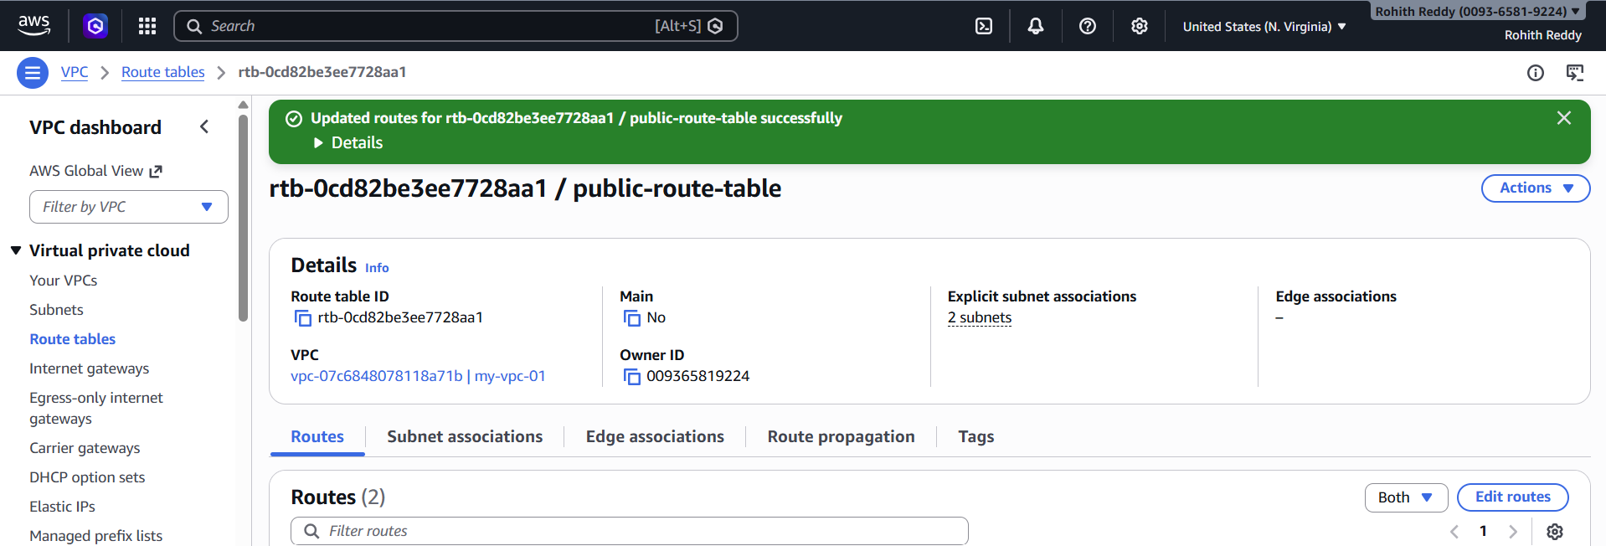
- Create EC2 in public subnet with t2.micro and install PHP.

Process to Install and Verify PHP on EC2
- Launched an EC2 instance in a public subnet with a public IP.
- Connected to the EC2 instance using SSH.
- Installed PHP using package manager (yum install php -y).
- Installed and started Apache web server (httpd).
- Created a test file info.php inside /var/www/html/ to check PHP functionality.
- Accessed the file in browser using public IP to verify PHP is working.

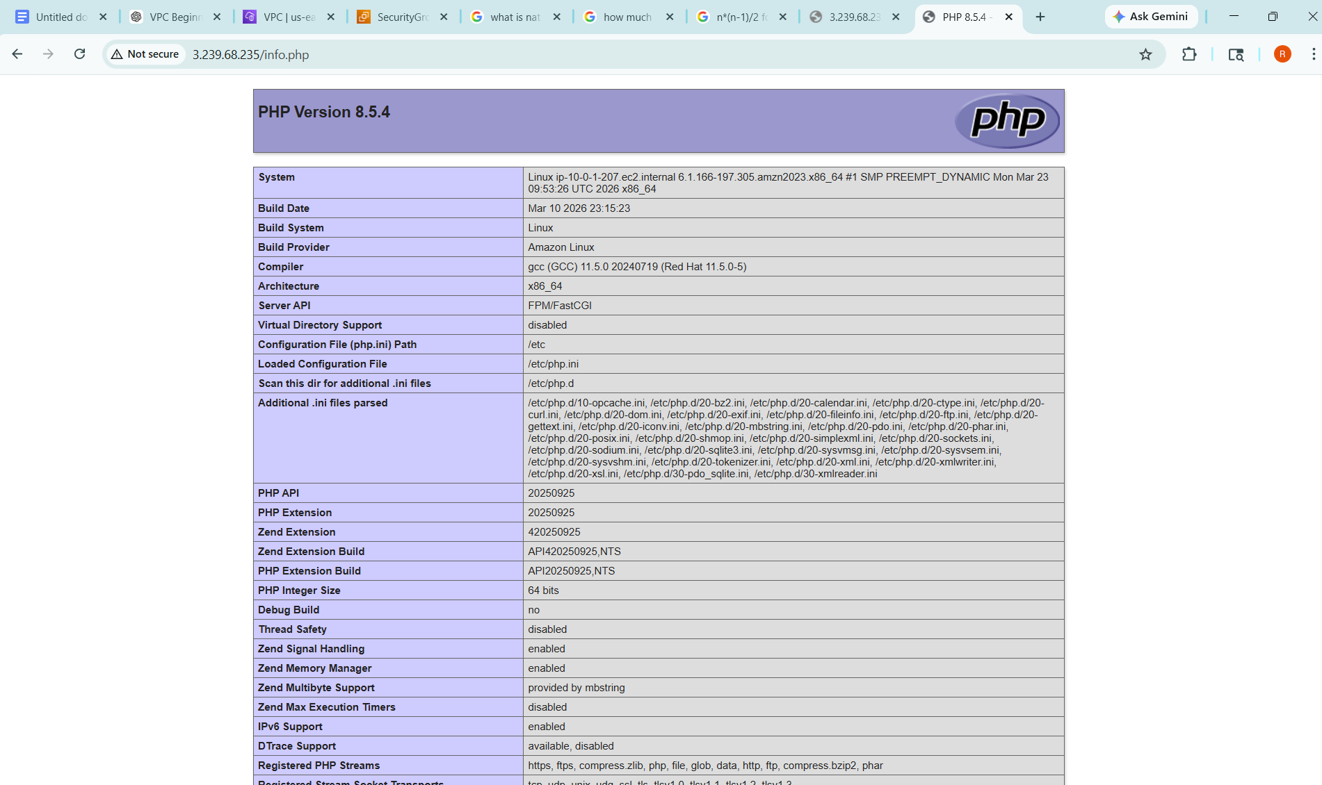
- Configure NAT gateway in public subnet and connect to private instance.

Created a NAT Gateway in the public subnet.
Allocated and attached an Elastic IP to the NAT Gateway.
Ensured NAT Gateway status is available.
Opened the private route table.
Added a route 0.0.0.0/0 with target as NAT Gateway.
Verified private EC2 can access internet through NAT Gateway.

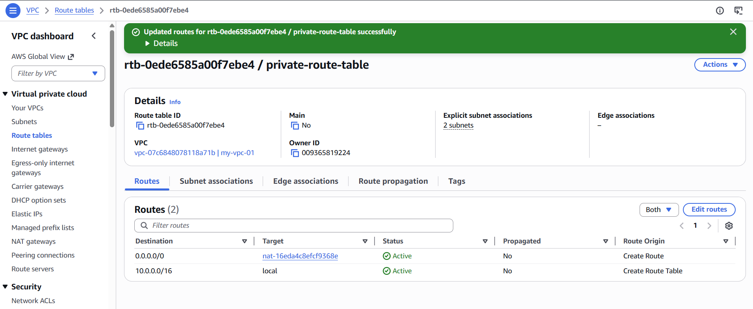

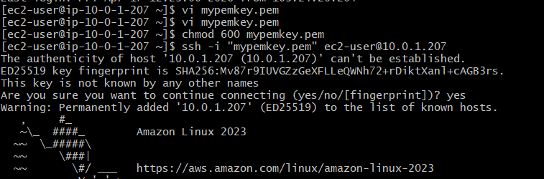
- Install Apache Tomcat in private EC2 and deploy a sample app.

Install Apache Tomcat in Private EC2 and Deploy Sample Application
- Connected to the private EC2 instance (via public EC2/bastion).
- Installed Java (required for Tomcat).
- Downloaded Apache Tomcat package using wget.
- Extracted the Tomcat file and started the Tomcat server.
- Placed the sample application (WAR file) inside the webapps folder.
- Accessed the application in browser using public EC2 (or via port forwarding) to verify deployment.

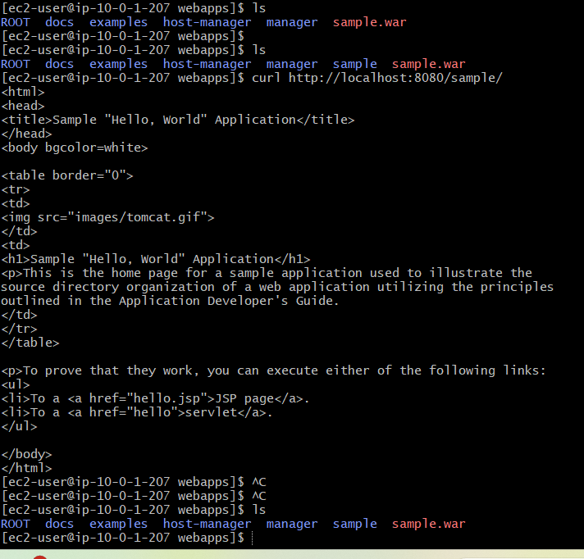
- Configure VPC flow logs and store the logs in S3 and CloudWatch.
