Jenkins-02.
- Configure 2 slave machines in the Jenkins master.
Launched two EC2 instances to act as Jenkins agents (agent-1, agent-2).
Installed required dependencies (Java 21 and fontconfig) on both agent machines.
Created a dedicated jenkins user on each agent for running builds.
Configured .ssh directory for jenkins user with proper permissions.
Verified Java installation on both agents to ensure Jenkins compatibility.
Logged into Jenkins controller and ensured jenkins user setup.
Created .ssh directory on controller for SSH communication.
Generated SSH key pair (id_rsa, id_rsa.pub) on controller as jenkins user.
Copied public key from controller and added it to agents’ authorized_keys.
Set correct permissions for SSH keys on both controller and agents.
Added agents’ host keys to controller’s known_hosts file to avoid prompts.
Verified password-less SSH connectivity from controller to both agents.
Configured both agents in Jenkins UI as Permanent Nodes.
Set SSH credentials and connection details for each agent.
Verified agents are online and jobs are successfully executed on them.

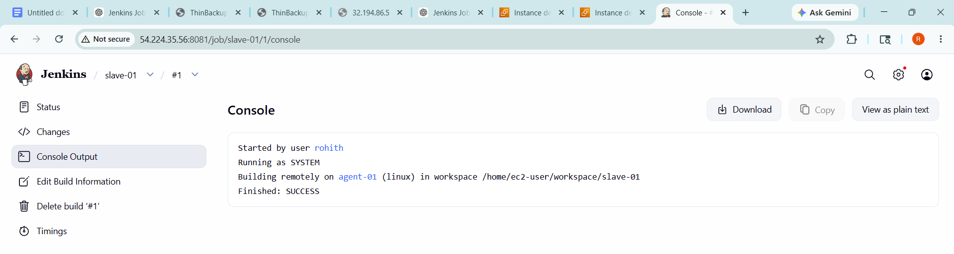

- Configure webhooks to the Jenkins job.

Opened Jenkins job configuration and enabled GitHub webhook trigger option.
Copied Jenkins webhook URL .
Navigated to GitHub repository settings → Webhooks.
Added new webhook with Jenkins URL and selected push events.
Saved webhook configuration in GitHub.
Verified job triggers automatically on code push.

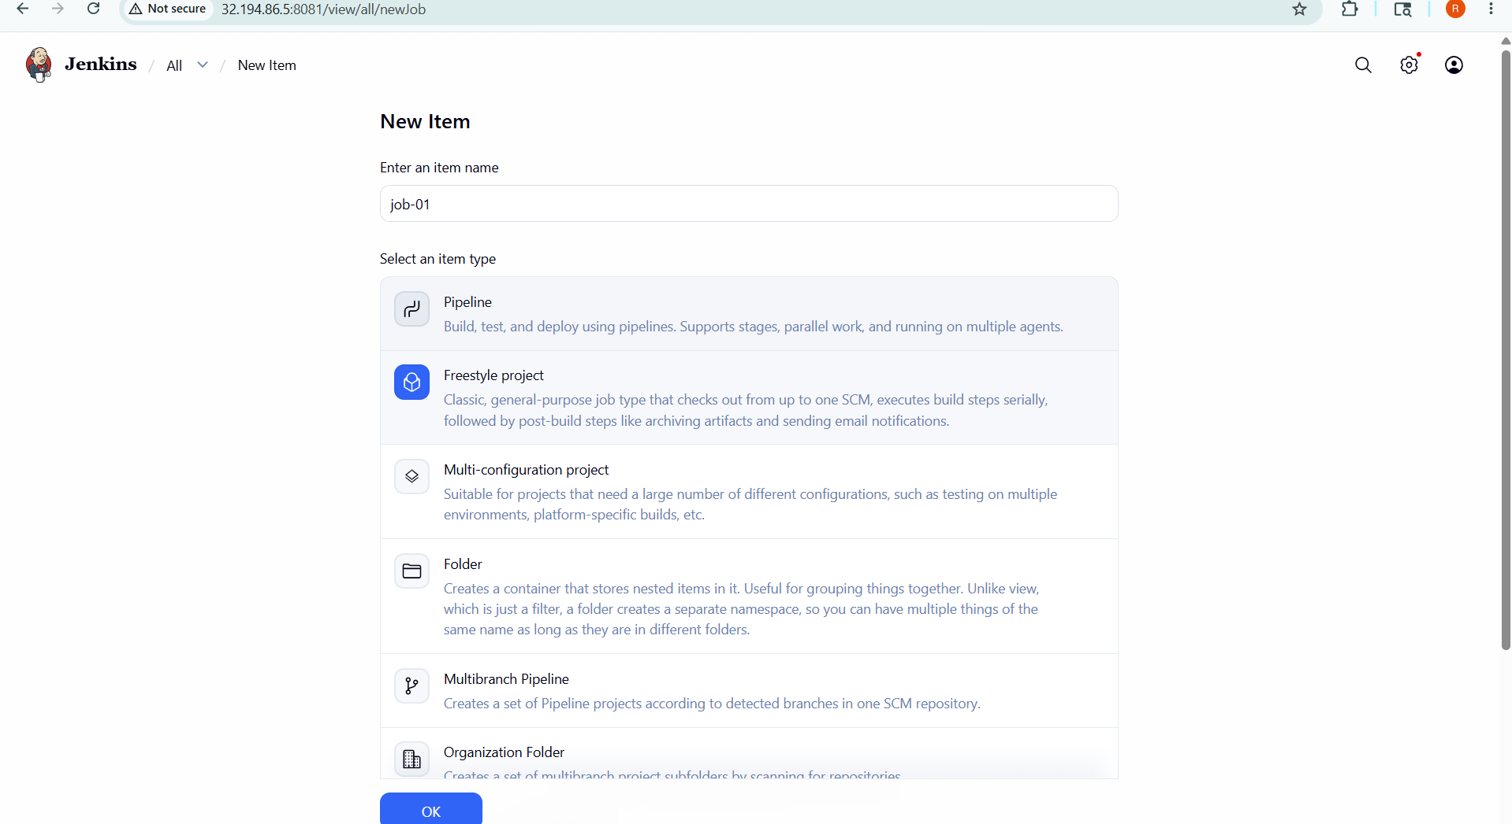

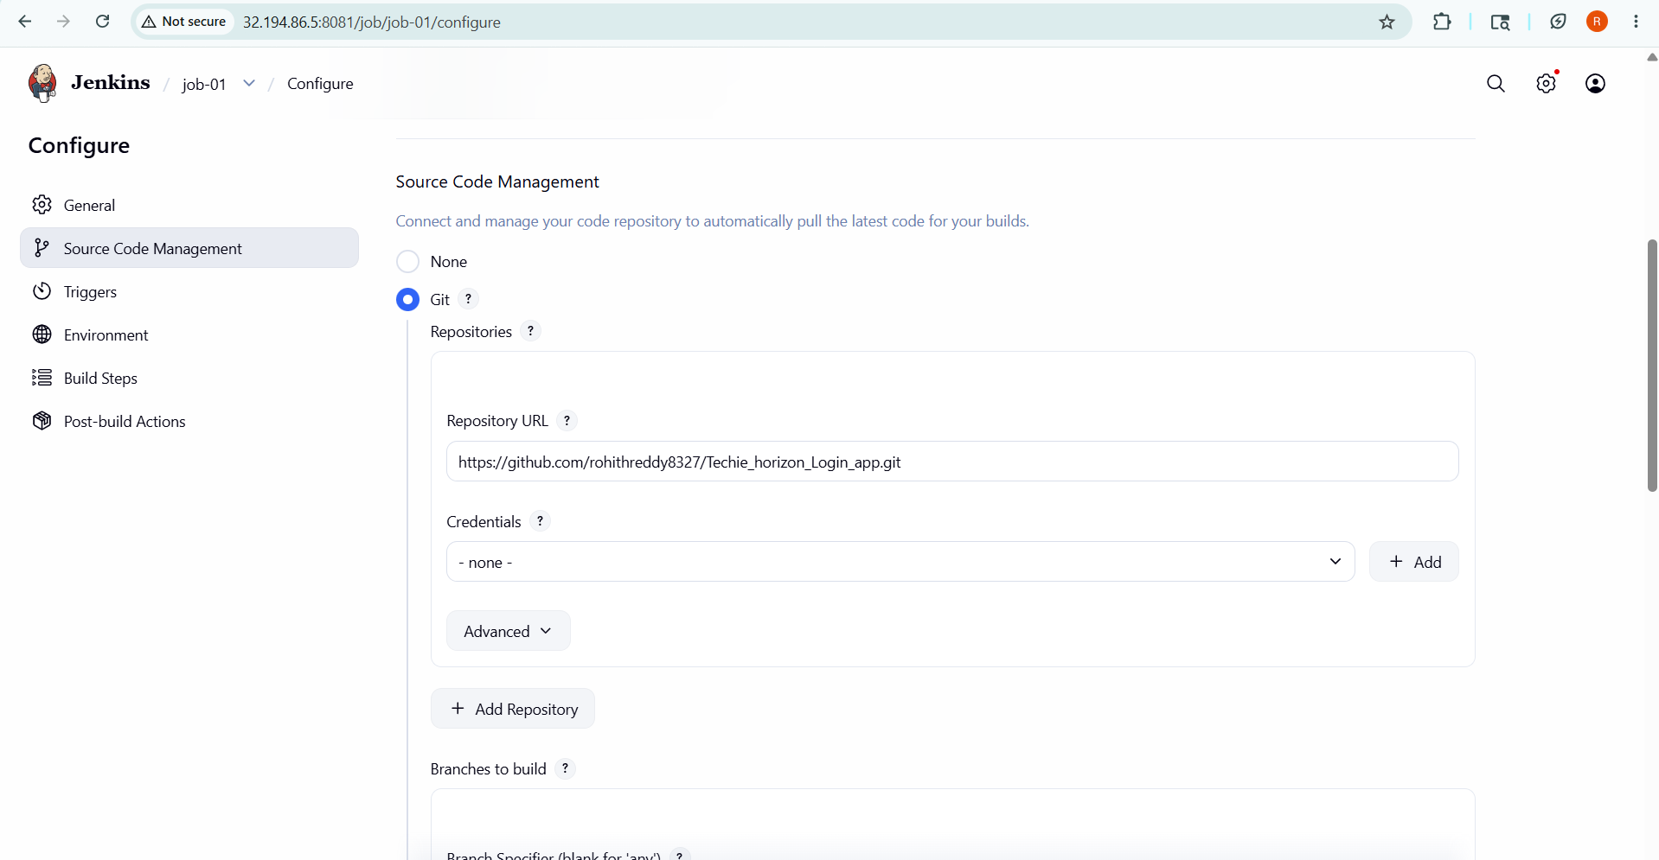

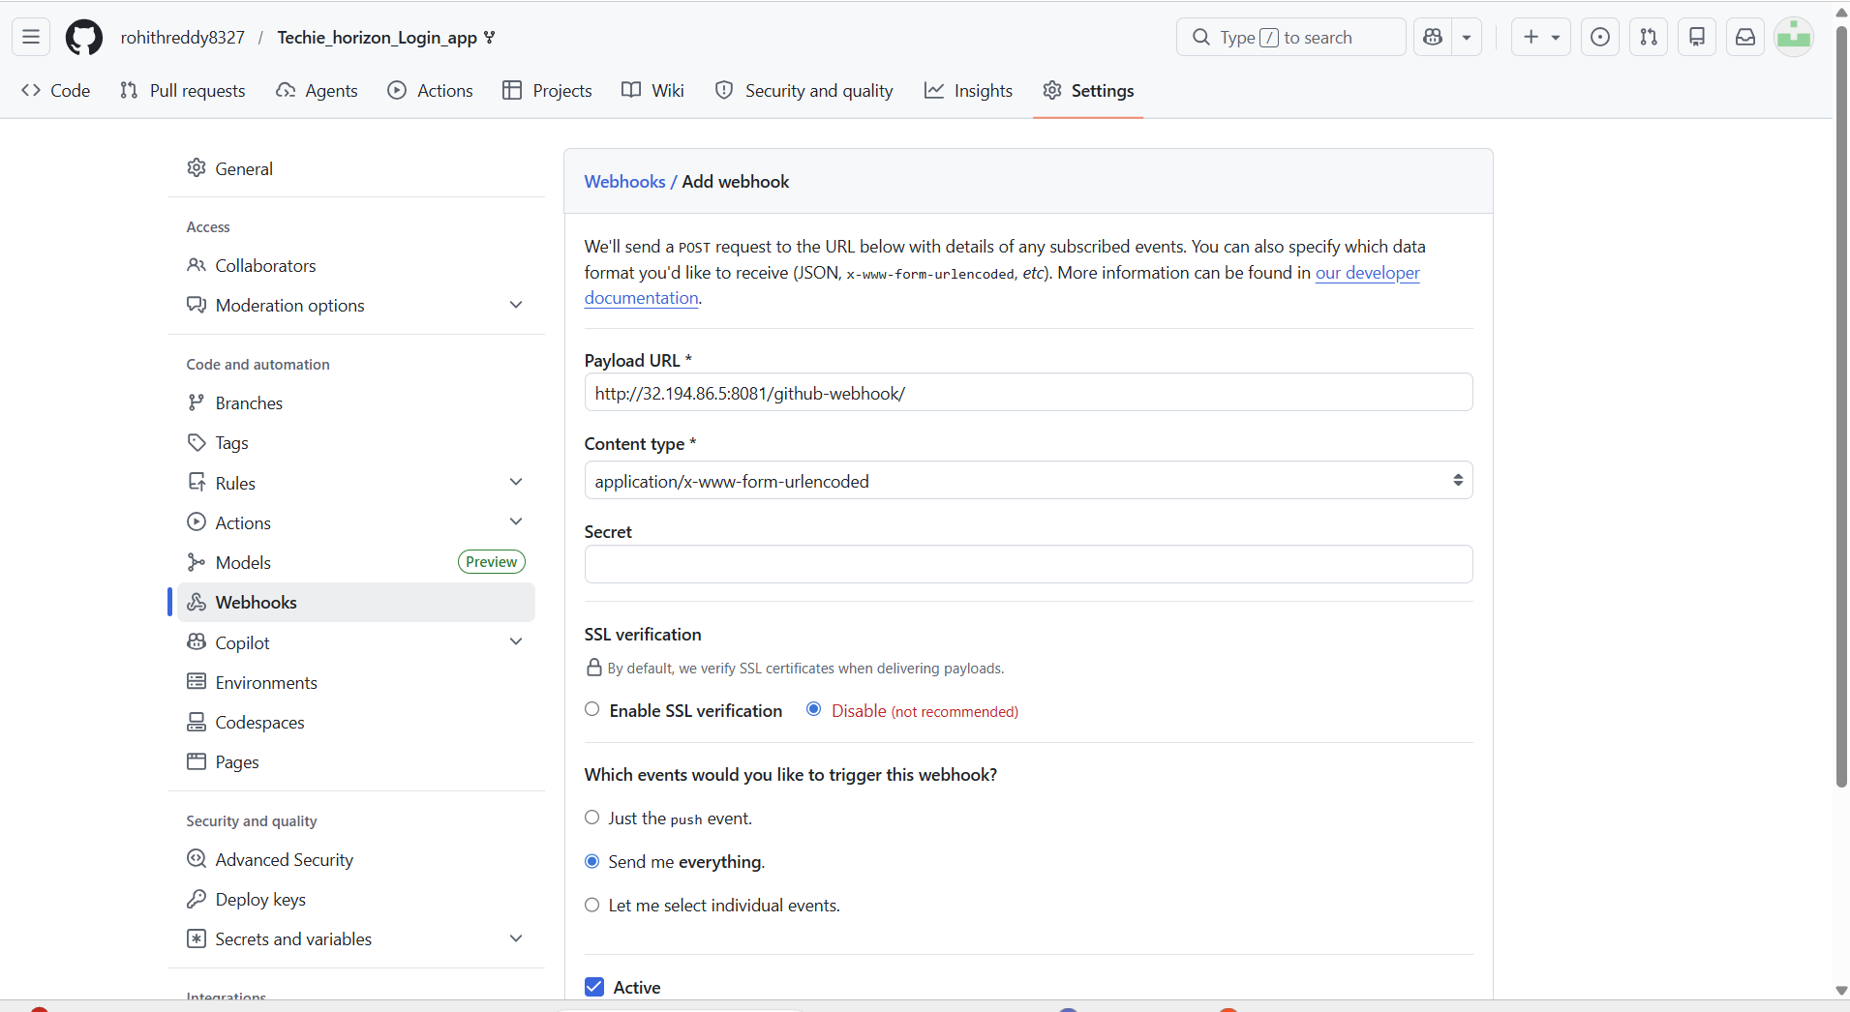

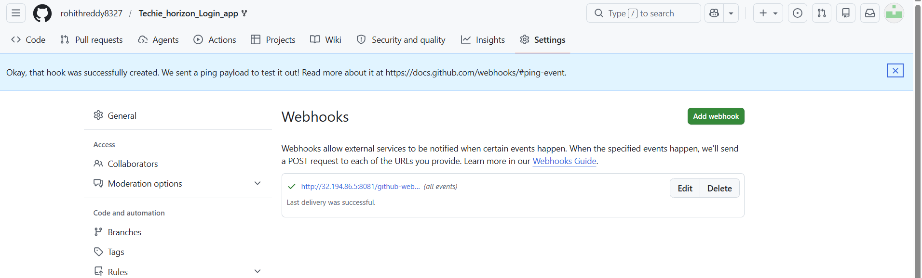

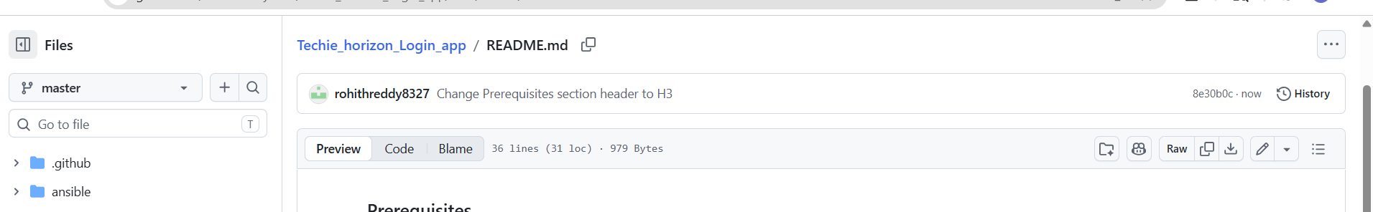

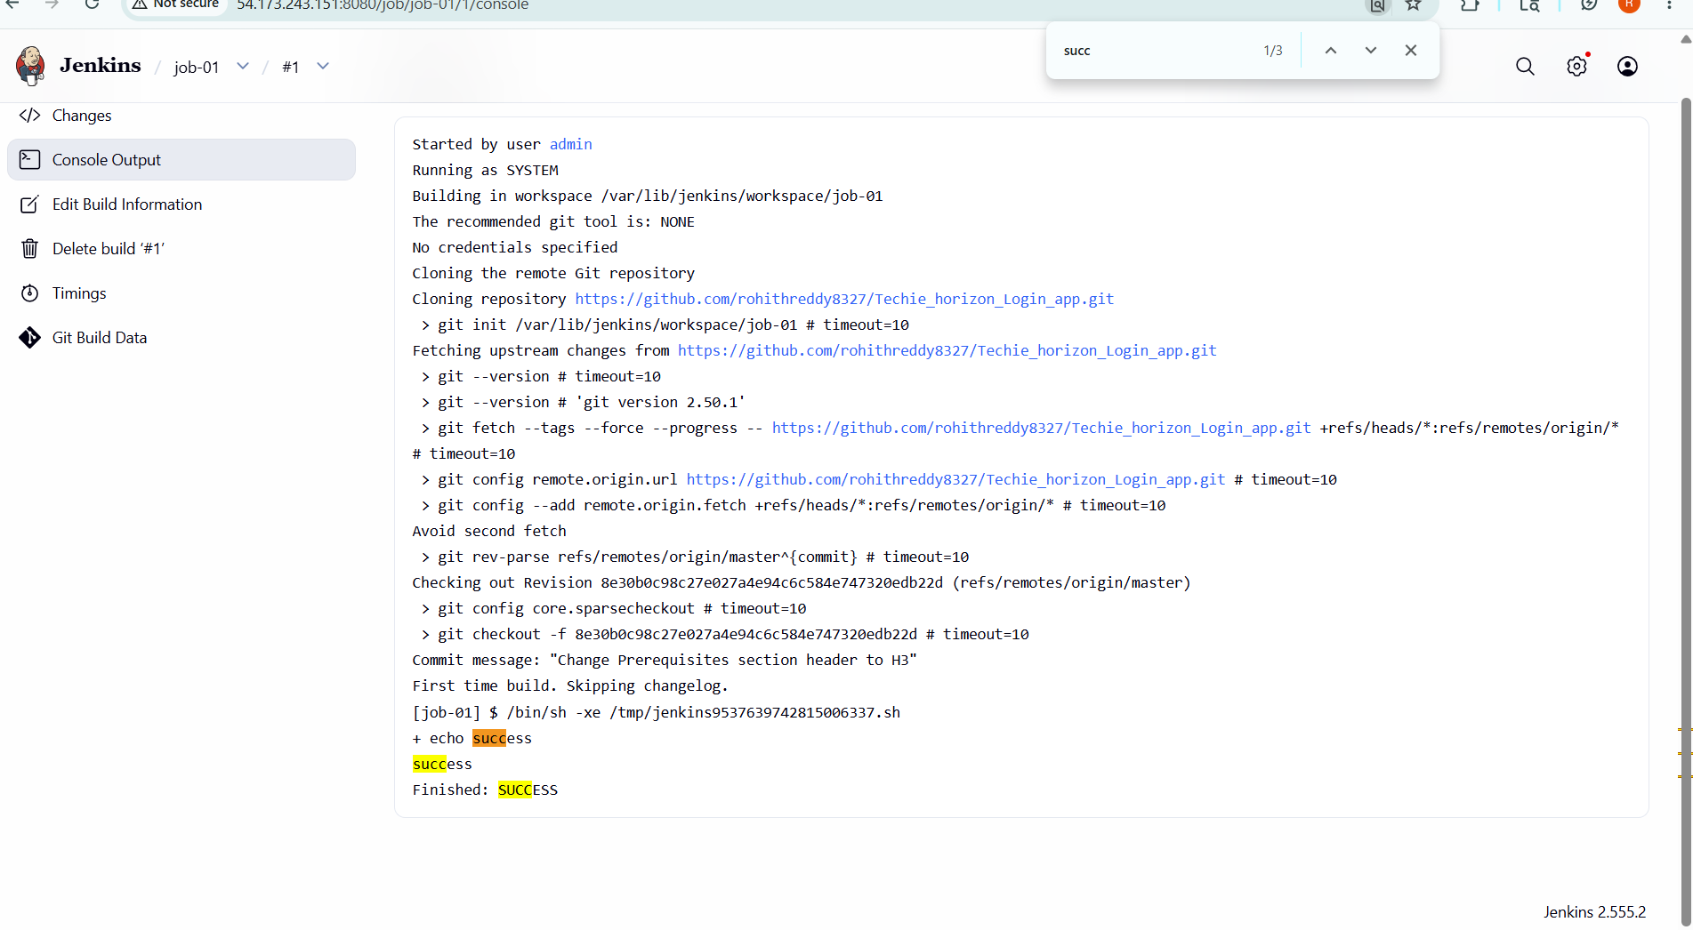

- ConfigurePoll SCMandBuild Periodicallyoptions in the Jenkins job.

Opened Jenkins job configuration and enabled Poll SCM option.
Configured cron schedule to check for code changes in repository.
Enabled Build Periodically option in the same job.
Set cron expression to trigger builds at fixed intervals.
Saved configuration and triggered test build.
Verified job triggers automatically based on schedule and SCM changes.

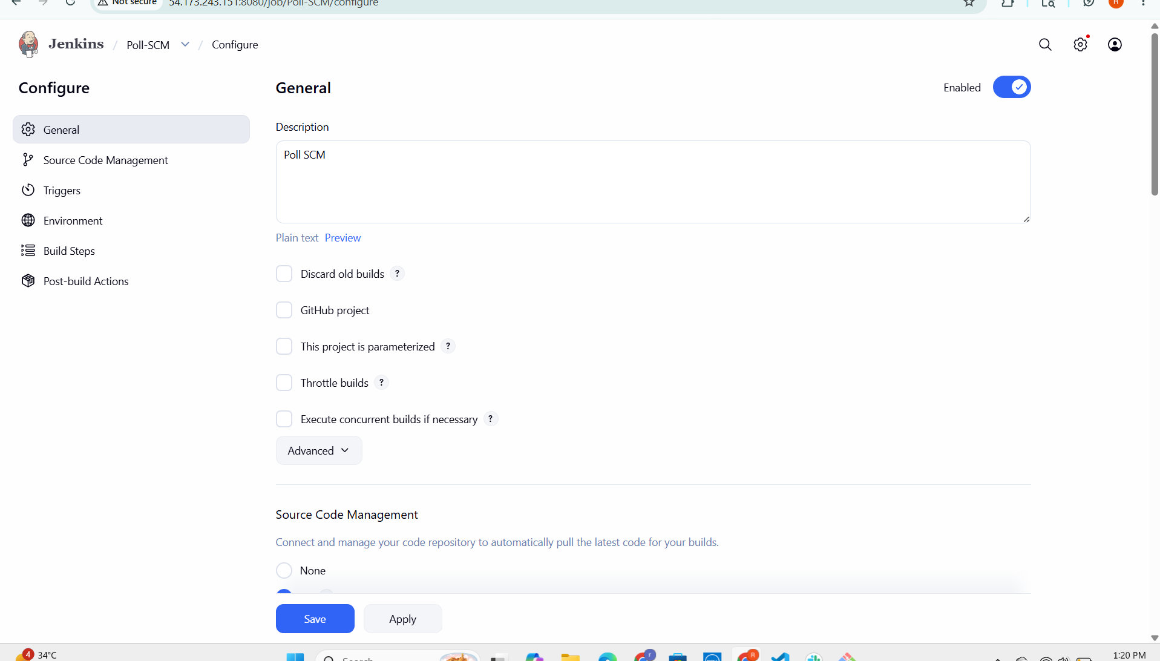

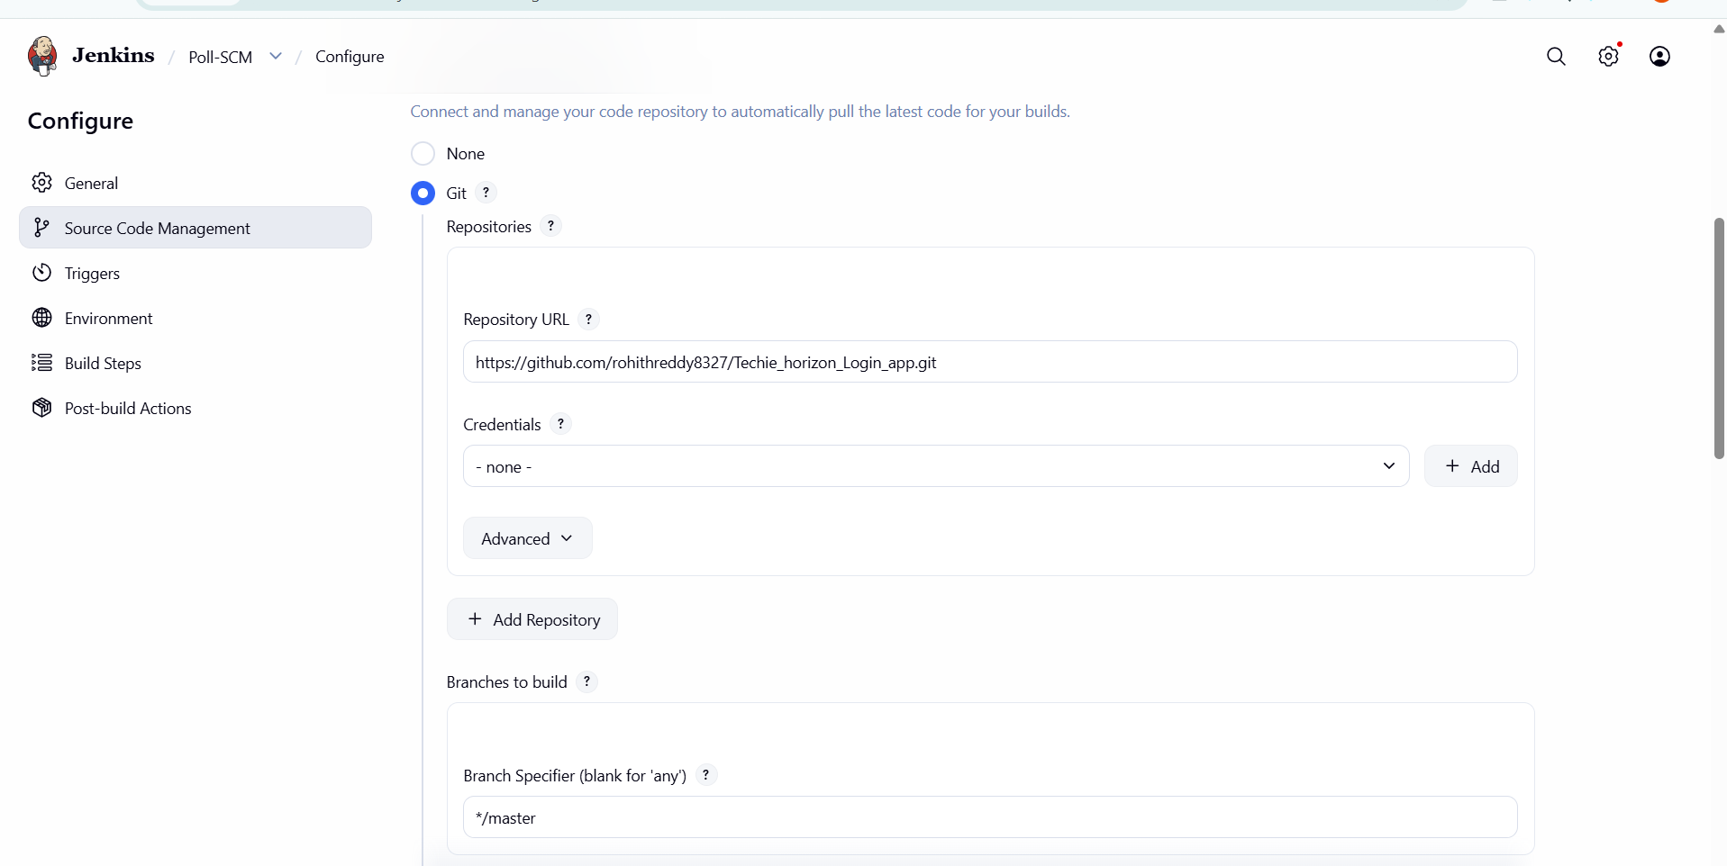

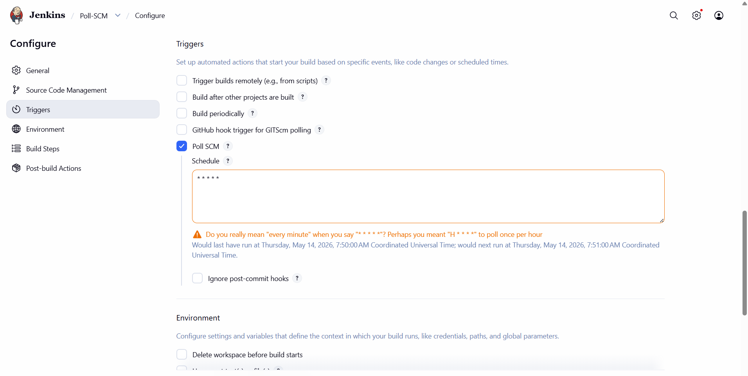

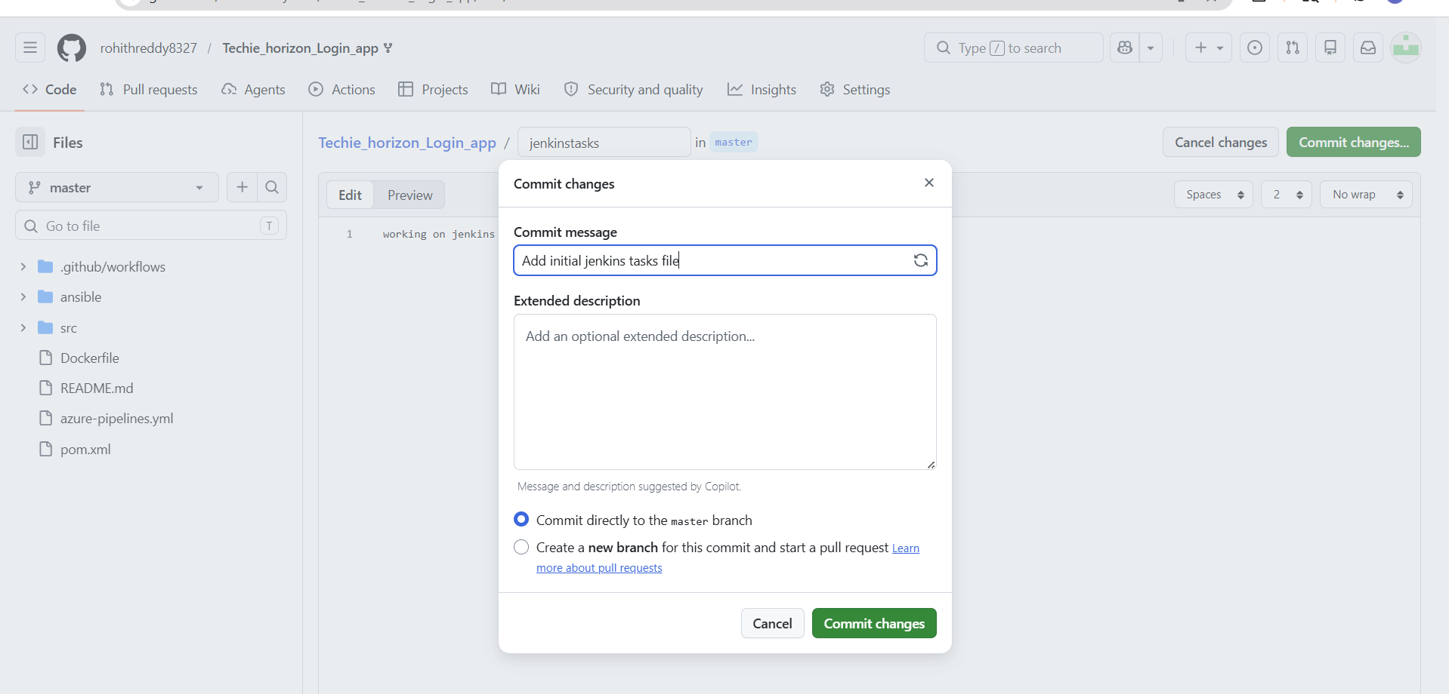

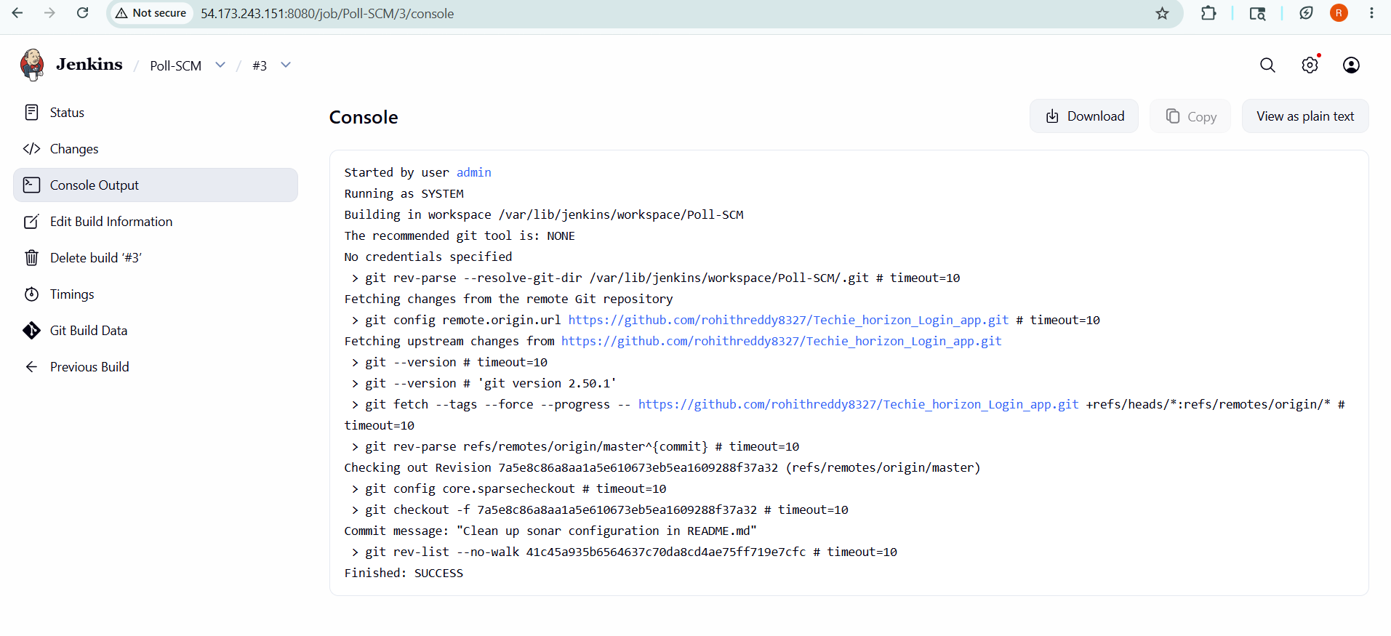

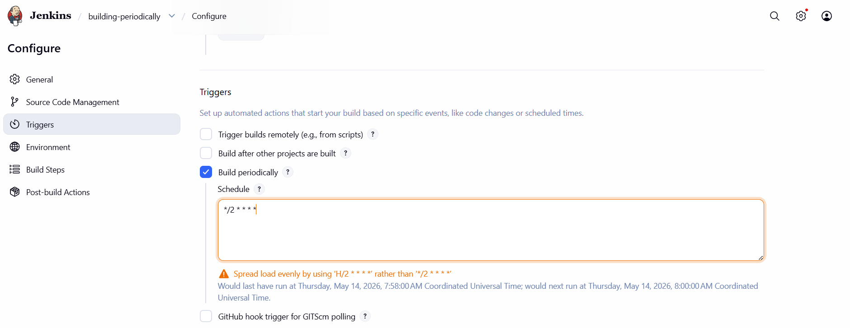

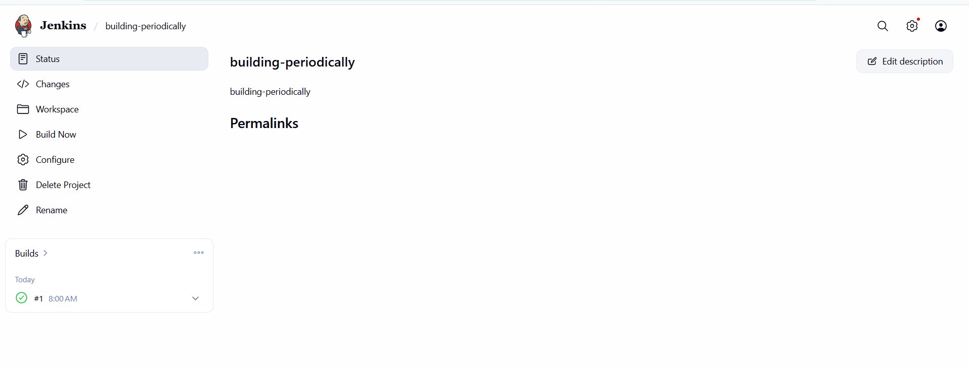

- Take a backup of the Jenkins server using abash-script.
Identified Jenkins home directory for backup.
Created a bash script to archive Jenkins data using tar.
Generated backup file (backup.tar) containing jobs and configurations.
Tested script manually to ensure backup file creation.
Configured cron job to automate backup at regular intervals.
Verified backup file is successfully created and stored.

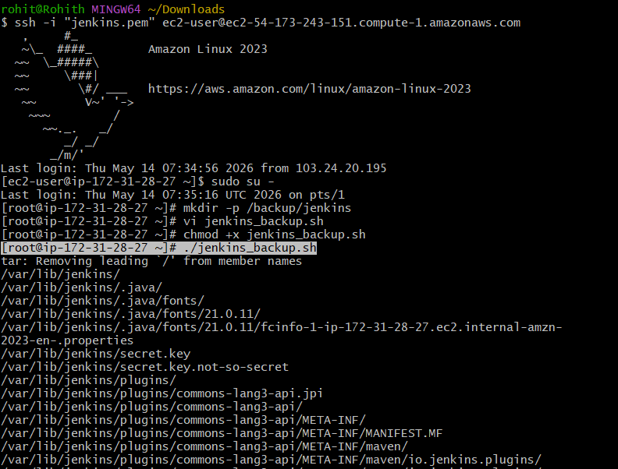

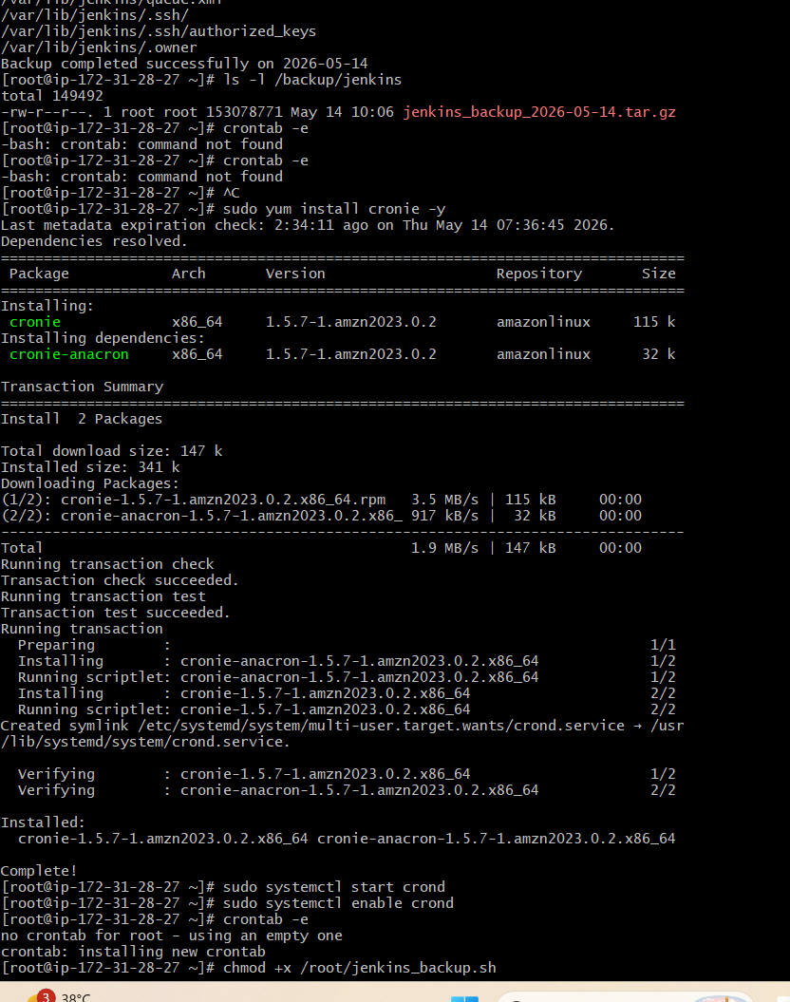

- Take a backup of Jenkins using theThinBackupplugin.

Installed ThinBackup plugin from Jenkins Plugin Manager.
Configured backup directory in ThinBackup settings.
Selected options to include jobs, plugins, and configurations.
Set up scheduled backup (periodic backup configuration).
Triggered manual backup to verify functionality.
Verified backup files are created in configured directory.

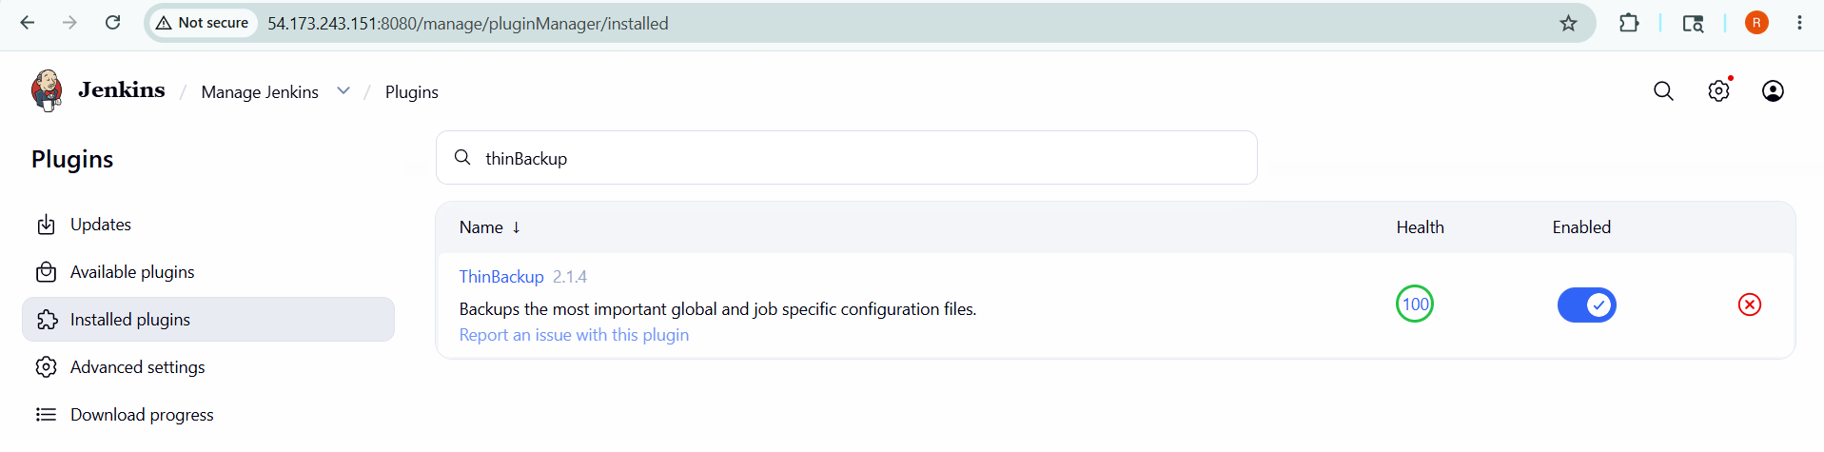

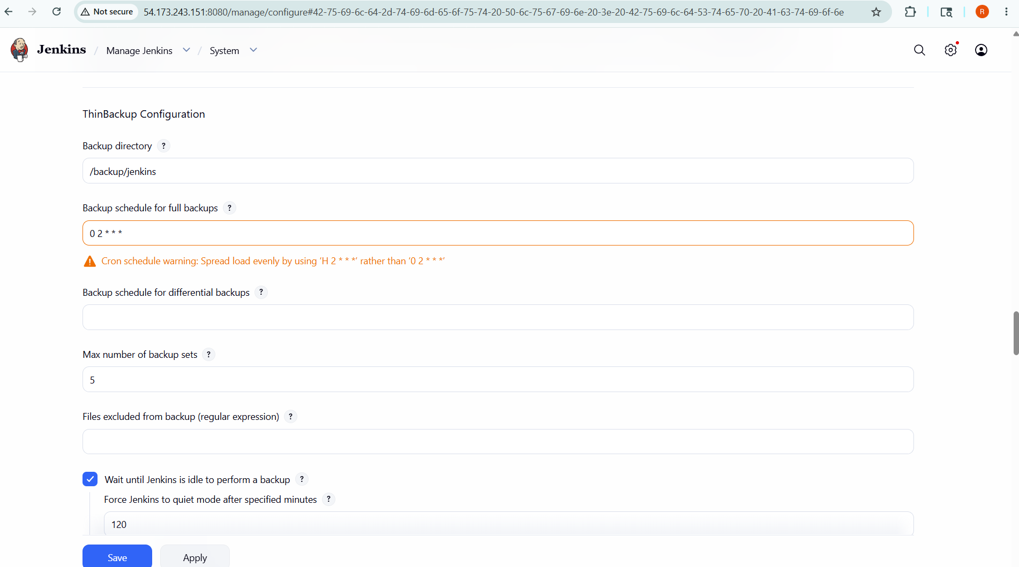

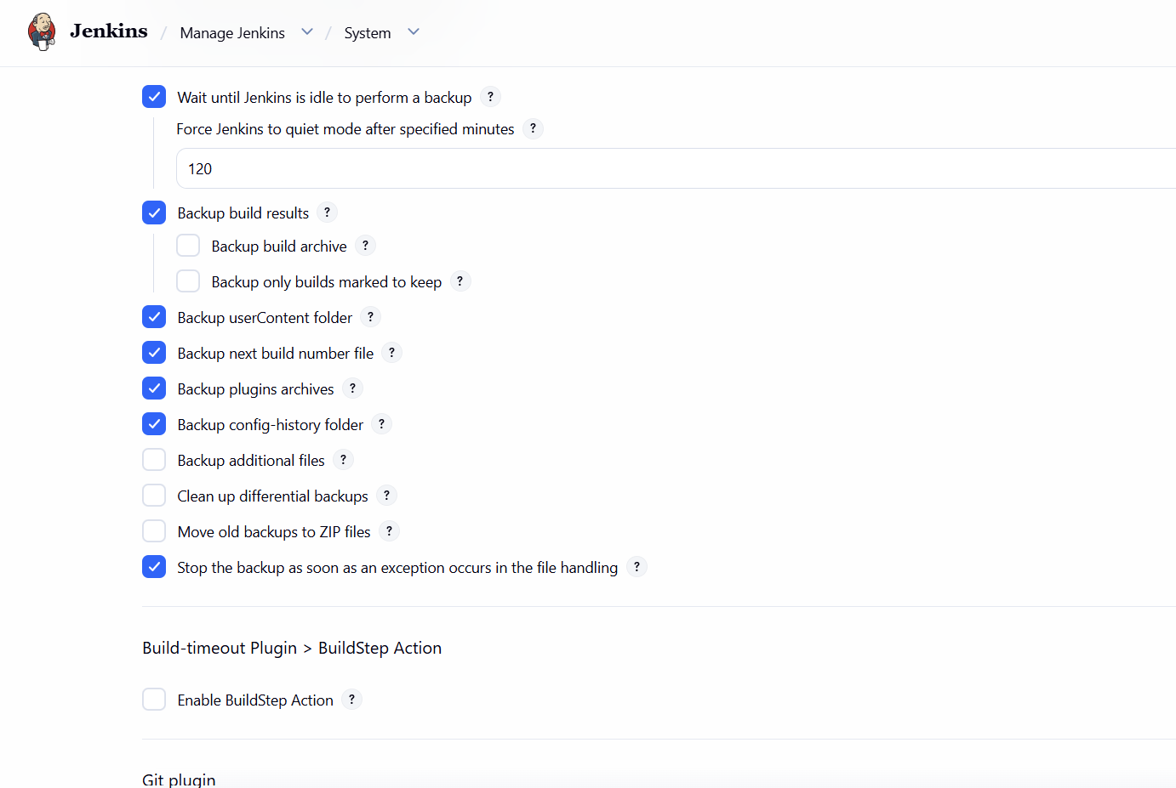

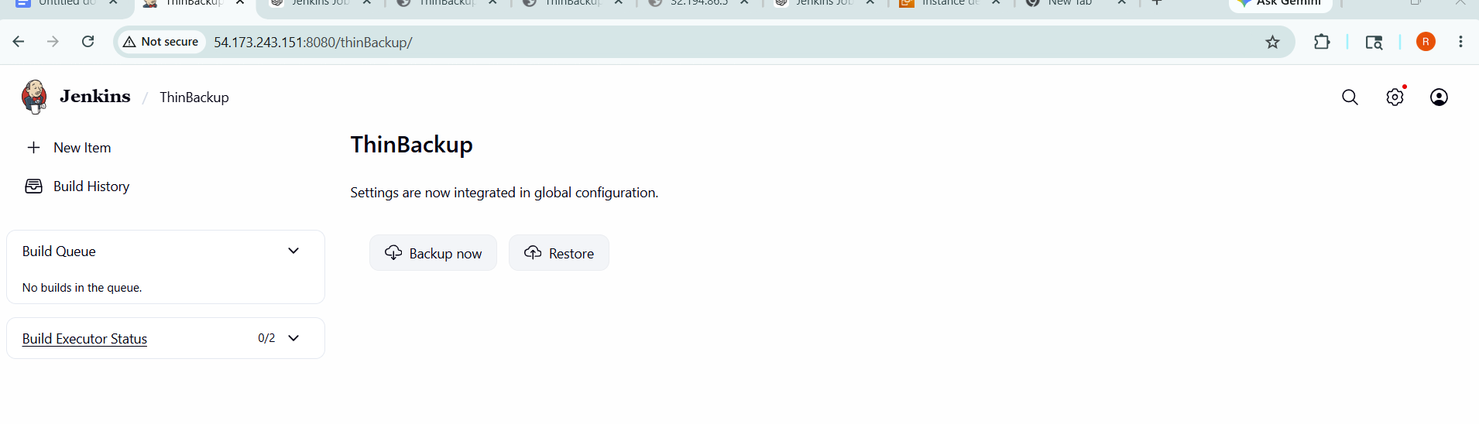
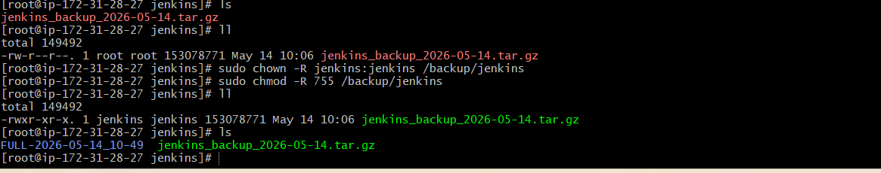
- Set up a new Jenkins server and restore the backup taken in task 4.

Launched new EC2 instance and installed Java & Jenkins.
Stopped Jenkins service before restoring backup.
Copied backup.tar from old server to new server.
Extracted backup into /backup/jenkins
Set proper permissions using chown -R jenkins:jenkins.
Started Jenkins and verified all jobs were restored.

